MINISTRY OF EDUCATION AND TRAINING



**Capstone Project Document**

**Photographic Studio Management**

**Project Code: PSM**

|  |  |  |
| --- | --- | --- |
| PSM Team | | |
| Group members | Nguyen Manh Huy | SE03199 |
| Nguyen Sy Bach | SE03704 |
| Pham Tuan Dung | SE03655 |
| Cao Lam Vu | SE03800 |
| Nguyen Hoang Trung | SE03608 |
| Supervisor | **Mr. Phan Truong Lam** | |
| Capstone Project Code | **PSM** | |

*Acknowledgements*

*We wish to express our deepest gratitude to our supervisor: Mr. Phan Truong Lam for his tutorial, sharing and motivating throught the project. Under the instructions of Mr. Phan Truong Lam, the project team has always complete at doing all assigned tasks and solving all problems. Apart from all the technologies and methodologies, Mr. Phan Truong Lam shared with us the philosophy of keeping the right attitude towards problems. We believe that was the most important factor that led to the success of this project.*

*We would also like to thank the instructors at FPT University for all the classes. We hope you will find this project as a reflection of the knowledge and experiences you have given us.*

*Finally, we truly appreciate all of our friends who has discussed with us. With your help, we have been recognized and solve every arised problem.*

Table of Contents 目次

1 INTRODUCTION はじめに 8

1.1 Purpose　目的 8

1.2 Project information　プロジェクトの情報 8

1.3 Project members　プロジェクトメンバー 8

1.4 Our proposal　提案 9

1.4.1 Problem　問題 9

1.4.2 Solution　解決 9

1.4.3 Idea　アイディア 9

1.5 Product　商品 9

1.5.1 Basic Functions　基本的な機能 9

1.6 Benefit from project　プロジェクトからベネフィット 11

1.6.1 For our group　グループのために 11

1.6.2 For user　ユーザーのために 11

2 SOFTWARE PROJECT MANAGEMENT　ソフトウェアプロジェクト管理 12

2.1 Software development process　ソフトウェア開発のプロセス 12

2.2 Project Organization　プロジェクト組織 13

2.2.1 Organizational Structure　組織構造 13

2.2.2 Project Team　プロジェクトチーム 14

2.3 Project schedule　プロジェクトスケジュール 15

2.4 Meeting minutes　打ち合わせ議事録 17

2.5 Project Millstones　プロジェクトマイルストーン 18

2.6 Project Deliverables　プロジェクトの成果物 19

2.7 Resource　リソース 20

2.7.1 Human resource　人的リソース 20

2.7.2 Non-human resource　機器やツール 20

2.8 Risk Management　リスク管理 20

2.9 Communication Management　コミュニケーション管理 22

2.9.1 Communication between Team Members　チームメンバーの間のコミュニケーション 22

2.9.2 Communication with Supervisor　指導教員とコミュニケーション 22

2.10 Configuration Management Process　コンフィグレーション管理 22

2.10.1 CI Identification and Naming Convention　構成アイテムと命名規則 22

2.10.2 Project Infrastructure　プロジェクトインフラストラクチャ 24

2.10.3 Directory structure　ディレクトリ構造 24

2.10.4 Coding convention　コーディング規約 26

3 SOFTWARE REQUIREMENTS SPECIFICATIONソフトウェア要件仕様 29

3.1 Introduction　はじめに 29

3.1.1 Purpose　目的 29

3.1.2 Scope　範囲 29

3.1.3 References　参照資料 29

3.1.4 Overview　概要 29

3.2 Overall Description　概要説明 30

3.2.1 Use Case Diagram　ユースケース図 30

3.3 Product Features 製品の特徴 32

3.3.1 Use Characteristics 35

3.3.2 User Documentationユーザードキュメンテーション 36

3.3.3 Assumption 仮定 36

3.4 Entity Relation Modelエンティティ関係モデル 37

3.4.1 Entity-Relationship Diagram エンティティ- 関係図 37

3.4.2 Entity descriptionエンティティの説明 42

3.4.3 Relationship 関係 42

3.5 Specific Requirements 　 要求仕様 44

3.5.1 Business Rules　ビジネスルール 44

3.5.2 Functionality　機能要求 45

3.6 Usability 　ユーザビリティ 132

3.7 Reliability 　信頼性 132

3.8 Performance　性能 133

3.9 Maintainability　保全性 133

3.10 Supporting Information　サポート情報 133

4 ARCHITECTURE DESIGN　アーキテクチャ設計書 134

4.1 Introduction　はじめに 134

4.1.1 Purpose　目的 134

4.1.2 References　参照資料 134

4.2 Architectural Overview　アーキテクチャ概要 134

4.2.1 System Architecture　システムアーキテクチャ 134

4.3 System Architecture Explanation　システムアーキテクチャについての説明 135

4.4 Design of Jobs Finding System　Jobs finding system の設計書 136

4.4.1 Database Design データベース設計 136

4.4.2 Database detail　データベースの詳細 136

4.5 Component Diagramコンポーネント図 143

4.6 CRC CARDS CRC カード 143

4.6.1 Modelモデル 144

4.6.2 Viewビュー 146

4.6.3 Controllerコントローラ 151

4.7 Detail Design　詳細設計 154

4.7.1 Customerゲスト 154

4.7.2 Managerメンバー 164

4.7.3 Admin　管理 211

4.7.4 System　システム 255

5 SOFWARE TESTING ソフトウェアテスト 256

5.1 Introduction　はじめに 256

5.1.1 Purpose　目的 256

5.1.2 References　参照資料 256

5.1.3 Background information　背景情報 256

5.1.4 Scope of testing　テスト範囲 257

5.2 Constraints　制約事項 257

5.2.1 Risk listリスク一覧 257

5.3 Requirements for Test　テスト要求 258

5.3.1 Test items　テスト頭目 258

5.3.2 Acceptance Test Criteria　テスト受入基準 261

5.3.3 Feature not to be tested　テストされない特徴 262

5.4 Test strategy　テスト戦略 262

5.4.1 Test Model　テストモデル 262

5.4.2 Test types テストタイプ 264

5.4.3 Function Testing　機能テスト 264

5.4.4 User Interface Testing　ユーザーインターフェーステスト 265

5.4.5 Data and Database Integrity Testing　でーたおよびデータベース整合性テスト 266

5.4.6 Test stages　テストステージ 266

5.5 Resource　リソース 267

5.5.1 Human Resource　人的リソース 267

5.5.2 Test management　テスト管理 267

5.5.3 Defect management　欠陥管理 268

5.6 Test environment　たテスト環境 269

5.6.1 Hardware ハードウェア 269

5.6.2 Software　ソフトウェア 269

5.7 Test Milestones　テストマイルストーン 270

5.8 Deliverables　納品物 271

5.9 Test Case　テストケース 271

5.10 Test Report　テストレポート 272

5.10.1 Unit Test Report 単体テスト 272

5.10.2 Common Test Report　一般テストレポート 273

5.10.3 Integration Test Report　統合テストレポート 273

5.10.4 System Test Report　システムテストレポート 273

5.10.5 Test Report　テストレポート 274

6 USER MANUAL　ユーザーマニュアル 274

6.1 Install Guide　インストールガイド 274

6.1.1 Introduction　はじめに 274

6.1.2 Installation Guideline　インストールのガイドライン 275

6.1.3 Other considerations 他の検討事項 279

6.2 User Guide　ユーザーガイド 279

6.2.1 Customerゲスト 279

6.2.2 Managerメンバー 284

6.2.3 Admin　管理 314

6.2.4 System　システム 338

Definition and acronyms

|  |  |  |
| --- | --- | --- |
| Acronym | Definition | Note |
| PSM | Website Studio Media | Project’s name |
| SRS | Software Requirement Specifications |  |
| CI | Configuration Item |  |
| CM | Configuration Management |  |
| Admin | Administrator |  |
| Manager | Photo Studio Manager |  |
| PM | Project Manager |  |
| PTL | Project Technical Leader |  |
| CRC | Class-Responsibility-Collaborators |  |
| AT | Acceptance Test |  |
| IT | Integration Test |  |
| KLOC | 1000 lines of code |  |
| PM | Project Manager |  |
| PTL | Project Technical Leader |  |
| PT/TT | Program Test/ Total Test |  |
| QA | Quality Assurance |  |
| UT | Unit Test |  |
| PC | Personal Computer |  |
| UI | User Interface |  |

# INTRODUCTION はじめに

## Purpose　目的

This chapter provides an overview of Website Studio Media system, it includes background information, literature review of existing system and raising a proposal for ideas of improvement.

## Project information　プロジェクトの情報

|  |  |
| --- | --- |
| Project name: | Website Studio Media |
| Project code: | PSM |
| Project type: | Website |
| Project category: | New development |
| Business type: | Website Service |
| Project manager: | Nguyen Manh Huy |
| Timeline: | *Work in progress* |

Table 1.1 - Project Information

## Project members　プロジェクトメンバー

* Supervisor:

|  |  |  |
| --- | --- | --- |
| Full name | E-mail | Title |
| Phan Truong Lam | Lampt2@fe.edu.vn | Lecturer |

* Team member:

|  |  |  |  |  |
| --- | --- | --- | --- | --- |
| Full name | Roll number | E-mail | Phone | Position |
| Nguyen Manh Huy | SE03199 | HuynmSE03199@fpt.edu.vn | 01689597078 | Leader |
| Nguyen Sy Bach | SE03704 | BachnsSE03704@fpt.edu.vn | 01228245737 | Member |
| Cao Lam Vu | SE03800 | VuclSE03800@fpt.edu.vn | 01689181825 | Member |
| Pham Tuan Dung | SE03655 | DungptSE03655@fpt.edu.vn | 01646426345 | Member |
| Nguyen Hoang Trung | SE03608 | TrungnhSE03608@fpt.edu.vn | 01635105330 | Member |

## Our proposal　提案

### Problem　問題

The rapid change in technology, knowledge explosion, the increased and complex demands for a good place with the best price to make their own memory with an album book full of picture of important moments in their life. Moreover, there are so much information about unknow photo studio on the internet, customer find it difficult to find their ideal photo studio because of the number and confusing information. Therefore, the posed problems are making an interaction between customer and photo studio, and help the customer to search for the best studio as quick as possible.

### Solution　解決

Create a website that have all the information about a coporation of photo studio to help the customer find the best one.

Provide a lot of service to help the customer to keep track of the photo contract and printing detail.

By the automatic searching function, cost and time are minimized.

### Idea　アイディア

Our idea is creating a website not only to link Customer and Photo Studio but also to help customer manage information about the photo conctract and printing requirement quickly and efficiently.

## Product　商品

After researching carefully about the market needs of photo conctract, we have chosen main functions which are necessary and important to our system. They will help the manager easy to use and operate. Besides, we also compare to other website and research about user’s habits to design good and intuitive interface. We want to reduce all limitation and improve our own advantages.

The objective user of our Website is Vietnamese people who living in VietNam. Therefore, our website using Vietnamese as primary language, to meet the criteria of user-friendly.

### Basic Functions　基本的な機能

**Customer:**

* Search for the nearest studio location.
* View studio basic informations and sample portfolio.
* See and pick a photo session contract package.
* Tracking the contract.
* See photo uploaded after photo shoot.
* Pick and choose size, material for the photo to print.

**Photo Studio Manager:**

**Photo Studio Manager can only access to these function after login.**

* View own photo studio information.
* Edit photo studio information and sample portfolio.
* Add photo studio information and sample portfolio.
* Delete photo studio information and sample portfolio.
* Search photo session package.
* View photo session package
* Edit photo session package.
* Add photo session package.
* Delete photo session package.
* See customer contract package register.
* Search customer contract package.
* Accept customer contract and add to contract list.
* Edit a contract.
* Upload photos after photo shoot.
* Accept printing order if customer request.
* Search priting size and material.
* View priting size and material.
* Edit priting size and material.
* Add priting size and material.
* Delete priting size and material

**Admin**

* **Manage Photo Studio Manager**
* Search Manager profile.
* View Manager profile
* Edit a Manager profile.
* Add a Manager.
* Delete a Manager.
* **Manage Province and District**
* Search Province and District information.
* View Province and District information.
* Edit Province and District information.
* Add a Province or District.
* Delete a Province or District.

**System**

* Send notification to Customer’s email in the following cases:
* Cutomer leave email information for photo studio to contact.
* Customer order a photo sessions package.
* The Studio Manager had accepted the customer’s order and awaiting the customer confirm.
* The Photo Taking Session is done and Photo Studio send customer a receipt

Out of scope

* **Manage Website’s payment activities**

By using website, when order a photo session or photo extra priting require customer to pay. Therefore, website will use online payment service .

## Benefit from project　プロジェクトからベネフィット

### For our group　グループのために

After developing and implementing this project, our group will get some benefits:

* Have more experiences of software project management: how to manage plan, time, member and risk.
* Have more knowledge and skill about Node.js, and HTML, MySQL.
* Know how to communicate with team members and how to make teamwork more effective.

### For user　ユーザーのために

* Improving chances to finding the best Photo Studio.
* Saving time and costs for Studio.
* Customer can track Photo Contract and order extra printing.

# SOFTWARE PROJECT MANAGEMENT　ソフトウェアプロジェクト管理

In this section, we will describe our organization and plan of project. Each member of team must use this section as a guideline tracking assigned tasks and deadlines. In addition, we introduce our team and overview about project. Meeting minute also present in this section. Moreover, we will describe risks of project and the way communication of our team.

## Software development process　ソフトウェア開発のプロセス

This figure below will describe the information and products waterfall process model.

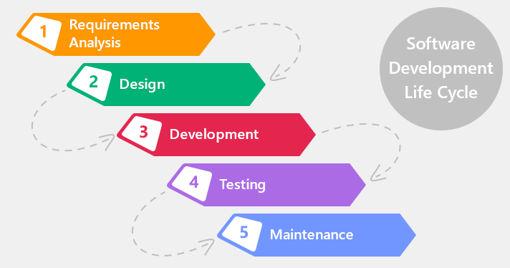

Figure 2.1Waterfall software process model

PSM project uses the Waterfall Software Process Model. We have chosen the Waterfall Software Process Model because the scope of our project is small, the technical documentation is a necessary part of the initial requirements pahse, this mean that everyone understands the objectives. By using this software process model, the phased development cycle enforces discipline. Each step has a clearly defined starting poin and conclusion, which makes progress easy to monitor. This model make testing easy, test scenarios are already detailed in the function specification phased. We easier to manage risk because risky pieces are identified and handled. Besides, the iterative model is easier than other models when the issues are discovered. All issue will be raised to the team. They will be solved while the project is still developed.

## Project Organization　プロジェクト組織

### 2.2.1 Organizational Structure　組織構造

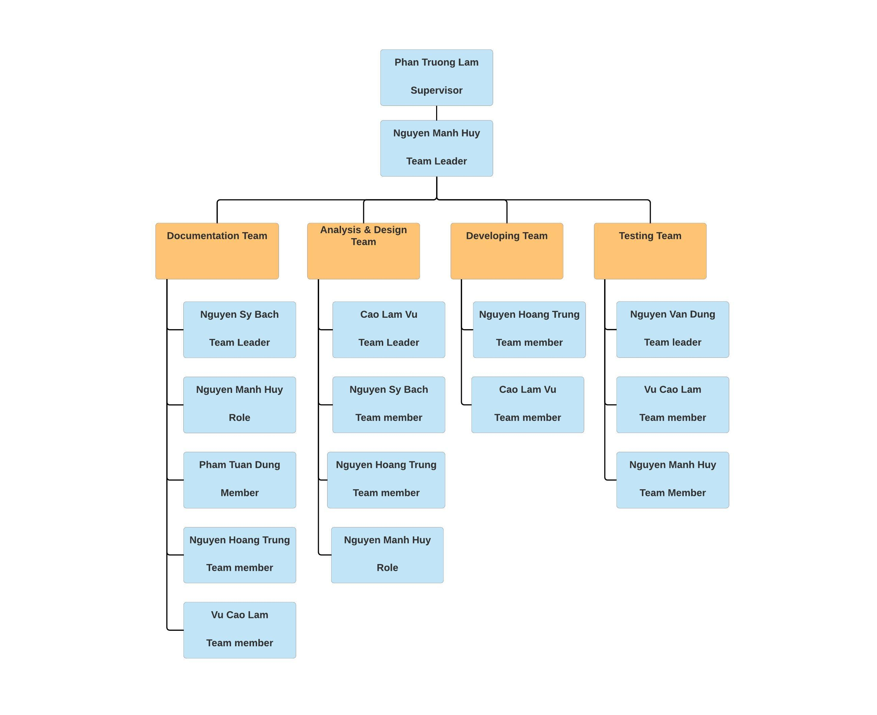

Figure 2.2.1Organizational structure chart

### 2.2.2 Project Team　プロジェクトチーム

|  |  |  |  |  |  |
| --- | --- | --- | --- | --- | --- |
| Role | Responsibility | Full name | % Effort | Start date | End date |
| Instructor | * Provide templates & tools * Review deliverables * Review project status * Resolve escalated issues * Consultant | Pham Truong Lam | 30% | January  08th,2018 | May  03th,2018 |
| PM | * Planning and defining scope * Developing schedule * Reviewing and Tracking document * Identify resources and assign individual responsibilities * Assign task to team members * Coordinating communication | Nguyen Manh Huy | 100% | January  08th,2018 | May  03th,2018 |
| Analysis and Design Team | | | | | |
| Team Leader | * Reviewing and Tracking design * Identify main UI * Draw prototype, Architecture Design * Database Design | Cao Lam Vu | 100% | January  09th,2018 | May  02th,2018 |
| Team member #1 | * Database Design * Draw prototype, Architecture Design | Nguyen Hoang Trung | 100% | January  09th,2018 | May  01th,2018 |
| Team member #2 | * Database Design * Draw prototype, Architecture Design. | Nguyen Sy Bach | 100% | January  09th,2018 | May  01th,2018 |
| Team member #3 | * Screen Design. | Nguyen Manh Huy | 100% | January  09th,2018 | May  01th,2018 |
| Documentation Team | | | | | |
| Team Leader | * Reviewing and Tracking Requirement. | Nguyen Sy Bach | 100% | January  09th,2018 | May  02th,2018 |
| Team member #1 | * Create SRS document. * Create Project Schedule. * Create Usecase. * Create User Manual. | Nguyen Manh Huy | 100% | January  09th,2018 | May  02th,2018 |
| Team member #2 | * Create Class Diagram and Sequence. | Vu Cao Lam | 100% | January  09th,2018 | May  02th,2018 |
| Team member #3 | * Create Class Diagram and Sequence. | Nguyen Hoang Trung | 100% | January  09th,2018 | May  02th,2018 |
| Team member #4 | * Create Class Diagram and Sequence. | Pham Tuan Dung | 100% | January  09th,2018 | May  02th,2018 |
| Development Team | | | | | |
| Team Leader | * Developing and review tracking. | Nguyen Hoang Trung | 100% | January  09th,2018 | May  02th,2018 |
| Developer #1 | * Developing. | Cao Lam Vu | 100% | January  09th,2018 | May  02th,2018 |
| QA and Test Team | | | | | |
| Test Leader | * Responsible for test execution. * Test results recording * Evaluation of test run and error recovery. | Pham Tuan Dung | 100% | January  11th,2018 | May  02th,2018 |
| Tester #1 | * Testing. | Nguyen Manh Huy | 100% | January  09th,2018 | May  02th,2018 |
| Tester #2 | * Testing. | Cao Lam Vu | 100% | January  09th,2018 | May  02th,2018 |

Table 2.2.2 Project Team

## Project schedule　プロジェクトスケジュール

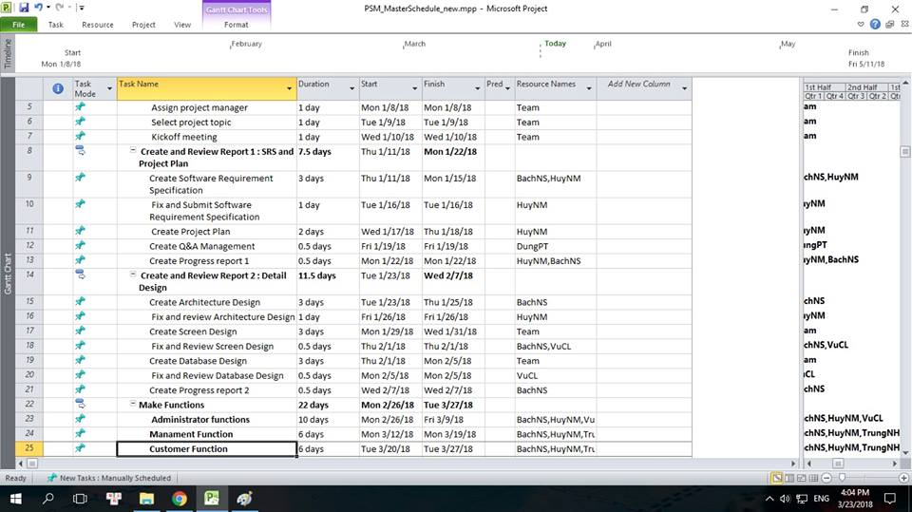

## Meeting minutes　打ち合わせ議事録

All meeting minutes will be written follow this template:

|  |  |  |  |
| --- | --- | --- | --- |
| Meeting Minutes 1 | | | |
| Subject | Comment on Report 1 | **Date** | 11/01/2018 |
| Conductor | Prof. LamPT | **Time** | 10h30’ |
| Location | Room 105L Beta building | **Secretary** | BachNS |
| Attendees | HuyNM, VuCL, TrungNH, DungPT, BachNS | | |
| Absent | No | | |

Table .4 Meeting minutes

|  |  |  |
| --- | --- | --- |
| Key Points Discussed | | |
| **No.** | Topic | Highlights |
| 1 | Common work progress. | Done: report 1.  Progress: report 2. |
| 2 | Setup working environment :Tools to manage source code, documents, database... | Done |
| 3 | Learn Nodejs, Learn Css | In progress |
| 4 | Assigning someone looking data for Studio. | TrungNH |
| 1 | Common work progress. | Done: report 1.  Progress: report 2. |
| 2 | Setup working environment: Tools to manage source code, documents, database... | Done |

Table .4.1 Key Points Discussed

|  |  |  |  |
| --- | --- | --- | --- |
| Action Plan | | | |
| No. | Action Item(s) | Owner | Target Date |
| 1 | Define the roles & responsibilities of each team member. | HuyNM | 11/01/2018 |
| 2 | Analyze requirement, make project plan to be written in template format. | HuyNM, TrungNH | 15/01/2018 |
| 3 | Design: ERD, System architecture, Class diagram, Sequence diagram, Use case diagram... | HuyNM, VuCL,  TrungNH,BachNS | 17/01/2018 |
| 4 | Estimate number of use cases, the number of 30 use cases is appropriate. | VuCL,TrungNH, BachNS | 19/01/2018 |
| 5 | Write the report 2, report 3 | HuyNM,BachNS | 22/01/2018 |

## Project Millstones　プロジェクトマイルストーン

|  |  |  |  |
| --- | --- | --- | --- |
| No | Milestone | Completion Date | Verification |
| 1 | Project Start | 08/01/2018 | Instructor approval |
| 2 | Submit report 1 | 21/01/2018 | Instructor approval |
| 3 | Submit report 2 | 07/02/2018 | Instructor approval |
| 4 | Submit report 3 | 13/02/2018 | Instructor approval |
| 5 | Submit report 4 | 01/03/2018 | Instructor approval |
| 6 | Submit report 5 | 25/03/2018 | Instructor approval |
| 7 | Submit report 6 | 27/04/2018 | Instructor approval |
| 9 | Defend project | 03/05/2018 | Instructor approval |

Table 2.5 Project Millstones

## Project Deliverables　プロジェクトの成果物

|  |  |  |  |  |
| --- | --- | --- | --- | --- |
| **No** | **Deliverable** | **Committed Delivery date** | **Description of Deliverable** | **Delivery media** |
| 1 | Capstone project register | 25/04/2018 |  | Hard copy |
| **Iteration 1** | | | | |
| 2 | Software Requirement Specifications - SRS | 11/01/2018 | Document | Commit to Github |
| 3 | Project plan | 13/01/2018 | Document | Commit to Github |
| 4 | User requirements | 18/01/2018 | Document | Commit to Github |
| 5 | Q&A Management | 19/01/2018 | Document | Commit to Github |
| 6 | Progress report 1 | 22/01/2018 | Document | Commit to Github |
| 7 | Architecture design | 23/01/2018 | Document | Commit to Github |
| 8 | User interface design | 26/02/2018 | Document | Commit to Github |
| 9 | Progress report 2 | 07/02/2018 | Document | Commit to Github |
| 10 | Database design | 08/02/2018 | Document | Commit to Github |
| 11 | Test plan | 10/02/2018 | Document | Commit to Github |
| 12 | Test case | 11/02/2018 | Document | Commit to Github |
| 13 | Progress report 3 | 13/02/2018 | Document | Commit to Github |
| 14 | Progress report 4 | 01/03/2018 | Document | Commit to Github |
| 15 | Test case - execute | 14/03/2018 | Document | Commit to Github |
| 16 | Test report | 16/03/2018 | Document | Commit to Github |
| 17 | Progress report 5 | 25/03/2018 | Document | Commit to Github |
| **Iteration 2** | | | | |
| 18 | User manual | 02/04/2018 | Document | Commit to Github |
| 19 | Progress report 6 | 27/04/2018 | Document | Commit to Github |
| 20 | Final report | 03/05/2018 | Document | Hard copy |

Table 2.6 Project Deliverables

## Resource　リソース

### Human resource　人的リソース

* Team members
* Supervisor

### Non-human resource　機器やツール

* Equipment: Desktop, Laptop.
* Building: ALFA & BETA Building - FPT University.

## Risk Management　リスク管理

|  |  |  |  |  |  |  |
| --- | --- | --- | --- | --- | --- | --- |
| No | Name | Root Cause | Probability | Avoidance plan | Contingency plan | Impact |
| 1 | Team don’t keep the deadline on time. | Members lack of responsibility, have bad habits.  Lack of management. | Medium | Make rules and penalties for people who doesn’t meet the deadline. | Working overtime to complete on time  Punish member by money... | High |
| 2 | Requirement changed while project is processing. | SRS is not provide all information about user requirement such as: lack of customer’s requirement, misunderstand requirement of customer. | High | SRS should be review carefully by PM and the Supervisor.  Always do brainstorming carefully to design detail system. Hold all meeting and make minimize effort to change and improve design by requirement changes. | Team members will have meetings with supervisor to analyze the requirement change, and make a specific action to resolve that problem. | High |
| 3 | Delivery does not meet the deadline. | Team member work late, lack of responsible causing not meet project schedule. | High | Assign tasks to suitable team members depending on their strengths and weakness. | Team leader should regularly care about deadline and project schedule to inform members.  Break down task to smaller tasks and assign new tasks to team members. | Medium |
| 4 | Lack of knowledge about technology needs for project. | With some member, they want to study new technology through this project. | Medium | Each team member must study to understand the technology, framework, which is needed for project. | Technical leader need support carefully for team members in group to develop required skills and knowledge.  Review complete task to make comment for team member. | Medium |
| 5 | Conflict among team members. | Team member doesn't understand each other. | Medium | Plan some games or team building activities to improve teammate’s relationship and to understand each other.  Clear role and responsibility between members. | Have a meeting to resolve conflict problems. | High |
| 6 | Data or Source Code Lost. | Delete Brand in GitHub.  Delete wrong source code. | Medium | Back up source code carefully. Commit all small tasks after complete to GitHub. | Restore data from backed up data.  Restore source code from history versions. | High |

Table 2.8 Risk Management

## Communication Management　コミュニケーション管理

### Communication between Team Members　チームメンバーの間のコミュニケーション

* **Face-to-face meeting:** at least twice a week at Monday and Thursday. This is the fastest way of communication to solve big problems in the project and members can help out each other easily.
* **E-mail and message:** Email, Skype and Facebook are used for members to keep tracking other team member’s progress and team members can also help each other online.
* **Mobile Phone:** is using for emergency to directly contact to others.
* **Collaboration tool:** GitHub is used for document and source code management.

### Communication with Supervisor　指導教員とコミュニケーション

* **Face-to-face meeting:** Weekly on every Thursday afternoons to make sure that supervisor can keep tracking of the team’s progress.
* **E-mail:** Gmail is the fastest way to get advice and document checking from supervisor.
* **Mobile phone:** is used to get time and place arranged for the meeting every weeks.

## Configuration Management Process　コンフィグレーション管理

### Project Infrastructure　プロジェクトインフラストラクチャ

Below is the list of tools and infrastructure requirements needed for development environment.

#### Software　ソフトウェア

|  |  |
| --- | --- |
| Programming languages | **Node.js , HTML, CSS, Javascript, JQuery** |
| Framework | **Express.js, Bootstrap v3.3.7, JQuery** |
| Version Control | **Github** |
| IDEs | **Webstorm, Visual studio Code** |
| DBMS | **MySQL v5.7, MySQL Workbench v6.3.7** |
| Deployment tools | **Webstorm, Visual studio Code** |
| Communication tools | **Skype, Facebook, Phone, Email.** |
| UML tools | **Lucidchart, WAVI** |
| Management tools | **Microsoft Project Professional 2013** |
| Web server | **StudioWeb v1.0** |
| Other | **Microsoft Office 2013** |

Table 2.10.2 Tools

#### Hardware　ハードウェア

* Personal computer for developing and testing with the configuration: 16GB RAM, 1TB of hard disk, Intel Core i7 Processor.
* Other computers and phone for testing.
* Internet network connection with minimum speech 512KByte/s.

#### Other infrastructure　その他のインフラストラクチャ

* Rooms for meeting and working.
* Internet and mobile phone services for communication.

### Directory structure　ディレクトリ構造

|  |  |  |
| --- | --- | --- |
| Main folder | Sub-folder | Purpose |
| Documents | Meeting minutes | Store project meeting minutes |
| Q&A | Store QA Management Sheet version English and version Japanese |
| Report | Store project reports |
| Final deliverable | Report 1 | Store final deliverables of phase 1 |
| Report 2 | Store final deliverables of phase 2 |
| Report 3 | Store final deliverables of phase 3 |
| Report 4 | Store final deliverables of phase 4 |
| Report 5 | Store final deliverables of phase 5 |
| Report 6 | Store final deliverables of phase 6 |
| Plan |  | Store project plan, Task list |
| Resource | Reference materials | Store Reference materials needed in project |
| Template | Store template needed in project |
| Tool | Store tool needed in project |
| Working space | Each team members has a folder.  ( Example: Them) | Team member’s working area |
| Archive | Baseline Name | To released versions of CIs at baselines |

### Coding convention　コーディング規約

The following rules follow the standard rule of developing applications using PHP. It refers to the coding convention on websites:

[https://www.w3schools.com/js/js_conventions.asp](https://l.facebook.com/l.php?u=https%3A%2F%2Fwww.w3schools.com%2Fjs%2Fjs_conventions.asp&h=ATP7YxbSkr15ISF95nAB9mIcs8LEFZ9ckzXvzOYmp4cUIWLvJnUX_QPIrvRoLYiq36GY6O15TXx0jlut3C8AzRhq2tHV6Gfj1kP9NmnJmoDDEH50SexXuw)

[https://www.w3schools.com/html/html5_syntax.asp](https://l.facebook.com/l.php?u=https%3A%2F%2Fwww.w3schools.com%2Fhtml%2Fhtml5_syntax.asp&h=ATP7YxbSkr15ISF95nAB9mIcs8LEFZ9ckzXvzOYmp4cUIWLvJnUX_QPIrvRoLYiq36GY6O15TXx0jlut3C8AzRhq2tHV6Gfj1kP9NmnJmoDDEH50SexXuw)

Coding conventions are **style guidelines for programming**. They typically cover:

* Naming and declaration rules for variables and functions.
* Rules for the use of white space, indentation, and comments.
* Programming practices and principles

Coding conventions **secure quality**:

* Improves code readability
* Make code maintenance easier

Coding conventions can be documented rules for teams to follow, or just be your individual coding practice.

#### Variable Names

At W3schools we use **camelCase** for identifier names (variables and functions).

All names start with a **letter**.

At the bottom of this page, you will find a wider discussion about naming rules.

firstName = "John";  
lastName = "Doe";  
  
price = 19.90;  
tax = 0.20;  
  
fullPrice = price + (price * tax);

#### Spaces Around Operators

Always put spaces around operators ( = + - * / ), and after commas:

var x = y + z;  
var values = ["Volvo", "Saab", "Fiat"];

#### Code Indentation

Always use 4 spaces for indentation of code blocks:

function toCelsius(fahrenheit) {  
    return (5 / 9) * (fahrenheit - 32);  
}

Do not use tabs (tabulators) for indentation. Different editors interpret tabs differently.

#### Statement Rules

General rules for simple statements:

* Always end a simple statement with a semicolon.

var values = ["Volvo", "Saab", "Fiat"];  
  
var person = {  
    firstName: "John",  
    lastName: "Doe",  
    age: 50,  
    eyeColor: "blue"  
};

General rules for complex (compound) statements:

* Put the opening bracket at the end of the first line.
* Use one space before the opening bracket.
* Put the closing bracket on a new line, without leading spaces.
* Do not end a complex statement with a semicolon

##### Functions:

function toCelsius(fahrenheit) {  
    return (5 / 9) * (fahrenheit - 32);  
}

##### Loops:

for (i = 0; i < 5; i++) {  
    x += i;  
}

##### Conditionals:

if (time < 20) {  
    greeting = "Good day";  
} else {  
    greeting = "Good evening";  
}

#### Object Rules

General rules for object definitions:

* Place the opening bracket on the same line as the object name.
* Use colon plus one space between each property and its value.
* Use quotes around string values, not around numeric values.
* Do not add a comma after the last property-value pair.
* Place the closing bracket on a new line, without leading spaces.
* Always end an object definition with a semicolon.

##### Example

var person = {  
    firstName: "John",  
    lastName: "Doe",  
    age: 50,  
    eyeColor: "blue"  
};

Short objects can be written compressed, on one line, using spaces only between properties, like this:

var person = {firstName:"John", lastName:"Doe", age:50, eyeColor:"blue"};

#### Line Length < 80

For readability, avoid lines longer than 80 characters.

If a JavaScript statement does not fit on one line, the best place to break it, is after an operator or a comma

##### Example

document.getElementById("demo").innerHTML =  
    "Hello Dolly.";

#### Naming Conventions

Always use the same naming convention for all your code. For example:

* Variable and function names written as **camelCase**
* Global variables written in **UPPERCASE**(We don't, but it's quite common)
* Constants (like PI) written in **UPPERCASE**

Should you use **hyp-hens**, **camelCase**, or **under_scores** in variable names?

This is a question programmers often discuss. The answer depends on who you ask:

**Hyphens in HTML and CSS:**

HTML5 attributes can start with data- (data-quantity, data-price).

CSS uses hyphens in property-names (font-size).

Hyphens can be mistaken as subtraction attempts. Hyphens are not allowed in JavaScript names.

**Underscores:**

Many programmers prefer to use underscores (date_of_birth), especially in SQL databases.

Underscores are often used in PHP documentation.

**PascalCase:**

PascalCase is often preferred by C programmers.

**camelCase:**

camelCase is used by JavaScript itself, by jQuery, and other JavaScript libraries.

Do not start names with a $ sign. It will put you in conflict with many JavaScript library names.

#### Loading JavaScript in HTML

Use simple syntax for loading external scripts (the type attribute is not necessary):

<script src="myscript.js"></script>

#### Accessing HTML Elements

A consequence of using "untidy" HTML styles, might result in JavaScript errors.

These two JavaScript statements will produce different results:

var obj = getElementById("Demo")  
  
var obj = getElementById("demo")

If possible, use the same naming convention (as JavaScript) in HTML.

#### File Extensions

HTML files should have a **.html** extension (not **.htm**).

CSS files should have a **.css** extension.

JavaScript files should have a **.js** extension.

#### Use Lower Case File Names

Most web servers (Apache, Unix) are case sensitive about file names:

london.jpg cannot be accessed as London.jpg.

Other web servers (Microsoft, IIS) are not case sensitive:

london.jpg can be accessed as London.jpg or london.jpg.

If you use a mix of upper and lower case, you have to be extremely consistent.

If you move from a case insensitive, to a case sensitive server, even small errors can break your web site.

To avoid these problems, always use lower case file names (if possible).

#### Performance

Coding conventions are not used by computers. Most rules have little impact on the execution of programs.

Indentation and extra spaces are not significant in small scripts.

For code in development, readability should be preferred. Larger production scripts should be minified.

HTML

#### HTML Coding Conventions

Web developers are often uncertain about the coding style and syntax to use in HTML.

Between 2000 and 2010, many web developers converted from HTML to XHTML.

With XHTML, developers were forced to write valid and "well-formed" code.

HTML5 is a bit more sloppy when it comes to code validation.

#### Be Smart and Future Proof

A consistent use of style, makes it easier for others to understand your HTML.

In the future, programs like XML readers, may want to read your HTML.

Using a well-formed-"close to XHTML" syntax, can be smart.

Always keep your code tidy, clean, and well-formed.

#### Use Correct Document Type

Always declare the document type as the first line in your document:

<!DOCTYPE html>

If you want consistency with lower case tags, you can use:

<!doctype html>

#### Use Lower Case Element Names

HTML5 allows mixing uppercase and lowercase letters in element names.

We recommend using lowercase element names because:

* Mixing uppercase and lowercase names is bad
* Developers normally use lowercase names (as in XHTML)
* Lowercase look cleaner
* Lowercase are easier to write

##### Bad:

<SECTION>   
  <p>This is a paragraph.</p>  
</SECTION>

##### Very Bad:

<Section>   
  <p>This is a paragraph.</p>  
</SECTION>

##### Good:

<section>   
  <p>This is a paragraph.</p>  
</section>

#### Close All HTML Elements

In HTML5, you don't have to close all elements (for example the <p> element).

We recommend closing all HTML elements.

##### Bad:

<section>  
  <p>This is a paragraph.  
  <p>This is a paragraph.  
</section>

##### Good:

<section>  
  <p>This is a paragraph.</p>  
  <p>This is a paragraph.</p>  
</section>

#### Close Empty HTML Elements

In HTML5, it is optional to close empty elements.

##### Allowed:

<meta charset="utf-8">

##### Also Allowed:

<meta charset="utf-8" />

However, the closing slash (/) is REQUIRED in XHTML and XML.

If you expect XML software to access your page, it is a good idea to keep the closing slash!

#### Use Lower Case Attribute Names

HTML5 allows mixing uppercase and lowercase letters in attribute names.

We recommend using lowercase attribute names because:

* Mixing uppercase and lowercase names is bad
* Developers normally use lowercase names (as in XHTML)
* Lowercase look cleaner
* Lowercase are easier to write

##### Bad:

<div CLASS="menu">

##### Good:

<div class="menu">

#### Quote Attribute Values

HTML5 allows attribute values without quotes.

We recommend quoting attribute values because:

* Mixing uppercase and lowercase values is bad
* Quoted values are easier to read
* You MUST use quotes if the value contains spaces

##### Very bad:

This will not work, because the value contains spaces:

<table class=table striped>

##### Bad:

<table class=striped>

##### Good:

<table class="striped">

#### Image Attributes

Always add the alt attribute to images. This attribute is important when the image for some reason cannot be displayed. Also, always define image width and height. It reduces flickering because the browser can reserve space for the image before loading.

##### Bad:

<img src="html5.gif">

##### Good:

<img src="html5.gif" alt="HTML5" style="width:128px;height:128px">

#### Spaces and Equal Signs

HTML5 allows spaces around equal signs. But space-less is easier to read, and groups entities better together.

##### Bad:

<link rel = "stylesheet" href = "styles.css">

##### Good:

<link rel="stylesheet" href="styles.css">

#### Avoid Long Code Lines

When using an HTML editor, it is inconvenient to scroll right and left to read the HTML code.

Try to avoid code lines longer than 80 characters.

#### Blank Lines and Indentation

Do not add blank lines without a reason.

For readability, add blank lines to separate large or logical code blocks.

For readability, add two spaces of indentation. Do not use the tab key.

Do not use unnecessary blank lines and indentation. It is not necessary to indent every element:

##### Unnecessary:

<body>  
  
  <h1>Famous Cities</h1>  
  
  <h2>Tokyo</h2>  
  
  <p>  
    Tokyo is the capital of Japan, the center of the Greater Tokyo Area,  
    and the most populous metropolitan area in the world.  
    It is the seat of the Japanese government and the Imperial Palace,  
    and the home of the Japanese Imperial Family.  
  </p>  
  
</body>

##### Better:

<body>  
  
<h1>Famous Cities</h1>  
  
<h2>Tokyo</h2>  
<p>Tokyo is the capital of Japan, the center of the Greater Tokyo Area,  
and the most populous metropolitan area in the world.  
It is the seat of the Japanese government and the Imperial Palace,  
and the home of the Japanese Imperial Family.</p>  
  
</body>

##### Table Example:

<table>  
  <tr>  
    <th>Name</th>  
    <th>Description</th>  
  </tr>  
  <tr>  
    <td>A</td>  
    <td>Description of A</td>  
  </tr>  
  <tr>  
    <td>B</td>  
    <td>Description of B</td>  
  </tr>  
</table>

##### List Example:

<ol>  
  <li>London</li>  
  <li>Paris</li>  
  <li>Tokyo</li>  
</ol>

#### Omitting <html> and <body>?

In the HTML5 standard, the <html> tag and the <body> tag can be omitted.

The following code will validate as HTML5:

##### Example

<!DOCTYPE html>  
<head>  
  <title>Page Title</title>  
</head>  
  
<h1>This is a heading</h1>  
<p>This is a paragraph.</p>

**We do not recommend omitting the <html> and the <body> tag.**

The <html> element is the document root. It is the recommended place for specifying the page language:

<!DOCTYPE html>  
<html lang="en-US">

Declaring a language is important for accessibility applications (screen readers) and search engines.

Omitting <html> or <body> can crash DOM and XML software.

Omitting <body> can produce errors in older browsers (IE9).

#### Omitting <head>?

In the HTML5 standard, the <head> tag can also be omitted.

By default, browsers will add all elements before <body>, to a default <head> element.

You can reduce the complexity of HTML, by omitting the <head> tag:

##### Example

<!DOCTYPE html>  
<html>  
<title>Page Title</title>  
  
<body>  
  <h1>This is a heading</h1>  
  <p>This is a paragraph.</p>  
</body>  
  
</html>

**We do not recommend omitting the <head> tag.**

Omitting tags is unfamiliar to web developers. It needs time to be established as a guideline.

#### Meta Data

The <title> element is required in HTML5. Make the title as meaningful as possible:

<title>HTML5 Syntax and Coding Style</title>

To ensure proper interpretation, and correct search engine indexing, both the language and the character encoding should be defined as early as possible in a document:

<!DOCTYPE html>  
<html lang="en-US">  
<head>  
  <meta charset="UTF-8">  
  <title>HTML5 Syntax and Coding Style</title>  
</head>

#### Setting The Viewport

HTML5 introduced a method to let web designers take control over the viewport, through the <meta> tag.

The viewport is the user's visible area of a web page. It varies with the device, and will be smaller on a mobile phone than on a computer screen.

You should include the following <meta> viewport element in all your web pages:

<meta name="viewport" content="width=device-width, initial-scale=1.0">

A <meta> viewport element gives the browser instructions on how to control the page's dimensions and scaling.

The width=device-width part sets the width of the page to follow the screen-width of the device (which will vary depending on the device).

The initial-scale=1.0 part sets the initial zoom level when the page is first loaded by the browser.

Here is an example of a web page without the viewport meta tag, and the same web page with the viewport meta tag:

**Tip:** If you are browsing this page with a phone or a tablet, you can click on the two links below to see the difference.

[[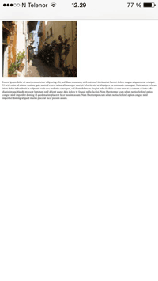](https://www.w3schools.com/html/example_withoutviewport.htm)  
  
Without the viewport meta tag](https://www.w3schools.com/html/example_withoutviewport.htm) 

[[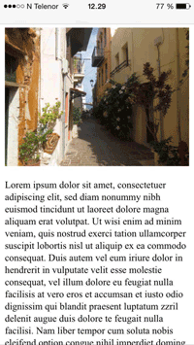](https://www.w3schools.com/html/example_withviewport.htm)  
  
With the viewport meta tag](https://www.w3schools.com/html/example_withviewport.htm) 

#### HTML Comments

Short comments should be written on one line, like this:

<!-- This is a comment -->

Comments that spans more than one line, should be written like this:

<!--   
  This is a long comment example. This is a long comment example.  
  This is a long comment example. This is a long comment example.  
-->

Long comments are easier to observe if they are indented two spaces.

#### Style Sheets

Use simple syntax for linking to style sheets (the type attribute is not necessary):

<link rel="stylesheet" href="styles.css">

Short rules can be written compressed, on one line, like this:

p.intro {font-family: Verdana; font-size: 16em;}

Long rules should be written over multiple lines:

body {  
  background-color: lightgrey;  
  font-family: "Arial Black", Helvetica, sans-serif;  
  font-size: 16em;  
  color: black;  
}

* Place the opening bracket on the same line as the selector
* Use one space before the opening bracket
* Use two spaces of indentation
* Use semicolon after each property-value pair, including the last
* Only use quotes around values if the value contains spaces
* Place the closing bracket on a new line, without leading spaces
* Avoid lines over 80 characters

#### Loading JavaScript in HTML

Use simple syntax for loading external scripts (the type attribute is not necessary):

<script src="myscript.js">

#### Accessing HTML Elements with JavaScript

A consequence of using "untidy" HTML styles, might result in JavaScript errors.

These two JavaScript statements will produce different results:

##### Example

var obj = getElementById("Demo")  
  
var obj = getElementById("demo")

#### Use Lower Case File Names

Some web servers (Apache, Unix) are case sensitive about file names: "london.jpg" cannot be accessed as "London.jpg".

Other web servers (Microsoft, IIS) are not case sensitive: "london.jpg" can be accessed as "London.jpg" or "london.jpg".

If you use a mix of upper and lower case, you have to be extremely consistent.

If you move from a case insensitive to a case sensitive server, even small errors will break your web!

To avoid these problems, always use lower case file names.

#### File Extensions

HTML files should have a **.html** or **.htm** extension.

CSS files should have a **.css** extension.

JavaScript files should have a **.js** extension.

#### Differences Between .htm and .html

There is no difference between the .htm and .html extensions. Both will be treated as HTML by any web browser or web server.

The differences are cultural:

.htm "smells" of early DOS systems where the system limited the extensions to 3 characters.

.html "smells" of Unix operating systems that did not have this limitation.

#### Technical Differences

When a URL does not specify a filename (like https://www.w3schools.com/css/), the server returns a default filename. Common default filenames are index.html, index.htm, default.html, and default.htm.

If your server is configured only with "index.html" as default filename, your file must be named "index.html", not "index.htm."

However, servers can be configured with more than one default filename, and normally you can set up as many default filenames as needed.

Anyway, the full extension for HTML files is .html, and there's no reason it should not be used.

# SOFTWARE REQUIREMENTS SPECIFICATIONソフトウェア要件仕様

## Introduction　はじめに

### Purpose　目的

This document is created as the introduction for project JFS – our Capstone Project at FPT University. In this document, we provide the describing of general requirement and non-functional requirements. These requirements will assure that the system will correctly and reliably perform its intended functionality. This specification will provide general, as well as specific requirements to be used in the design, testing and validation of the system. It is intended for both stakeholders and the project team of the system.

### Scope　範囲

PSM is a system that build on web platform to create the connect between Photo Studio Manager and Customers by provide all necessary information that all Managers and Customers need, and help them to find each other in a fastest way. To do this, we build our system a special feature to help Manager and Customers keep track od their contract.

### References　参照資料

|  |  |  |
| --- | --- | --- |
| No. | Document | Source/Web Address |
| 1 | System Requirements Specification Template | FPT Software Cop. |

### Overview　概要

The rest of this document contains 4 sections:

* **Introduction**: provides an overview of this document. It includes the purpose, scope, definitions, acronyms, abbreviations, references, and overview.
* **Overall Description**: describes the general factors that affect to the product and their requirements.
* **Specific Requirement**: Contains all requirements to a level of detail sufficient to help designers and testers satisfy those requirements.
* **Supporting Information**: Provide some other reference information that can help people understand easier.

## Overall Description　概要説明

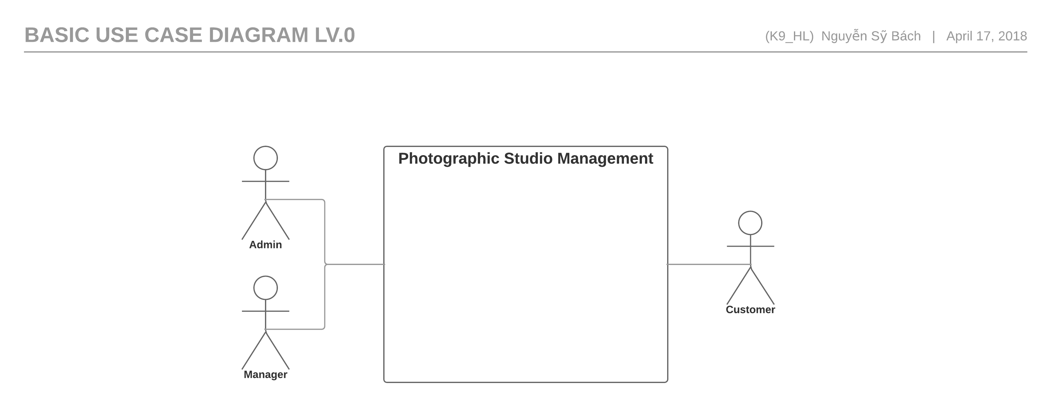

Figure 3.2.1 :Use Case of PSM Lv.0

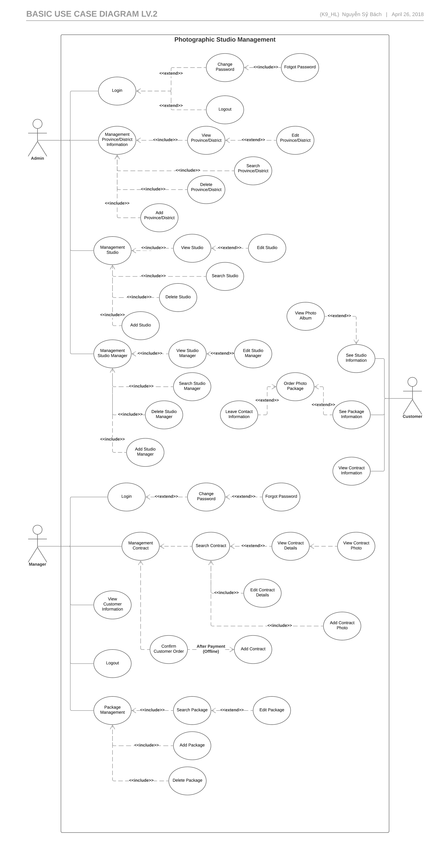

Figure 3.2.1: List Of Use Case of PSM

## Entity Relation Modelエンティティ関係モデル

### Entity-Relationship Diagram エンティティ- 関係図

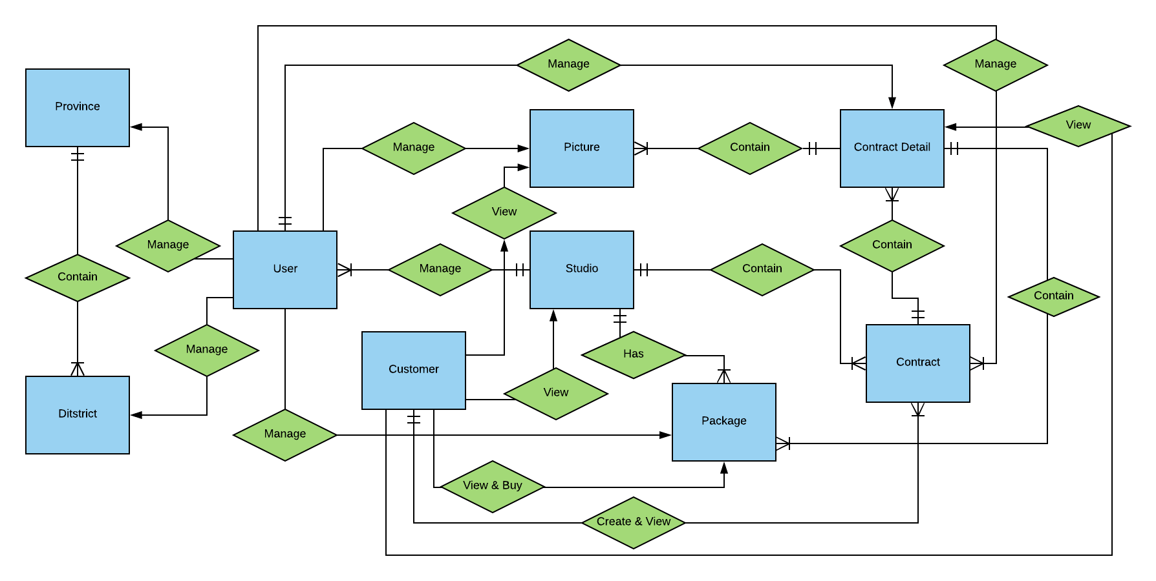

Figure 3.4.1**:** Entity Relationship Diagram

#### User(Manager)

|  |  |  |  |  |
| --- | --- | --- | --- | --- |
| No | Attribute | Type | Mandatory | Description |
| 1 | User_ID | String | Y | User’s username |
| 2 | Studio_ID | int | Y | Studio’s ID |
| 3 | User_Role | String | Y | User’s role |
| 4 | User_Password | String | Y | User’s password |

#### Studio

|  |  |  |  |  |
| --- | --- | --- | --- | --- |
| No | Attribute | Type | Mandatory | Description |
| 1 | Studio_ID | Int | Y | Studio’s ID |
| 2 | District_ID | String | Y | District’s ID. |
| 3 | Studio_Name | String | Y | Studio’s name |
| 4 | Studio_Address | String | Y | Studio’s physical address |
| 5 | Studio_Email | String | Y | Studio’s email address |
| 6 | Studio_Number | Number | Y | Studio’s phone number |
| 7 | Studio_Coordinate | String | Y | Studio’s location coordinate |
| 8 | Studio_Icon | String | N | Studio’s icon |
| 9 | Studio_main_pic | String | N | Studio’s main picture at studio’s page |
| 10 | Studio_project_1 | String | N | Studio’s project 1 picture at studio’s page |
| 11 | Studio_project_2 | String | N | Studio’s project 2 picture at studio’s page |
| 12 | Studio_project_3 | String | N | Studio’s project 3 picture at studio’s page |
| 13 | Studio_project_4 | String | N | Studio’s project 4 picture at studio’s page |
| 14 | Studio_project_5 | String | N | Studio’s project 5 picture at studio’s page |
| 15 | Studio_project_6 | String | N | Studio’s project 6 picture at studio’s page |
| 16 | Studio_project_7 | String | N | Studio’s project 7 picture at studio’s page |
| 17 | Studio_quote_pic | String | N | Quote’s picture |
| 18 | Studio_quote | String | N | Studio’s quote |
| 19 | Studio_about_pic | String | N | About’s picture |

#### District

|  |  |  |  |  |
| --- | --- | --- | --- | --- |
| No | Attribute | Type | Mandatory | Description |
| 1 | District_ID | Int | Y | District’s ID |
| 2 | Province_ID | Int | Y | Province that have the current district |
| 3 | District_Name | String | Y | District’s Name |

#### Province

|  |  |  |  |  |
| --- | --- | --- | --- | --- |
| No | Attribute | Type | Mandatory | Description |
| 1 | Province_ID | Int | Y | Province’s ID |
| 2 | Province_Name | String | Y | Province’s Name |

#### Contract

|  |  |  |  |  |
| --- | --- | --- | --- | --- |
| No | Attribute | Type | Mandatory | Description |
|  | Contract_ID | String | Y | Contract’s ID |
|  | Customer_ID | Int | Y | Customer’s ID |
|  | Studio_ID | Int | Y | Studio’s ID |
|  | Contract_Description | String | N | The Description about the current contract |
|  | Contract_cDate | Date | Y | The create date of the contract |
|  | Contract_sDate | Date | N | The start the contract start have effectness |
|  | Contract_eDate | Date | N | The date the contract end lost effectness |
|  | Contract_State | String | Y | The state of the contract |

#### Customer

|  |  |  |  |  |
| --- | --- | --- | --- | --- |
| No | Attribute | Type | Mandatory | Description |
| 1 | Customer_ID | Int | Y | Customer’s ID |
| 2 | Customer_Name | String | Y | Customer’s name |
| 3 | Customer_Gender | String | Y | Customer’s gender |
| 4 | Customer_Address | String | Y | Customer’s address |
| 5 | Customer_Email | String | Y | Customer’s email |
| 6 | Customer_Number | String | Y | Customer’s number |
| 7 | Customer_Note | String | N | Customer’s note |
| 8 | Customer_Other | String | N | Customer’s social media |

#### Contract Detail

|  |  |  |  |  |
| --- | --- | --- | --- | --- |
| No | Attribute | Type | Mandatory | Description |
| 1 | ConDetail_ID | Int | Y | Feedback’s ID |
| 2 | Contract_ID | String | Y | Contract’s ID that relate to the contract’s detail |
| 3 | Package_ID | Int | Y | Real time that member create feedback |
| 4 | Package_Name | String | Y | Name of the current available package |
| 5 | Package_Detail | String | Y | Detail of the current available package |
| 6 | Package_Price | Int | Y | Price of the current available package |
| 7 | Package_Note | String | N | Note about package |

#### Package

|  |  |  |  |  |
| --- | --- | --- | --- | --- |
| No | Attribute | Type | Mandatory | Description |
|  | Package_ID | Int | Y | package’s ID |
|  | Package_Name | String | Y | Package’s Name |
|  | Package_Detail | String | Y | Package’s Detail |
|  | Package_Price | Int | Y | Package’s price |
|  | Package_Available | Boolean | Y | Define that the package is available or not |
|  | Package_pic | String | N | The picture represent the package |

#### Picture

|  |  |  |  |  |
| --- | --- | --- | --- | --- |
| No | Attribute | Type | Mandatory | Description |
| 1 | Picture_ID | Int | Y | Picrure’s ID |
| 2 | ConDetail_ID | Int | Y | Comtract’s ID |
| 3 | Picture_Detail | String | N | Picture’s detail |
| 4 | Picture_Url | String | N | Picture’s Url link |

### Entity descriptionエンティティの説明

|  |  |  |
| --- | --- | --- |
| No | Table Name | Description |
|  | User | Account of member of Studio. Manage Users, Studios, Provinces, Districts, Package, Contract, Contract Detail, Picture, Customer depend on role of the User. |
|  | Picture | The Picture of the current Contract Detail. |
|  | Province | The information of the Province. |
|  | District | The information of the District where it belong in a Province. |
|  | Package | The information of the Contract . |
|  | Studio | The information of the Studio. |
|  | Contract | A contract of a Studio where Customer order Packages. |
|  | Contract Detail | Details of the current Contract that contain the information of the Packages that the Customer order. |
|  | Customer | Customer who buy Packages. |
|  | User | Account of member of Studio. Manage Users, Studios, Provinces, Districts, Package, Contract, Contract Detail, Picture, Customer depend on role of the User. |
|  | Picture | The Picture of the current Contract Detail. |
|  | Province | The information of the Province. |
|  | District | The information of the District where it belong in a Province. |

Table 3.4.2: Entity Description

### Relationship 関係

|  |  |  |  |  |  |
| --- | --- | --- | --- | --- | --- |
| No | Relation | Properties | From | To | Description |
|  | CONTAIN | Province_ID | Province | District | A Province has one or many District. |
|  | MANAGE | District_ID | User | District | User role Admin manages all district at District management page. |
|  | MANAGE | Province_ID | User | Province | User role Admin manages all Province at Province management page. |
|  | MANAGE | Package_ID | User | Package | User role manager manages all packages of the User’s current Studio at Package management page. |
|  | MANAGE | Contract_ID | User | Contract | User role manager manages all their contracts of the user’s current Studio at Contract management page. |
|  | MANAGE | ConDetail_ID | User | Contract Detail | User role manager manages all thier contract’s details of it current contract at Contract management page. |
|  | MANAGE | Picture_ID | User | Picture | User role manager manages all pictures of the current contract’s detail page at view picture page. |
|  | MANAGE | Studio_ID | User | Studio | User role Admin manages all Studios at Studio Management page. User role manager manage their own Studio at Profile management page. |
|  | MANAGE | Customer_ID | User | Customer | User role manager can manages their own Customer at Contract management page. |
|  | VIEW | None | Customer | Picture | A customer can view picture of the contract they order at Contract view page. |
|  | VIEW | None | Customer | Contract Detail | A customer can view contract’s detail at Contract view page. |
|  | VIEW | None | Customer | Studio | A customer can view Studio information and Packages’s information inside the Studio view page. |
|  | VIEW & CREATE | Contract_ID | Customer | Contract | A customer can view contract’s information at Contract view page. Customer can also create new Contract by buying one or many packages at checkout page |
|  | VIEW & BUY | None | Customer | Package | A customer can buy packages by add to cart at the Studio view page. Customer can also view them at Studio view page |
|  | HAS | Package_ID | Studio | Package | A studio can have one or many Packages. |
|  | CONTAIN | Studio_ID | Studio | Contract | A studio can have one or many Contracts. |

Table 3.4.3 Relationship

## Specific Requirements 　 要求仕様

### Business Rules　ビジネスルール

|  |  |
| --- | --- |
| No | Description |
|  | Search textbox cannot be empty |
|  | Text field cannot be empty |
|  | Content of post is limited to 1000 characters |
|  | Chat box cannot be empty |
|  | If user accesses to nonexistent page, PSM displays error message”Page not found” |
|  | Email must characters ‘@’ and ‘.’content |
|  | Date of birth must be chosen |
|  | Displayed date is mm/dd/yyyy format |
|  | Date time input format is date time |
|  | Number is rounded to 2 decimal number |
|  | Unit of money is VND |
|  | Displayed money is rounded to 2 decimal number |
|  | Allowed file extension: .jpg, .png, .bmp |
|  | File size is limited to 100 MB |
|  | Message displayed like a Gmail format |

Table 3.5: Business Rules

### Actor

|  |  |
| --- | --- |
| Actor | Description |
| Admin | Manage all Studio and Studio Manager. |
| Manager | Manage work of one Studio include package, photo and contract with customer. Need an account from Admin. |
| Customer | People who browsing the web and order photo package. |

Table 3.5.1: Actor

### Use Case List

|  |  |  |  |
| --- | --- | --- | --- |
| ID | Primary Actor | Secondary Actor | Name |
| UC-001 | Admin |  | Login |
| UC-002 | Admin |  | Logout |
| UC-003 | Admin |  | Change Password |
| UC-004 | Admin |  | View and Search Province/District |
| UC-005 | Admin |  | Edit Province/District |
| UC-006 | Admin |  | Delete Province/District |
| UC-007 | Admin |  | Add Province/District |
| UC-008 | Admin |  | View and Search Studio |
| UC-009 | Admin |  | Edit Studio |
| UC-010 | Admin |  | Delete Studio |
| UC-011 | Admin |  | Add Studio |
| UC-012 | Admin |  | View and Search Studio Manager |
| UC-013 | Admin |  | Edit Studio Manager |
| UC-014 | Admin |  | Delete Studio Manager |
| UC-015 | Admin |  | Add Studio Information |
| UC-016 | Manager |  | Login |
| UC-016 | Manager |  | Logout |
| UC-017 | Manager |  | Change Password |
| UC-018 | Manager |  | Forgot Password |
| UC-019 | Manager |  | Search & View Contract Information |
| UC-020 | Manager |  | Edit Contract |
| UC-021 | Manager |  | Add Contract |
| UC-022 | Manager |  | Search & View Package |
| UC-023 | Manager |  | Add Package |
| UC-024 | Manager |  | Edit Package |
| UC-025 | Manager |  | View Picture |
| UC-026 | Manager |  | Edit Picture Info |
| UC-027 | Manager |  | Upload Picture |
| UC-028 | Manager |  | Delete Picture |
| UC-029 | Manager |  | View Customer Information |
| UC-030 | Customer |  | See Studio Information |
| UC-031 | Customer |  | See Package Information |
| UC-032 | Customer |  | See Package Information |
| UC-033 | Customer |  | Order photo Package & Leave Information |
| UC-034 | Customer |  | View Contract |
| UC-035 | Customer |  | View Contract photo |

Table 3.5.1: Use Case List

### Functionality　機能要求

#### Admin

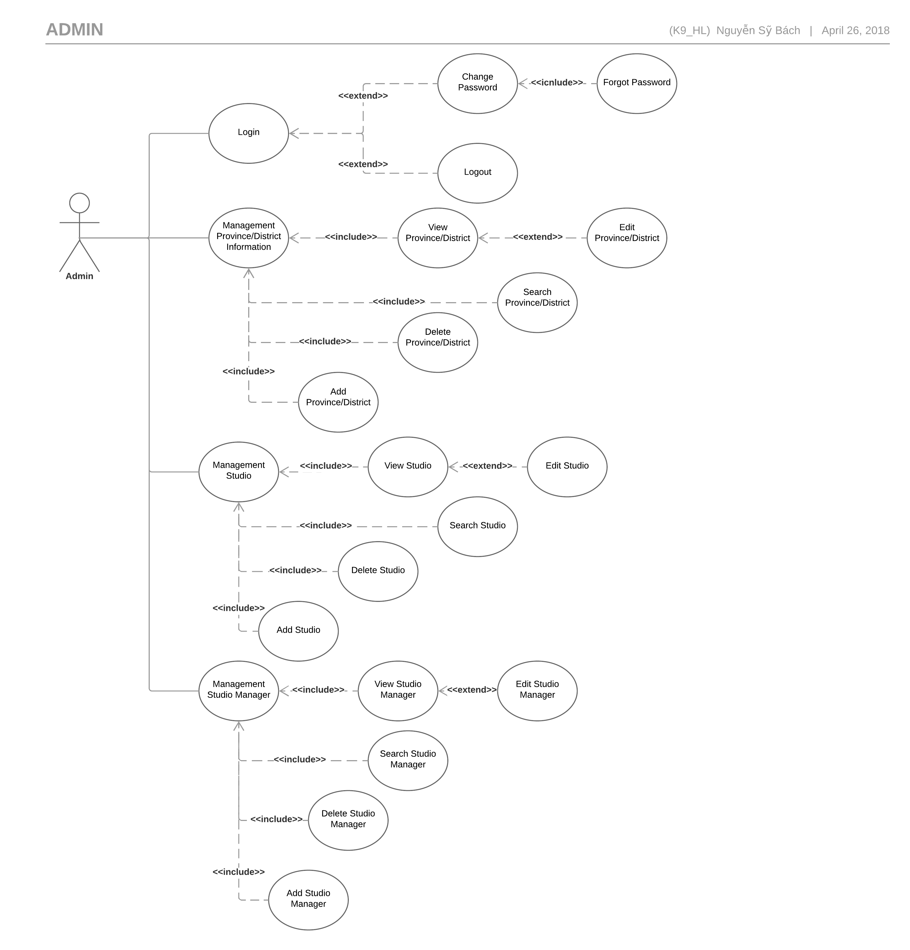Figure 3.5.2**:** Admin Use Case Diagram

##### Login

|  |  |  |  |  |
| --- | --- | --- | --- | --- |
| Use Case ID | | UC-001 | Version | 1.0 |
| Use Case Name | | Login | | |
| Created by: | | HuyNM | **Date Created:** | 12/04/2018 |
| Primary Actor | | Admin | **Secondary Actor** |  |
| Description: | | When Manager want to login by registered account to use more functions in website. | | |
| Preconditions: | | Systems must be connected to the Internet. | | |
| Trigger: | | Click on”Login”quick menu. | | |
| Post conditions: | | 1. Log Manager into system. 2. Redirect manager to Studio Management page. | | |
| Normal Flow | | | | |
| Step | **Actor Event** | **System Response** | | |
|  | Click on”Login”quick menu at the homepage. |  | | |
|  |  | Display”Login”page include:   1. Username textbox. 2. Password textbox. 3. “Login”button. 4. “Forgot password”hyperlink. | | |
|  | Enter Username and Password. |  | | |
|  | Click”Login”button. |  | | |
|  |  | Log Manager in to the systems. | | |
|  |  | Display Studio Management page with message:”Login Successfully”. | | |
| Alternative Flows: N/A | | | | |
| Exceptions | | | | |
| EC1 | At step 3 in main flow, if user entered wrong User name or Password | | | |
| Step | **Actor Event** | **System Response** | | |
| 3.1 | User entered wrong User name or Password |  | | |
|  |  | Pop error message. | | |
|  | | | | |
| Priority | | High | | |
| Frequency of Use: | | High | | |
| Business Rules: | | B2 | | |
| Other Information: | | N/A | | |

##### Logout

|  |  |  |  |  |
| --- | --- | --- | --- | --- |
| Use Case ID | | UC-002 | Version | 1.0 |
| Use Case Name | | Logout | | |
| Created by: | | HuyNM | **Date Created:** | 12/04/2018 |
| Primary Actor | | Admin | **Secondary Actor** |  |
| Description: | | This function allows a manager to logout | | |
| Preconditions: | | 1. Systems must be connected to the Internet. 2. Manager has login to the systems. | | |
| Trigger: | | Click on”Logout”quick menu. | | |
| Post conditions: | | 1. Log user out of the systems. 2. Redirect user back to the home page. | | |
| Normal Flow | | | | |
| Step | **Actor Event** | **System Response** | | |
| 1 | Click on”Logout”quick menu. |  | | |
| 2 |  | 1. Log user out of the systems. 2. Redirect user back to the home page as customer. | | |
| Alternative Flows: N/A | | | | |
| Exceptions: N/A | | | | |
|  | | | | |
| Priority | | High | | |
| Frequency of Use: | | Normal | | |
| Business Rules: | | N/A | | |
| Other Information: | | N/A | | |

##### Change Password

|  |  |  |  |  |  |
| --- | --- | --- | --- | --- | --- |
| Use Case ID | | | UC-003 | Version | 1.0 |
| Use Case Name | | | Change Password | | |
| Created by: | | | HuyNM | **Date Created:** | 12/04/2018 |
| Primary Actor | | | Admin | **Secondary Actor** |  |
| Description: | | | This function allows Manager to change password or forgot their password. | | |
| Preconditions: | | | Systems must be connected to the Internet. | | |
| Trigger: | | | Click on “Change Password” header. | | |
| Post conditions: | | | Systems redirect user to”Change Password”page. | | |
| Normal Flow | | | | | |
| Step | **Actor Event** | | **System Response** | | |
| 1 | Click on “Change Password” header | |  | | |
| 2 |  | | Display” Change Password” page include:   1. Old password textbox. 2. New password textbox. 3. New password confirms. 4. OK button. 5. Cancel button. | | |
| 3 | Enter old pass and new password. | |  | | |
| 4 | Click on OK button. | |  | | |
| 5 |  | | Display password has been changed suscessful. Redirect user back to manager page. | | |
| Alternative Flows | | | | | |
| AT1 | At step 4, Manager click ”Cancel”button. | | | | |
| Step | **Actor Event** | | **System Response** | | |
| 4.1 | Click”Cancel”button | |  | | |
| 4.2 |  | | Redirect user back to Admin page. | | |
|  | | | | | |
| Exceptions | | | | | |
| EC1 | | At step 2 in main flow, if user entered wrong User name or Password | | | |
| Step | | **Actor Event** | **System Response** | | |
| 2.1 | | User entered wrong old password |  | | |
| 2.2 | |  | Pop error message. | | |
|  | | | | | |
| Priority | | | High | | |
| Frequency of Use: | | | Low | | |
| Business Rules: | | | B2 | | |
| Other Information: | | | N/A | | |

##### Forgot Password

|  |  |  |  |  |  |
| --- | --- | --- | --- | --- | --- |
| Use Case ID | | | UC-004 | Version | 1.0 |
| Use Case Name | | | Change Password | | |
| Created by: | | | BachNS | **Date Created:** | 12/04/2018 |
| Primary Actor | | | Admin | **Secondary Actor** |  |
| Description: | | | This function allows Admin to change password or forgot their password. | | |
| Preconditions: | | | Systems must be connected to the Internet. | | |
| Trigger: | | | Click on “Forgot Password” hyperlink. | | |
| Post conditions: | | | Systems redirect user to ”Change Password”page. | | |
| Normal Flow | | | | | |
| Step | **Actor Event** | | **System Response** | | |
| 1 | Click on ”Login”quick menu at the homepage. | |  | | |
| 2 |  | | Display “Login”page include:   1. Username textbox. 2. Password textbox. 3. “Login”button. 4. “Forgot password”hyperlink. | | |
| 3 | Click on”Forgot password”hyperlink. | |  | | |
| 4 |  | | Redirect user to”Change Password”page include:   1. Username textbox. 2. “Please enter your username”message. 3. “Enter”button. | | |
| 5 | Enter Username. | |  | | |
| 6 | Click”Enter”button. | |  | | |
| 7 |  | | Change”Change Password”page to:   1. “Old password has been send to your email”message. 2. “Old password”textbox. 3. “New password”textbox. 4. “OK”button. 5. “Cancel”button. | | |
| 8 | Enter”Old password”,”New password”. | |  | | |
| 9 | Click”OK”button. | |  | | |
| 10 |  | | Change user password, redirect user to login page. | | |
| Alternative Flows | | | | | |
| AT1 | At step 6, Admin click”Cancel”button. | | | | |
| Step | **Actor Event** | | **System Response** | | |
| 6.1 | Click”Cancel”button | |  | | |
| 6.2 |  | | Redirect user back to”Login”page | | |
|  | | | | | |
| Exceptions | | | | | |
| EC1 | | At step 8 in main flow, if user entered wrong User name or Password | | | |
| Step | | **Actor Event** | **System Response** | | |
| 8.1 | | User entered wrong old password |  | | |
| 8.2 | |  | Pop error message. | | |
|  | | | | | |
| Priority | | | High | | |
| Frequency of Use: | | | Low | | |
| Business Rules: | | | B2 | | |
| Other Information: | | | N/A | | |

##### View and Search Province/District

|  |  |  |  |  |  |  |
| --- | --- | --- | --- | --- | --- | --- |
| Use Case ID UC-005 | | | | Version | | 1.0 |
| Use Case Name | | | View province/District | | | |
| Created by: | | | HuyNM | **Date Created:** | | 12/03/2018 |
| Primary Actor | | | Admin | **Secondary Actor** | |  |
| Description: | | | Show information about province and district. | | | |
| Preconditions: | | | Login by account admin PSM. | | | |
| Trigger: | | | Click “Quản lý tỉnh thành” hyper link. | | | |
| Post conditions: | | | Information of Studio need to exist. | | | |
| Normal Flow | | | | | | |
| Step | **Actor event** | | | | **System response** | |
| 1 | Select Province in combo box then click “Tìm kiếm”. | | | |  | |
| 2 |  | | | | Display all districts of the province. | |
| 3 | Click to the name of District hyperlink. | | | |  | |
| 4 |  | | | | Display district details and display all Studios in the district. | |
| Alternative Flows: N/A | | | | | | |
|  | | | | | | |
| Exceptions | | | | | | |
| EC1 | | At step 4 in main flow, if don’t have studio in district. | | | | | |
| Step | | **Actor Event** | | **System Response** | | | |
| 4.1 | | User search unvalid district. | |  | | | |
| 4.2 | |  | | Pop error message”Hiện không có Studio tại đây”. | | | |
|  | | | | | | | |
| Priority | | High | | | | | |
| Frequency of Use: | | Low | | | | | |
| Business Rules: | | B2 | | | | | |
| Other Information: | | N/A | | | | | |

##### Edit Province/District

|  |  |  |  |  |  |
| --- | --- | --- | --- | --- | --- |
| Use Case ID UC-006 | | | | Version | 1.0 |
| Use Case Name | | | Edit Province/District | | |
| Created by: | | | HuyNM | **Date Created:** | 12/03/2018 |
| Primary Actor | | | Admin | **Secondary Actor** |  |
| Description: | | | Edit province and district. | | |
| Preconditions: | | | Login by account admin PSM.  Province/District data has been added to the database.  Display district details. | | |
| Trigger: | | | Click one District hyper link. | | |
| Post conditions: | | | Information of District need to exist. | | |
| Normal Flow | | | | | |
| Step | | **Actor event** | | **System response** | |
| 1 | | Write the textbox in table “Chỉnh sửa tên quận huyện” then click button “Chỉnh Sửa tên”. | |  | |
| 2 | |  | | Display popup ”Bạn chắc chắn muốn thay đổi.” | |
| 3 | | Click on“OK” button. | |  | |
| 4 | |  | | Display district details | |
| Alternative Flows: N/A | | | | | |
| AT1 | At step 3, Manager click “Cancel” button. | | | | |
| Step | **Actor Event** | | | **System Response** | |
| 3.1 | Click “Cancel” button. | | |  | |
| 3.2 |  | | | PSM return Page District. | |
|  | | | |  | |
| Exceptions | | | |  | |
| EC1 | At step 4 in main flow, if user entered same Province/District. | | | | |
| Step | **Actor Event** | | | **System Response** | |
| 4.1 | User entered same Province/District. | | |  | |
| 4.2 |  | | | Popup”Dữ liệu đã có”. | |
| 4.3 | Click “ok”. | | |  | |
| 4.4 |  | | | PSM return Page District manger. | |
|  | | | | | |
| Priority | High | | | | |
| Frequency of Use: | Low | | | | |
| Business Rules: | B4 | | | | |
| Other Information: | N/A | | | | |

##### Delete Province/District

|  |  |  |  |  |  |  |
| --- | --- | --- | --- | --- | --- | --- |
| Use Case ID UC-007 | | | | | Version | 1.0 |
| Use Case Name | | | Delete Province/District | | | |
| Created by: | | | HuyNM | | **Date Created:** | 12/03/2018 |
| Primary Actor | | | Admin | | **Secondary Actor** |  |
| Description: | | | Delete province and district. | | | |
| Preconditions: | | | Login by account admin PSM.  Province/District data has been added to the database.  Display district details. | | | |
| Trigger: | | | Click one “Quận/huyện” hyper link. | | | |
| Post conditions: | | | District removed in database. | | | |
| Normal Flow | | | | | | |
| Step | | **Actor event** | | | **System response** | |
| 1 | | Select Province in combo box then click “Tìm kiếm”. | | |  | |
| 2 | |  | | | Display name of district. | |
| 3 | | Click to the button “Xoá” | | |  | |
| 4 | |  | | | Displayed popup “Bạn có muốn xoá địa điểm này không”. | |
| 5 | | Click “Ok”. | | |  | |
| 6 | |  | | | PSM return page district manager. | |
| Alternative Flows: N/A | | | | | | |
| AT1 | At step 5, Manager click “Back” button. | | | | | |
| Step | **Actor Event** | | | **System Response** | | |
| 5.1 | Click “Back” button | | |  | | |
| 5.2 |  | | | PSM return page district manager. | | |
|  | | | |  | | |
| Exceptions | | | |  | | |
| EC1 | At step 5 in main flow, if user Delete district exist studio. | | | | | |
| Step | **Actor Event** | | | **System Response** | | |
| 5.1 | User delete district. | | |  | | |
| 5.2 |  | | | Popup error ”không thể xoá tỉnh thành đã có Studio ”. | | |
| 5.3 | Click “ok”. | | |  | | |
| 5.4 |  | | | PSM return page district manage. | | |
|  | | | | | | |
| Priority | High | | | | | |
| Frequency of Use: | Low | | | | | |
| Business Rules: | B4 | | | | | |
| Other Information: | N/A | | | | | |

##### Add Province/District

|  |  |  |  |  |  |
| --- | --- | --- | --- | --- | --- |
| Use Case ID UC-008 | | | Version | | 1.0 |
| Use Case Name | | Add Province/District | | | |
| Created by: | | HuyNM | **Date Created:** | | 14/03/2018 |
| Primary Actor | | Admin | **Secondary Actor** | |  |
| Description: | | Add province and district. | | | |
| Preconditions: | | Login by account admin PSM.  Province/District data has been added to the database.  Display district details. | | | |
| Trigger: | | Click one “Quản lý tỉnh thành” hyper link. | | | |
| Post conditions: | | Information of new District have to exist. | | | |
| Normal Flow | | | | | |
| Step | **Actor event** | | **System response** | | |
| 1 | Select Province in table “Thêm Quận huyện mới” then write in the text box Quận/huyện after that click“Thêm”. | |  | | |
| 2 |  | | Display popup “Thêm thành công”. | | |
| 3 | Click to the “OK”. | |  | | |
| 4 |  | | New district appear in province. | | |
| Alternative Flows | | | | | |
| AT1: At Step 3 click Button “Cancel”. | | | | | |
| Step | **Actor Event** | | | **System Response** | |
| 3.1 | Click “Cancel”button. | | |  | |
| 3.2 |  | | | PSM return page district manager. | |
|  | | | | | |
|  | | | | | |
| Exceptions | | | |  | |
| EC1 | At step 3 in main flow, if user entered same district, | | | | |
| Step | **Actor Event** | | | **System Response** | |
| 3.1 | User entered same district. | | |  | |
| 3.2 |  | | | Pop error message”Địa chỉ đã tồn tại”. | |
|  | | | | | |
| Priority | High | | | | |
| Frequency of Use: | Low | | | | |
| Business Rules: | B4 | | | | |
| Other Information: | N/A | | | | |

##### View and search Studio

|  |  |  |  |  |  |  |  |  |  |
| --- | --- | --- | --- | --- | --- | --- | --- | --- | --- |
| Use Case ID UC-009 | | | | | | | | Version | 1.0 |
| Use Case Name | | | | View Studio | | | | | |
| Created by: | | | | HuyNM | | **Date Created:** | | | 14/03/2018 |
| Primary Actor | | | | Admin | | **Secondary Actor** | | |  |
| Description: | | | | Show all information about Studio in PSM. | | | | | |
| Preconditions: | | | | Login by account admin PSM.  Studio data has been added to the database. | | | | | |
| Trigger: | | | | Click to “Quản lý Studio” hyper link. | | | | | |
| Post conditions: | | | | Information of Studio need to exist. | | | | | |
| Normal Flow | | | | | | | | | |
| Step | | **Actor event** | | | | **System response** | | | |
| 1 | | Select“hiển thị tất cả”. | | | |  | | | |
| 2 | |  | | | | PSM will display:   1. Số Studio tìm thấy 2. Studio ID 3. Tên Studio 4. Package Detail 5. Studio Email 6. Số ĐT Studio 7. Toà độ Studio 8. Quận/huyện | | | |
| Alternative Flows | | | | | | | | | |
| AT1 | At step 1, Manager click “Tìm kiếm” button. | | | | | | | | |
| Step | **Actor Event** | | | | | **System Response** | | | |
| 1.1 | Click “Tìm kiếm” button | | | | |  | | | |
| 1.2 |  | | | | | PSM will display:   1. Số Studio tìm thấy 2. Studio ID 3. Tên Studio 4. Package Detail 5. Studio Email 6. Số ĐT Studio 7. Toà độ Studio 8. Quận/huyện | | | |
| Exceptions | | | | | | | | | |
| EC1: If admin enter characters unlike existing studio names. | | | | | | | | | |
| Step | | | **Actor event** | | | | **System response** | | |
| 1.1 | | | Enter characters unlike existing studio names | | | |  | | |
| 1.2 | | |  | | | | Popup “Không tìm thấy Studio nào!!”. | | |
|  | | | | | | | | | |
| Priority | | | | | Normal | | | | |
| Frequency of Use: | | | | | Normal | | | | |
| Business Rules: | | | | | N/A | | | | |
| Other Information: | | | | | N/A | | | | |

##### Edit Studio

|  |  |  |  |  |  |
| --- | --- | --- | --- | --- | --- |
| Use Case ID UC-010 | | | | Version | 1.0 |
| Use Case Name | | Edit Studio | | | |
| Created by: | | HuyNM | | **Date Created:** | 14/03/2018 |
| Primary Actor | | Admin | | **Secondary Actor** |  |
| Description: | | Edit information of Studio. | | | |
| Preconditions: | | Login by account admin PSM.  Studio data has been added to the database. | | | |
| Trigger: | | Click to “Chỉnh Sửa” hyper link. | | | |
| Post conditions: | | Information of Studio changed. | | | |
| Normal Flow | | | | | |
| Step | **Actor event** | | | **System response** | |
| 1 | Click Button ”Chỉnh Sửa” | | |  | |
| 2 |  | | | Display table “Chỉnh Sửa Studio”   1. Stuio ID 2. Tên Studio 3. Địa chỉ Studio 4. Tỉnh 5. Quận/huyện 6. Studio email 7. Số ĐT Studio 8. Toạ độ Studio | |
| 3 | Write to the textbox then click “Chỉnh sửa” | | |  | |
| 4 |  | | | Popup appear ”Bạn có chắc chắc muốn thay đổi”. | |
| 5 | Click “Ok” | | |  | |
| 6 |  | | | Popup appear “Thêm thành công”. | |
| Alternative Flows | | | | | |
| ET1: At Step 5 click “Cancel” button. | | | | | |
| Step | **Actor event** | | | **System response** | |
| 5.1 | Click “Cancel”button. | | |  | |
| 5.2 |  | | | PSM return Studio information Page. | |
|  | | | | | |
| Exceptions | | | | | |
| EC1: When admin entered wrong email. | | | | | |
| Step | **Actor event** | | | **System response** | |
| 1.1 | Admin entered wrong email. | | |  | |
| 1.2 |  | | | Email không hợp lệ (ví dụ: abc@gmail.com) | |
| EC2: When admin entered wrong number. | | | | | |
| Step | **Actor event** | | | **System response** | |
| 2.1 | Admin entered wrong number. | | |  | |
| 2.2 |  | | | Số điện thoại phải là kiểu số | |
| EC3: When admin entered wrong coordinate. | | | | | |
| Step | **Actor event** | | | **System response** | |
| 3.1 | Admin entered wrong coordinate. | | |  | |
| 3.2 |  | | | Cooridnate không hợp lệ (theo form: XX,XX) | |
|  | | | | | |
| Priority | | | Normal | | |
| Frequency of Use: | | | Normal | | |
| Business Rules: | | | B3,B5,B6 | | |
| Other Information: | | | N/A | | |

##### Delete Studio

|  |  |  |  |  |  |  |  |
| --- | --- | --- | --- | --- | --- | --- | --- |
| Use Case ID UC-011 | | | | | | Version | 1.0 |
| Use Case Name | | | Delete Studio | | | | |
| Created by: | | | HuyNM | | | **Date Created:** | 14/03/2018 |
| Primary Actor | | | Admin | | | **Secondary Actor** |  |
| Description: | | | Delete Studio information. | | | | |
| Preconditions: | | | Login by account admin PSM.  Studio information data has been added to the database. | | | | |
| Trigger: | | | Click to “Xoá” hyper link. | | | | |
| Post conditions: | | | Information of Studio remove in the data. | | | | |
| Normal Flow | | | | | | | |
| Step | | **Actor event** | | | | **System response** | |
| 1 | | Click to delete in table Studio information. | | | |  | |
| 2 | |  | | | | Display popup “Bạn có muốn xoá Studio này”. | |
| 3 | | Click to the “OK”. | | | |  | |
| 4 | |  | | | | Display new table information of Studio. | |
| Alternative Flows | | | | | | | |
| AT1 | At step 3, click “Cancel” button. | | | | | | |
| Step | **Actor Event** | | | | **System Response** | | |
| 5.1 | Click “Cancel” button | | | |  | | |
| 5.2 |  | | | | Display new table information of Studio. | | |
|  | | | | |  | | |
|  | | | | | | | |
| Exceptions: N/A | | | | | | | |
|  | | | | | | | |
| Priority | | | | Normal | | | |
| Frequency of Use: | | | | Normal | | | |
| Business Rules: | | | | N/A | | | |
| Other Information: | | | | N/A | | | |

##### Add Studio

|  |  |  |  |  |  |  |
| --- | --- | --- | --- | --- | --- | --- |
| Use Case ID UC-012 | | | | Version | 1.0 | |
| Use Case Name | | Add Studio | | | | |
| Created by: | | HuyNM | | **Date Created:** | | 14/03/2018 |
| Primary Actor | | Admin | | **Secondary Actor** | |  |
| Description: | | Add Studio information | | | | |
| Preconditions: | | Login by account admin PSM.  Province/District data has been added to the database.  Display district details. | | | | |
| Trigger: | | Click “Thêm Studio mới”hyper link. | | | | |
| Post conditions: | | Updated new Studio in database. | | | | |
| Normal Flow | | | | | | |
| Step | **Actor event** | | | **System response** | | |
| 1 | Click to Add new Studio hyperlink. | | |  | | |
| 2 |  | | | Display all information:   1. Tên Studio 2. Địa chỉ Studio 3. Province 4. Tỉnh 5. Huyện 6. Studio Email 7. Số ĐT Studio 8. Toạ độ Studio | | |
| 3 | Click to the “Thêm mới”. | | |  | | |
| 4 |  | | | Thêm Studio thành công. | | |
| Alternative Flows | | | | | | |
| AT1: At Step 3 click “Reset” button. | | | | | | |
| Step | **Actor event** | | | **System response** | | |
| 1.1 | Click “Reset”button. | | |  | | |
| 1.2 |  | | | Information in all textbox will reset. | | |
| Exceptions | | | | | | |
| EC1: When admin entered wrong email. | | | | | | |
| Step | **Actor event** | | | **System response** | | |
| 1.1 | Admin entered wrong email. | | |  | | |
| 1.2 |  | | | Email không hợp lệ (ví dụ: abc@gmail.com) | | |
| EC2: When admin entered wrong number. | | | | | | |
| Step | **Actor event** | | | **System response** | | |
| 2.1 | Admin entered wrong number. | | |  | | |
| 2.2 |  | | | Số điện thoại phải là kiểu số | | |
| EC3: When admin entered wrong coordinate. | | | | | | |
| Step | **Actor event** | | | **System response** | | |
| 3.1 | Admin entered wrong coordinate. | | |  | | |
| 3.2 |  | | | Cooridnate không hợp lệ (theo form: XX,XX) | | |
|  | | | | | | |
| Priority | | | Normal | | | |
| Frequency of Use: | | | Normal | | | |
| Business Rules: | | | B3,B5,B6 | | | |
| Other Information: | | | N/A | | | |
|  | | | | | | |

##### View and Search Studio Manager

|  |  |  |  |  |  |  |  |
| --- | --- | --- | --- | --- | --- | --- | --- |
| Use Case ID UC-013 | | | | | | Version | 1.0 |
| Use Case Name | | | View Studio Manager | | | | |
| Created by: | | | HuyNM | | | **Date Created:** | 14/03/2018 |
| Primary Actor | | | Admin | | | **Secondary Actor** |  |
| Description: | | | Show all information about Studio manager in PSM. | | | | |
| Preconditions: | | | Login by account admin PSM.  Studio manager data has been added to the database. | | | | |
| Trigger: | | | Click to “Quản lý Nhân viên” hyper link. | | | | |
| Post conditions: | | | Information of User need to exist. | | | | |
| Normal Flow | | | | | | | |
| Step | | **Actor event** | | | | **System response** | |
| 1 | | Select “hiển thị tất cả”. | | | |  | |
| 2 | |  | | | | PSM will display:   1. Số nhân viên tìm được. 2. Tài khoản. 3. Mật khẩu. 4. Tên studio. 5. Quyền quản lý. | |
| Alternative Flows | | | | | | | |
| AT1: Select button “Tìm kiếm”. | | | | | | | |
| Step | | **Actor event** | | | | **System response** | |
| 1.1 | | Write the textbox name or character of Studio Manager want to show then Select“tìm kiếm”. | | | |  | |
| 1.2 | |  | | | | Display all Studio Manager have name or character same that. | |
| Exceptions | | | | | | | |
| EC1 | At step 1.1 in main flow, if don’t have Studio Manager. | | | | | | |
| Step | **Actor Event** | | | | **System Response** | | |
| 1.1.1 | User search Studio in district. | | | |  | | |
| 1.1.2 |  | | | | Pop up error message”Hiện không có quản lý này tại đây”. | | |
|  | | | | | | | |
| Priority | | | | Normal | | | |
| Frequency of Use: | | | | Normal | | | |
| Business Rules: | | | | N/A | | | |
| Other Information: | | | | N/A | | | |

##### Edit Studio Manager

|  |  |  |  |  |  |
| --- | --- | --- | --- | --- | --- |
| Use Case ID UC-014 | | | | Version | 1.0 |
| Use Case Name | | Edit Studio Manager | | | |
| Created by: | | HuyNM | | **Date Created:** | 14/03/2018 |
| Primary Actor | | Admin | | **Secondary Actor** |  |
| Description: | | Edit information of Studio Manager. | | | |
| Preconditions: | | Login by account admin PSM.  User data has been added to the database.  Display User details. | | | |
| Trigger: | | Click to“Chỉnh sửa” hyper link. | | | |
| Post conditions: | | Information of User need to edited. | | | |
| Normal Flow | | | | | |
| Step | **Actor event** | | | **System response** | |
| 1 | Click Button ”Chỉnh Sửa” | | |  | |
| 2 |  | | | Display table “Chỉnh Sửa quản lý”  1. Tài khoản  2. Mật khẩu  3.Chọn Studio | |
| 3 | Write to the textbox bật khâủ and select drop down Studio then click “Chỉnh Sửa” Button. | | |  | |
| 4 |  | | | Popup appear ”Bạn có chắc chắc muốn thay đổi”. | |
| 5 | Click“Ok” | | |  | |
| 6 |  | | | Popup appear “Chỉnh sửa thành công”. | |
| Alternative Flows | | | | | |
| ET1: At Step 5 click “Cancel” button. | | | | | |
| Step | **Actor event** | | | **System response** | |
| 5.1 | Click “Cancel”button. | | |  | |
| 5.2 |  | | | PSM return User information Page. | |
|  | | | | | |
| Exceptions | | | | | |
| EC1: When admin entered wrong mật khẩu. | | | | | |
| Step | **Actor event** | | | **System response** | |
| 1.1 | Admin entered wrong Mật khẩu | | |  | |
| 1.2 |  | | | Messenger “Mật khẩu cầncos từ 6 ký tự trở lên.” | |
|  | | | | | |
| Priority | | | Normal | | |
| Frequency of Use: | | | Normal | | |
| Business Rules: | | | B2,B3 | | |
| Other Information: | | | N/A | | |

##### Delete Studio Manager

|  |  |  |  |  |  |  |  |
| --- | --- | --- | --- | --- | --- | --- | --- |
| Use Case ID UC-015 | | | | | | Version | 1.0 |
| Use Case Name | | | Delete Studio Manager | | | | |
| Created by: | | | HuyNM | | | **Date Created:** | 14/03/2018 |
| Primary Actor | | | Admin | | | **Secondary Actor** |  |
| Description: | | | Delete Studio Manager information. | | | | |
| Preconditions: | | | Login by account admin PSM.  Studio manager information data has been added to the database. | | | | |
| Trigger: | | | Click to “Xoá” hyper link. | | | | |
| Post conditions: | | | Information of Studio manager remove in the data. | | | | |
| Normal Flow | | | | | | | |
| Step | | **Actor event** | | | | **System response** | |
| 1 | | Click to delete in table Studio manager information. | | | |  | |
| 2 | |  | | | | Display popup “Bạn có muốn xoá người quản lý Studio này”. | |
| 3 | | Click to the“OK”. | | | |  | |
| 4 | |  | | | | Display new table Studio manager information. | |
| Alternative Flows: N/A | | | | | | | |
| AT1 | At step 3, click “Cancel” button. | | | | | | |
| Step | **Actor Event** | | | | **System Response** | | |
| 3.1 | Click “Cancel” button | | | |  | | |
| 3.2 |  | | | | Display new table information of Studio. | | |
|  | | | | | | | |
| Exceptions: N/A | | | | | | | |
|  | | | | | | | |
| Priority | | | | Normal | | | |
| Frequency of Use: | | | | Normal | | | |
| Business Rules: | | | | N/A | | | |
| Other Information: | | | | N/A | | | |

##### Add Studio Manager

|  |  |  |  |  |  |
| --- | --- | --- | --- | --- | --- |
| Use Case ID UC-016 | | | | Version | 1.0 |
| Use Case Name | | Add Studio Manager | | | |
| Created by: | | HuyNM | | **Date Created:** | 14/03/2018 |
| Primary Actor | | Admin | | **Secondary Actor** |  |
| Description: | | Add Studio Manager information | | | |
| Preconditions: | | Login by account admin PSM. | | | |
| Trigger: | | Click “Thêm quản lý”hyper link. | | | |
| Post conditions: | | Updated new Studio Manager in database. | | | |
| Normal Flow | | | |  | |
| Step | **Actor event** | | | **System response** | |
| 1 | Click to Add new Studio Manager hyperlink. | | |  | |
| 2 |  | | | Display table “Thêm người quản lý mới”   1. Tài khoản 2. Mật khẩu 3. Chọn Studio | |
| 3 | Click to the “Thêm”. | | |  | |
| 4 |  | | | Message “Thêm Quản Lý mới thành công”. | |
| Alternative Flows: At step 3 click “Reset”. | | | | | |
| Step | **Actor event** | | | **System response** | |
| 3.1 | Admin click “Reset”. | | |  | |
| 3.2 |  | | | PSM reset information on table “Thêm người quản lý mới”. | |
|  | | | | | |
| Exceptions | | | | | |
| EC1: When admin entered wrong Account. | | | | | |
| Step | **Actor event** | | | **System response** | |
| 2.1 | Admin entered wrong account. | | |  | |
| 2.2 |  | | | Message “tài khoản cần 6 ký tự trở lên”. | |
| EC2: When admin entered wrong password | | | | | |
| Step | **Actor event** | | | **System response** | |
| 2.1 | Admin entered wrong Password | | |  | |
| 3.2 |  | | | Message “ Mật khẩu cần 6 ký tự trở lên”. | |
| Step | | | | | |
| Priority | | | Normal | | |
| Frequency of Use: | | | Normal | | |
| Business Rules: | | | B3,B7 | | |
| Other Information: | | | N/A | | |

#### Manager

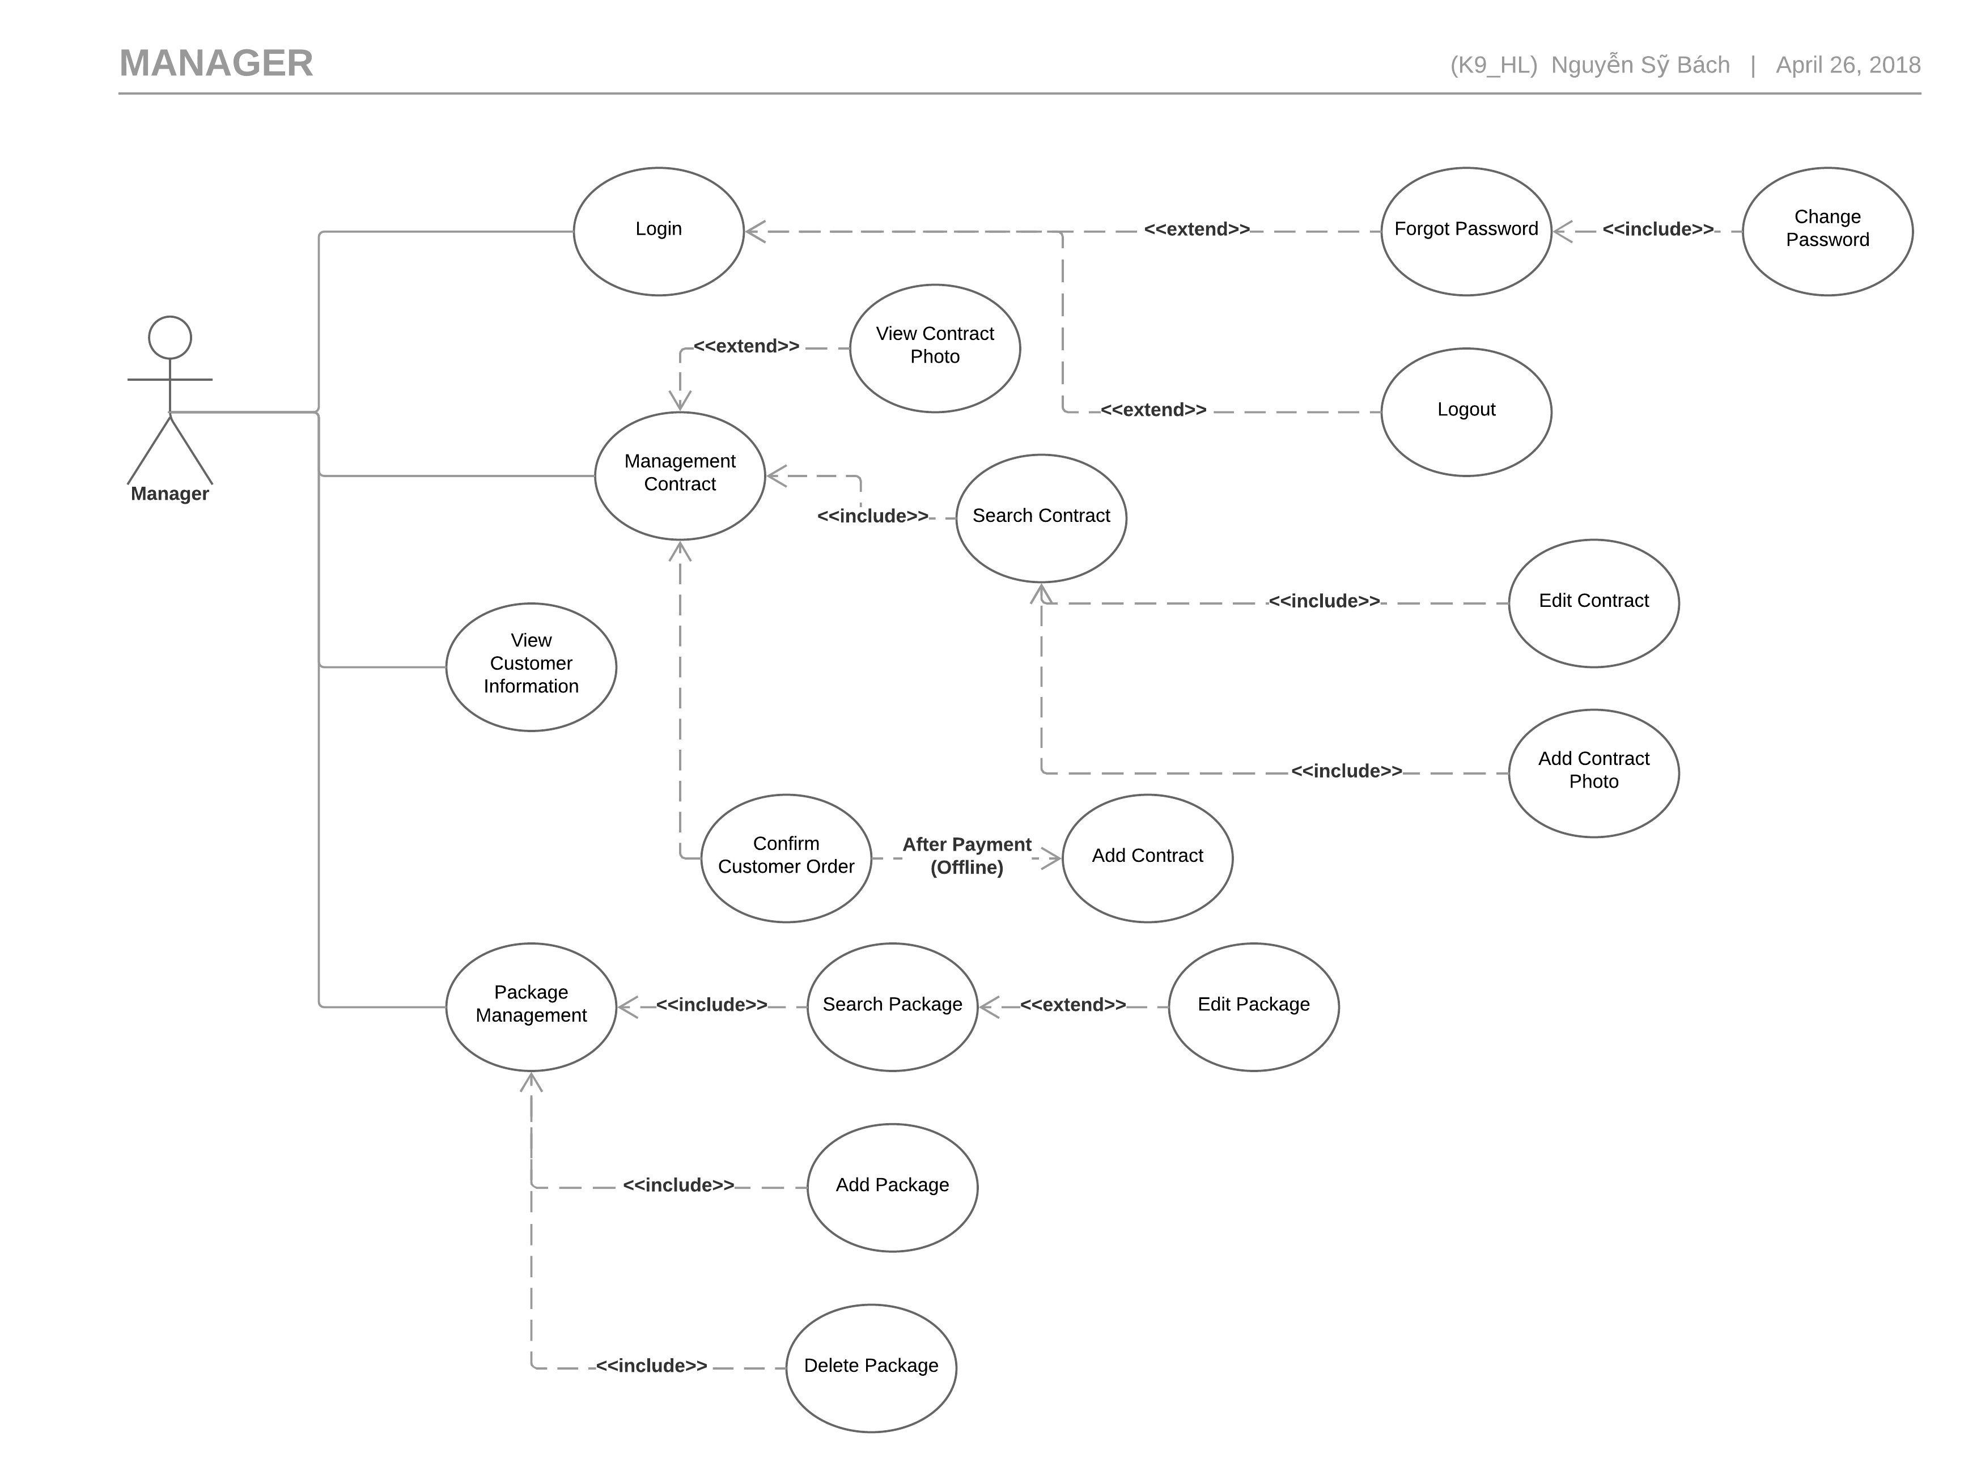

Figure .5.2.2.1**:** Manager Use Case Diagram

##### Login

|  |  |  |  |  |
| --- | --- | --- | --- | --- |
| Use Case ID | | UC-017 | Version | 1.0 |
| Use Case Name | | Login | | |
| Created by: | | BachNS | **Date Created:** | 12/04/2018 |
| Primary Actor | | Manager | **Secondary Actor** |  |
| Description: | | When Manager want to login by registered account to use more functions in website. | | |
| Preconditions: | | Systems must be connected to the Internet. | | |
| Trigger: | | Click on”Login”quick menu. | | |
| Post conditions: | | 1. Log Manager into system. 2. Redirect manager to Studio Management page. | | |
| Normal Flow | | | | |
| Step | **Actor Event** | **System Response** | | |
|  | Click on”Login”quick menu at the homepage. |  | | |
|  |  | Display”Login”page include:   1. Username textbox. 2. Password textbox. 3. “Login”button. 4. “Forgot password”hyperlink. | | |
|  | Enter Username and Password. |  | | |
|  | Click”Login”button. |  | | |
|  |  | Log Manager in to the systems. | | |
|  |  | Display Studio Management page with message:”Login Successfully”. | | |
| Alternative Flows: N/A | | | | |
| Exceptions | | | | |
| EC1 | At step 3 in main flow, if user entered wrong User name or Password | | | |
| Step | **Actor Event** | **System Response** | | |
| 3.1 | User entered wrong User name or Password |  | | |
|  |  | Pop error message. | | |
|  | | | | |
| Priority | | High | | |
| Frequency of Use: | | High | | |
| Business Rules: | | B2 | | |
| Other Information: | | N/A | | |

##### Logout

|  |  |  |  |  |
| --- | --- | --- | --- | --- |
| Use Case ID | | UC-018 | Version | 1.0 |
| Use Case Name | | Logout | | |
| Created by: | | BachNS | **Date Created:** | 12/04/2018 |
| Primary Actor | | Manager | **Secondary Actor** |  |
| Description: | | This function allows a manager to logout | | |
| Preconditions: | | 1. Systems must be connected to the Internet. 2. Manager has login to the systems. | | |
| Trigger: | | Click on”Logout”quick menu. | | |
| Post conditions: | | 1. Log user out of the systems. 2. Redirect user back to the home page. | | |
| Normal Flow | | | | |
| Step | **Actor Event** | **System Response** | | |
| 1 | Click on”Logout”quick menu. |  | | |
| 2 |  | 1. Log user out of the systems. 2. Redirect user back to the home page as customer. | | |
| Alternative Flows: N/A | | | | |
| Exceptions: N/A | | | | |
|  | | | | |
| Priority | | High | | |
| Frequency of Use: | | Normal | | |
| Business Rules: | | N/A | | |
| Other Information: | | N/A | | |

##### Change Password

|  |  |  |  |  |  |
| --- | --- | --- | --- | --- | --- |
| Use Case ID | | | UC-019 | Version | 1.0 |
| Use Case Name | | | Change Password | | |
| Created by: | | | BachNS | **Date Created:** | 12/04/2018 |
| Primary Actor | | | Manager | **Secondary Actor** |  |
| Description: | | | This function allows Manager to change password or forgot their password. | | |
| Preconditions: | | | Systems must be connected to the Internet. | | |
| Trigger: | | | Click on “Change Password” header. | | |
| Post conditions: | | | Systems redirect user to”Change Password”page. | | |
| Normal Flow | | | | | |
| Step | **Actor Event** | | **System Response** | | |
| 1 | Click on “Change Password” header | |  | | |
| 2 |  | | Display” Change Password” page include:   1. Old password textbox. 2. New password textbox. 3. New password confirms. 4. OK button. 5. Cancel button. | | |
| 3 | Enter old pass and new password. | |  | | |
| 4 | Click on OK button. | |  | | |
| 5 |  | | Display password has been changed suscessful. Redirect user back to manager page. | | |
| Alternative Flows | | | | | |
| AT1 | At step 6, Manager click ”Cancel”button. | | | | |
| Step | **Actor Event** | | **System Response** | | |
| 6.1 | Click”Cancel”button | |  | | |
| 6.2 |  | | Redirect user back to Manager page. | | |
|  | | | | | |
| Exceptions | | | | | |
| EC1 | | At step 8 in main flow, if user entered wrong User name or Password | | | |
| Step | | **Actor Event** | **System Response** | | |
| 8.1 | | User entered wrong old password |  | | |
| 8.2 | |  | Pop error message. | | |
|  | | | | | |
| Priority | | | High | | |
| Frequency of Use: | | | Low | | |
| Business Rules: | | | B2 | | |
| Other Information: | | | N/A | | |

##### Forgot Password

|  |  |  |  |  |  |
| --- | --- | --- | --- | --- | --- |
| Use Case ID | | | UC-020 | Version | 1.0 |
| Use Case Name | | | Change Password | | |
| Created by: | | | BachNS | **Date Created:** | 12/04/2018 |
| Primary Actor | | | Manager | **Secondary Actor** |  |
| Description: | | | This function allows Manager to change password or forgot their password. | | |
| Preconditions: | | | Systems must be connected to the Internet. | | |
| Trigger: | | | Click on “Forgot Password” hyperlink. | | |
| Post conditions: | | | Systems redirect user to ”Change Password”page. | | |
| Normal Flow | | | | | |
| Step | **Actor Event** | | **System Response** | | |
| 1 | Click on ”Login”quick menu at the homepage. | |  | | |
| 2 |  | | Display “Login”page include:   1. Username textbox. 2. Password textbox. 3. “Login”button. 4. “Forgot password”hyperlink. | | |
| 3 | Click on”Forgot password”hyperlink. | |  | | |
| 4 |  | | Redirect user to”Change Password”page include:   1. Username textbox. 2. “Please enter your username”message. 3. “Enter”button. | | |
| 5 | Enter Username. | |  | | |
| 6 | Click”Enter”button. | |  | | |
| 7 |  | | Change”Change Password”page to:   1. “Old password has been send to your email”message. 2. “Old password”textbox. 3. “New password”textbox. 4. “OK”button. 5. “Cancel”button. | | |
| 8 | Enter”Old password”,”New password”. | |  | | |
| 9 | Click”OK”button. | |  | | |
| 10 |  | | Change user password, redirect user to login page. | | |
| Alternative Flows | | | | | |
| AT1 | At step 6, Manager click”Cancel”button. | | | | |
| Step | **Actor Event** | | **System Response** | | |
| 6.1 | Click”Cancel”button | |  | | |
| 6.2 |  | | Redirect user back to”Login”page | | |
|  | | | | | |
| Exceptions | | | | | |
| EC1 | | At step 8 in main flow, if user entered wrong User name or Password | | | |
| Step | | **Actor Event** | **System Response** | | |
| 8.1 | | User entered wrong old password |  | | |
| 8.2 | |  | Pop error message. | | |
|  | | | | | |
| Priority | | | High | | |
| Frequency of Use: | | | Low | | |
| Business Rules: | | | B2 | | |
| Other Information: | | | N/A | | |

##### Search & View Contract Information

|  |  |  |  |  |  |
| --- | --- | --- | --- | --- | --- |
| Use Case ID | | | UC-021 | Version | 1.0 |
| Use Case Name | | | Search & View Contract Information | | |
| Created by: | | | BachNS | **Date Created:** | 12/04/2018 |
| Primary Actor | | | Manager | **Secondary Actor** |  |
| Description: | | | Manager can search old Contract | | |
| Preconditions: | | | Manager must login to the systems. | | |
| Trigger: | | | Click on”Contract”hyperlink in the menu. | | |
| Post conditions: | | | Open table of detail information of the search contract. | | |
| Normal Flow | | | | | |
| Step | **Actor Event** | | **System Response** | | |
| 1 | Click on”Contract”hyperlink menu. | |  | | |
| 2 |  | | Show search table include:   1. Dropdown menu include:”ContractID, CutomerName, CustomerPhone”. 2. Textbox field for dropdown menu choice 3. “Search”button. | | |
| 3 | Pick dropdown menu options, enter textbox field. | |  | | |
| 4 | Click”Search”button. | |  | | |
| 5 |  | | Show table with fitted Contract information include:   1. Number of Contract found. 2. Contract ID 3. Customer ID 4. Studio ID 5. Contract Description. 6. Create Date. 7. Start Date. 8. End Date. 9. “Edit”Button. 10. “More Information”Button. | | |
| Alternative Flows | | | | | |
| AT1 | At step 3, Manager type nothing in the Search textbox. | | | | |
| Step | **Actor Event** | | **System Response** | | |
| 6.1 | Leave textbox empty, click Search. | |  | | |
| 6.2 |  | | List all Contract. | | |
|  | | | | | |
| Exceptions: | | | | | |
| EC1 | | At step 3 in main flow, if user entered invalid Contract information | | | |
| Step | | **Actor Event** | **System Response** | | |
| 8.1 | | User entered invalid information |  | | |
| 8.2 | |  | Pop error message. | | |
|  | | | | | |
| Priority | | | Normal | | |
| Frequency of Use: | | | Normal | | |
| Business Rules: | | | B3, B8 | | |
| Other Information: | | | N/A | | |

##### Edit Contract

|  |  |  |  |  |
| --- | --- | --- | --- | --- |
| Use Case ID | | UC-022 | Version | 1.0 |
| Use Case Name | | Edit Contract | | |
| Created by: | | BachNS | **Date Created:** | 12/04/2018 |
| Primary Actor | | Manager | **Secondary Actor** |  |
| Description: | | Manager can change old contract information. | | |
| Preconditions: | | 1. Manager must log-in to the systems. 2. Case UC-020”Search Contract”must be executed successful first. | | |
| Trigger: | | Manager click on”Edit”Button in the Contract Information table. | | |
| Post conditions: | | New edit information saved in the Contract. | | |
| Normal Flow | | | | |
| Step | **Actor Event** | **System Response** | | |
| 1 | Click on”Edit”Button. |  | | |
| 2 |  | Open”Edit Contract”table include:   1. “Họ và Tên”textbox. 2. “Số điện thoại”textbox. 3. “Email”textbox. 4. “Ghi Chú”textbox. 5. “Save”Button. 6. “Reset”Button. | | |
| 3 | Enter new edit information |  | | |
| 4 |  | Save new edit information. | | |
| Alternative Flows | | | | |
| AT1 | At step 2, Manager click”Reset”button. | | | |
| Step | **Actor Event** | **System Response** | | |
| 2.1 | Click”Reset”Button. |  | | |
| 2.2 |  | Discard all textbox. Keep old information. | | |
| Exceptions | | | | |
| EX1 | At step 2, Manager leave on of the textbox empty, exclude “Ghi chú”. | | | |
| Step | **Actor Event** | **System Response** | | |
| 2.1 | Manager leave on of the textbox empty, exclude “Ghi chú”. |  | | |
| 2.2 |  | Show error messages. | | |
|  | | | | |
| Priority | | Normal | | |
| Frequency of Use: | | Normal | | |
| Business Rules: | | B2, B3, B11 | | |
| Other Information: | | N/A | | |

##### Add Contract

|  |  |  |  |  |  |
| --- | --- | --- | --- | --- | --- |
| Use Case ID | | | UC-023 | Version | 1.0 |
| Use Case Name | | | Add Contract | | |
| Created by: | | | BachNS | **Date Created:** | 12/04/2018 |
| Primary Actor | | | Manager | **Secondary Actor** |  |
| Description: | | | Manager can add new Contract with customer. | | |
| Preconditions: | | | Manager must log-in to the systems. | | |
| Trigger: | | | Manager click on”Add Contract”hyperlink. | | |
| Post conditions: | | | New Contract added to the systems. | | |
| Normal Flow | | | | | |
| Step | **Actor Event** | | **System Response** | | |
|  | Manager click on”Add Contract”hyperlink. | |  | | |
|  |  | | Open”Add Contract”table include:   1. “Họ và Tên”textbox. 2. “Số điện thoại”textbox. 3. “Giới tính” checkbox. 4. “Khách hang cũ” checkbox. 5. “Email”textbox. 6. “Địa chỉ khách hàng”textbox. 7. “Studio làm việc”dropdown box. 8. “Tên sản phẩm”dropdown box. 9. “Chi tiết sản phẩm”textbox. 10. “Ghi chú”textbox. 11. “Chi tiết hợp đồng”textbox. 12. “Ngày lập hợp đồng”datetime. 13. “Ngày kết thúc hợp đồng”datetime. 14. “Ngày chụp”datetime. 15. “Add”Button. 16. “Reset”Button. | | |
|  | Enter new Contract information | |  | | |
|  | Click”Add” | |  | | |
|  |  | | Added new Contract to the systems. | | |
| Alternative Flows | | | | | |
| AT1 | At step 4, Manager click”Reset”button. | | | | |
| Step | **Actor Event** | | **System Response** | | |
| 4.1 | Manager click”Reset”button | |  | | |
| 4.2 |  | | Discard all textbox. | | |
| Exceptions | | | | | |
| EX1 | At step 3, Manager leave on of the textbox empty, exclude “Ghi chú”. | | | | |
| Step | **Actor Event** | **System Response** | | | |
| 3.1 | Manager leave on of the textbox empty, exclude “Ghi chú”. |  | | | |
| 3.2 |  | Show error messages. | | | |
| EX2 | At step 3, Manager enter wrong type text to textbox (special character). | | | | |
| Step | **Actor Event** | **System Response** | | | |
| 3.1 | Manager enter wrong type text to textbox (special character). |  | | | |
| 3.2 |  | Show error messages. | | | |
| EX2 | At step 3, Manager check on “Khách hàng cũ” checkbox but type in wrong key information. | | | | |
| Step | **Actor Event** | **System Response** | | | |
| 2.1 | Manager check on “Khách hàng cũ” checkbox but type in wrong key information. |  | | | |
| 2.2 |  | Show error messages. | | | |
|  | | | | | |
| Priority | | | Normal | | |
| Frequency of Use: | | | Normal | | |
| Business Rules: | | | B2, B3, B11 | | |
| Other Information: | | | N/A | | |

##### Search & View Package

|  |  |  |  |  |  |
| --- | --- | --- | --- | --- | --- |
| Use Case ID | | | UC-024 | Version | 1.0 |
| Use Case Name | | | Search & View Package | | |
| Created by: | | | BachNS | **Date Created:** | 12/04/2018 |
| Primary Actor | | | Manager | **Secondary Actor** |  |
| Description: | | | Manager can search Photo Package | | |
| Preconditions: | | | Manager must login to the systems. | | |
| Trigger: | | | Click on”Package Manager”hyperlink in the menu. | | |
| Post conditions: | | | Open table of detail information of the search package. | | |
| Normal Flow | | | | | |
| Step | **Actor Event** | | **System Response** | | |
| 1 | Click on”Package Manager”hyperlink menu. | |  | | |
| 2 |  | | Show search table include:   1. Package name textbox. 2. Search button. | | |
| 3 | Enter search package name. | |  | | |
| 4 | Click Search button. | |  | | |
| 5 |  | | Show search package table include:   1. Number of Package found. 2. Package ID. 3. Package name. 4. Package Detail. 5. Package Price. 6. Package Priview picture. 7. Available. 8. “Show all”Hyperlink 9. “Add new Package”Hyperlink. 10. “Edit”button. 11. “Delete”button. | | |
| Alternative Flows: N/A | | | | | |
| Exceptions | | | | | |
| EC1 | | At step 3 in main flow, if user entered invalid Contract information | | | |
| Step | | **Actor Event** | **System Response** | | |
| 8.1 | | User entered invalid information |  | | |
| 8.2 | |  | Pop error message. | | |
|  | | | | | |
| Priority | | | Normal | | |
| Frequency of Use: | | | Normal | | |
| Business Rules: | | | B3 | | |
| Other Information: | | | N/A | | |

##### Add Package

|  |  |  |  |  |
| --- | --- | --- | --- | --- |
| Use Case ID | | UC-025 | Version | 1.0 |
| Use Case Name | | Add Package | | |
| Created by: | | BachNS | **Date Created:** | 12/04/2018 |
| Primary Actor | | Manager | **Secondary Actor** |  |
| Description: | | Manager can add new package for customer. | | |
| Preconditions: | | Manager must log-in to the systems. | | |
| Trigger: | | Manager click on”Add Package”hyperlink. | | |
| Post conditions: | | New Contract added to the systems. | | |
| Normal Flow | | | | |
| Step | **Actor Event** | **System Response** | | |
| 1 | Manager click on”Add Contract”hyperlink. |  | | |
| 2 |  | Open”Add Package”table include:   1. Package name textbox. 2. Package details textbox. 3. Package price textbox. 4. Package availability drop check box. 5. “Add”button. 6. “Reset”button. | | |
| 3 | Enter new Package information |  | | |
| 4 | Click”Add” |  | | |
| 5 |  | Added new Package to the systems. | | |
| Alternative Flows | | | | |
| AT1 | At step 4, Manager click”Reset”button. | | | |
| Step | **Actor Event** | **System Response** | | |
| 4.1 | Manager click”Reset”button |  | | |
| 4.2 |  | Discard all textbox. | | |
| Exceptions: N/A | | | | |
| Priority | | Normal | | |
| Frequency of Use: | | Normal | | |
| Business Rules: | | B2, B3 | | |
| Other Information: | | N/A | | |

##### Edit Package

|  |  |  |  |  |
| --- | --- | --- | --- | --- |
| Use Case ID | | UC-026 | Version | 1.0 |
| Use Case Name | | Edit Package | | |
| Created by: | | BachNS | **Date Created:** | 12/04/2018 |
| Primary Actor | | Manager | **Secondary Actor** |  |
| Description: | | Manager can edit old package information. | | |
| Preconditions: | | 1. Manager must log-in to the systems. 2. Case UC-023”Search Package”must be executed successful first. | | |
| Trigger: | | Manager click on”Edit”Button in the Package Information table. | | |
| Post conditions: | | New edit information saved in the Package. | | |
| Normal Flow | | | | |
| Step | **Actor Event** | **System Response** | | |
| 1 | Click on”Edit”Button. |  | | |
| 2 |  | Open”Edit package”table include:   1. Package Id (Cannot edit). 2. Package Name textbox. 3. Package Detail textbox. 4. Package price textbox. 5. Package preview picture. 6. Package availability drop check box. 7. “Add”button. 8. “Reset”button | | |
| 3 | Enter new edit information |  | | |
| 4 |  | Save new edit information. | | |
| Alternative Flows | | | | |
| AT1 | At step 3, Manager click”Reset”button. | | | |
| Step | **Actor Event** | **System Response** | | |
| 2.1 | Click”Reset”Button. |  | | |
| 2.2 |  | Discard all textbox. Keep old information. | | |
| Exceptions: N/A | | | | |
| Priority | | Normal | | |
| Frequency of Use: | | Normal | | |
| Business Rules: | | B2, B3, B11 | | |
| Other Information: | | N/A | | |

##### View Picture

|  |  |  |  |  |
| --- | --- | --- | --- | --- |
| Use Case ID | | UC-027 | Version | 1.0 |
| Use Case Name | | View Picture | | |
| Created by: | | BachNS | **Date Created:** | 12/04/2018 |
| Primary Actor | | Manager | **Secondary Actor** |  |
| Description: | | Manager can view Contract uploaded picture. | | |
| Preconditions: | | Manager must login to the systems. | | |
| Trigger: | | Click on”Picture”hyperlink in the menu. | | |
| Post conditions: | | Open all Contract picture. | | |
| Normal Flow | | | | |
| Step | **Actor Event** | **System Response** | | |
| 1 | Click on”Picture”hyperlink in the menu. |  | | |
| 2 |  | Show Picture table:   1. Pictures. 2. Contract name of the pictures. | | |
| Alternative Flows: N/A | | | | |
| Exceptions: N/A | | | | |
| Priority | | Normal | | |
| Frequency of Use: | | Normal | | |
| Business Rules: | | N/A | | |
| Other Information: | | N/A | | |

##### Edit Picture Info

|  |  |  |  |  |
| --- | --- | --- | --- | --- |
| Use Case ID | | UC-028 | Version | 1.0 |
| Use Case Name | | Edit Picture Info | | |
| Created by: | | BachNS | **Date Created:** | 12/04/2018 |
| Primary Actor | | Manager | **Secondary Actor** |  |
| Description: | | Manager can upload Contract uploaded picture. | | |
| Preconditions: | | 1. Manager must login to the systems. 2. Case UC-012”Search Contract”must be executed successful first. | | |
| Trigger: | | Click on” Update Picture Detail” button. | | |
| Post conditions: | | Picture information has changed. | | |
| Normal Flow | | | | |
| Step | **Actor Event** | **System Response** | | |
| 1 | Click on “Update Picture’s Detail”menu. |  | | |
| 2 |  | Show Update menu:   1. Contract Detail ID. 2. New Picture Detail. 3. New Picture URL. 4. Update Picture’s Detail Button. 5. Delete Button. | | |
| 3 | Click” Update Picture’s Detail Button ” button. |  | | |
| 4 |  |  | | |
|  |  | Update new picture to the systems. | | |
| Alternative Flows: N/A | | | | |
| Exceptions: N/A | | | | |
| Priority | | Normal | | |
| Frequency of Use: | | Normal | | |
| Business Rules: | | B14, B13. | | |
| Other Information: | | N/A | | |

##### Upload Picture

|  |  |  |  |  |  |
| --- | --- | --- | --- | --- | --- |
| Use Case ID | | UC-029 | | Version | 1.0 |
| Use Case Name | | Upload Picture | | | |
| Created by: | | BachNS | | **Date Created:** | 12/04/2018 |
| Primary Actor | | Manager | | **Secondary Actor** |  |
| Description: | | Manager can upload Contract uploaded picture. | | | |
| Preconditions: | | 1. Manager must login to the systems. 2. Case UC-020”Search Contract”must be executed successful first. | | | |
| Trigger: | | Click on”Upload Pictures”button. | | | |
| Post conditions: | | Uploaded all picture to the Contract. | | | |
| Normal Flow | | | | | |
| Step | **Actor Event** | **System Response** | | | |
| 1 | Click on”Upload”button |  | | | |
| 2 |  | Show Upload pop-up:   1. Upload button. 2. Cancel button. | | | |
| 3 | Choose picture to upload. |  | | | |
| 4 | Click”Upload”button. |  | | | |
|  |  | Upload picture to the systems. | | | |
| Alternative Flows | | | | | |
| AT1 | At step 4, Manager click”Cancel”button. | | | | |
| Step | **Actor Event** | | **System Response** | | |
| 4.1 | Manager click”Cancel”button | |  | | |
| 4.2 |  | | Discard all upload picture. Close upload pop-up. | | |
| Exceptions: N/A | | | | | |
| Priority | | Normal | | | |
| Frequency of Use: | | Normal | | | |
| Business Rules: | | B14, B13. | | | |
| Other Information: | | N/A | | | |

##### Delete Picture

|  |  |  |  |  |
| --- | --- | --- | --- | --- |
| Use Case ID | | UC-030 | Version | 1.0 |
| Use Case Name | | Upload Picture | | |
| Created by: | | BachNS | **Date Created:** | 12/04/2018 |
| Primary Actor | | Manager | **Secondary Actor** |  |
| Description: | | Manager can upload Contract uploaded picture. | | |
| Preconditions: | | 1. Manager must login to the systems. 2. Case UC-020”Search Contract”must be executed successful first. | | |
| Trigger: | | Click on ”Delete”button. | | |
| Post conditions: | | Delete picture to the Contract. | | |
| Normal Flow | | | | |
| Step | **Actor Event** | **System Response** | | |
| 1 | Click on”Delete”button |  | | |
| 2 |  | Delete picture to the Contract. | | |
| Alternative Flows: N/A | | | | |
| Exceptions: N/A | | | | |
| Priority | | Normal | | |
| Frequency of Use: | | Normal | | |
| Business Rules: | | B14, B13. | | |
| Other Information: | | N/A | | |

##### View Customer Information

|  |  |  |  |  |
| --- | --- | --- | --- | --- |
| Use Case ID | | UC-031 | Version | 1.0 |
| Use Case Name | | View Customer Information | | |
| Created by: | | BachNS | **Date Created:** | 12/04/2018 |
| Primary Actor | | Manager | **Secondary Actor** |  |
| Description: | | Manager can view Customers information. | | |
| Preconditions: | | Manager must log-in to the systems. | | |
| Trigger: | | Manager click on”View Customer Information”hyperlink. | | |
| Post conditions: | | Manager can view table of customer information. | | |
| Normal Flow | | | | |
| Step | **Actor Event** | **System Response** | | |
| 1 | Click on”View Customer Information”hyperlink. |  | | |
| 2 |  | Open”Customer Information”table include:   1. Họ và Tên. 2. Số điện thoại. 3. Email. 4. Giới tính. 5. Địa chỉ. 6. Lịch sử mua hàng. | | |
| Alternative Flows: N/A | | | | |
| Exceptions: N/A | | | | |
| Priority | | Normal | | |
| Frequency of Use: | | Normal | | |
| Business Rules: | | B2, B3, B11 | | |
| Other Information: | | N/A | | |

#### Customer

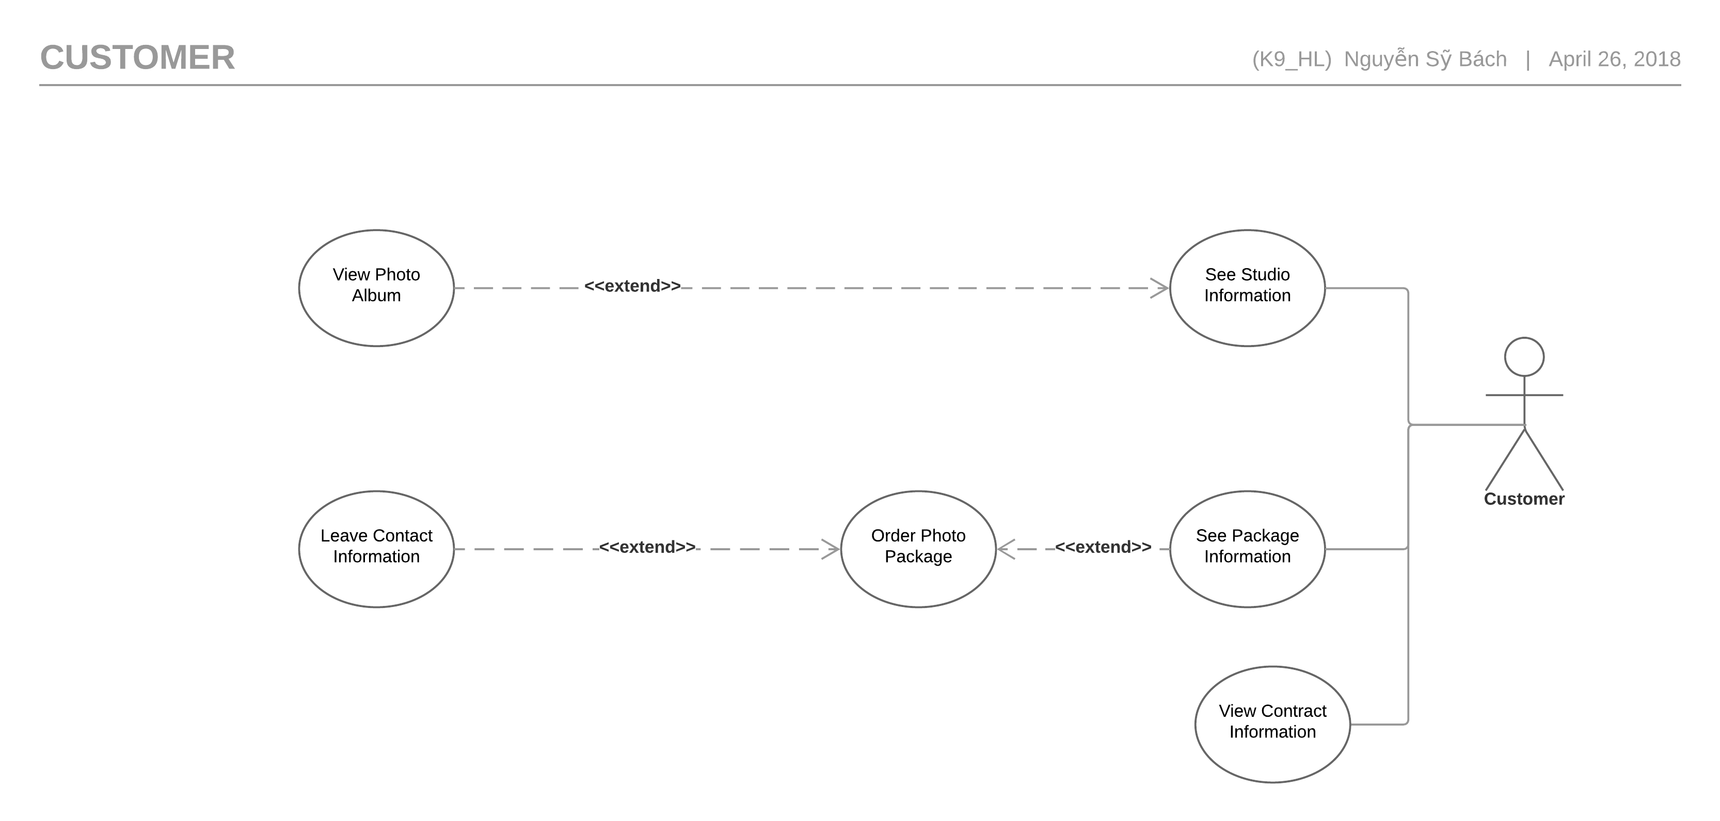

Figure .5.2.2.2: Customer Use Case Diagram

##### See Studio Information

|  |  |  |  |  |  |
| --- | --- | --- | --- | --- | --- |
| Use Case ID UC-032 | | | | Version | 1.0 |
| Use Case Name | | See Studio Information | | | |
| Created by: | | HuyNM | | **Date Created:** | 14/03/2018 |
| Primary Actor | | Customer | | **Secondary Actor** |  |
| Description: | | Add Studio Manager information. | | | |
| Preconditions: | | Customer must to go PSM website. | | | |
| Trigger: | | Customer click to button”Studio”. | | | |
| Post conditions: | | Display all information Studio. | | | |
| Normal Flow | | | | | |
| Step | **Actor event** | | | **System response** | |
| 1 | Click to button “Studio” | | |  | |
| 2 |  | | | Display above “Studio” is list of Studio. | |
| 3 | Click on name of Studio. | | |  | |
| 4 |  | | | Display all Information studio at bottom of website.   1. Name Studio 2. Studio Phone number 3. Studio Email 4. Studio address 5. Studio map location | |
| Alternative Flows | | | | | |
| AT1: Move mouse to button “Studio”. | | | | | |
| Step | **Actor event** | | | **System response** | |
| 1 | Move mouse to button “Studio”. | | |  | |
| 2 |  | | | List of Studio will display dropdown below “Studio” button. | |
| 3 | Select and Click to Studio want to show. | | |  | |
| 4 |  | | | PSM will go to the page of Studio. | |
|  | | | | | |
| Exceptions: N/A | | | | | |
|  | | | | | |
| Priority | | | Normal | | |
| Frequency of Use: | | | Normal | | |
| Business Rules: | | | N/A | | |
| Other Information: | | | N/A | | |

##### See album

|  |  |  |  |  |  |
| --- | --- | --- | --- | --- | --- |
| Use Case ID UC-033 | | | | Version | 1.0 |
| Use Case Name | | See album | | | |
| Created by: | | HuyNM | | **Date Created:** | 14/03/2018 |
| Primary Actor | | Customer | | **Secondary Actor** |  |
| Description: | | Someone want to see sample picture of studio. | | | |
| Preconditions: | | Customer must to go PSM website.  Customer must to go page of Studio on PSM. | | | |
| Trigger: | | Customer click to Picture. | | | |
| Post conditions: | | Picture is showed | | | |
| Normal Flow | | | | | |
| Step | **Actor event** | | | **System response** | |
| 1 | Customer go to page of Studio on PSM. | | |  | |
| 2 |  | | | Show the album at bottom website. | |
| 3 | Click to album. | | |  | |
| 4 |  | | | Show Detail of album. | |
| Alternative Flows: N/A | | | | | |
|  | | | | | |
| Exceptions: N/A | | | | | |
|  | | | | | |
| Priority | | | Normal | | |
| Frequency of Use: | | | Normal | | |
| Business Rules: | | | N/A | | |
| Other Information: | | | N/A | | |

##### See Studio Location

|  |  |  |  |  |  |
| --- | --- | --- | --- | --- | --- |
| Use Case ID UC-034 | | | | Version | 1.0 |
| Use Case Name | | See Studio Location | | | |
| Created by: | | HuyNM | | **Date Created:** | 14/03/2018 |
| Primary Actor | | Customer | | **Secondary Actor** |  |
| Description: | | Show for customer location of Studio | | | |
| Preconditions: | | Customer must to go PSM website.  Customer must to go page of Studio on PSM. | | | |
| Trigger: | | Customer click to button “Studio”. | | | |
| Post conditions: | | Location of Studio will show on the map. | | | |
| Normal Flow | | | | | |
| Step | **Actor event** | | | **System response** | |
| 1 | Customer go to page of Studio on PSM. | | |  | |
| 2 |  | | | Information of Studio will show on the table “Studio Information”. | |
| 3 | Click on Link of “Studio map location” hyperlink. | | |  | |
| 4 |  | | | Show map studio on the googlemap. | |
| Alternative Flows: N/A | | | | | |
|  | | | | | |
| Exceptions: N/A | | | | | |
|  | | | | | |
| Priority | | | Normal | | |
| Frequency of Use: | | | Normal | | |
| Business Rules: | | | N/A | | |
| Other Information: | | | N/A | | |

##### See Package Information

|  |  |  |  |  |  |  |
| --- | --- | --- | --- | --- | --- | --- |
| Use Case ID UC-035 | | | | Version | | 1.0 |
| Use Case Name | | See Package Information | | | | |
| Created by: | | HuyNM | | **Date Created:** | | 10/03/2018 |
| Primary Actor | | Customer | | **Secondary Actor** | |  |
| Description: | | Show for customer packages of studio. | | | | |
| Preconditions: | | Customer must to go PSM website. | | | | |
| Trigger: | | Customer selected to name of Studio. | | | | |
| Post conditions: | | Show all package Studio. | | | | |
| Normal Flow | | | | | | |
| Step | **Actor event** | | | | **System response** | |
| 1 | Customer go to page of Studio on PSM. | | | |  | |
| 2 |  | | | | Website will show   1. Các gói 2. Dự án đã làm 3. Name about leader of Studio. | |
| 3 | At functions “Các gói” Click to the“Đọc thêm” on package. | | | |  | |
|  |  | | | | Detail of package will show all.   1. Package name 2. Package detail 3. Package price | |
| Alternative Flows | | | | | | |
| Step | **Actor event** | | | | **System response** | |
| 1 | Click to “Hiện thêm gói hàng”. | | | |  | |
|  |  | | | | PSM show all information of Package. | |
|  | | | | | | |
| Exceptions: N/A | | | | | | |
|  | | | | | | |
| Priority | | | Normal | | | |
| Frequency of Use: | | | Normal | | | |
| Business Rules: | | | N/A | | | |
| Other Information: | | | N/A | | | |

##### Order photo Package and leave Information

|  |  |  |  |  |  |
| --- | --- | --- | --- | --- | --- |
| Use Case ID UC-036 | | | | Version | 1.0 |
| Use Case Name | | Order photo Package and leave Information | | | |
| Created by: | | HuyNM | | **Date Created:** | 10/03/2018 |
| Primary Actor | | Customer | | **Secondary Actor** |  |
| Description: | | Customer Order package. | | | |
| Preconditions: | | Customer must to go PSM website.  Customer need choose the Studio want to take picture. | | | |
| Trigger: | | Customer click to icon “Bag” for order package. | | | |
| Post conditions: | | PSM will send email for customer. | | | |
| Normal Flow | | | | | |
| Step | **Actor event** | | | **System response** | |
| 1 | After Customer select the cart. Click to the button “Buy”. | | |  | |
| 2 |  | | | PSM will move to checkout page and show price of package. | |
| 3 | Write in table Customer information:   1. Tên khách hàng 2. Giới tính 3. SDT khách hàng 4. Link facebook khách hang 5. Yêu cầu khác.   Then click“Mua”. | | |  | |
| 4 |  | | | Message ”Đơn hàng của bạn đã được tạo mời bạn bấm vào [đây](http://localhost:5000/view-contract.html) và điền "…" vào ô trống. | |
| 5 |  | | | PSM send email for Customer and Manager of package. | |
| Alternative Flows: N/A | | | | | |
|  | | | | | |
| Exceptions | | | | | |
| EC1: Phone number need is number 11~13. | | | | | |
| Step | **Actor event** | | | **System response** | |
| 3.1 | Customer entered wrong phone number. | | |  | |
| 3.2 |  | | | Message”SDT cần 11~13 ký tự.” | |
|  | | | | | |
| EC2: Email khách hàng The email must be valid. | | | | | |
| Step | **Actor event** | | | **System response** | |
| 3.3 | Customer entered wrong email. | | |  | |
| 3.4 |  | | | Message”Sai địa chỉ email.” | |
|  | | | | | |
|  | | | | | |
| Priority | | | Normal | | |
| Frequency of Use: | | | Normal | | |
| Business Rules: | | | B5,B6. | | |
| Other Information: | | | N/A | | |

##### View contract

|  |  |  |  |  |  |  |
| --- | --- | --- | --- | --- | --- | --- |
| Use Case ID UC-037 | | | | Version | | 1.0 |
| Use Case Name | | View contract | | | | | |
| Created by: | | HuyNM | | **Date Created:** | 10/03/2018 | |
| Primary Actor | | Customer | | **Secondary Actor** |  | |
| Description: | | Show contract for customer | | | | | |
| Preconditions: | | Customer must to go PSM website. | | | | | |
| Trigger: | | Customer click to “Hợp đồng” hyperlink. | | | | | |
| Post conditions: | | All information displayed. | | | | | |
| Normal Flow | | | | | | | |
| Step | **Actor event** | | | **System response** | | |
| 1 | Click to contract hyperlink | | |  | | |
| 2 |  | | | PSM will display table contract. | | |
| 3 | Write character of contract to text box in header then hit Enter. | | |  | | |
| 4 |  | | | PSM will display detail of your contract, contract Status. | | |
| Alternative Flows: N/A | | | | | | | |
|  | | | | | | | |
| Exceptions: N/A | | | | | | | |
|  | | | | | | | |
| Priority | | | Normal | | | | |
| Frequency of Use: | | | Normal | | | | |
| Business Rules: | | | B1 | | | | |
| Other Information: | | | N/A | | | | |

#### System　システム

Figure 3.5.2.4 System use case diagram

## Usability 　ユーザビリティ

* Interface should be beauty, simple, easy-to-use, clear.
* Provide an introduction to support users.

## Reliability 　信頼性

* Search result return must be correctly.
* Use’s information must be reliable.
* The database must be backed up daily and can be recovered if necessary.

## Performance　性能

* Maximum response time for display information must be smaller than 1 second.
* Waiting time of processing any functions will be 2 to 5 seconds.

## Maintainability　保全性

* The output of the project must include naming conventions and coding standards documentations. Code implementation must be easy to maintain.
* All code must be comment clearly, including class and method documentations.
* The design of the system must be loosely coupled that chances on some module will not affect others.

## Supporting Information　サポート情報

N/A

# ARCHITECTURE DESIGN　アーキテクチャ設計書

## Introduction　はじめに

### Purpose　目的

The purpose of this chapter is to give developers the overview and the detailed technical design of Jobs Finding System. This chapter consist of:

* Architecture overview
* Component diagram
* Detailed design
* Detailed description of components
* Database design

### References　参照資料

|  |  |  |
| --- | --- | --- |
| No. | Document | Source/Web Address |
| 1 | Architecture Design Template | FPT Software Cop. |
| 2 | JFS_Software_Requirements_Specification_v1.0 | Internal Resource |

## Architectural Overview　アーキテクチャ概要

### System Architecture　システムアーキテクチャ

In our project we use MVC architectural model.

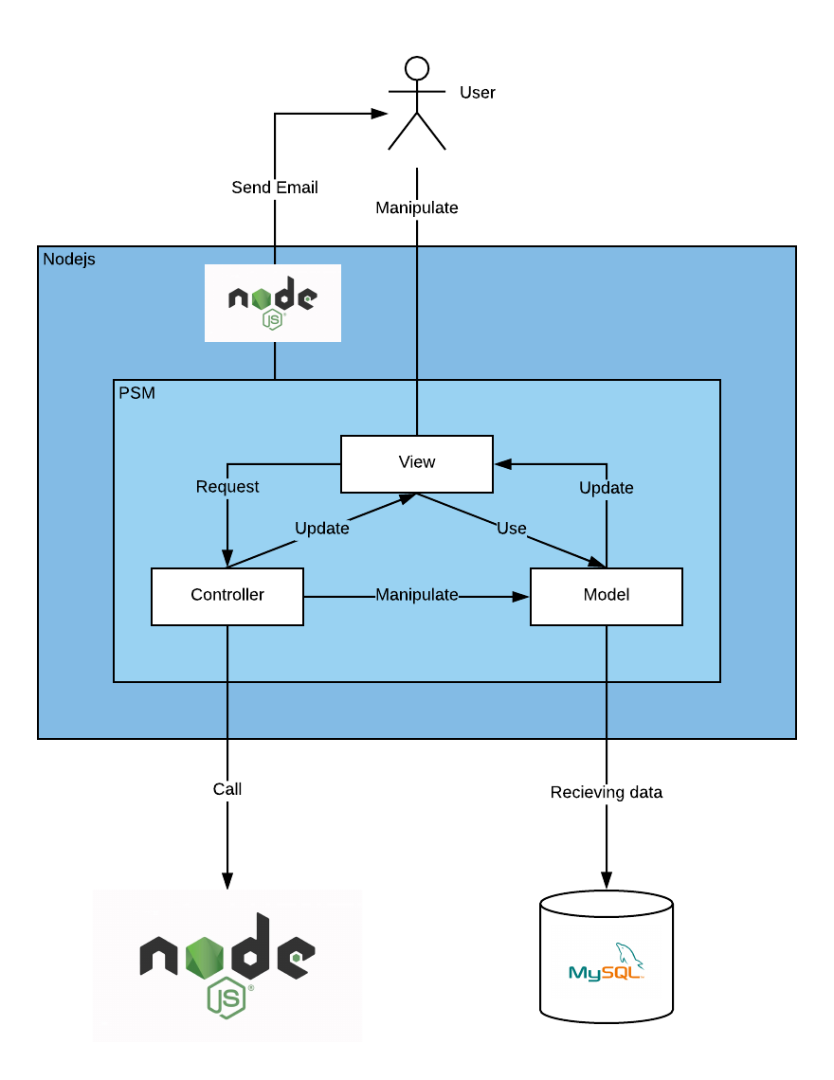

***Figure 4.1****: System Overview*

## System Architecture Explanation　システムアーキテクチャについての説明

The following is the explanation of the function and mechanism of each unit in the System Design.

**Azure Cloud Service:** The entire system will be deployed to Azure Cloud. Our target is developing a highly available and responsive system.

**Azure SendGrid**: We use SendGrid to send information to Users by email. SendGrid is a cloud-based email service that provides reliable transactional email delivery and real time analytics.

**Tawk.to API**: This is a free live chat API which we use to chat with all visitor on our website.

**MySQL**: MySQL is an open-source relational database management system. We use MySQL for adding, accessing and managing content of our system’s database.

## Design of Jobs Finding System　Jobs finding system の設計書

### Database Design データベース設計

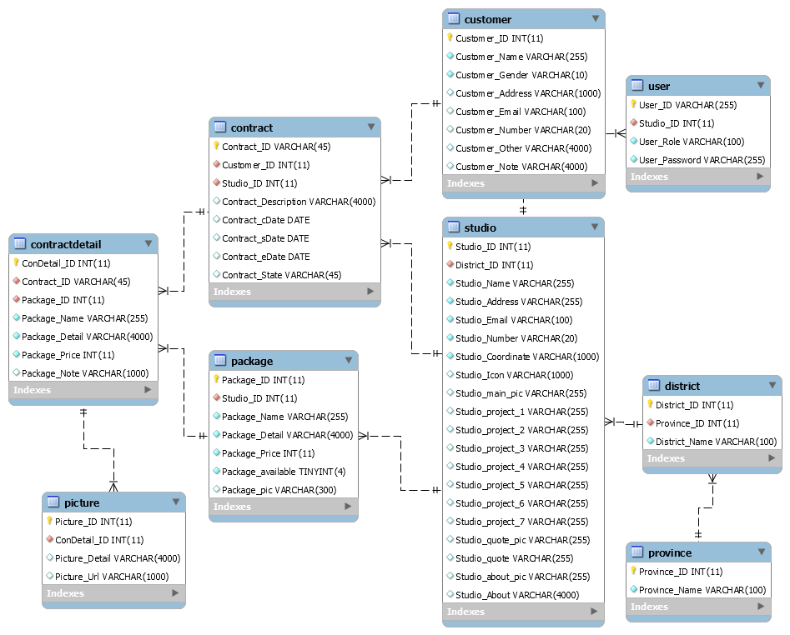

**Figure 4.4.1:** Table Diagram

### Database detail　データベースの詳細

#### Manager

|  |  |  |  |  |
| --- | --- | --- | --- | --- |
| No | Attribute | Type | Mandatory | Description |
| 1 | User_ID | String | Y | User’s username |
| 2 | Studio_ID | int | Y | Studio’s ID |
| 3 | User_Role | String | Y | User’s role |
| 4 | User_Password | String | Y | User’s password |

#### Studio

|  |  |  |  |  |
| --- | --- | --- | --- | --- |
| No | Attribute | Type | Mandatory | Description |
| 1 | Studio_ID | Int | Y | Studio’s ID |
| 2 | District_ID | String | Y | District’s ID. |
| 3 | Studio_Name | String | Y | Studio’s name |
| 4 | Studio_Address | String | Y | Studio’s physical address |
| 5 | Studio_Email | String | Y | Studio’s email address |
| 6 | Studio_Number | Number | Y | Studio’s phone number |
| 7 | Studio_Coordinate | String | Y | Studio’s location coordinate |
| 8 | Studio_Icon | String | N | Studio’s icon |
| 9 | Studio_main_pic | String | N | Studio’s main picture at studio’s page |
| 10 | Studio_project_1 | String | N | Studio’s project 1 picture at studio’s page |
| 11 | Studio_project_2 | String | N | Studio’s project 2 picture at studio’s page |
| 12 | Studio_project_3 | String | N | Studio’s project 3 picture at studio’s page |
| 13 | Studio_project_4 | String | N | Studio’s project 4 picture at studio’s page |
| 14 | Studio_project_5 | String | N | Studio’s project 5 picture at studio’s page |
| 15 | Studio_project_6 | String | N | Studio’s project 6 picture at studio’s page |
| 16 | Studio_project_7 | String | N | Studio’s project 7 picture at studio’s page |
| 17 | Studio_quote_pic | String | N | Quote’s picture |
| 18 | Studio_quote | String | N | Studio’s quote |
| 19 | Studio_about_pic | String | N | About’s picture |

#### District

|  |  |  |  |  |
| --- | --- | --- | --- | --- |
| No | Attribute | Type | Mandatory | Description |
| 1 | District_ID | Int | Y | District’s ID |
| 2 | Province_ID | Int | Y | Province that have the current district |
| 3 | District_Name | String | Y | District’s Name |

#### Province

|  |  |  |  |  |
| --- | --- | --- | --- | --- |
| No | Attribute | Type | Mandatory | Description |
| 1 | Province_ID | Int | Y | Province’s ID |
| 2 | Province_Name | String | Y | Province’s Name |

#### Contract

|  |  |  |  |  |
| --- | --- | --- | --- | --- |
| No | Attribute | Type | Mandatory | Description |
|  | Contract_ID | String | Y | Contract’s ID |
|  | Customer_ID | Int | Y | Customer’s ID |
|  | Studio_ID | Int | Y | Studio’s ID |
|  | Contract_Description | String | N | The Description about the current contract |
|  | Contract_cDate | Date | Y | The create date of the contract |
|  | Contract_sDate | Date | N | The start the contract start have effectness |
|  | Contract_eDate | Date | N | The date the contract end lost effectness |
|  | Contract_State | String | Y | The state of the contract |

#### Customer

|  |  |  |  |  |
| --- | --- | --- | --- | --- |
| No | Attribute | Type | Mandatory | Description |
| 1 | Customer_ID | Int | Y | Customer’s ID |
| 2 | Customer_Name | String | Y | Customer’s name |
| 3 | Customer_Gender | String | Y | Customer’s gender |
| 4 | Customer_Address | String | Y | Customer’s address |
| 5 | Customer_Email | String | Y | Customer’s email |
| 6 | Customer_Number | String | Y | Customer’s number |
| 7 | Customer_Note | String | N | Customer’s note |
| 8 | Customer_Other | String | N | Customer’s social media |

#### Contract Detail

|  |  |  |  |  |
| --- | --- | --- | --- | --- |
| No | Attribute | Type | Mandatory | Description |
| 1 | ConDetail_ID | Int | Y | Feedback’s ID |
| 2 | Contract_ID | String | Y | Contract’s ID that relate to the contract’s detail |
| 3 | Package_ID | Int | Y | Real time that member create feedback |
| 4 | Package_Name | String | Y | Name of the current available package |
| 5 | Package_Detail | String | Y | Detail of the current available package |
| 6 | Package_Price | Int | Y | Price of the current available package |
| 7 | Package_Note | String | N | Note about package |

#### Package

|  |  |  |  |  |
| --- | --- | --- | --- | --- |
| No | Attribute | Type | Mandatory | Description |
|  | Package_ID | Int | Y | package’s ID |
|  | Package_Name | String | Y | Package’s Name |
|  | Package_Detail | String | Y | Package’s Detail |
|  | Package_Price | Int | Y | Package’s price |
|  | Package_Available | Boolean | Y | Define that the package is available or not |
|  | Package_pic | String | N | The picture represent the package |

#### Picture

|  |  |  |  |  |
| --- | --- | --- | --- | --- |
| No | Attribute | Type | Mandatory | Description |
| 1 | Picture_ID | Int | Y | Picrure’s ID |
| 2 | ConDetail_ID | Int | Y | Comtract’s ID |
| 3 | Picture_Detail | String | N | Picture’s detail |
| 4 | Picture_Url | String | N | Picture’s Url link |

## Component Diagramコンポーネント図

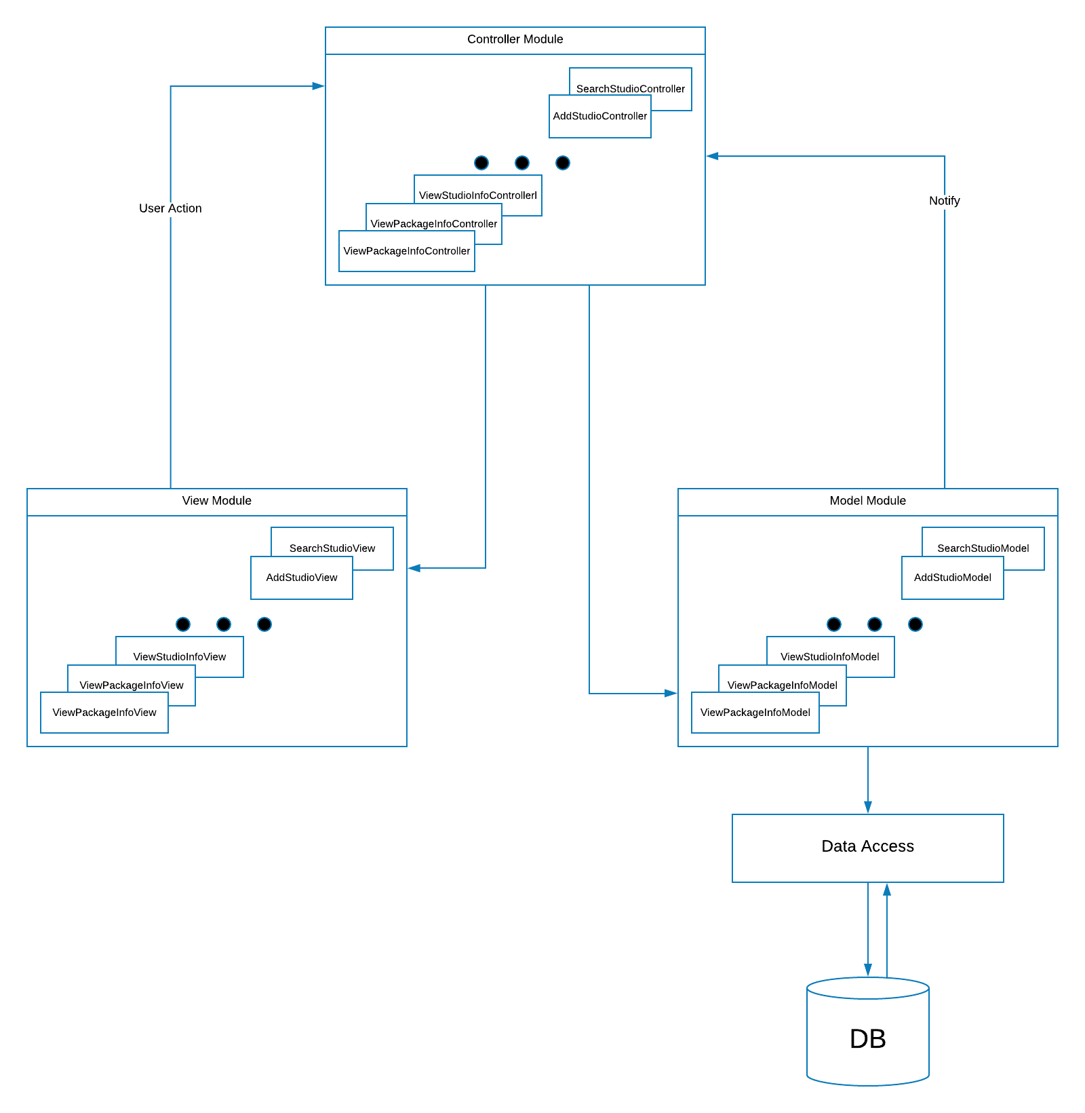

Figure 4.5 Componet Diagram

The **Model** manages behavior of application in terms of its problem domain including data, logic and rules of application. It takes request form controller layer and makes changes to database of the system.

The **View** provides the user interface element of the application. It takes information form model and display in a form that suitable for users.

The **Controller** receives user action and makes calls to model object.

## Detail Design　詳細設計

### Admin

#### Login

##### Description

Admin can Login to the systems.

##### Design

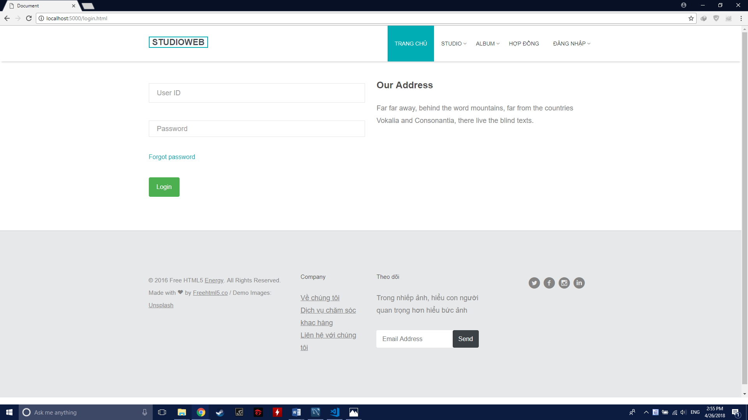

##### Class Diagram

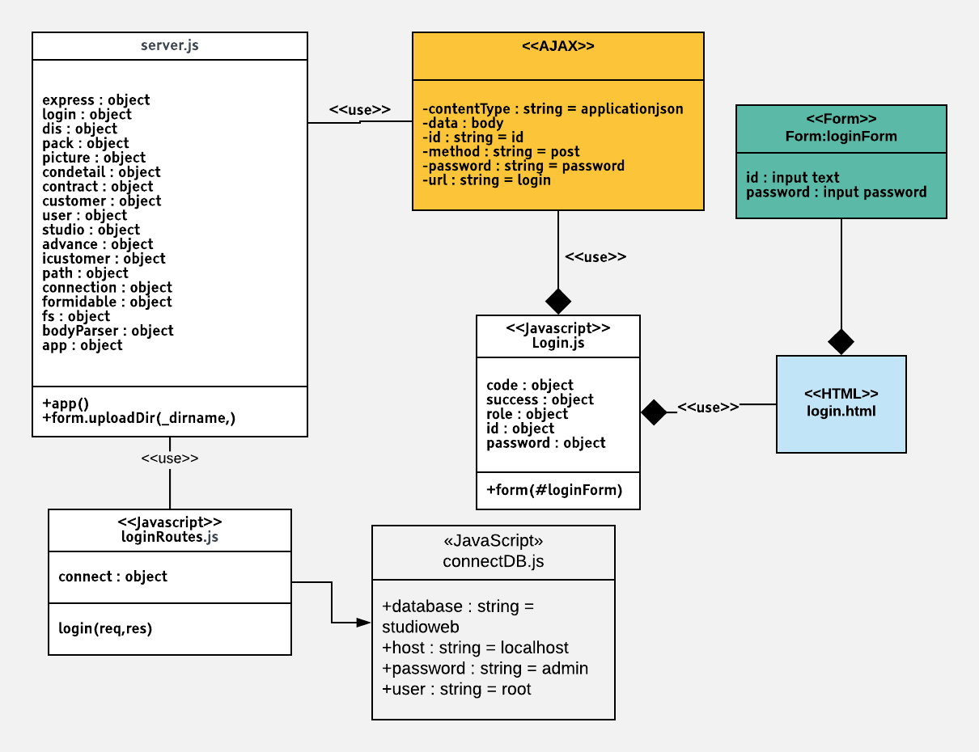

##### Class Specification

|  |  |  |  |  |
| --- | --- | --- | --- | --- |
| **Class** | loginRoutes | | | |
| **Description** | Control Admin login action | | | |
| **Base Class** | Controller | | | |
| **Source File** | loginRoutes.js | | | |
| **Namespace** | app/public/routes/ | | | |
| **Attributes** | **N/A** | | | |
| **Methods** | **Name** | **Input** | **Output** | **Description** |
| login | Request, result | View | Allow user to login into the system |

##### Sequence Diagram

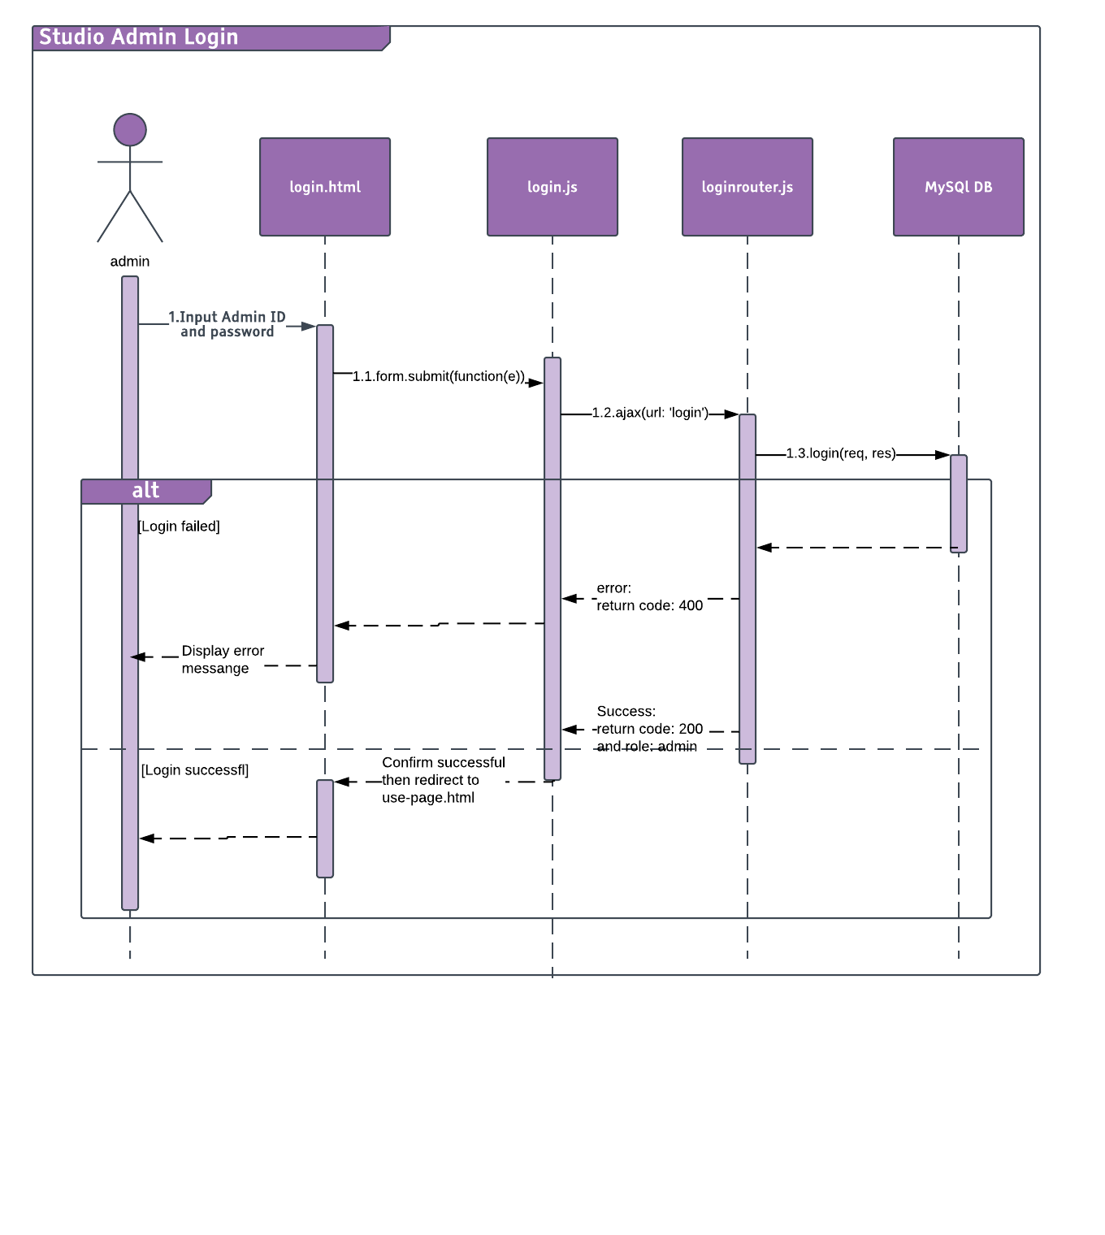

#### Logout

##### Description

Admin can Logout the system.

##### Design

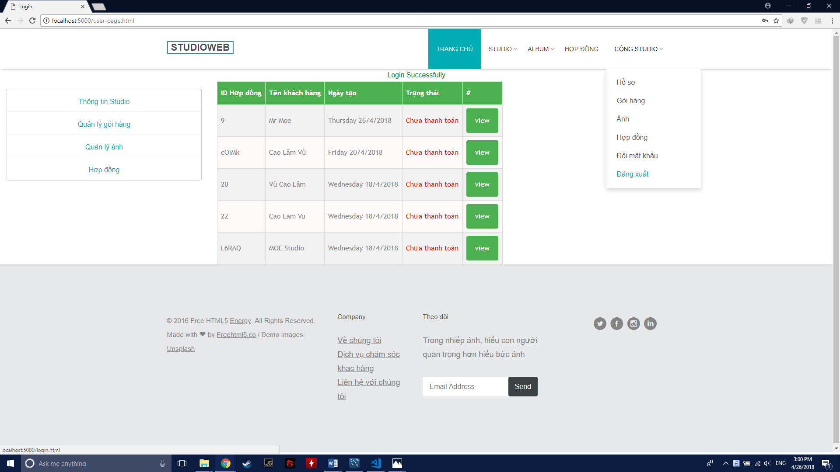

##### Class Diagram

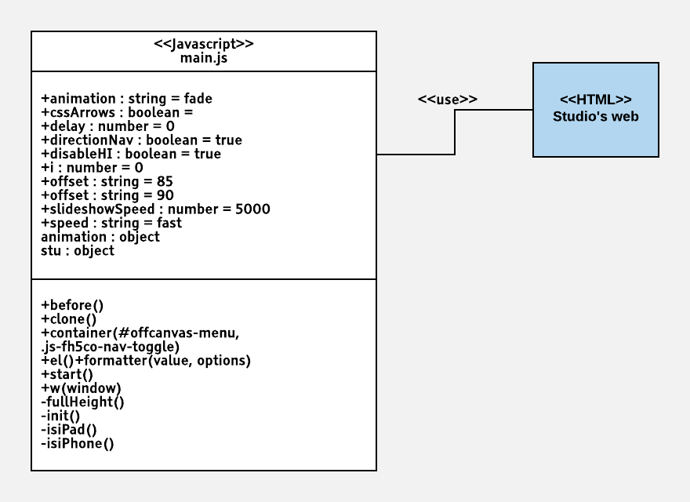

##### Class Specification

|  |  |  |  |  |
| --- | --- | --- | --- | --- |
| **Class** | main | | | |
| **Description** | Control Admin logout action | | | |
| **Base Class** | model | | | |
| **Source File** | Main.js | | | |
| **Namespace** | app/public/js/ | | | |
| **Attributes** | **N/A** | | | |
| **Methods** | **Name** | **Input** | **Output** | **Description** |
| logout | Request | View | Logout the current User |

##### Sequence Diagram

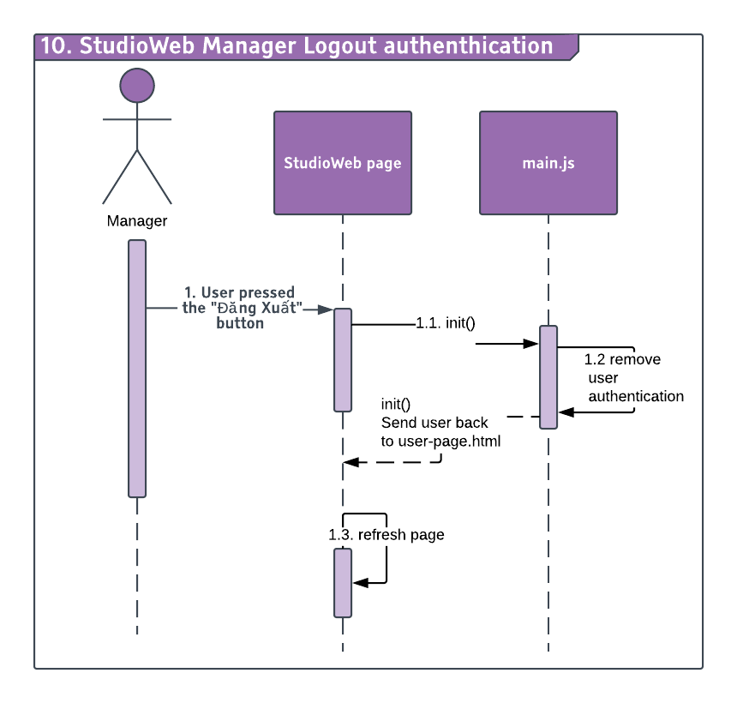

#### Change Password

##### Description

Admin can change password.

##### Design

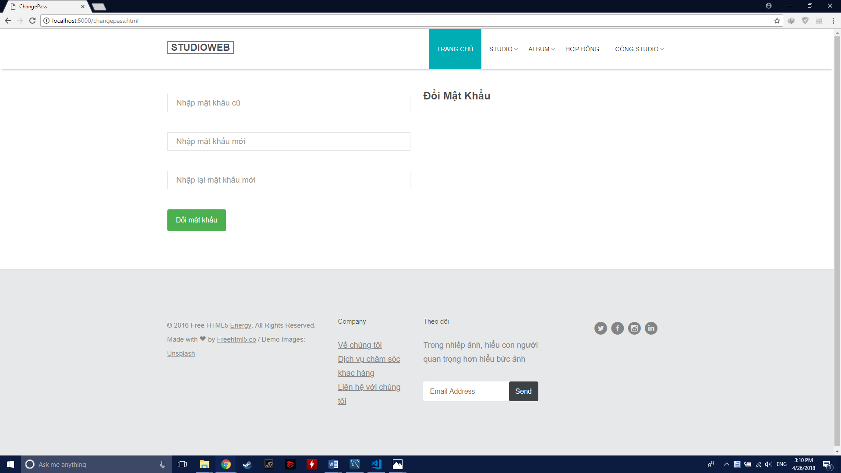

##### Class Diagram

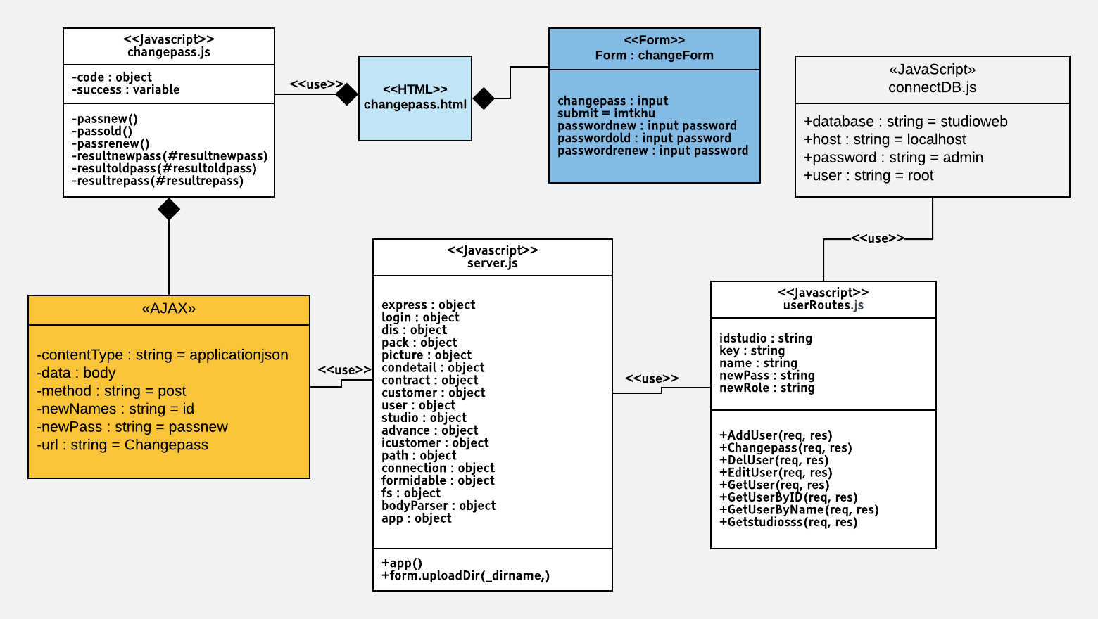

##### Class Specification

|  |  |  |  |  |
| --- | --- | --- | --- | --- |
| **Description** | Control Admin change password action | | | |
| **Base Class** | Controller | | | |
| **Source File** | userRoutes.js | | | |
| **Namespace** | app/public/routes/ | | | |
| **Attributes** | **N/A** | | | |
| **Methods** | **Name** | **Input** | **Output** | **Description** |
| changepass | Request, result | View | Change the password of the current user |

##### Sequence Diagram

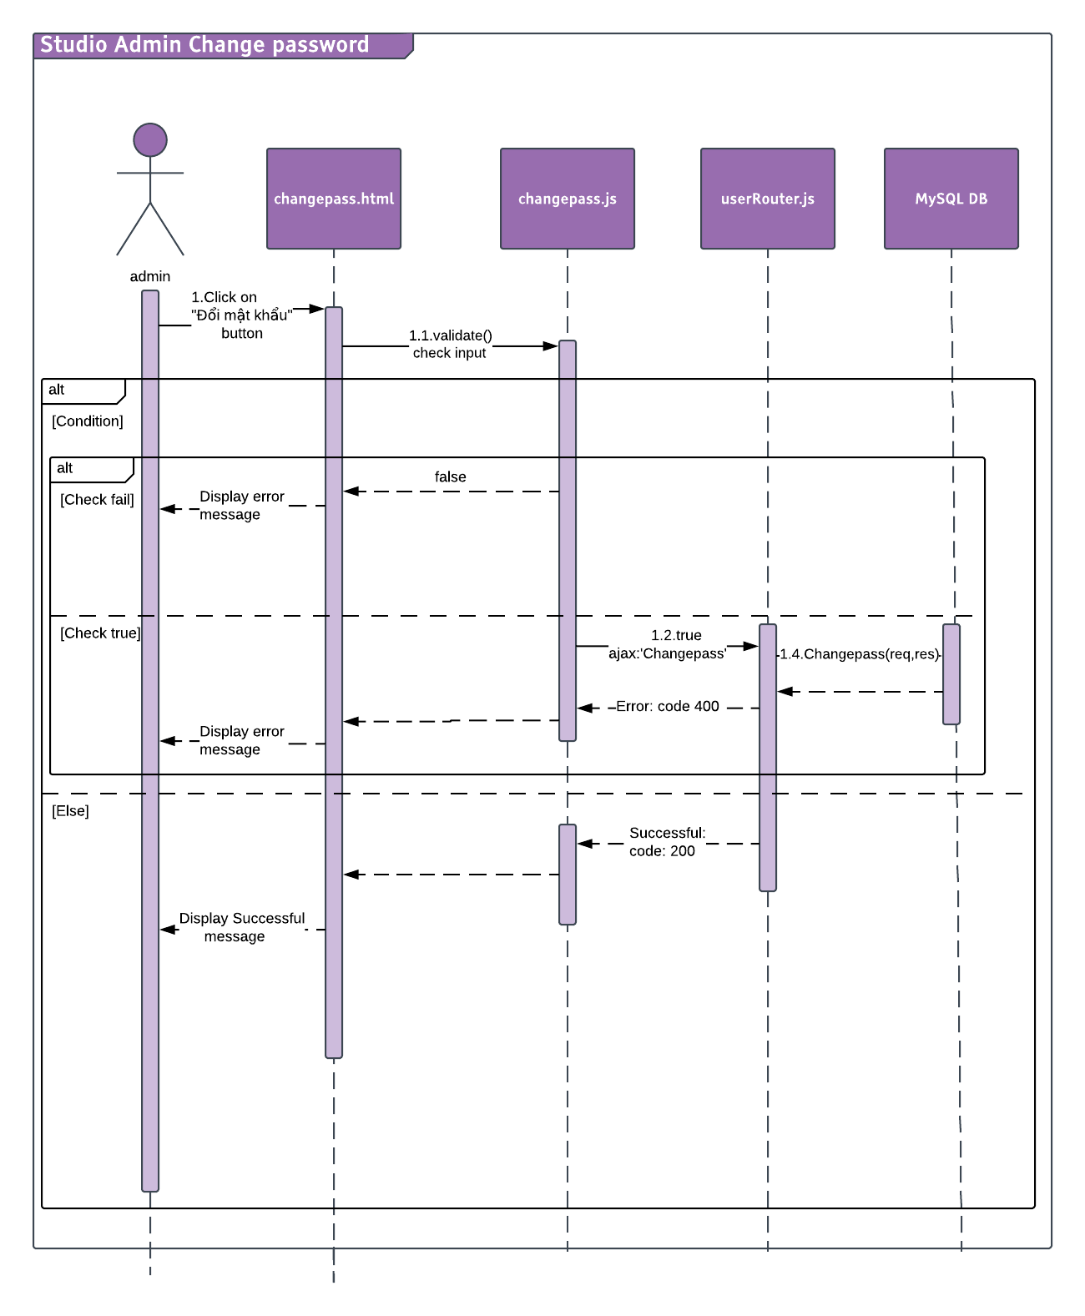

#### Forgot Password

##### Description

Admin can change password if fogot old password.

##### Design

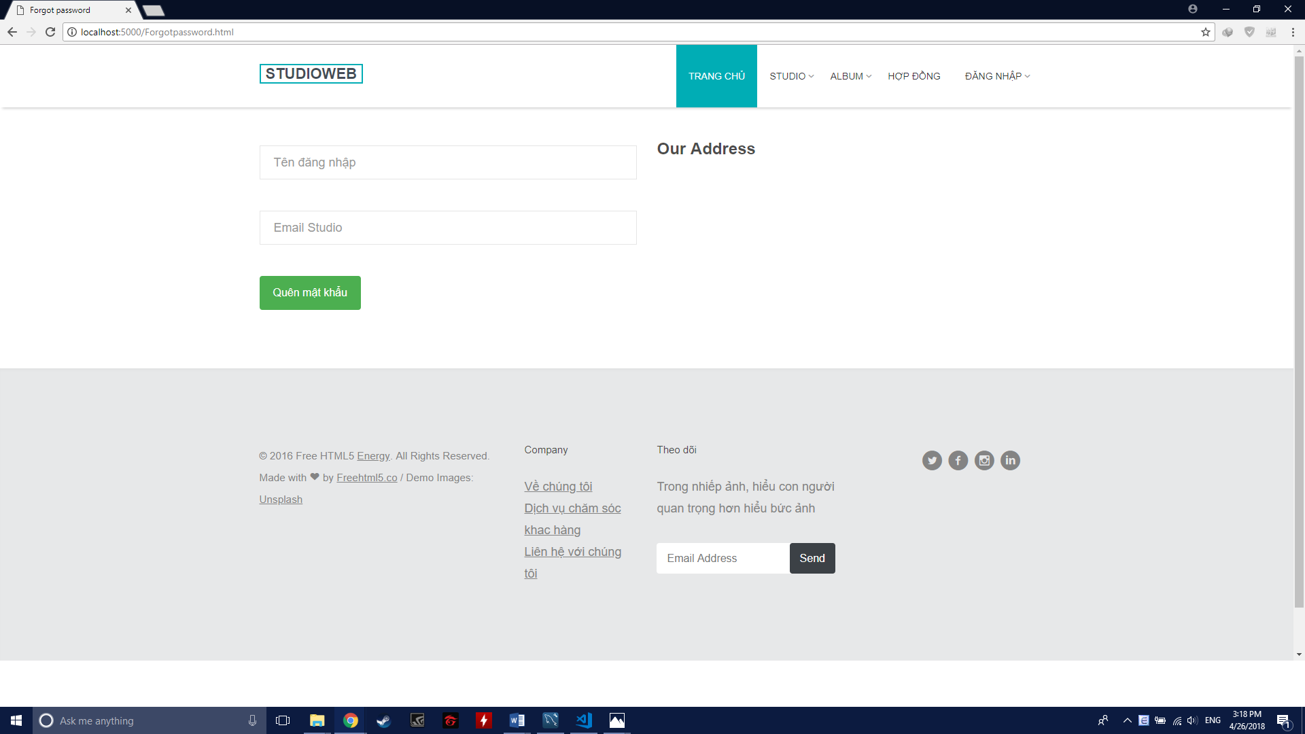

##### Class Diagram

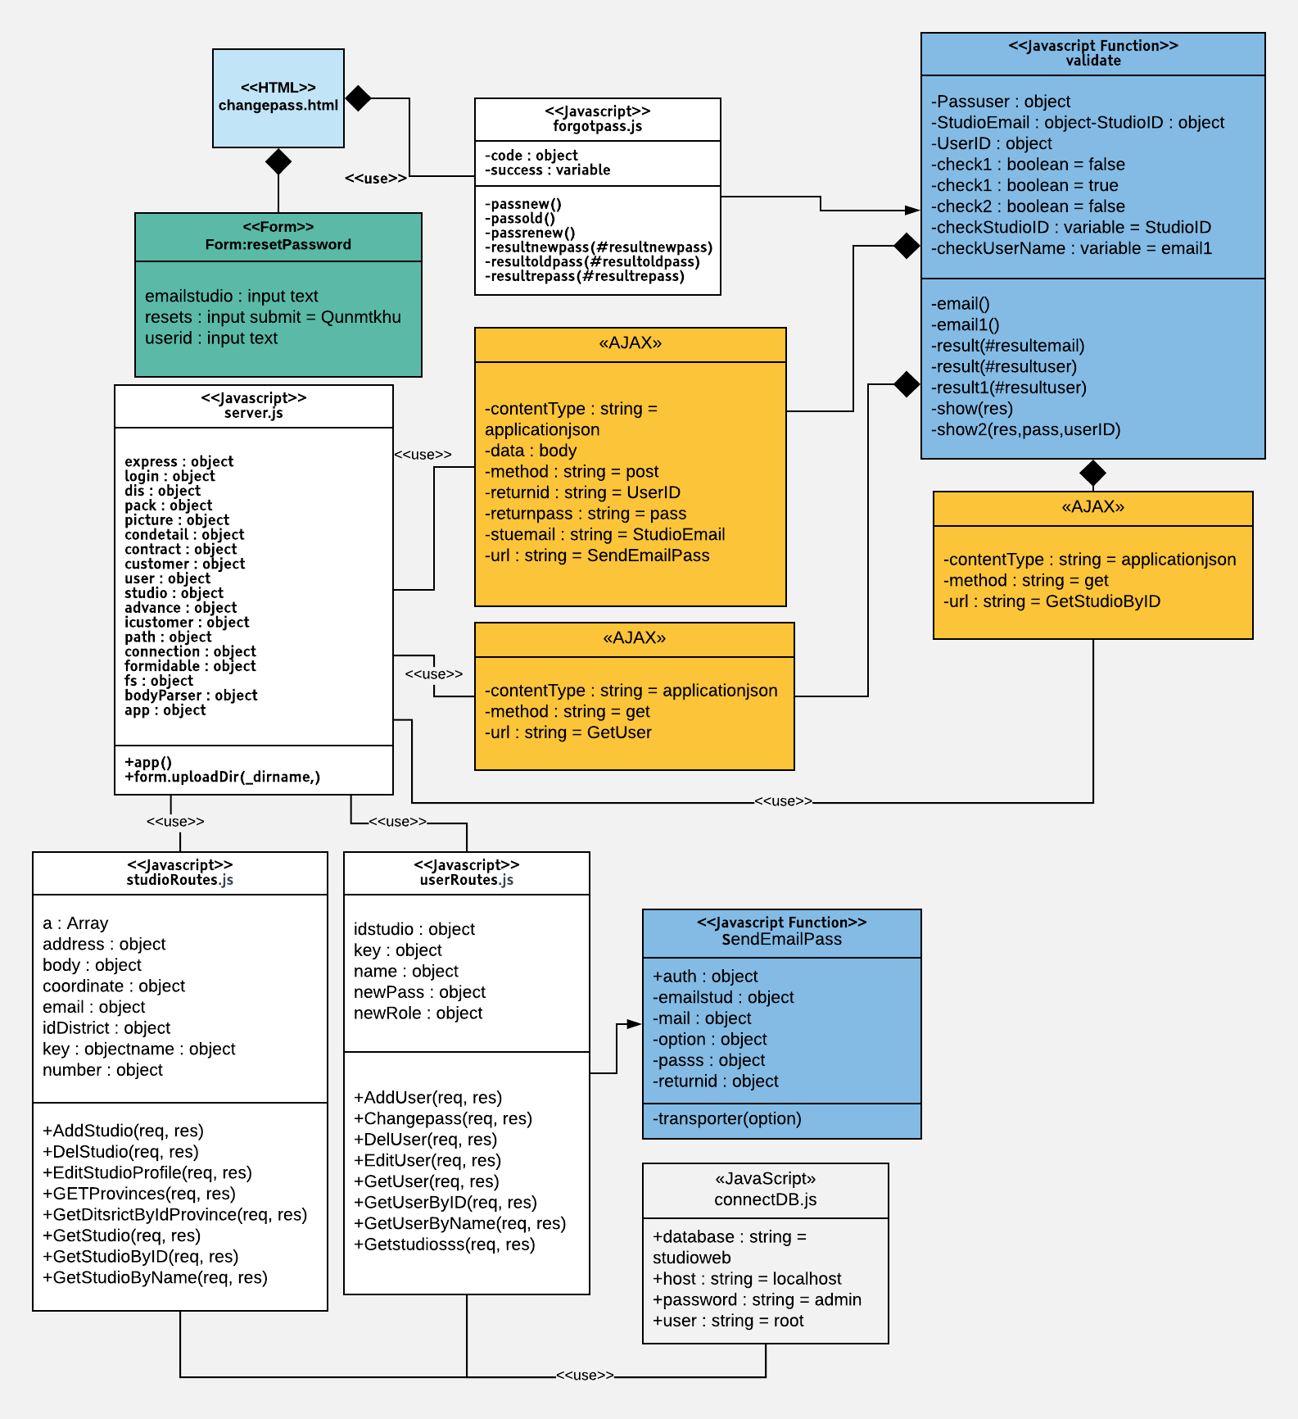

##### Class Specification

|  |  |  |  |  |
| --- | --- | --- | --- | --- |
| **Description** | Control Admin forgot password action | | | |
| **Base Class** | Controller | | | |
| **Source File** | userRoutes.js | | | |
| **Namespace** | app/public/routes/ | | | |
| **Attributes** | **N/A** | | | |
| **Methods** | **Name** | **Input** | **Output** | **Description** |
| SendEmailPass | Request, result | View | Change the password of the current user |
|  | GetUser | Request, result | View | Get user |

|  |  |  |  |  |
| --- | --- | --- | --- | --- |
| **Description** | Specify which Studio does user belong to | | | |
| **Base Class** | Controller | | | |
| **Source File** | studioRoutes.js | | | |
| **Namespace** | app/public/routes/ | | | |
| **Attributes** | **N/A** | | | |
| **Methods** | **Name** | **Input** | **Output** | **Description** |
| GetStudioByID | Request, result | View | Get studio by User ID |

##### Sequence Diagram

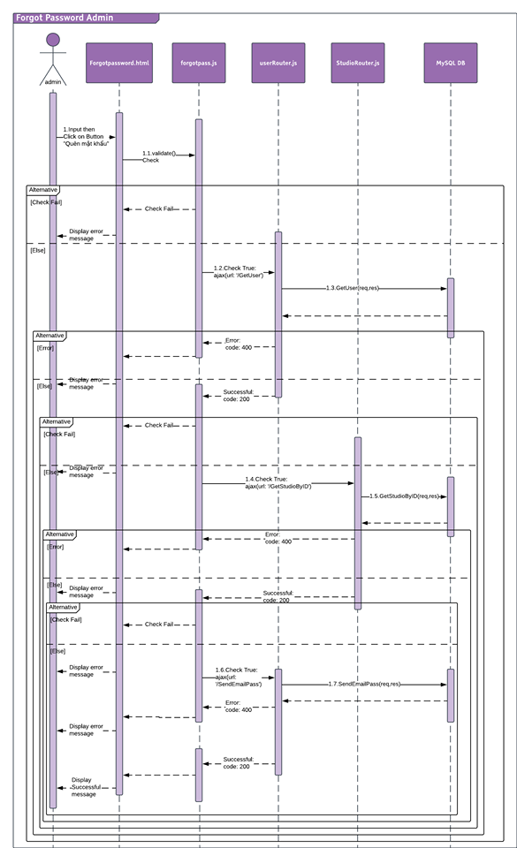

#### Search & View Province/District

##### Description

Admin can search and view province, district information.

##### Design

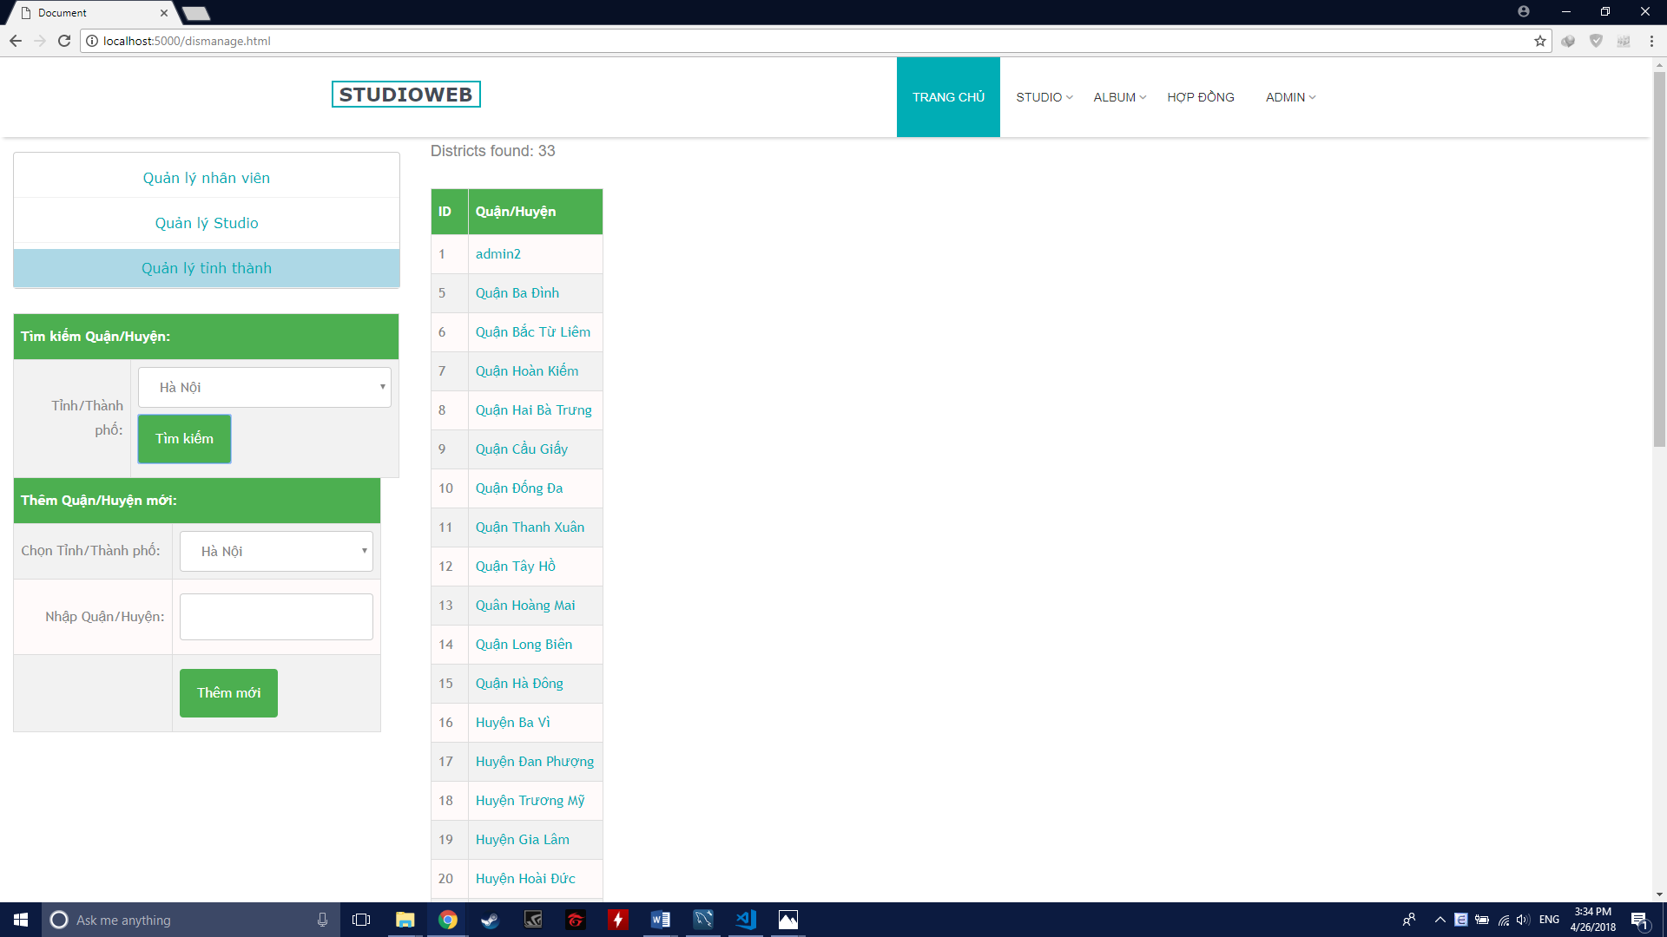

##### Class Diagram

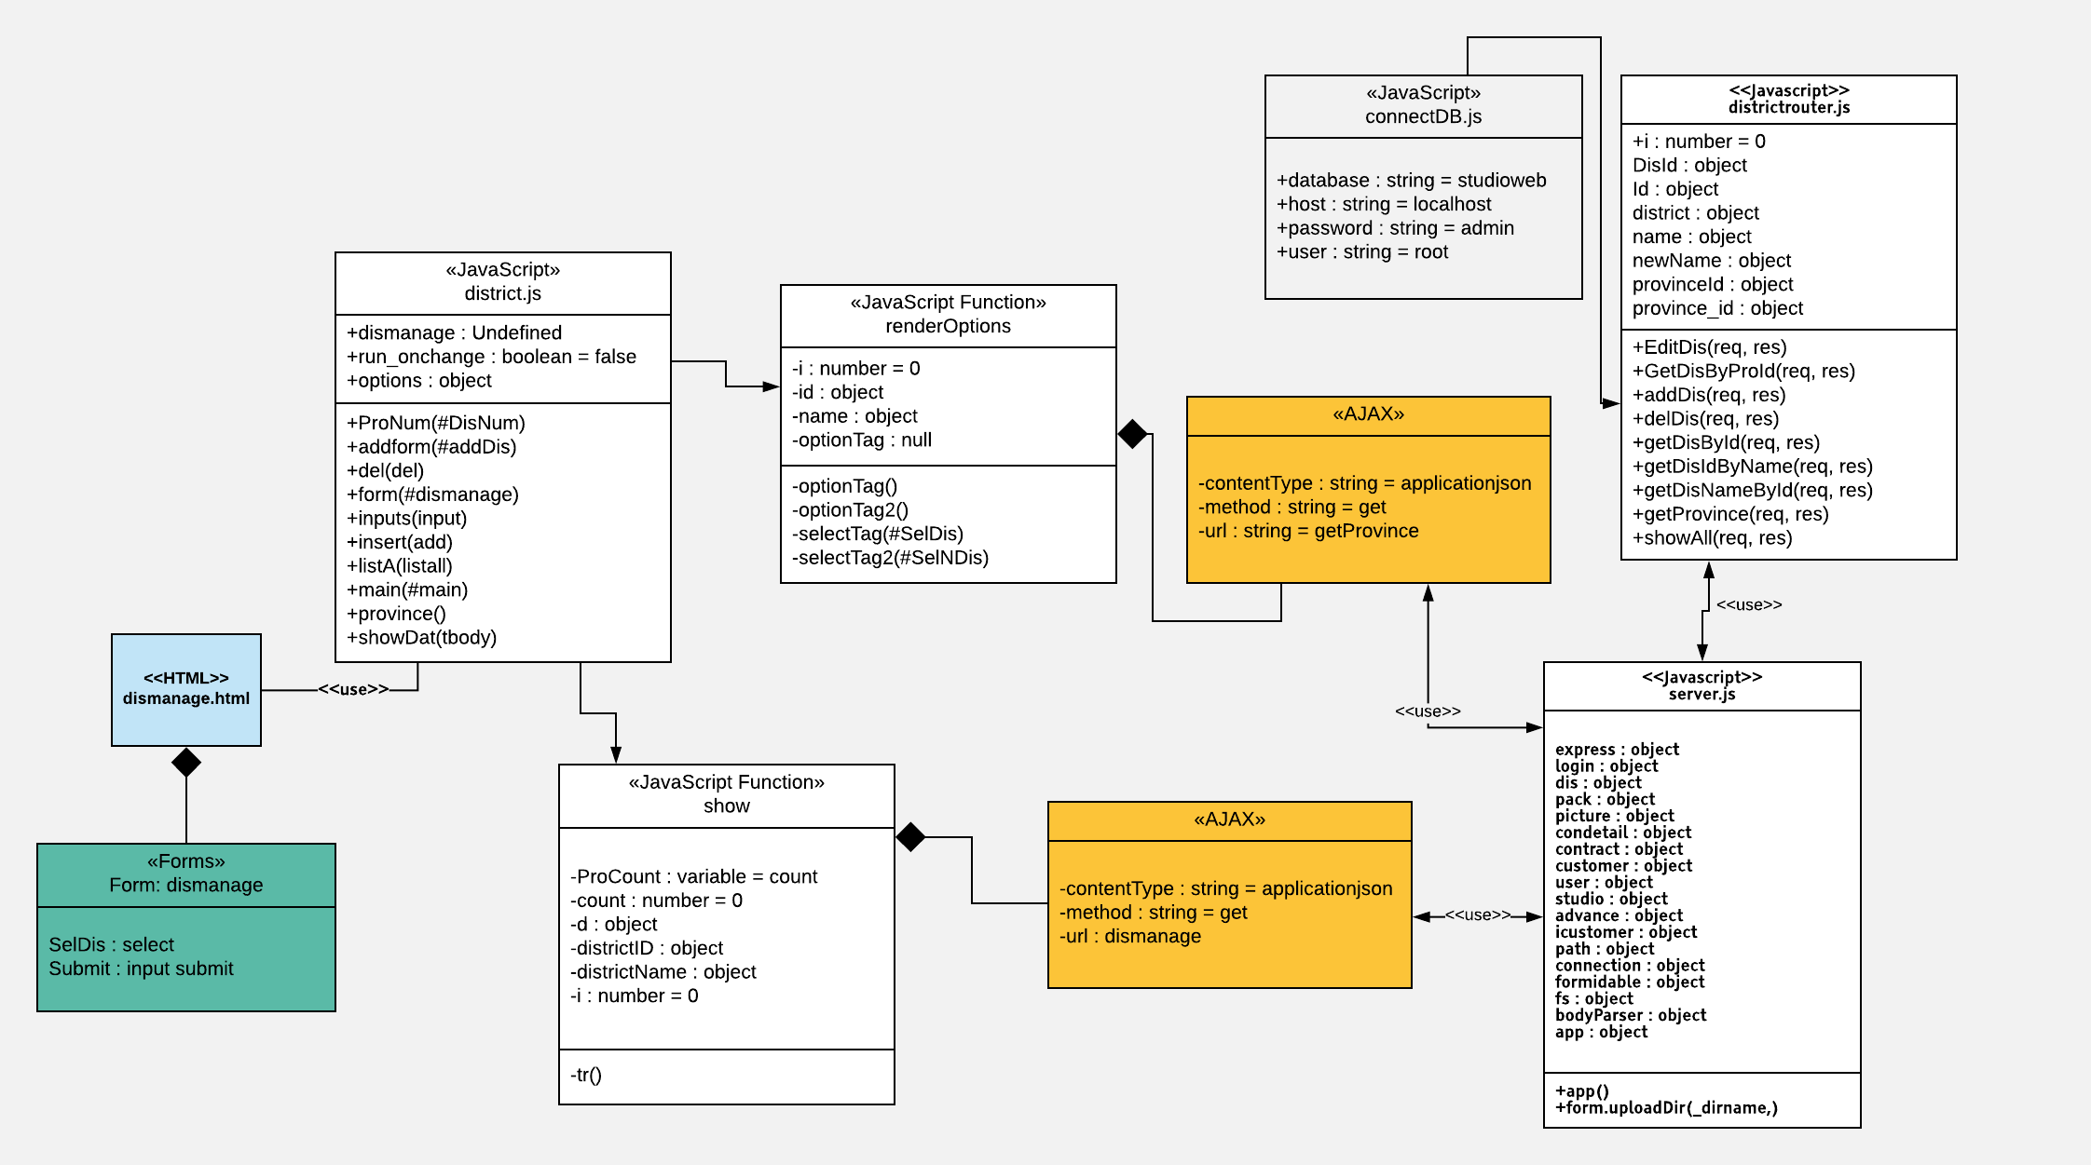

##### Class Specification

|  |  |  |  |  |
| --- | --- | --- | --- | --- |
| **Description** | Specify which Studio does user belong to | | | |
| **Base Class** | Controller | | | |
| **Source File** | districtRoutes.js | | | |
| **Namespace** | app/public/routes/ | | | |
| **Attributes** | **N/A** | | | |
| **Methods** | **Name** | **Input** | **Output** | **Description** |
| GetProvince | Request, result | View | Get province to bind to combobox |
|  | Dismanage | Request, result | View | Search and display district |

##### Sequence Diagram

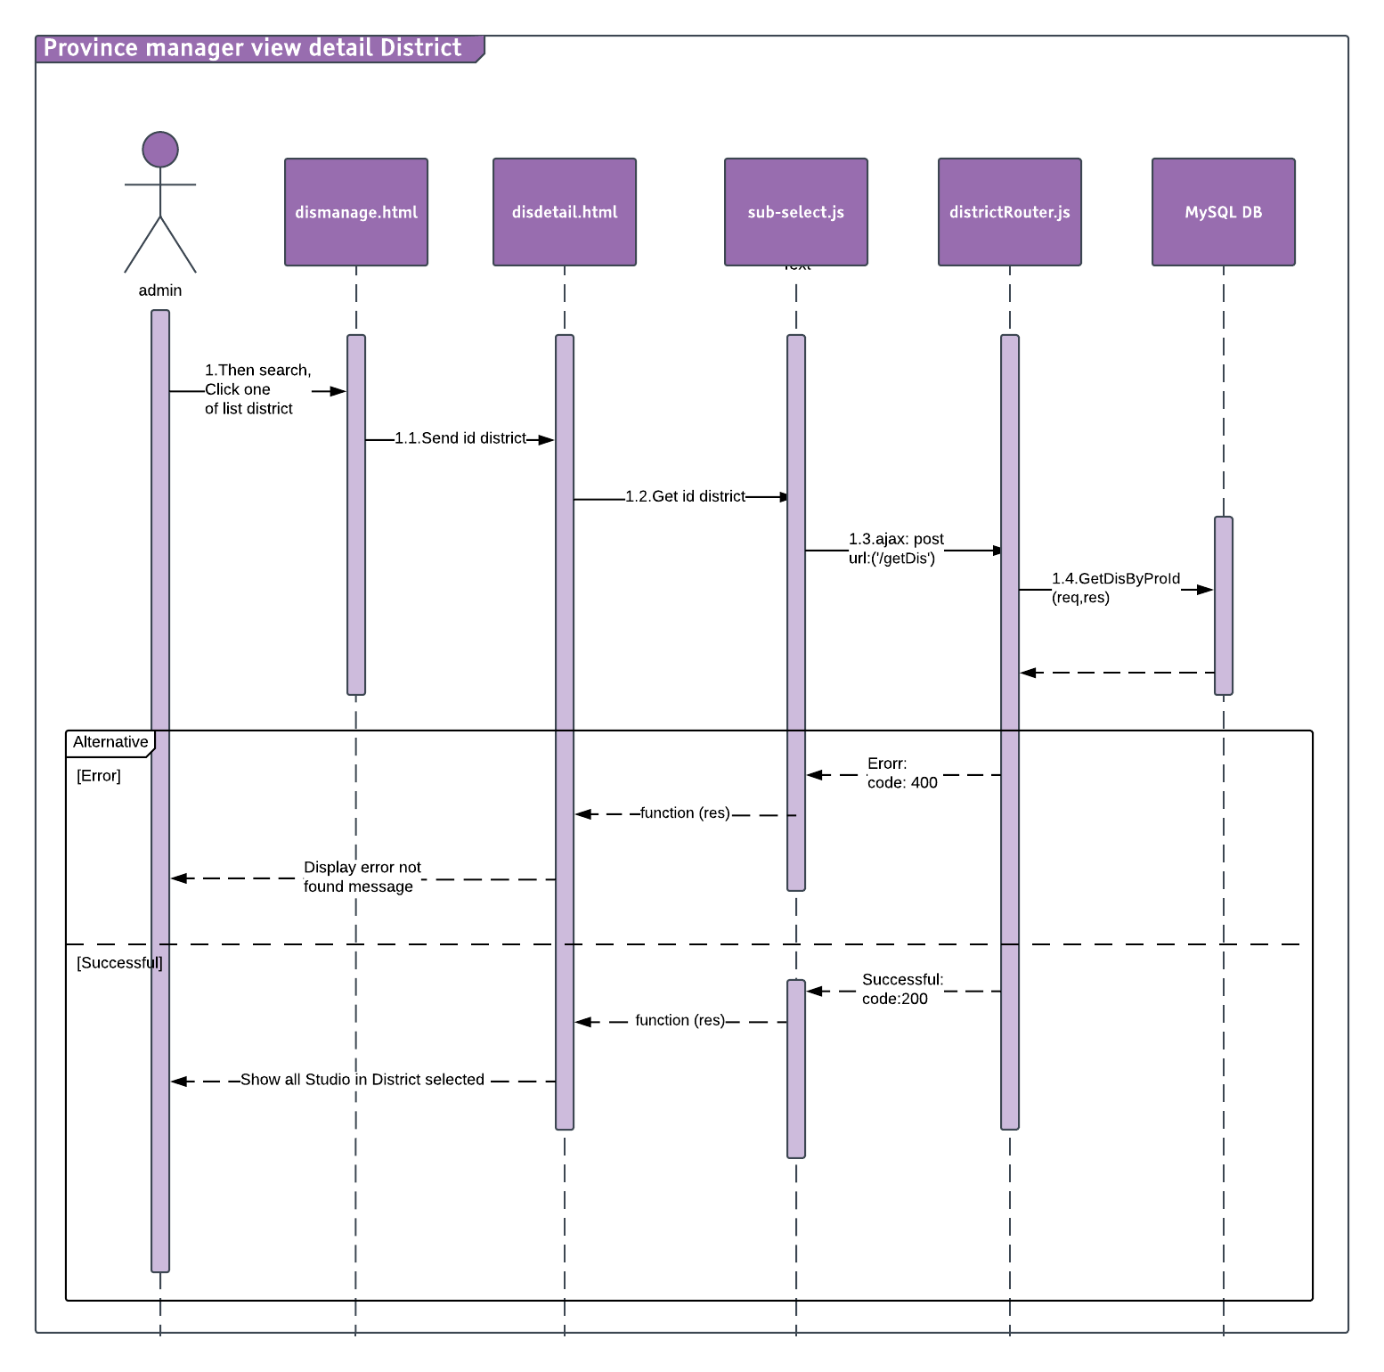

#### Add Province/District

##### Description

Admin can add more Province/District.

##### Design

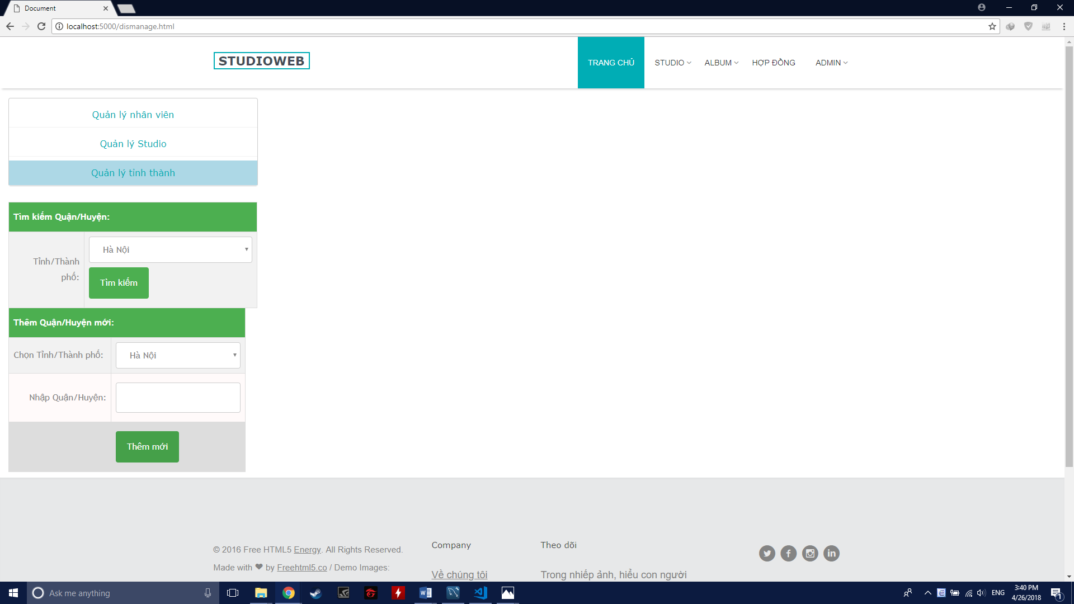

##### Class Diagram

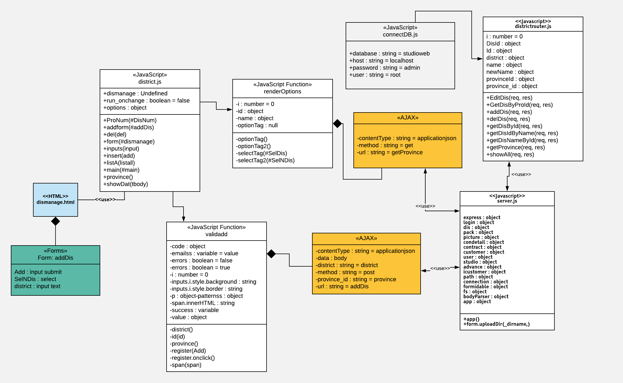

##### Class Specification

|  |  |  |  |  |
| --- | --- | --- | --- | --- |
| **Description** | Specify which Studio does user belong to | | | |
| **Base Class** | Controller | | | |
| **Source File** | districtRoutes.js | | | |
| **Namespace** | app/public/routes/ | | | |
| **Attributes** | **N/A** | | | |
| **Methods** | **Name** | **Input** | **Output** | **Description** |
| GetProvince | Request, result | View | Get province to bind to combobox |
|  | AddDis | Request, result | View | Add new district |

##### Sequence Diagram

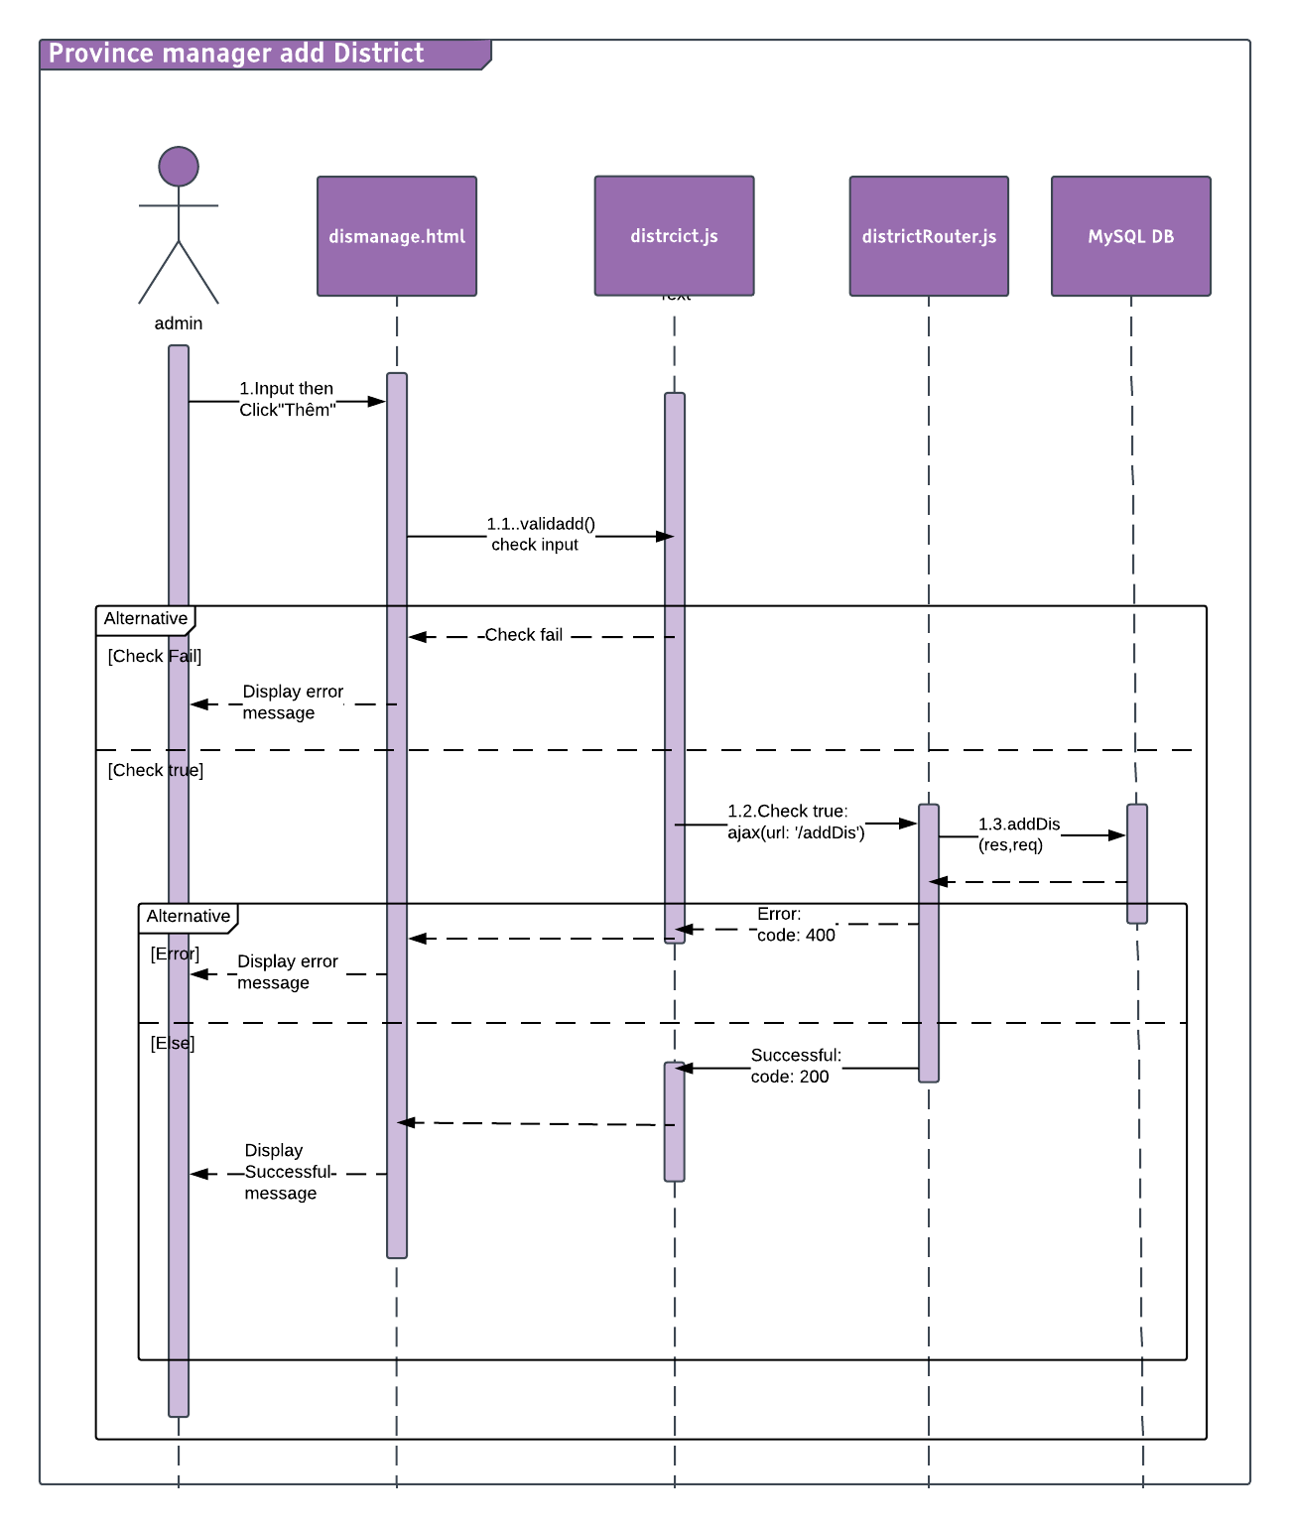

#### Edit Province/District

##### Description

Addmin can edit Province/District information.

##### Design

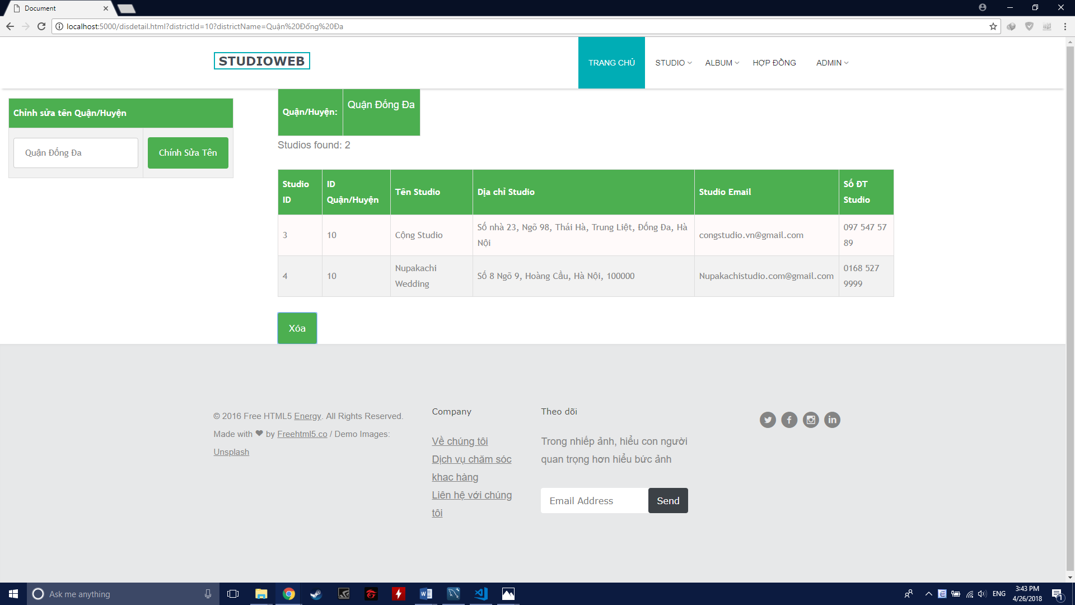

##### Class Diagram

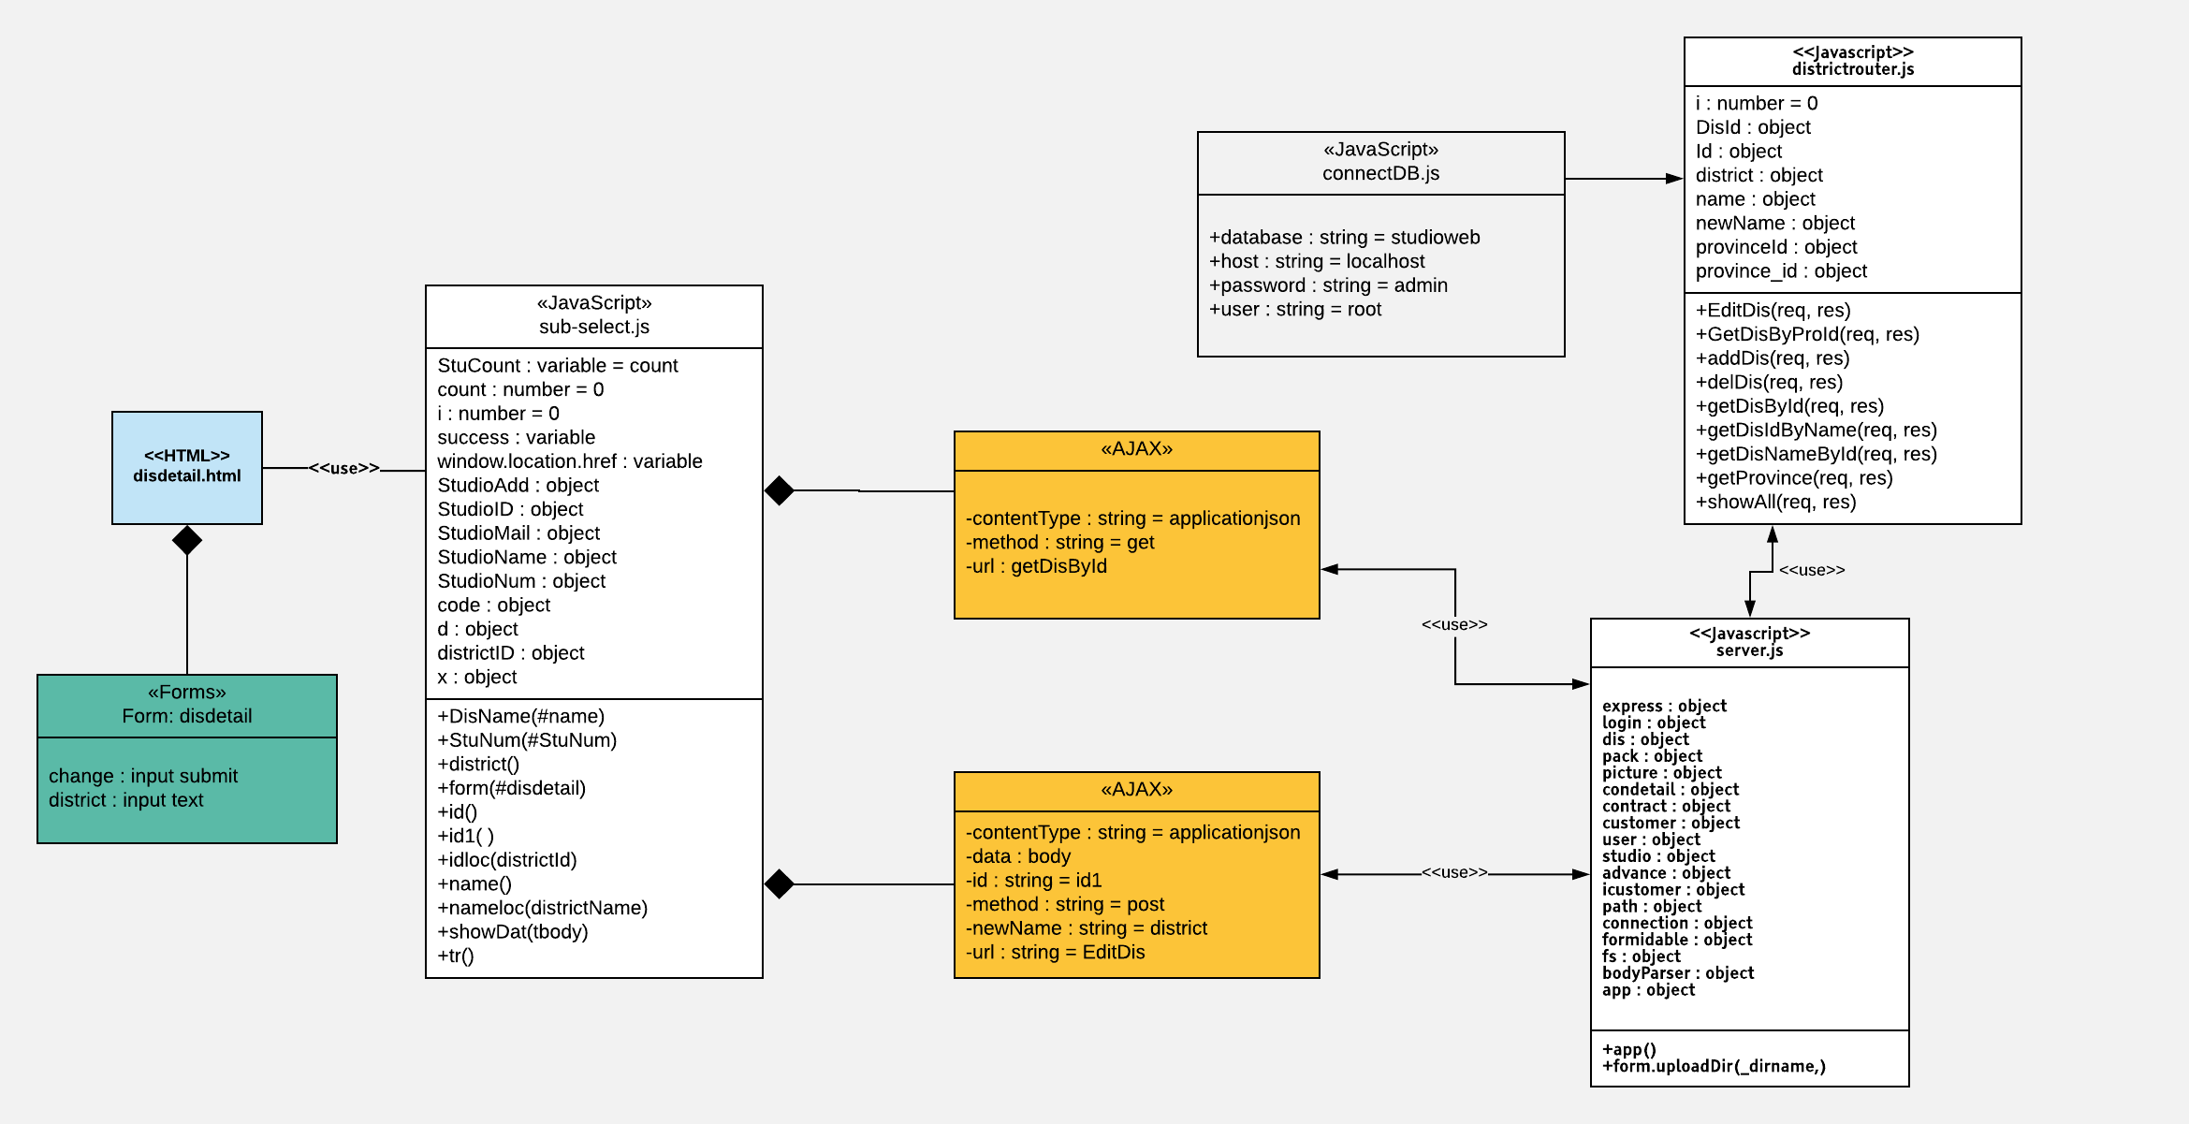

##### Class Specification

|  |  |  |  |  |
| --- | --- | --- | --- | --- |
| **Description** | Specify which Studio does user belong to | | | |
| **Base Class** | Controller | | | |
| **Source File** | districtRoutes.js | | | |
| **Namespace** | app/public/routes/ | | | |
| **Attributes** | **N/A** | | | |
| **Methods** | **Name** | **Input** | **Output** | **Description** |
| GetProvince | Request, result | View | Get province to bind to combobox |
|  | EditDis | Request, result | View | Edit one district |

##### Sequence Diagram

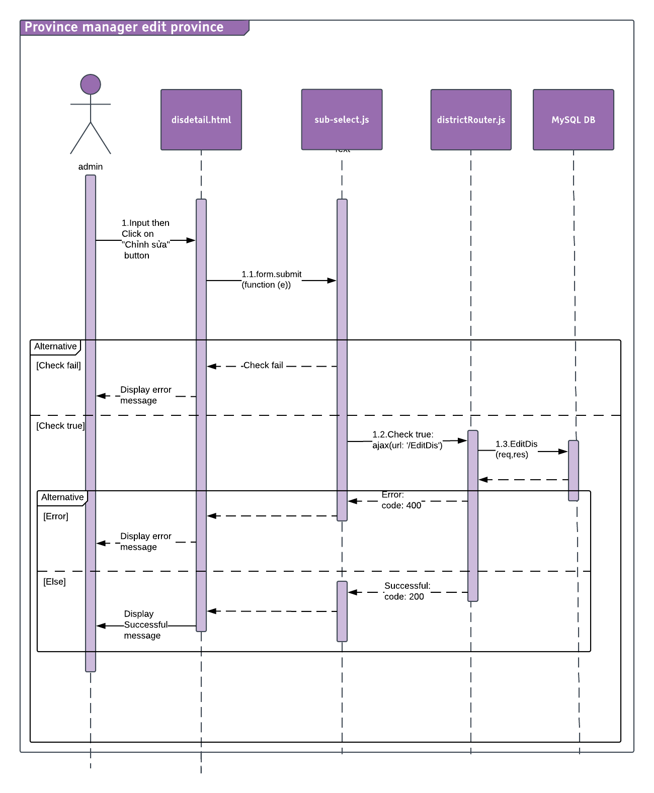

#### Delete Province/District

##### Description

Admin can delete Province/District.

##### Design

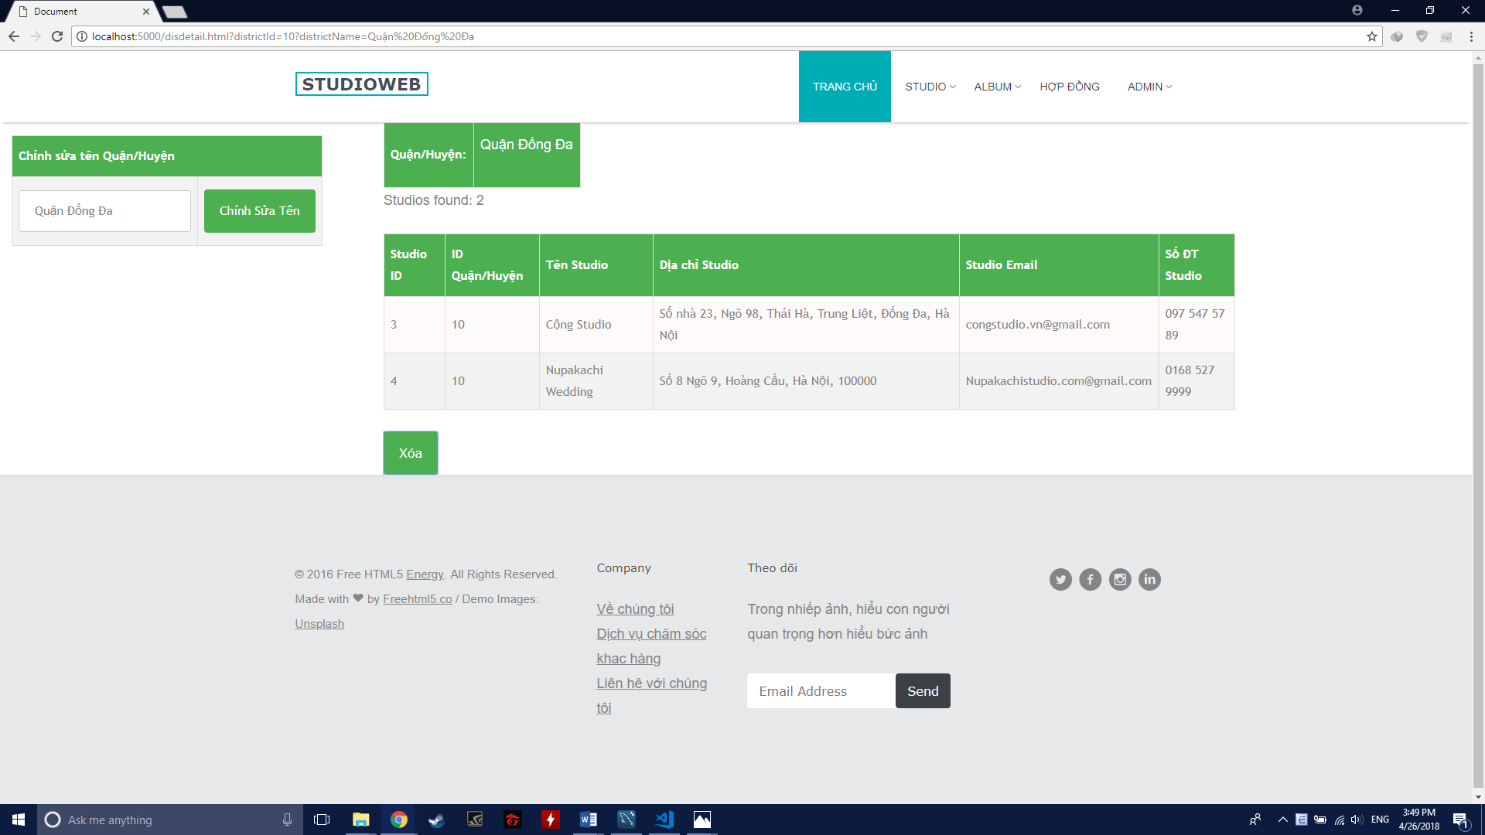

##### Class Diagram

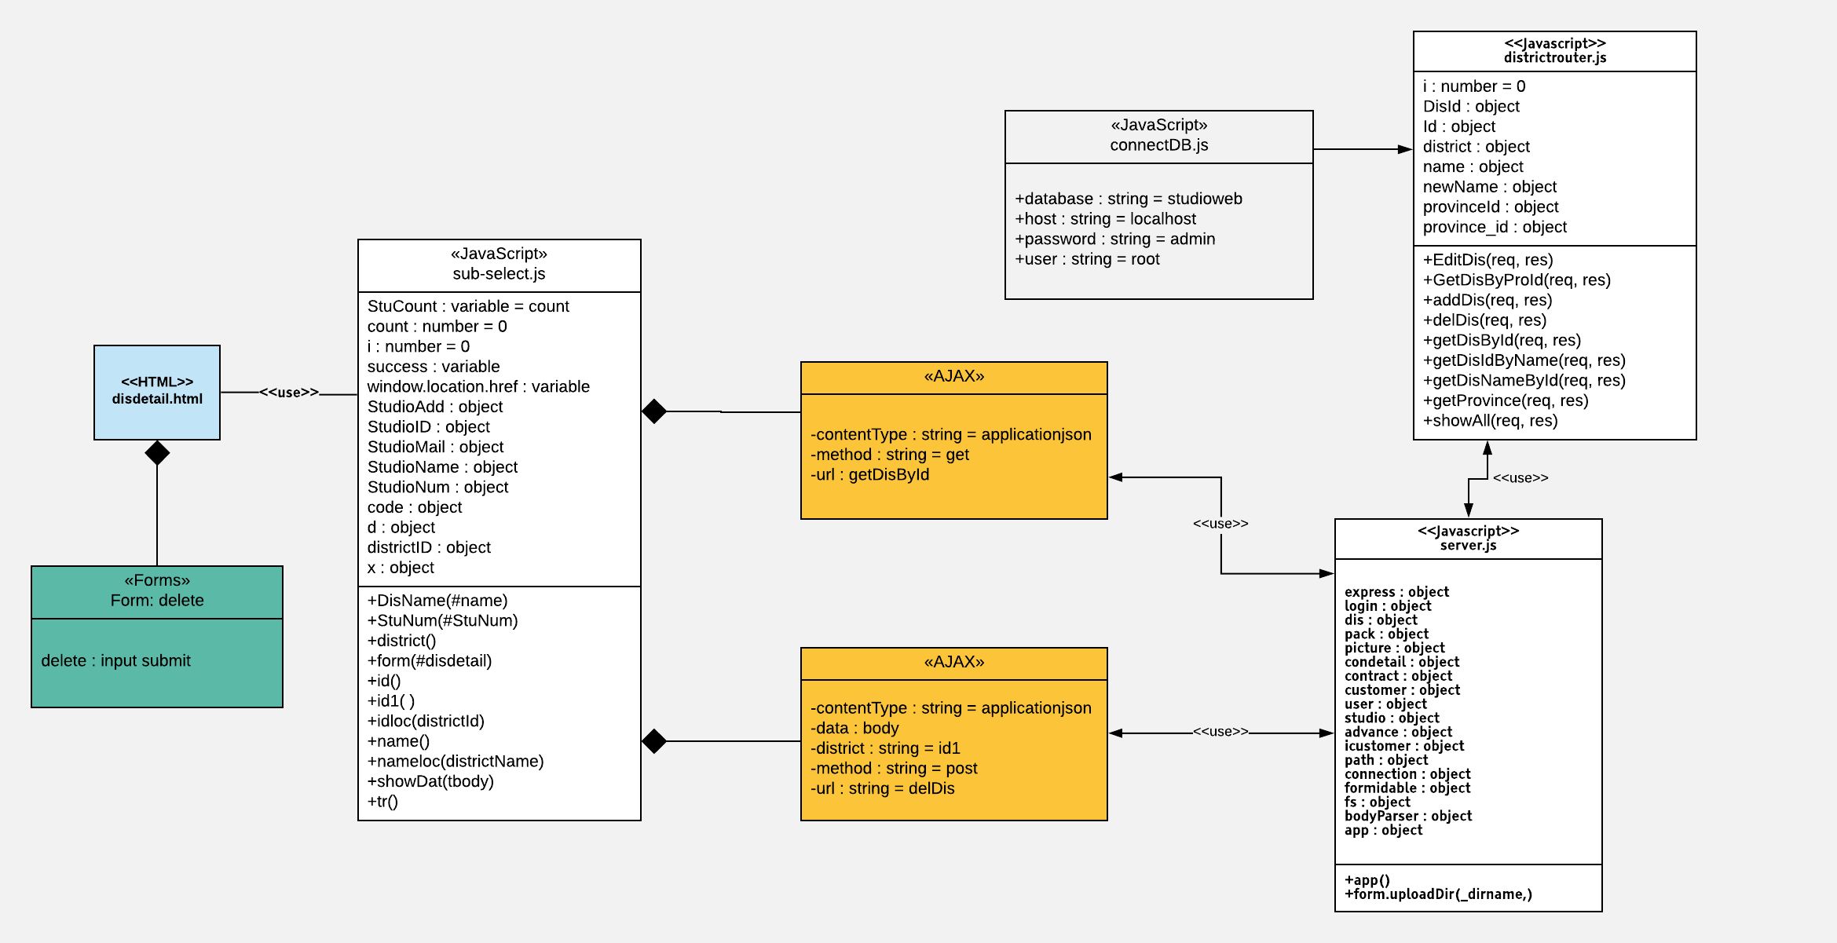

##### Class Specification

|  |  |  |  |  |
| --- | --- | --- | --- | --- |
| **Description** | Specify which Studio does user belong to | | | |
| **Base Class** | Controller | | | |
| **Source File** | districtRoutes.js | | | |
| **Namespace** | app/public/routes/ | | | |
| **Attributes** | **N/A** | | | |
| **Methods** | **Name** | **Input** | **Output** | **Description** |
| GetDisById | Request, result | View | Get district info by distirct ID |
|  | delDis | Request, result | View | Delete one district |

##### Sequence Diagram

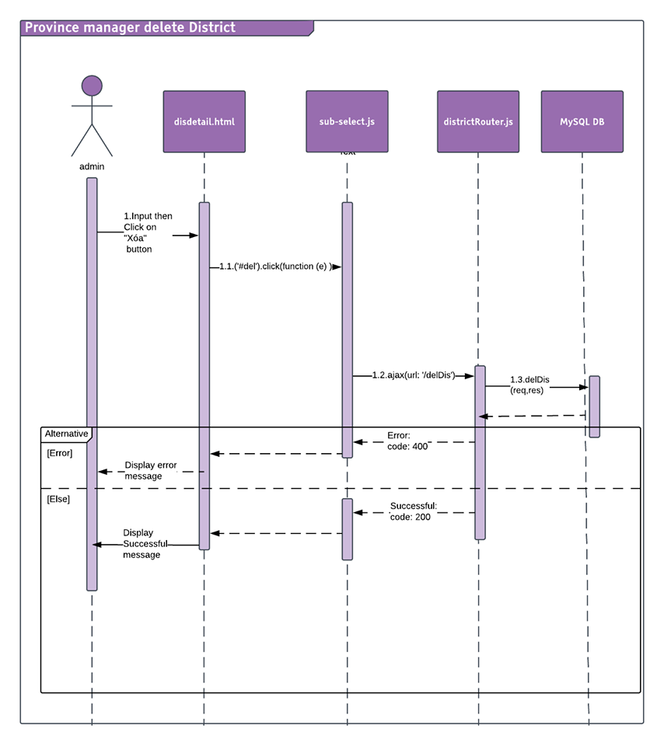

#### Search & view Studio

##### Description

Admin can search and view studio information.

##### Design

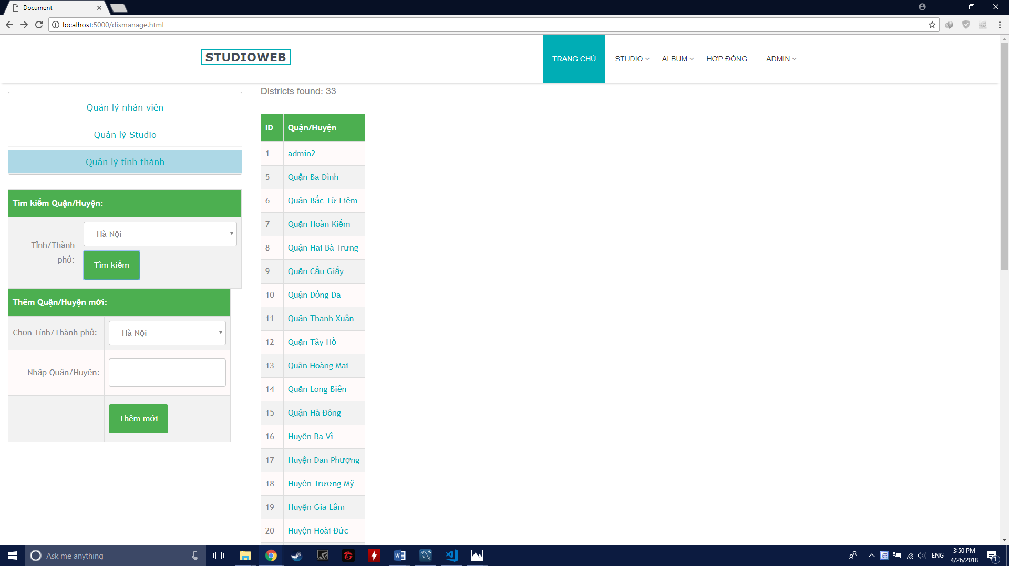

##### Class Diagram

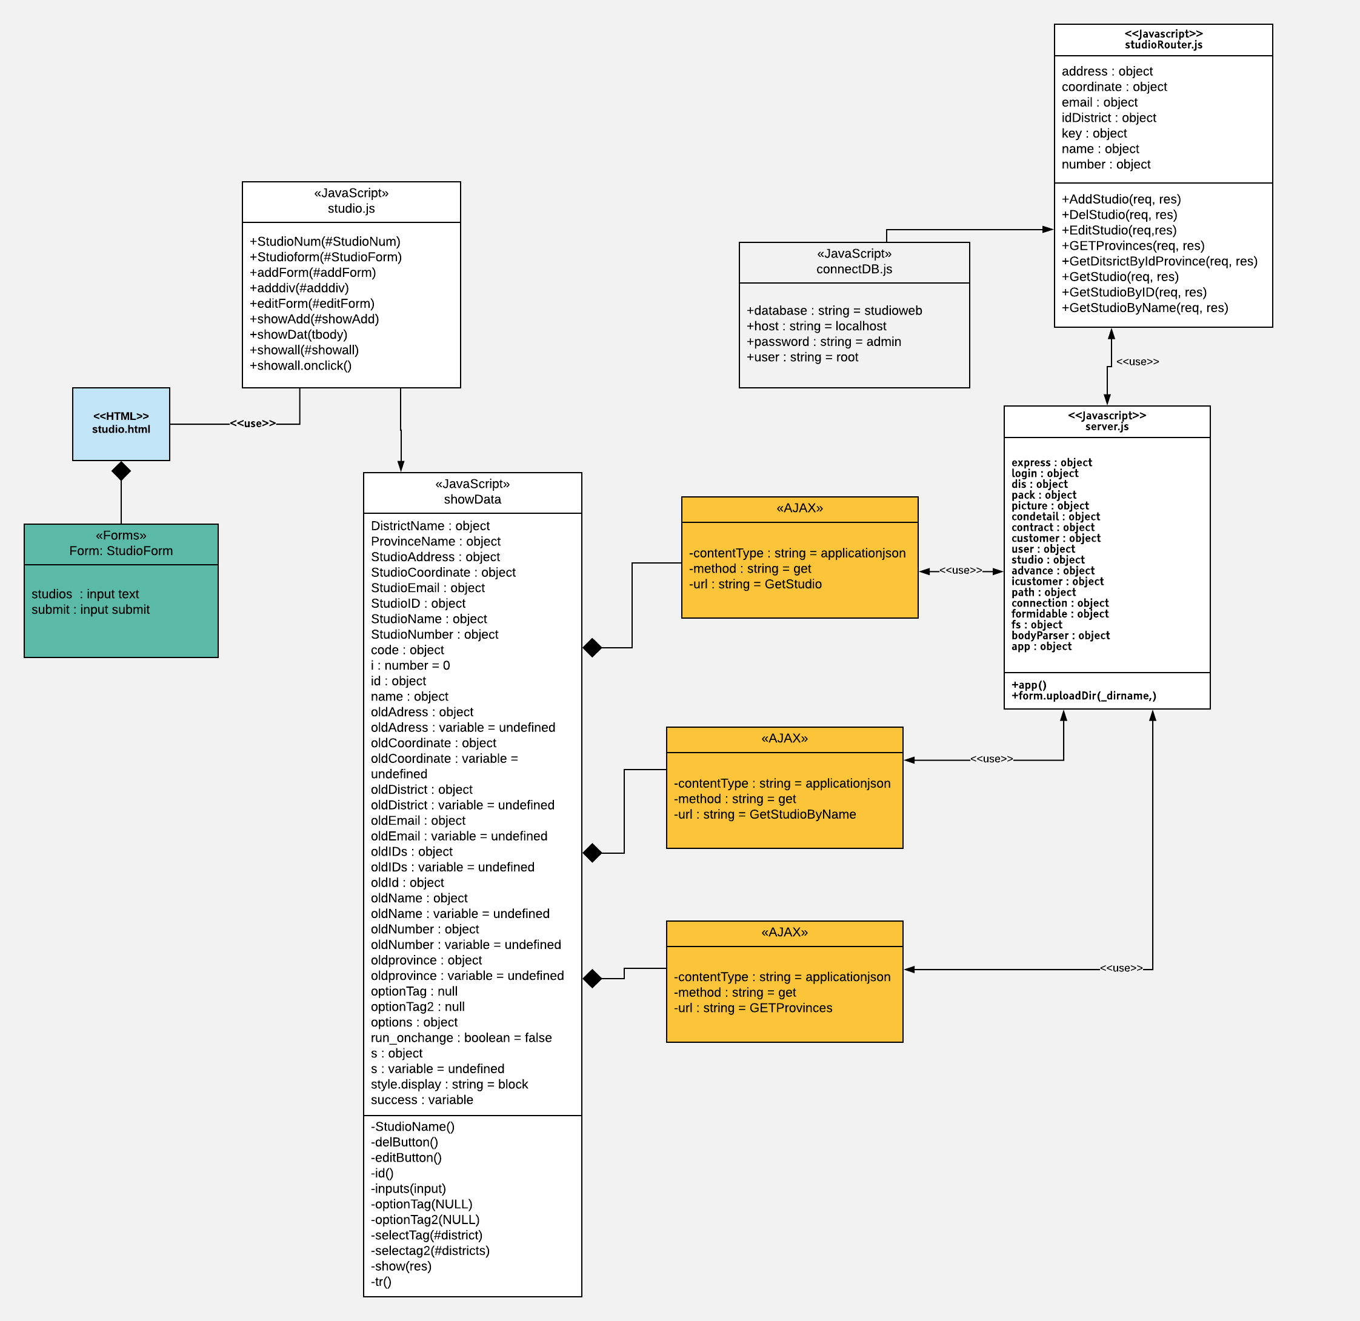

##### Class Specification

|  |  |  |  |  |
| --- | --- | --- | --- | --- |
| **Description** | Get Studio information | | | |
| **Base Class** | Controller | | | |
| **Source File** | studioRoutes.js | | | |
| **Namespace** | app/public/routes/ | | | |
| **Attributes** | **N/A** | | | |
| **Methods** | **Name** | **Input** | **Output** | **Description** |
| GetStudio | Request, result | View | Get all Studio info to bind combobox |
|  | GetStudioByName | Request, result | View | Search Studio info by studio name |

|  |  |  |  |  |
| --- | --- | --- | --- | --- |
| **Description** | Specify which Studio does user belong to | | | |
| **Base Class** | Controller | | | |
| **Source File** | districtRoutes.js | | | |
| **Namespace** | app/public/routes/ | | | |
| **Attributes** | **N/A** | | | |
| **Methods** | **Name** | **Input** | **Output** | **Description** |
| GetProvince | Request, result | View | Get province to bind to combobox |

##### Sequence Diagram

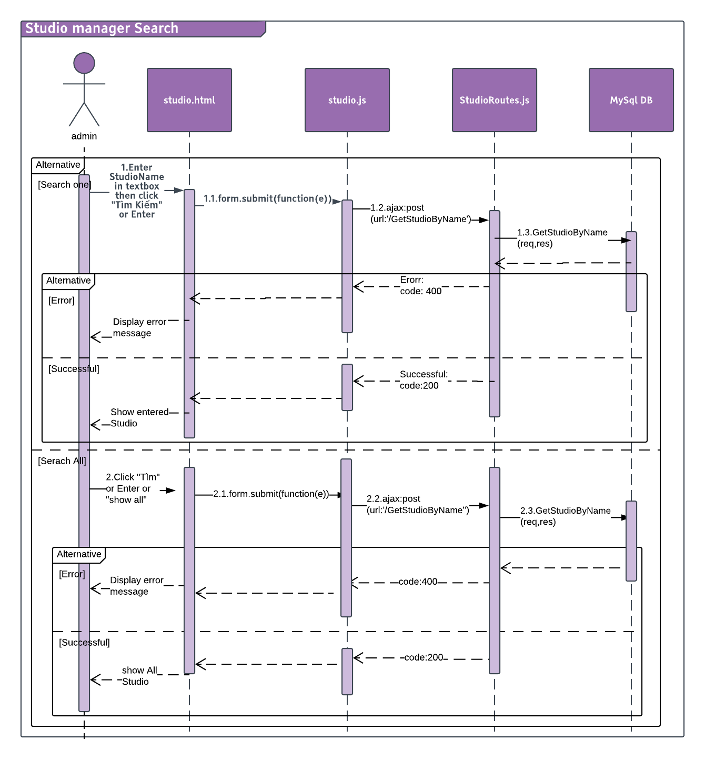

#### Add Studio

##### Description

Admin can add more Studio.

##### Design

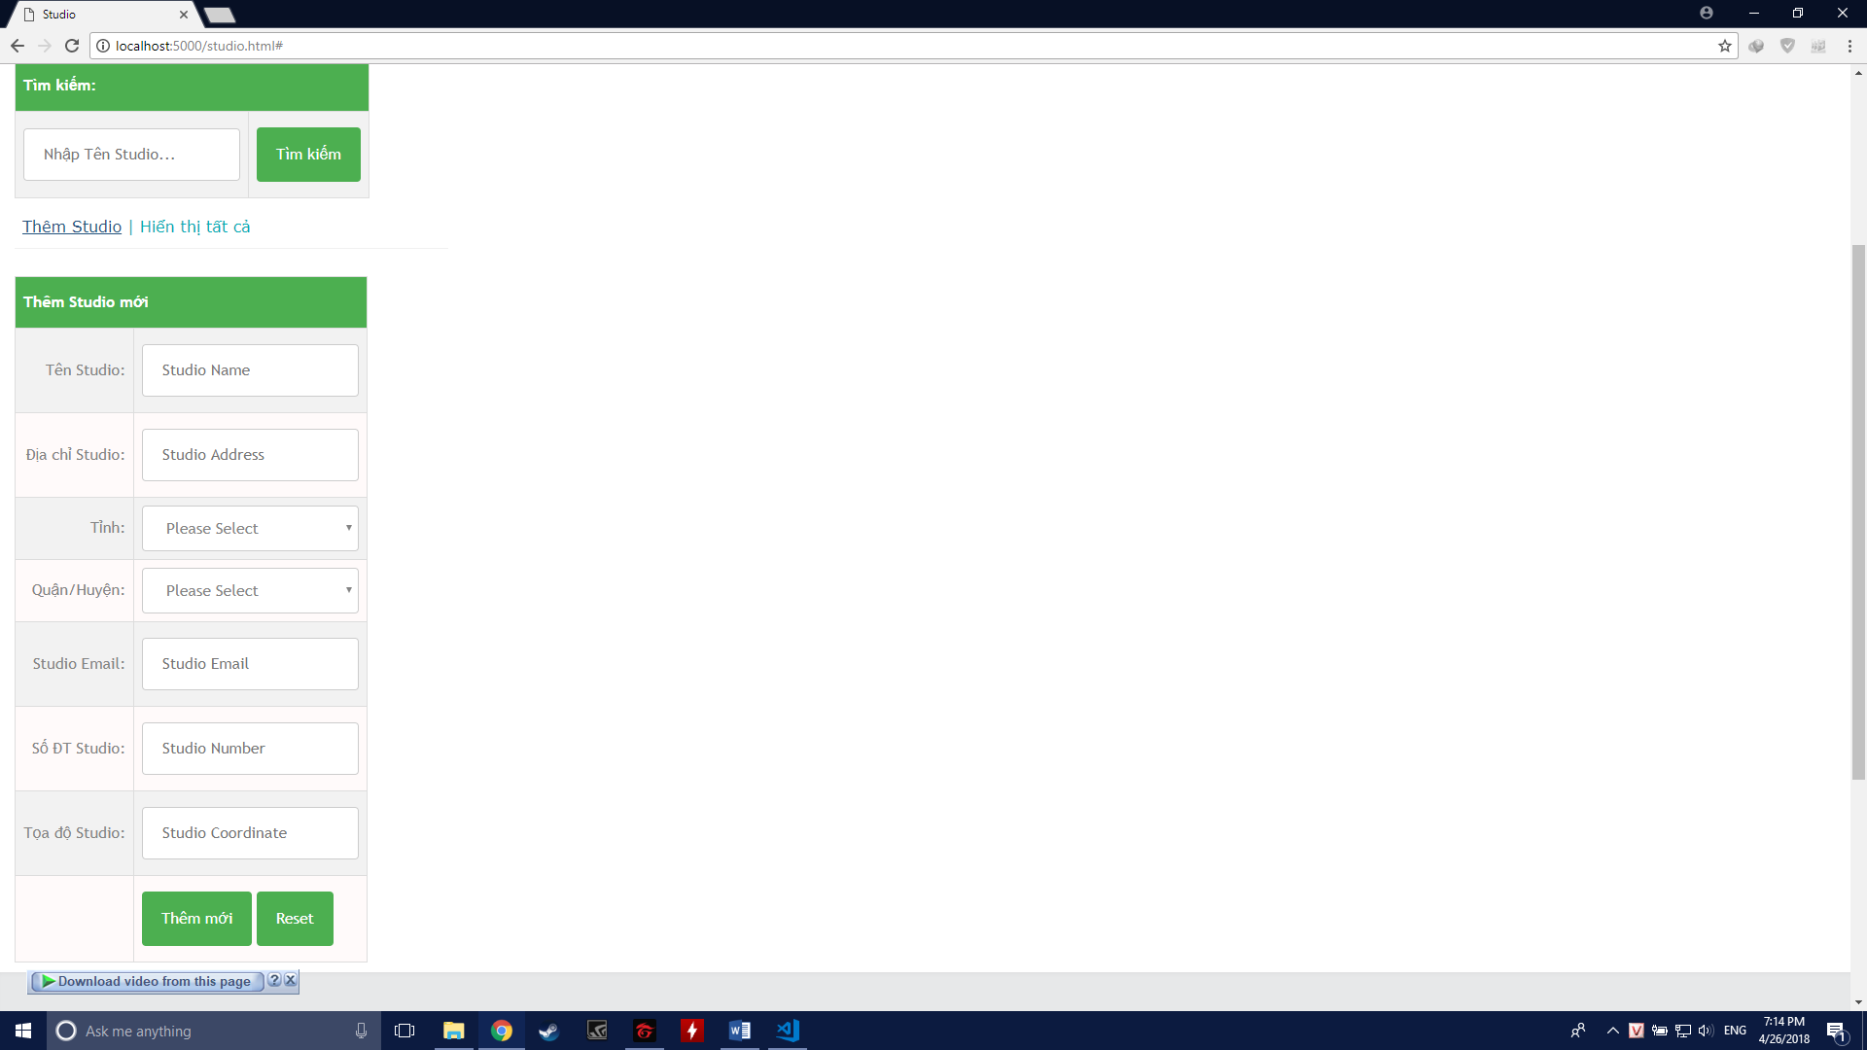

##### Class Diagram

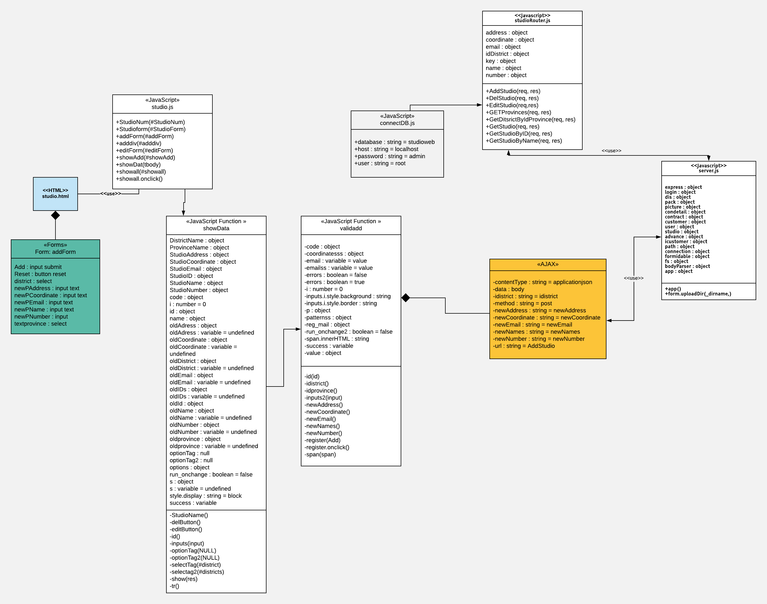

##### Class Specification

|  |  |  |  |  |
| --- | --- | --- | --- | --- |
| **Description** | Add new Studio | | | |
| **Base Class** | Controller | | | |
| **Source File** | studioRoutes.js | | | |
| **Namespace** | app/public/routes/ | | | |
| **Attributes** | **N/A** | | | |
| **Methods** | **Name** | **Input** | **Output** | **Description** |
| AddStudio | Request, result | View | Add new studio into the system |

##### Sequence Diagram

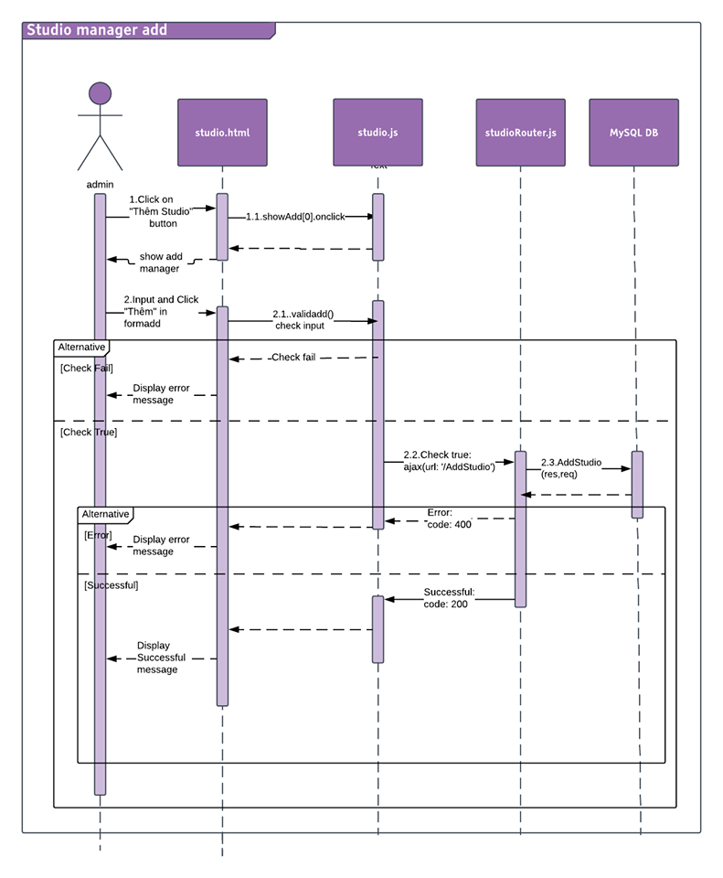

#### Edit Studio

##### Description

Admin can change Studio information.

##### Design

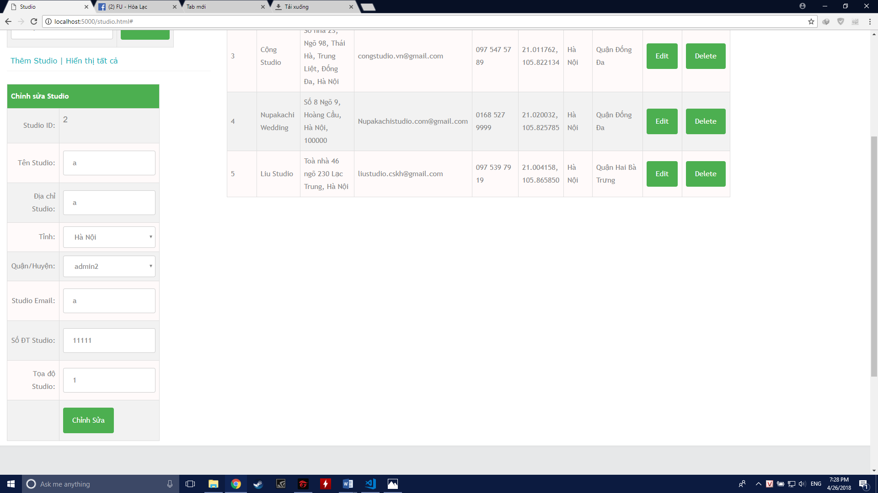

##### Class Diagram

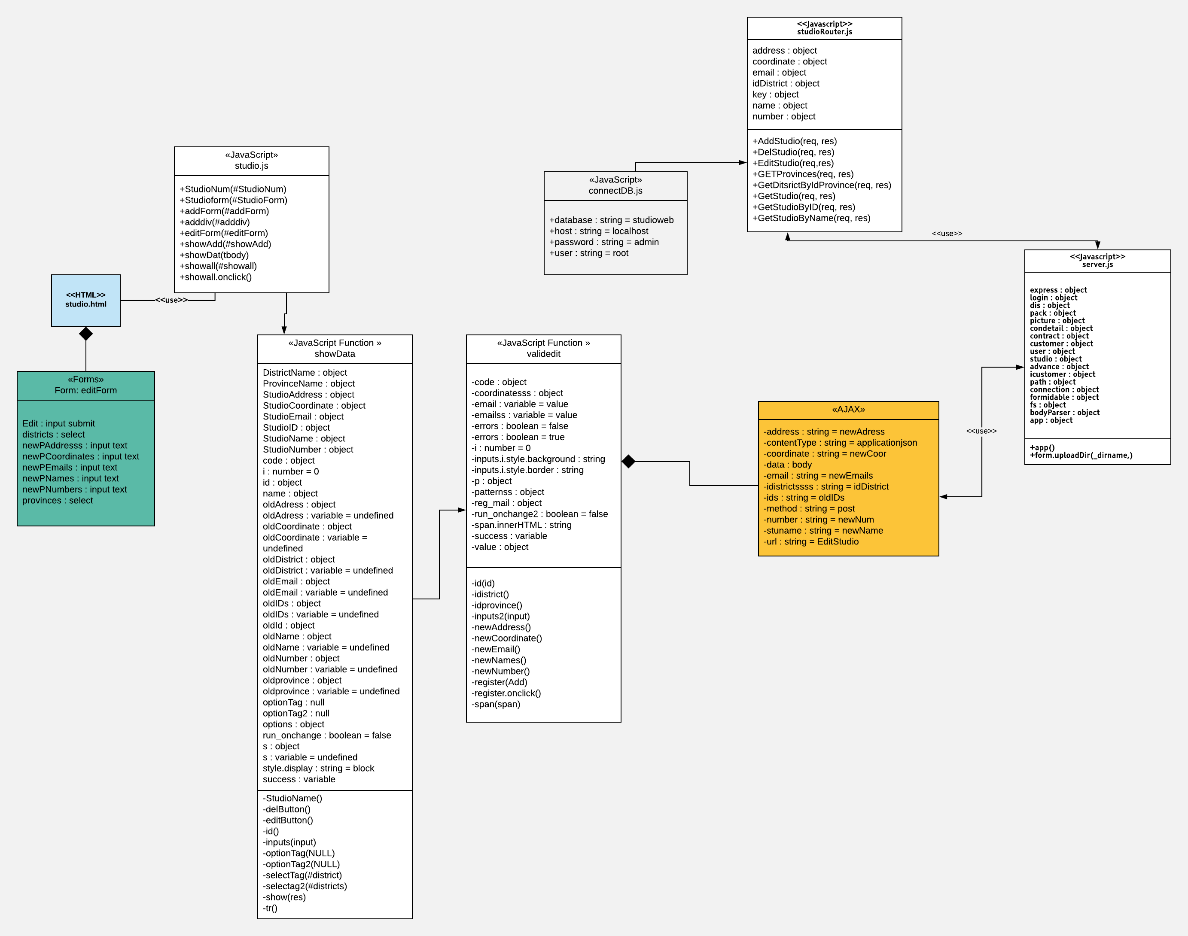

##### Class Specification

|  |  |  |  |  |
| --- | --- | --- | --- | --- |
| **Description** | Edit a Studio | | | |
| **Base Class** | Controller | | | |
| **Source File** | studioRoutes.js | | | |
| **Namespace** | app/public/routes/ | | | |
| **Attributes** | **N/A** | | | |
| **Methods** | **Name** | **Input** | **Output** | **Description** |
| EditStudio | Request, result | View | Add new studio into the system |

##### Sequence Diagram

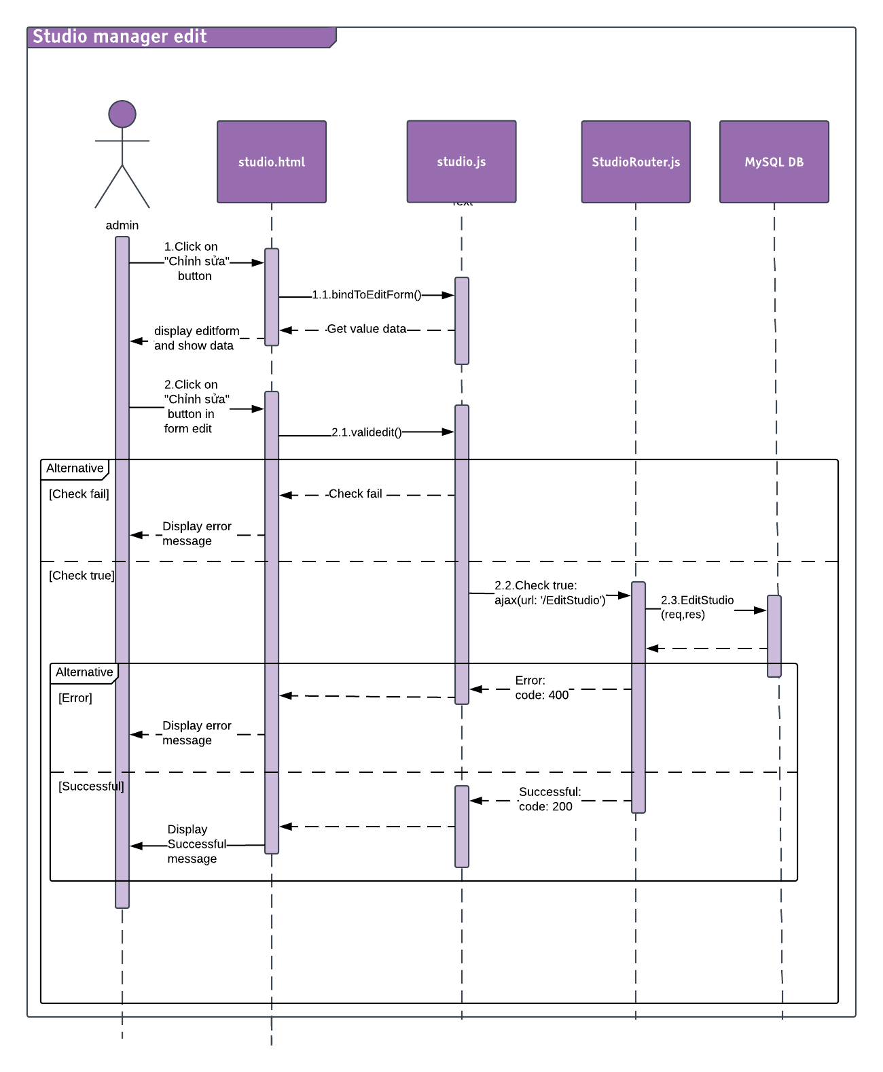

#### Delete Studio

##### Description

Admin can delete Studio.

##### Design

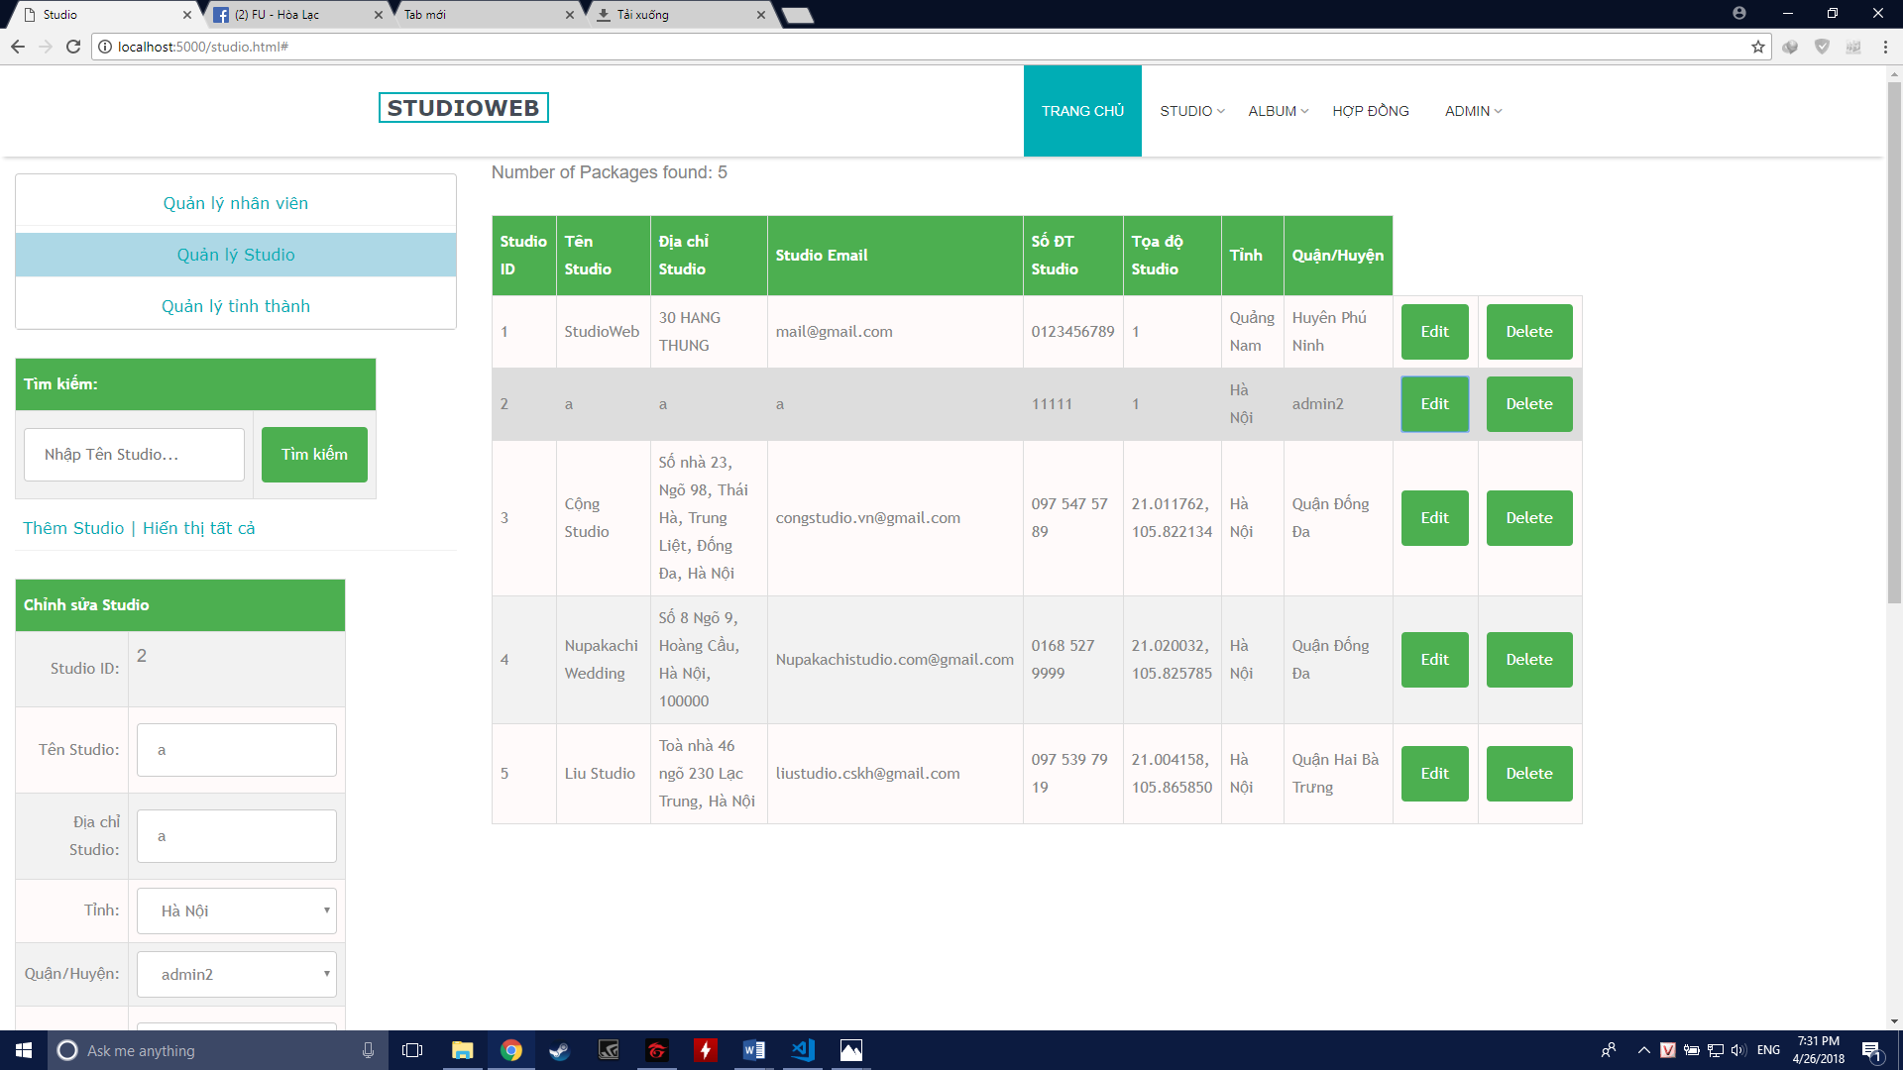

##### Class Diagram

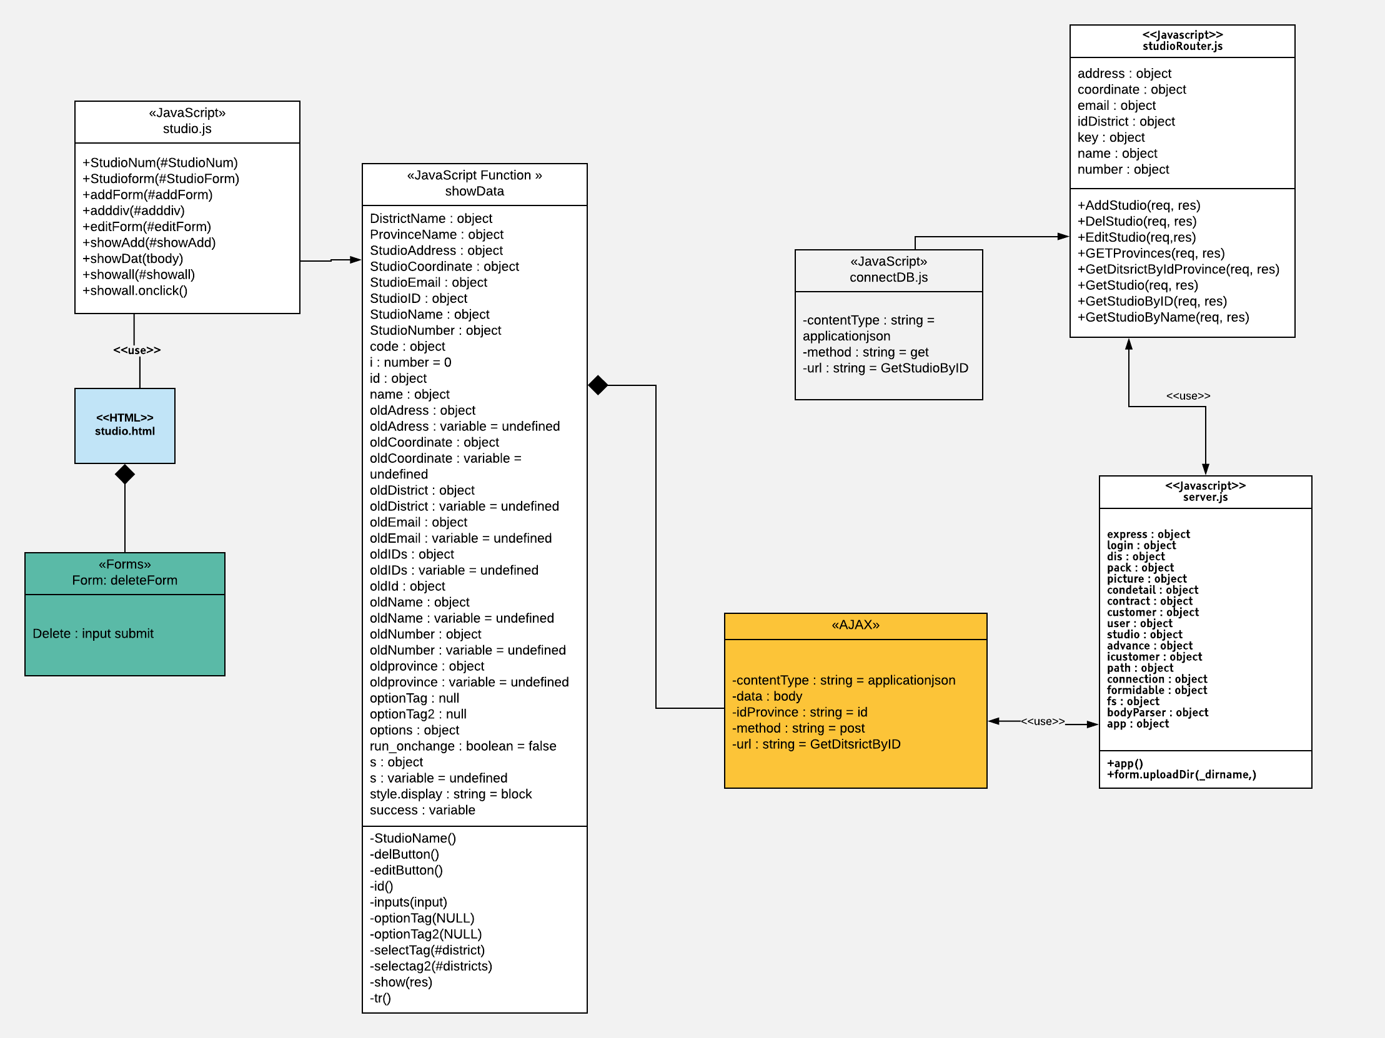

##### Class Specification

|  |  |  |  |  |
| --- | --- | --- | --- | --- |
| **Description** | Edit a Studio | | | |
| **Base Class** | Controller | | | |
| **Source File** | studioRoutes.js | | | |
| **Namespace** | app/public/routes/ | | | |
| **Attributes** | **N/A** | | | |
| **Methods** | **Name** | **Input** | **Output** | **Description** |
| EditStudio | Request, result | View | Add new studio into the system |

##### Sequence Diagram

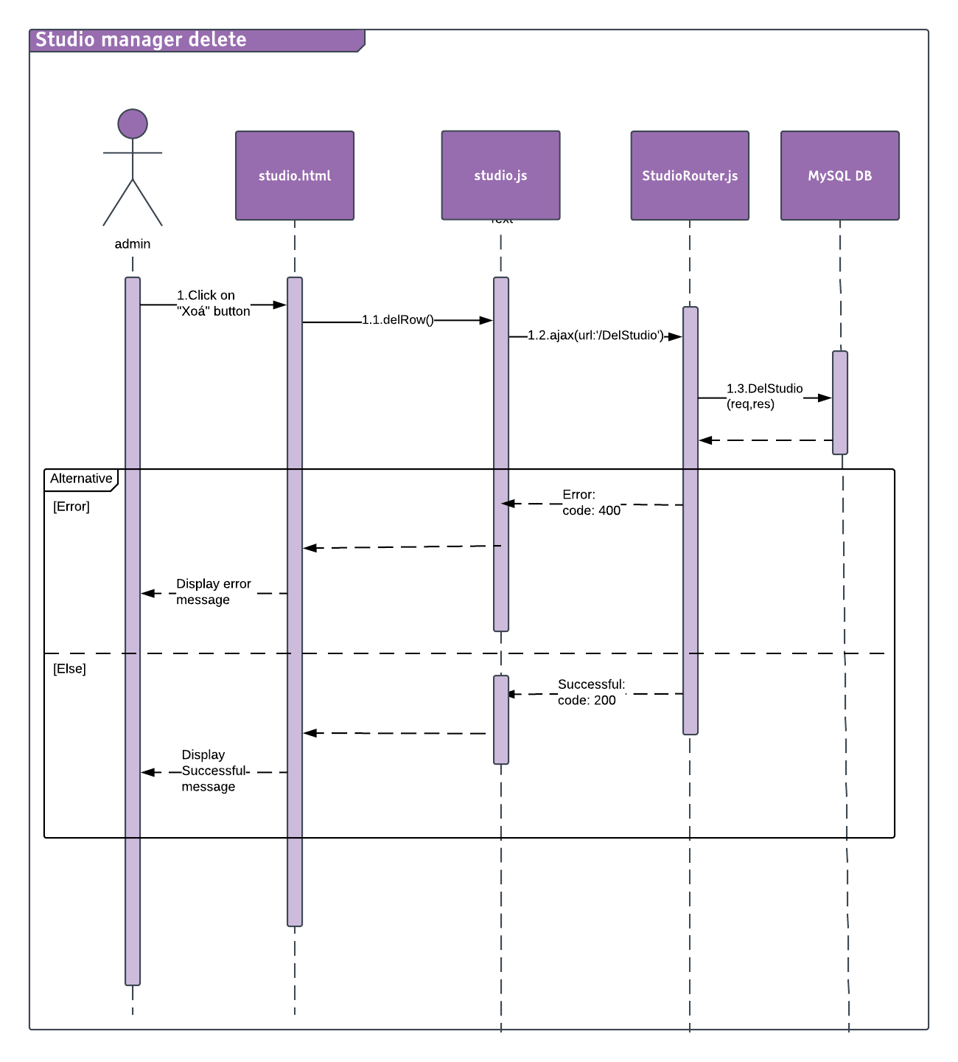

#### Search and View Studio Manager

##### Description

Admin can search and view studio Manager information.

##### Design

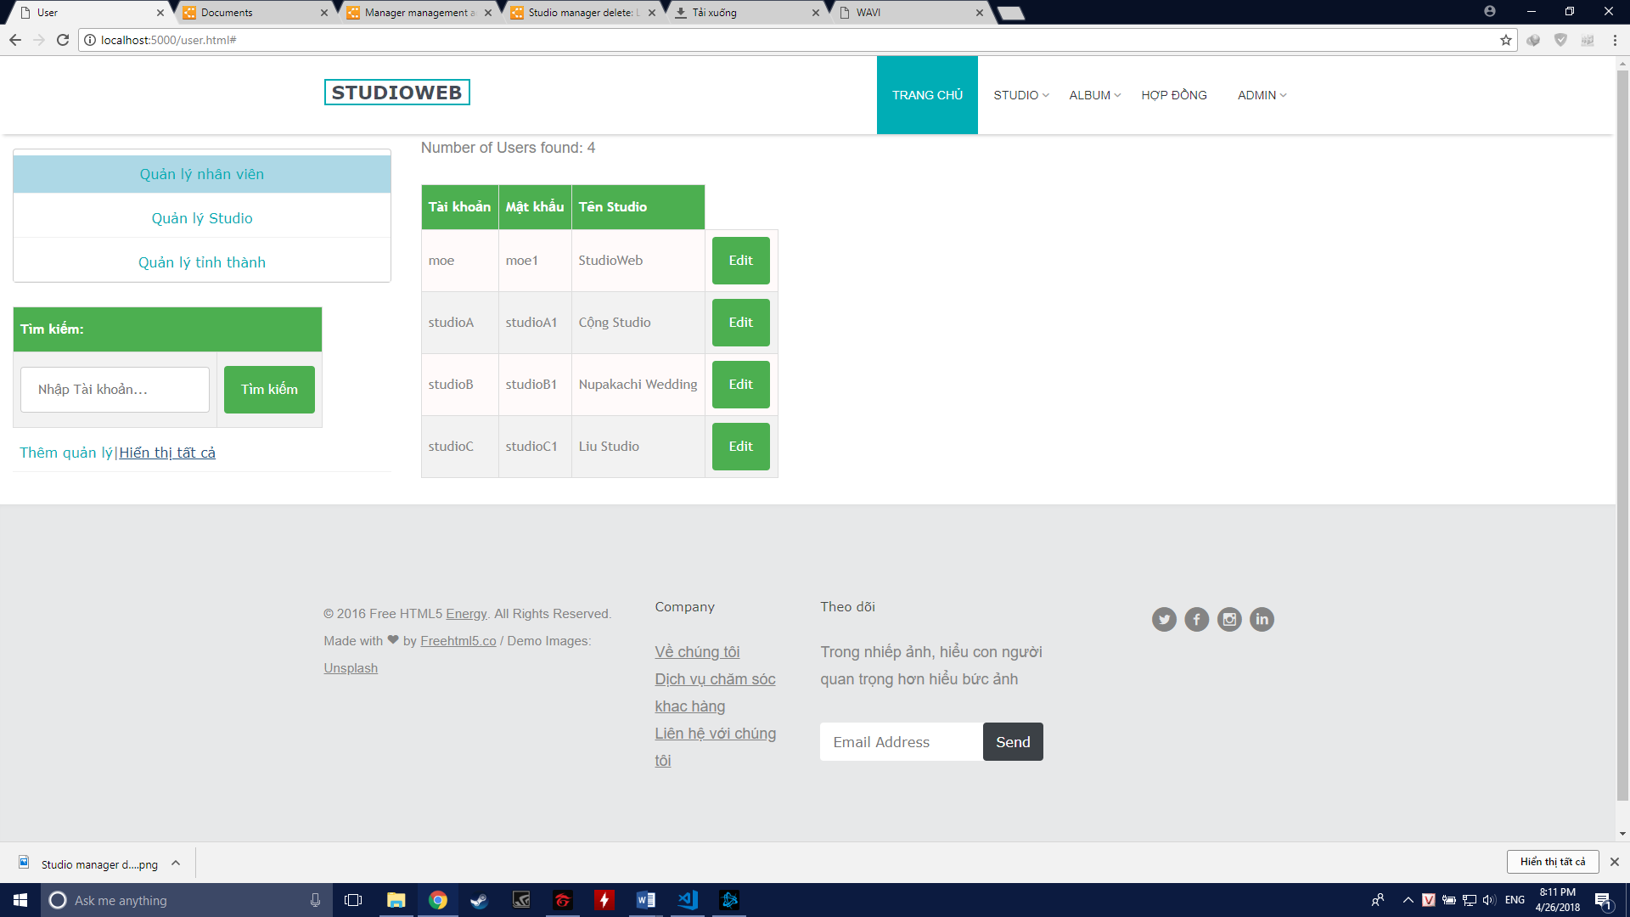

##### Class Diagram

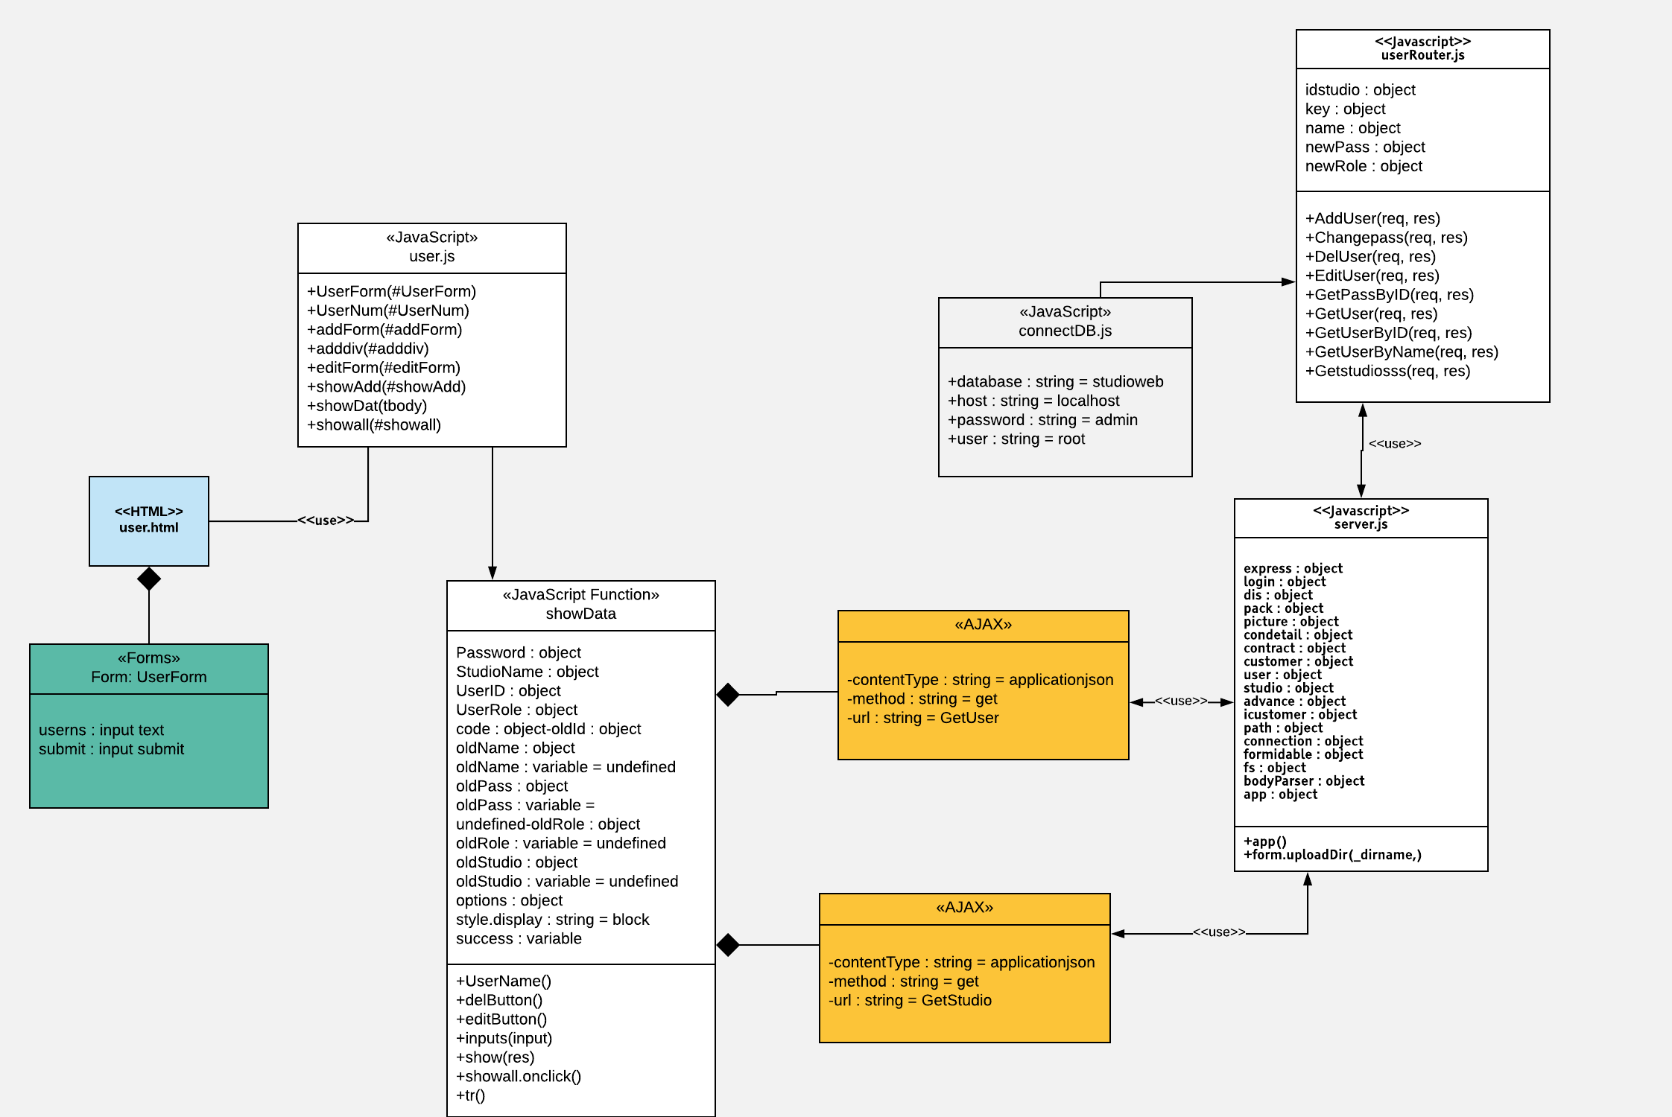

##### Class Specification

|  |  |  |  |  |
| --- | --- | --- | --- | --- |
| **Description** | View and Search an user | | | |
| **Base Class** | Controller | | | |
| **Source File** | UserRoutes.js | | | |
| **Namespace** | app/public/routes/ | | | |
| **Attributes** | **N/A** | | | |
| **Methods** | **Name** | **Input** | **Output** | **Description** |
| GetStudio | Request, result | View | Get Studio Info to bind combobox to find User by Studio |
|  | GetUser | Request, result | View | Show all user |

##### Sequence Diagram

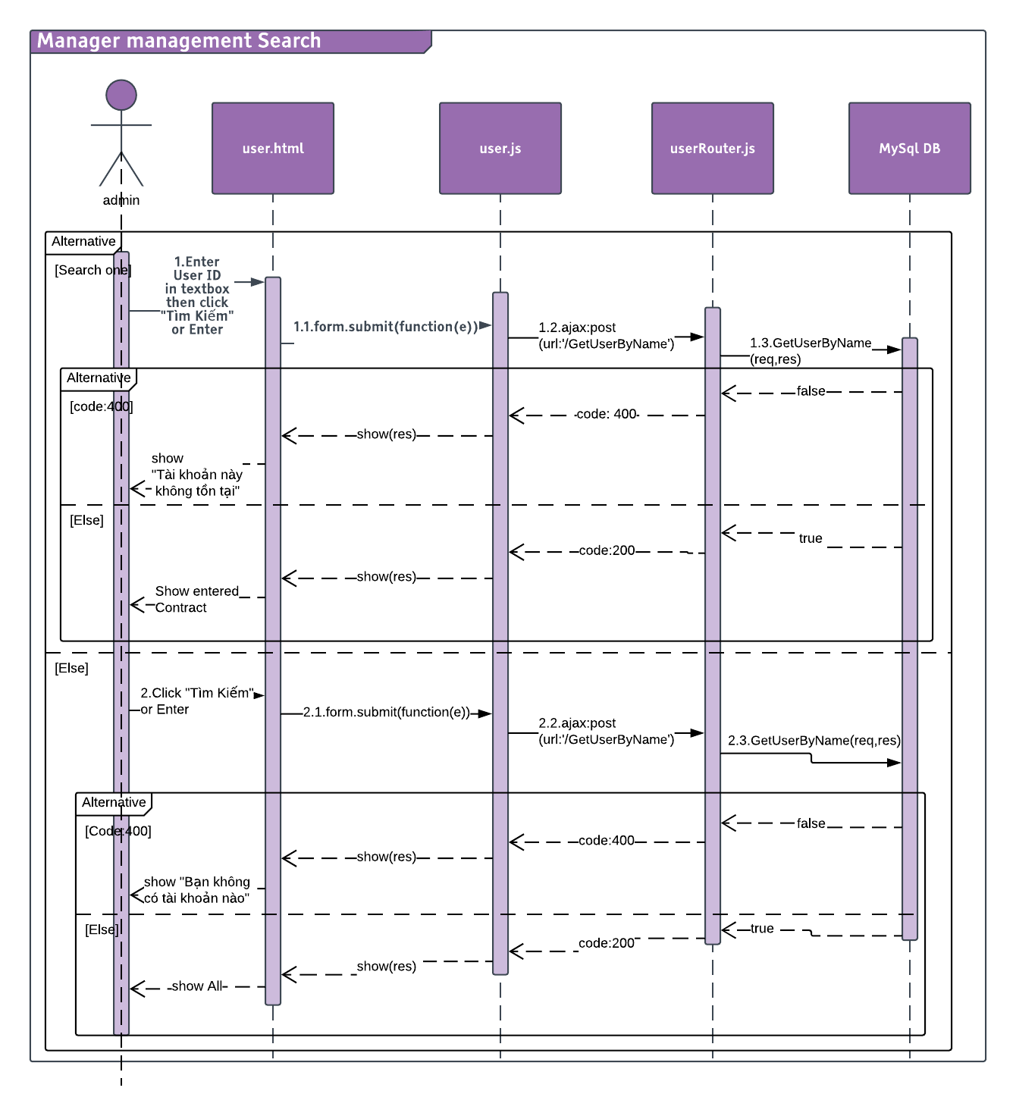

#### Add Studio Manager

##### Description

Admin can add more Studio Manager.

##### Design

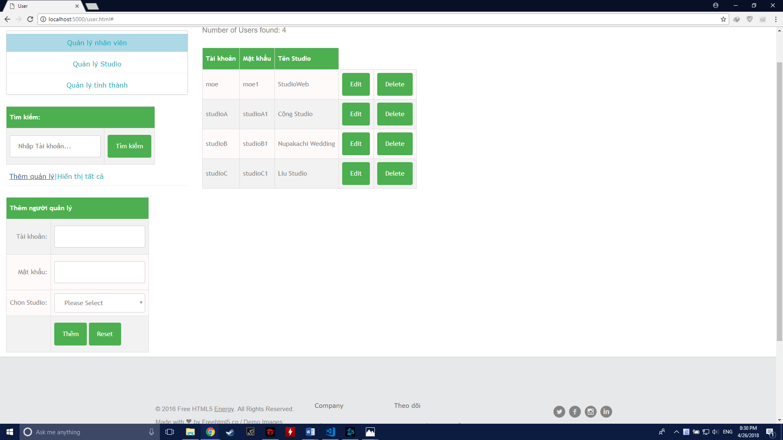

##### Class Diagram

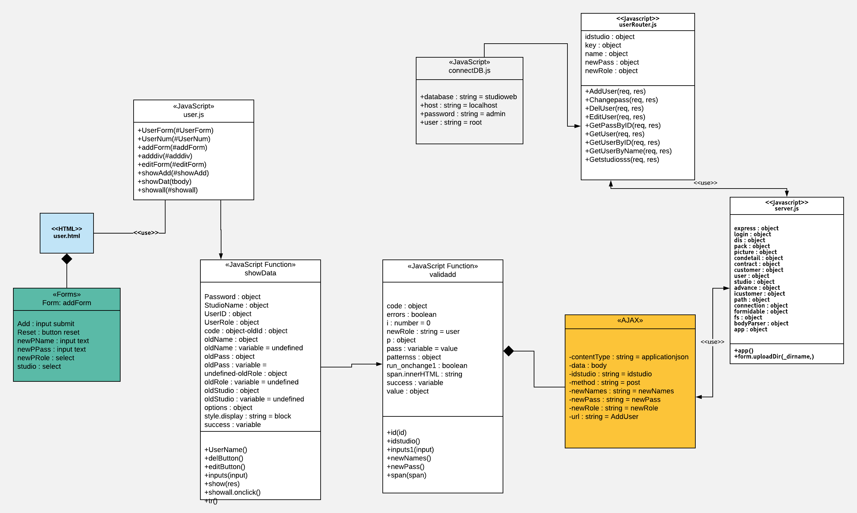

##### Class Specification

|  |  |  |  |  |
| --- | --- | --- | --- | --- |
| **Description** | Add an user | | | |
| **Base Class** | Controller | | | |
| **Source File** | UserRoutes.js | | | |
| **Namespace** | app/public/routes/ | | | |
| **Attributes** | **N/A** | | | |
| **Methods** | **Name** | **Methods** | **Name** | **Methods** |
| AddUser | Request, result | AddUser | Edit user name, studio user belong and password |

##### Sequence Diagram

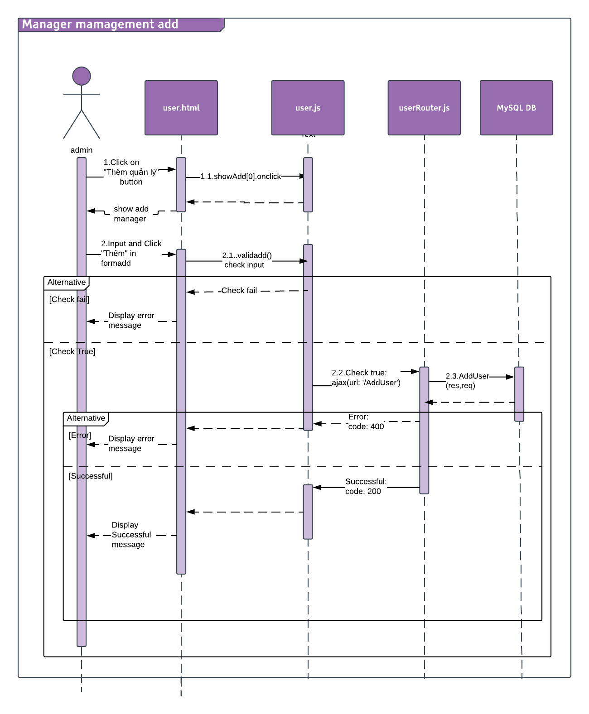

#### Edit Studio Manager

##### Description

Admin can edit Studio Manager information.

##### Design

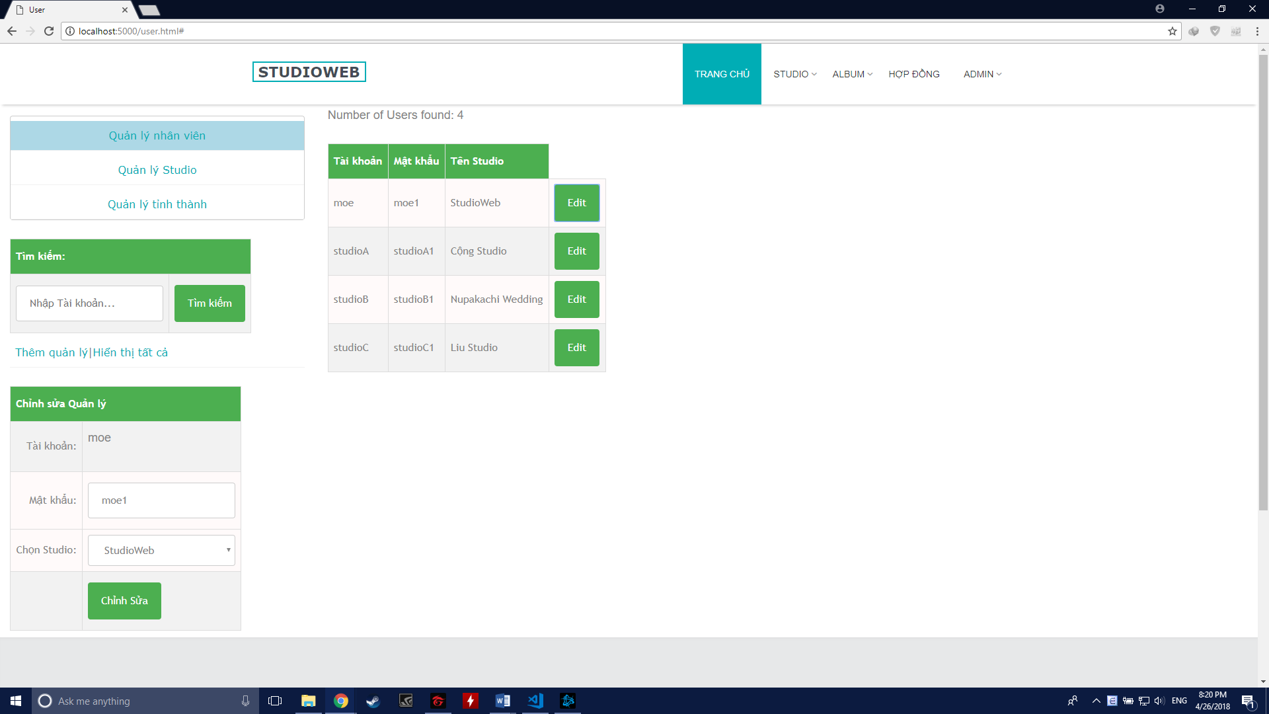

##### Class Diagram

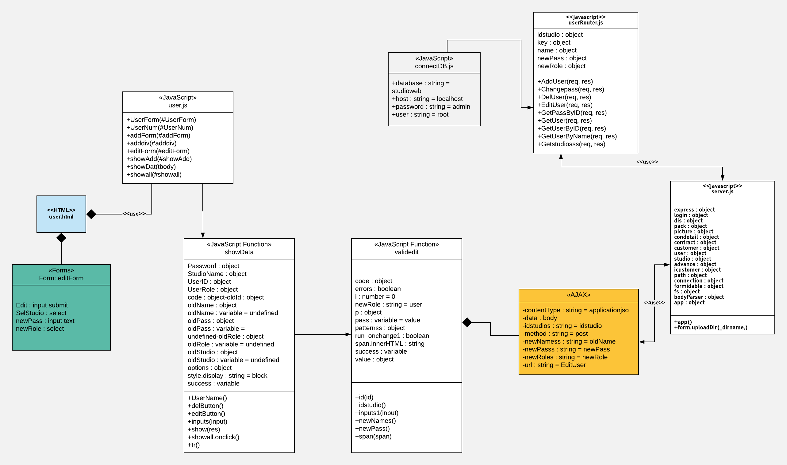

##### Class Specification

|  |  |  |  |  |
| --- | --- | --- | --- | --- |
| **Description** | Edit an user’s info | | | |
| **Base Class** | Controller | | | |
| **Source File** | UserRoutes.js | | | |
| **Namespace** | app/public/routes/ | | | |
| **Attributes** | **N/A** | | | |
| **Methods** | **Name** | **Input** | **Output** | **Description** |
| EditUser | Request, result | View | Edit user name, studio user belong and password |

##### Sequence Diagram

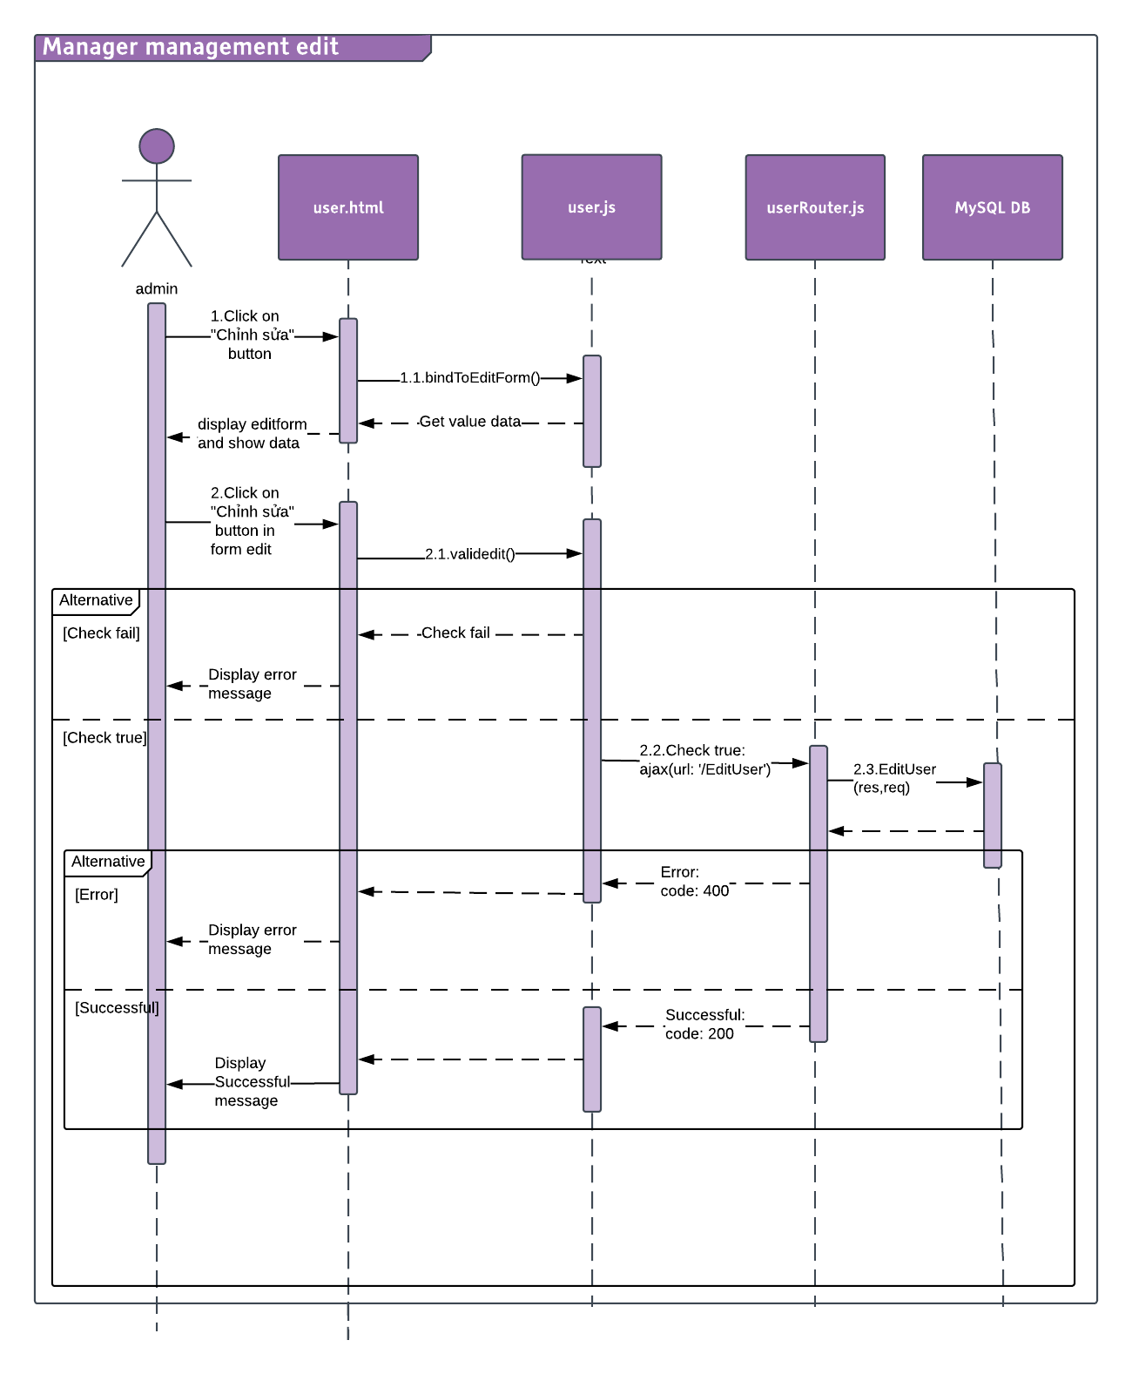

#### Delete Studio Manager

##### Description

Admin can delete Studio Manager.

##### Design

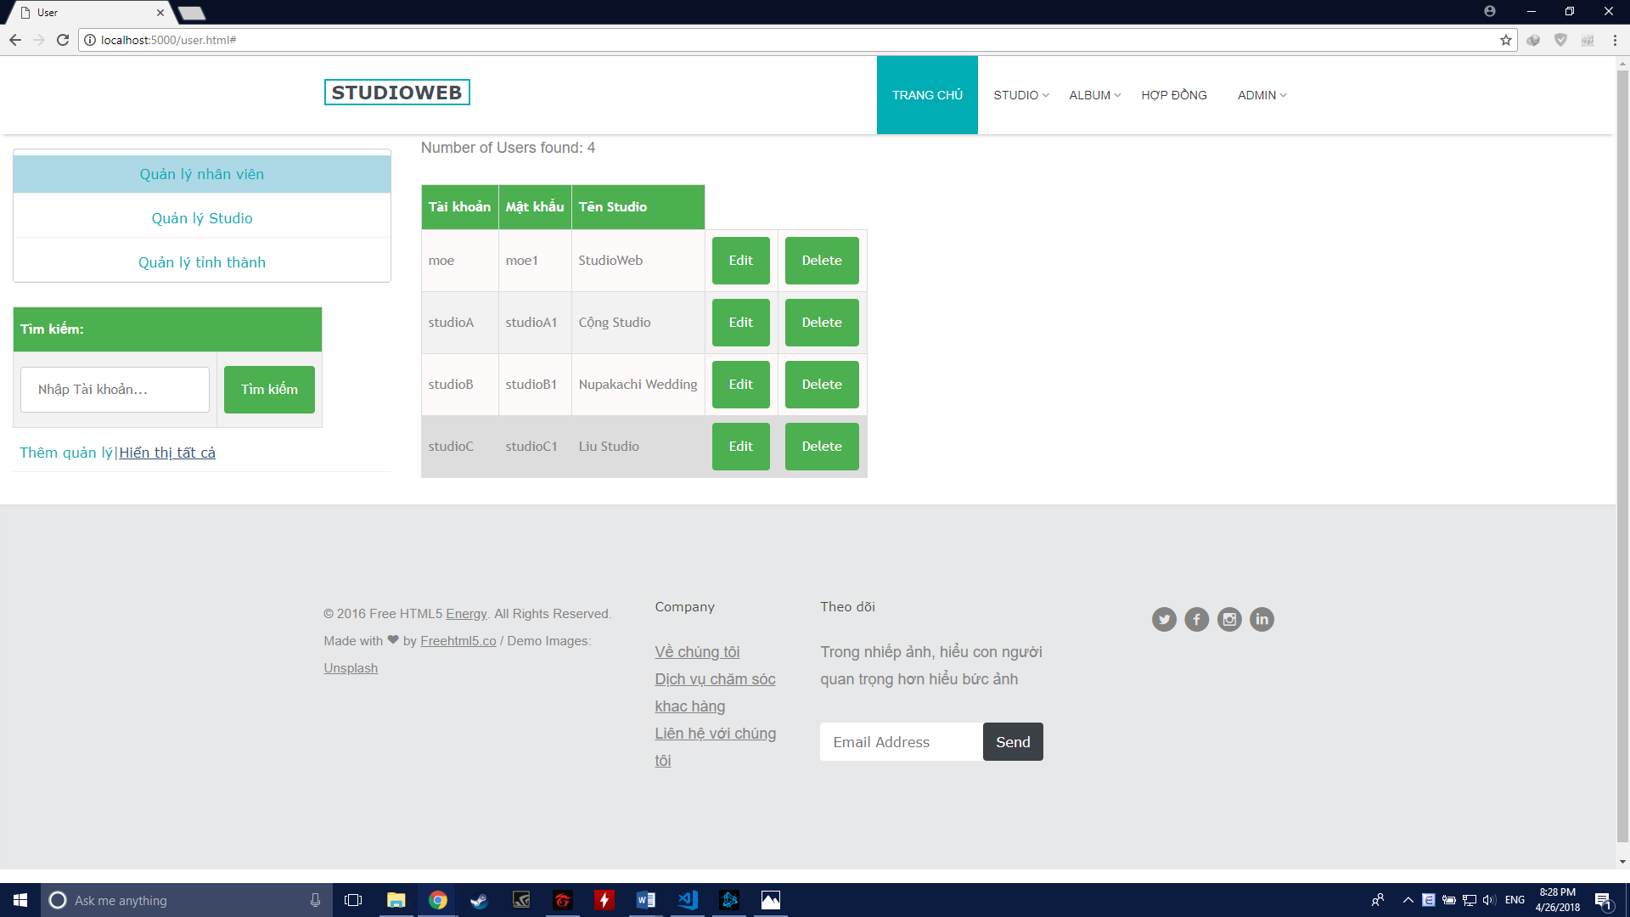

##### Class Diagram

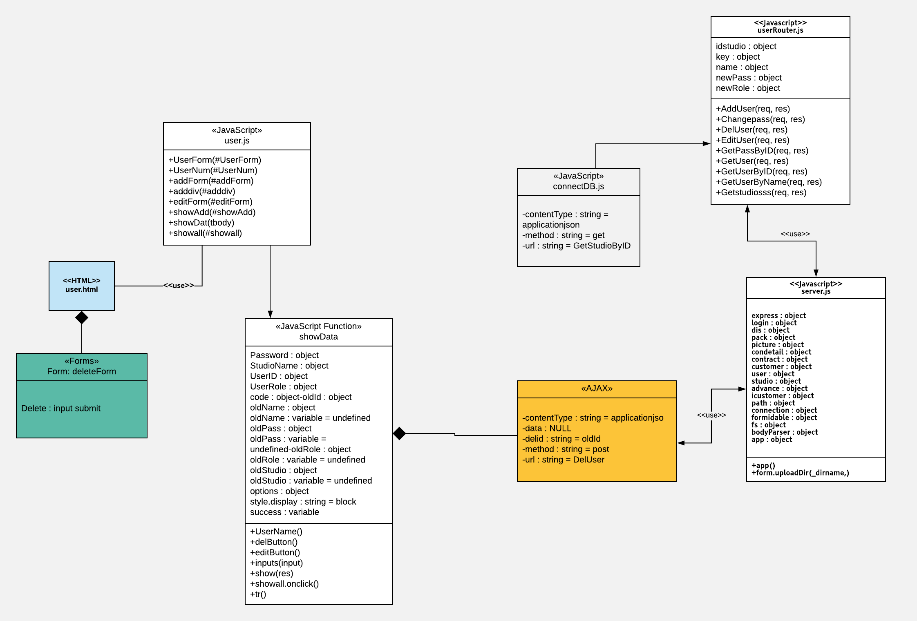

##### Class Specification

|  |  |  |  |  |
| --- | --- | --- | --- | --- |
| **Description** | Delete an user | | | |
| **Base Class** | Controller | | | |
| **Source File** | UserRoutes.js | | | |
| **Namespace** | app/public/routes/ | | | |
| **Attributes** | **N/A** | | | |
| **Methods** | **Name** | **Input** | **Output** | **Description** |
| DelUser | Request, result | View | Delete an user from the system |

##### Sequence Diagram

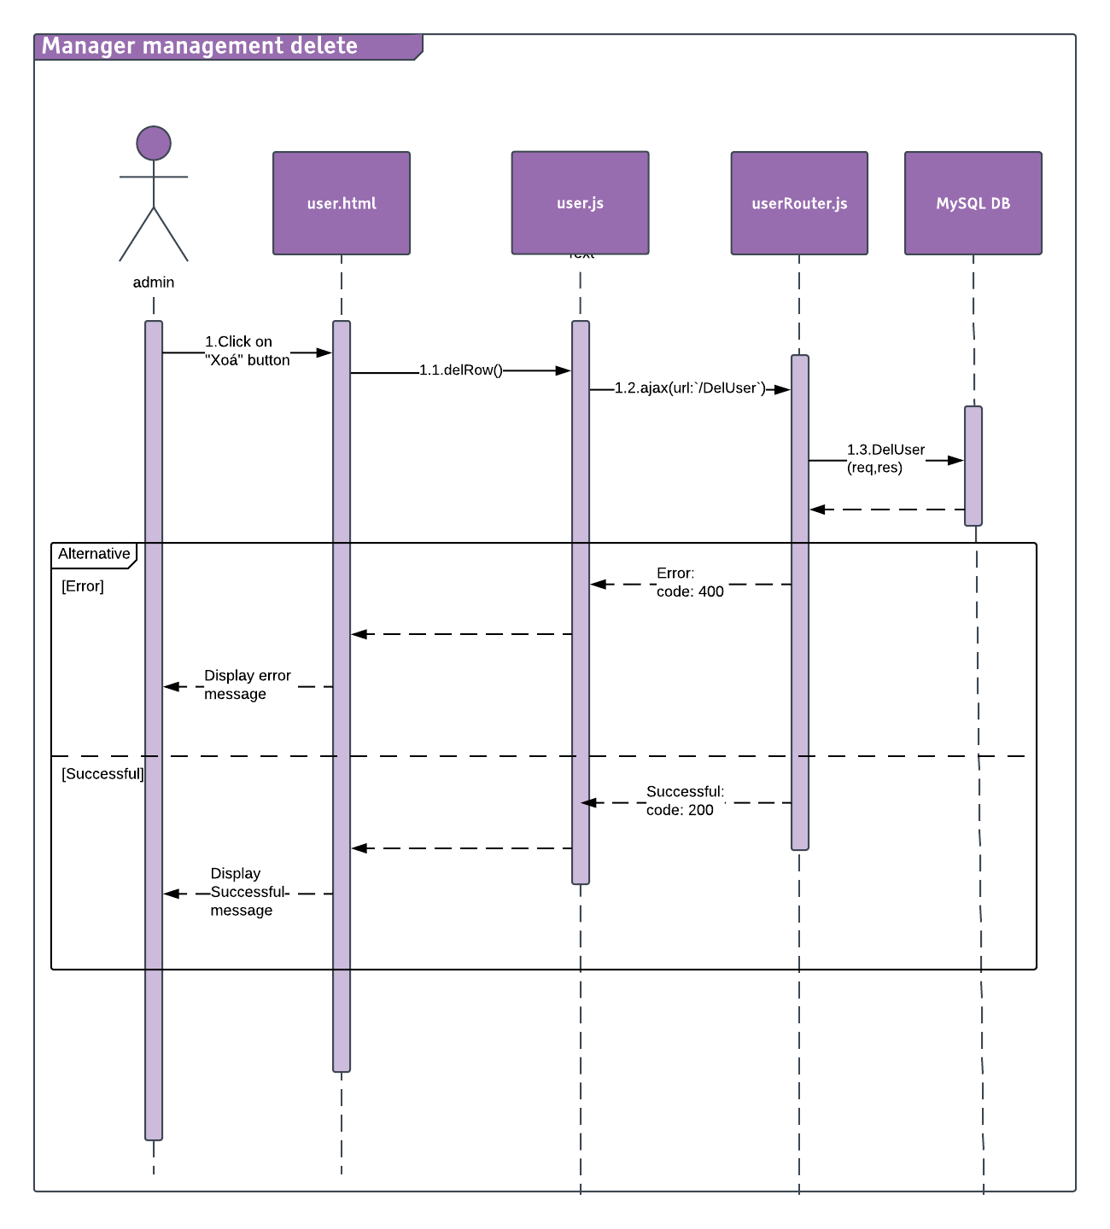

### Manager

#### Login

##### Description

Mamanger can Login to the systems.

##### Design



##### Class Diagram



##### Class Specification

|  |  |  |  |  |
| --- | --- | --- | --- | --- |
| **Class** | loginRoutes | | | |
| **Description** | Control Manager login action | | | |
| **Base Class** | Controller | | | |
| **Source File** | loginRoutes.js | | | |
| **Namespace** | app/public/routes/ | | | |
| **Attributes** | **N/A** | | | |
| **Methods** | **Name** | **Input** | **Output** | **Description** |
| login | Request, result | View | Allow user to login into the system |

##### Sequence Diagram

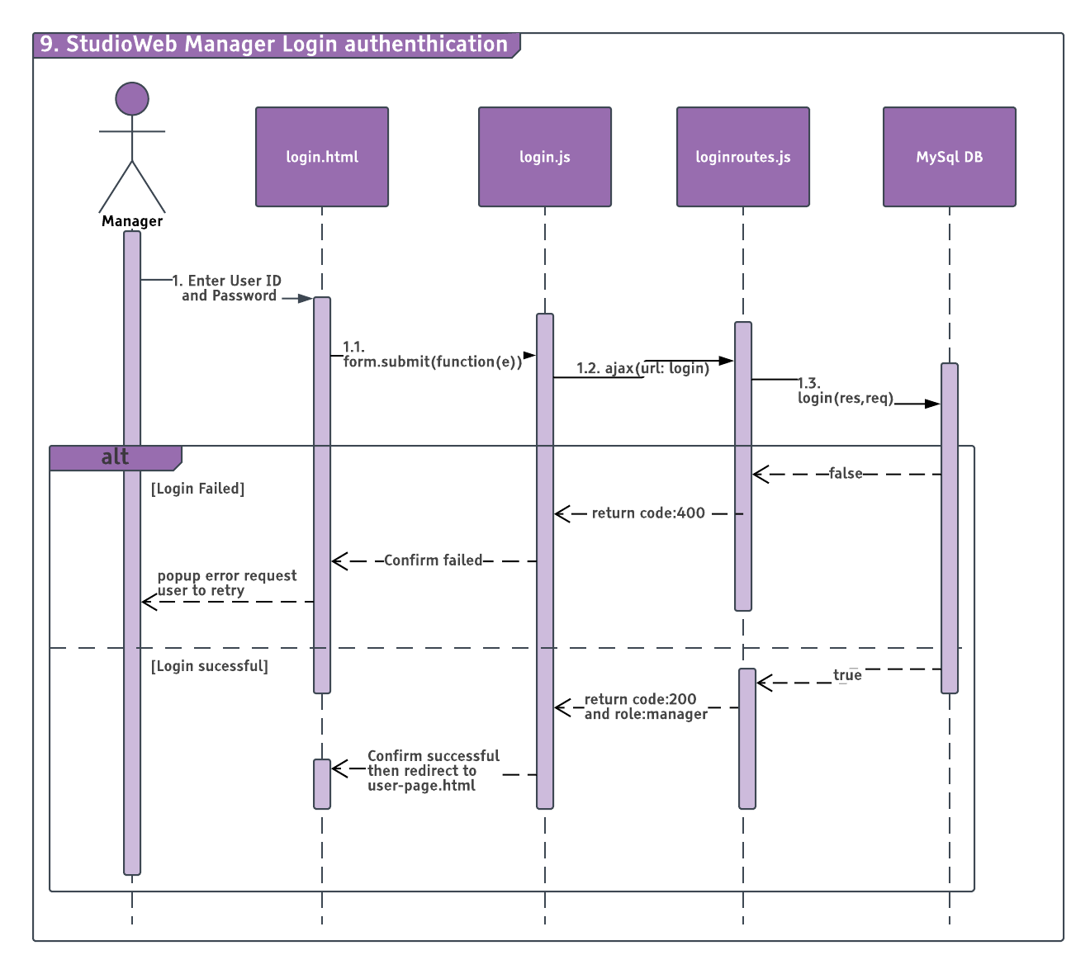

#### Logout

##### Description

Manager can Logout the system.

##### Design



##### Class Diagram



##### Class Specification

|  |  |  |  |  |
| --- | --- | --- | --- | --- |
| **Class** | main | | | |
| **Description** | Control Manager logout action | | | |
| **Base Class** | model | | | |
| **Source File** | Main.js | | | |
| **Namespace** | app/public/js/ | | | |
| **Attributes** | **N/A** | | | |
| **Methods** | **Name** | **Input** | **Output** | **Description** |
| logout | Request | View | Logout the current User |

##### Sequence Diagram



#### Change Password

##### Description

Manager can change password.

##### Design



##### Class Diagram



##### Class Specification

|  |  |  |  |  |
| --- | --- | --- | --- | --- |
| **Description** | Control Manager change password action | | | |
| **Base Class** | Controller | | | |
| **Source File** | userRoutes.js | | | |
| **Namespace** | app/public/routes/ | | | |
| **Attributes** | **N/A** | | | |
| **Methods** | **Name** | **Input** | **Output** | **Description** |
| changepass | Request, result | View | Change the password of the current user |

##### Sequence Diagram

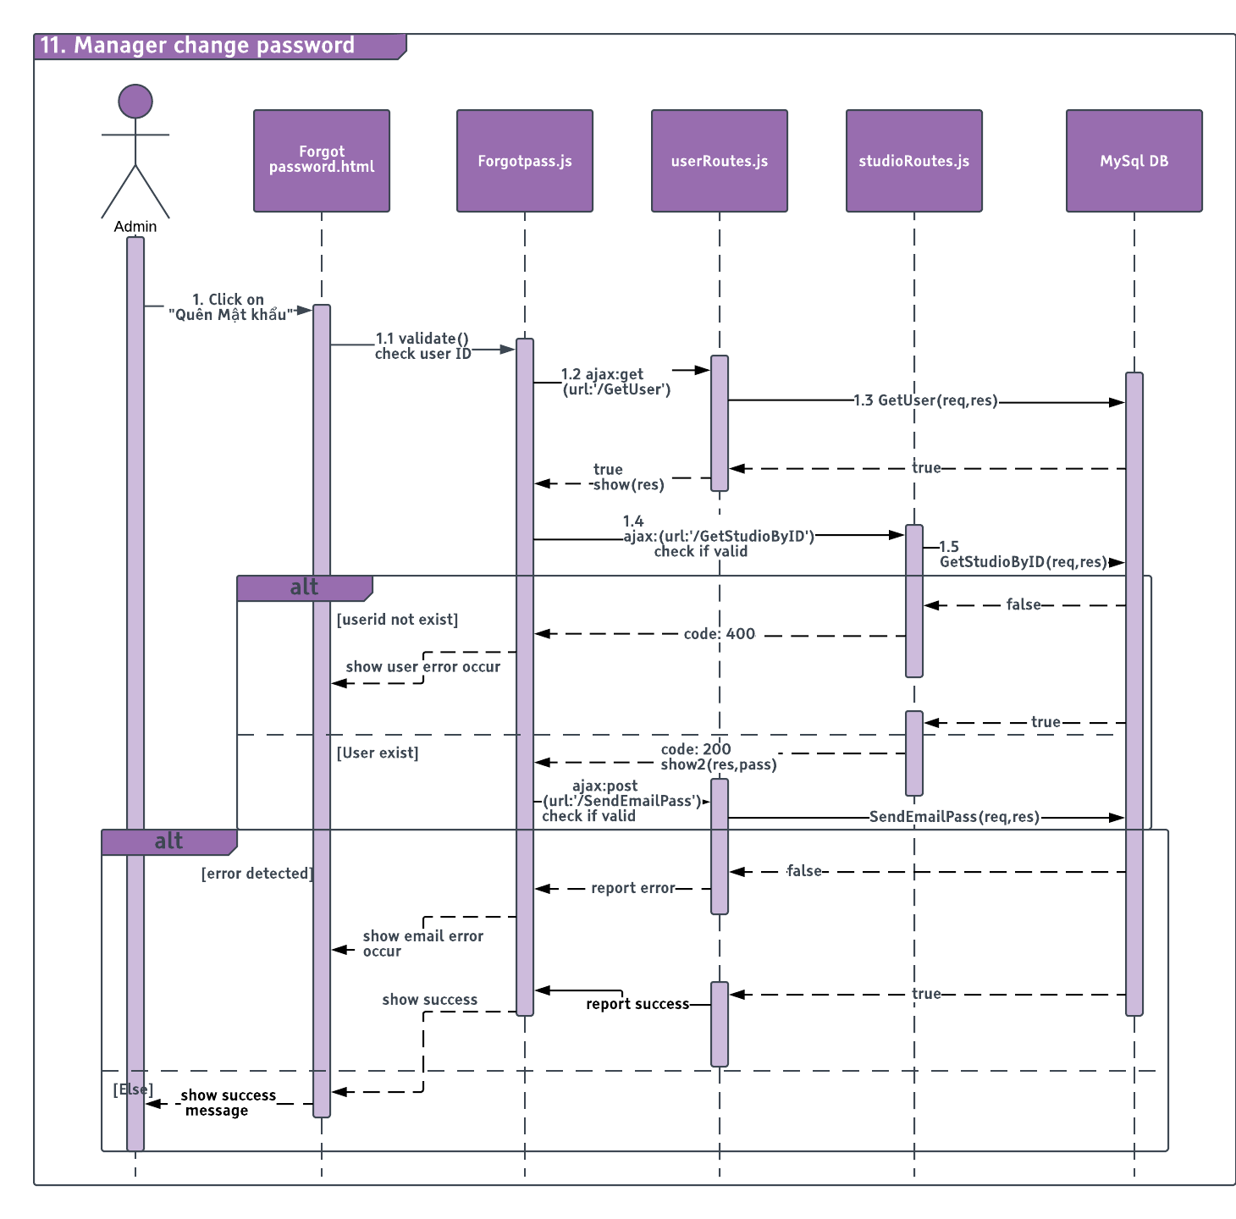

#### Forgot Password

##### Description

Manager can change password if fogot old password.

##### Design



##### Class Diagram



##### Class Specification

|  |  |  |  |  |
| --- | --- | --- | --- | --- |
| **Description** | Control Manager forgot password action | | | |
| **Base Class** | Controller | | | |
| **Source File** | userRoutes.js | | | |
| **Namespace** | app/public/routes/ | | | |
| **Attributes** | **N/A** | | | |
| **Methods** | **Name** | **Input** | **Output** | **Description** |
| SendEmailPass | Request, result | View | Change the password of the current user |
|  | GetUser | Request, result | View | Get user |

|  |  |  |  |  |
| --- | --- | --- | --- | --- |
| **Description** | Specify which Studio does user belong to | | | |
| **Base Class** | Controller | | | |
| **Source File** | studioRoutes.js | | | |
| **Namespace** | app/public/routes/ | | | |
| **Attributes** | **N/A** | | | |
| **Methods** | **Name** | **Input** | **Output** | **Description** |
| GetStudioByID | Request, result | View | Get studio by User ID |

##### Sequence Diagram

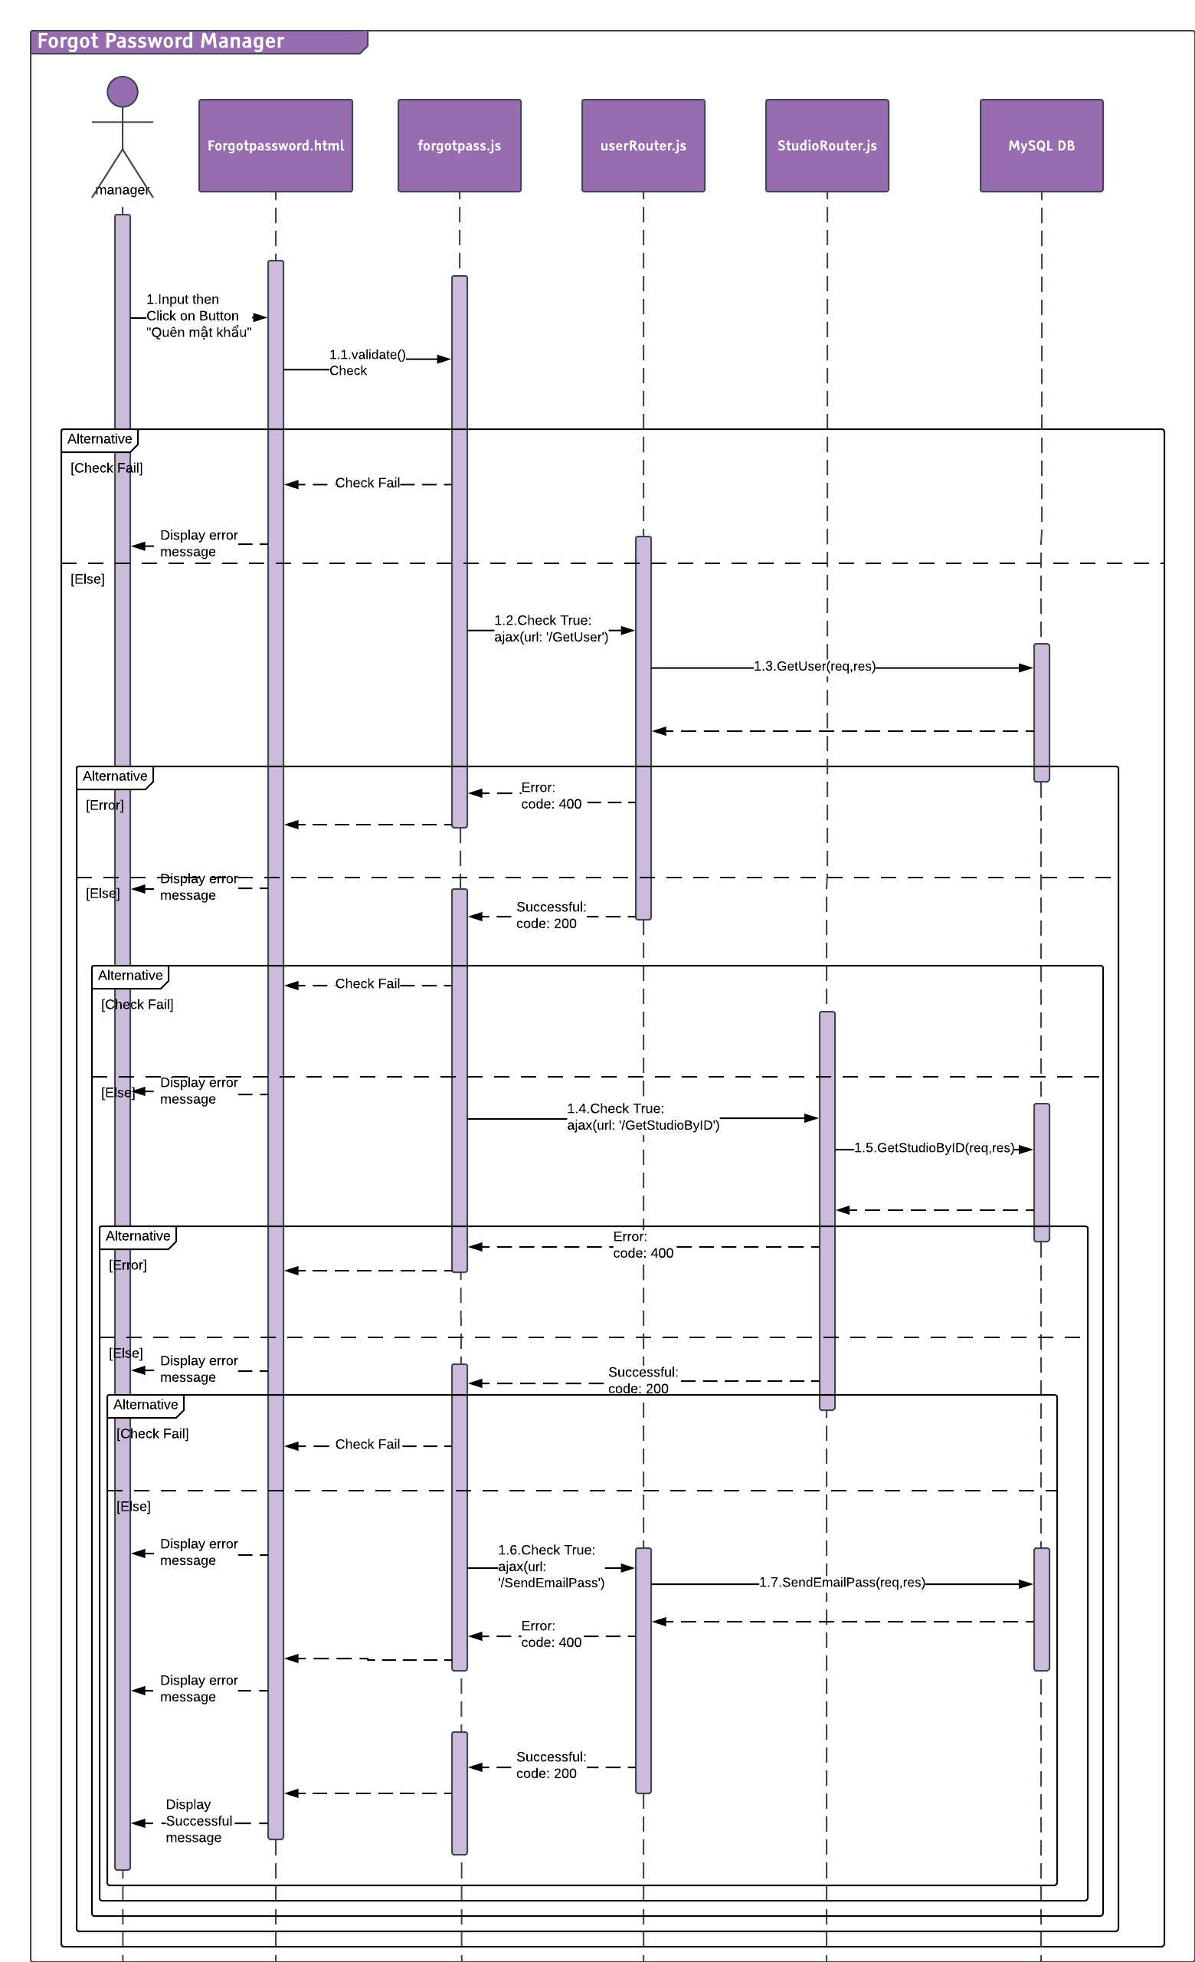

#### Search & View Contract Information

##### Description

Manager can search and view Contract.

##### Design

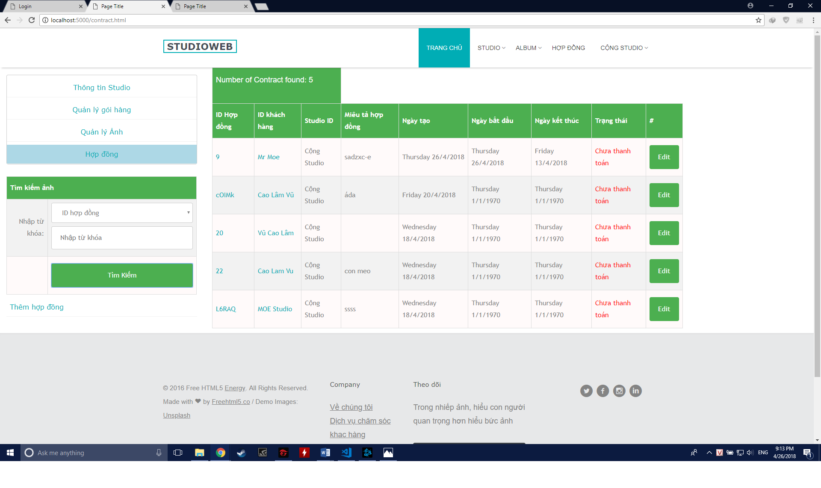

##### Class Diagram

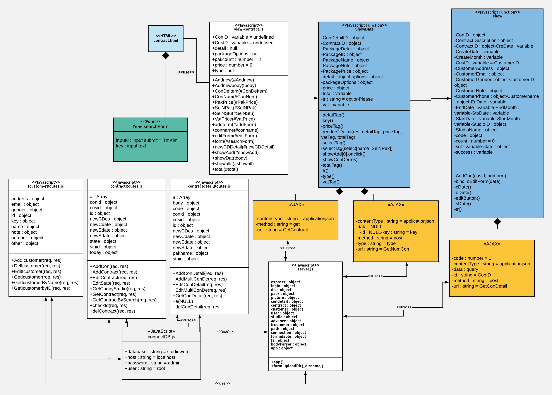

##### Class Specification

|  |  |  |  |  |
| --- | --- | --- | --- | --- |
| **Description** | Search and view Contract action | | | |
| **Base Class** | Controller | | | |
| **Source File** | contractRoutes.js | | | |
| **Namespace** | app/public/routes/ | | | |
| **Attributes** | **N/A** | | | |
| **Methods** | **Name** | **Input** | **Output** | **Description** |
| GetconByStudio | Request, result | View | Get contract by Studio ID |

##### Sequence Diagram

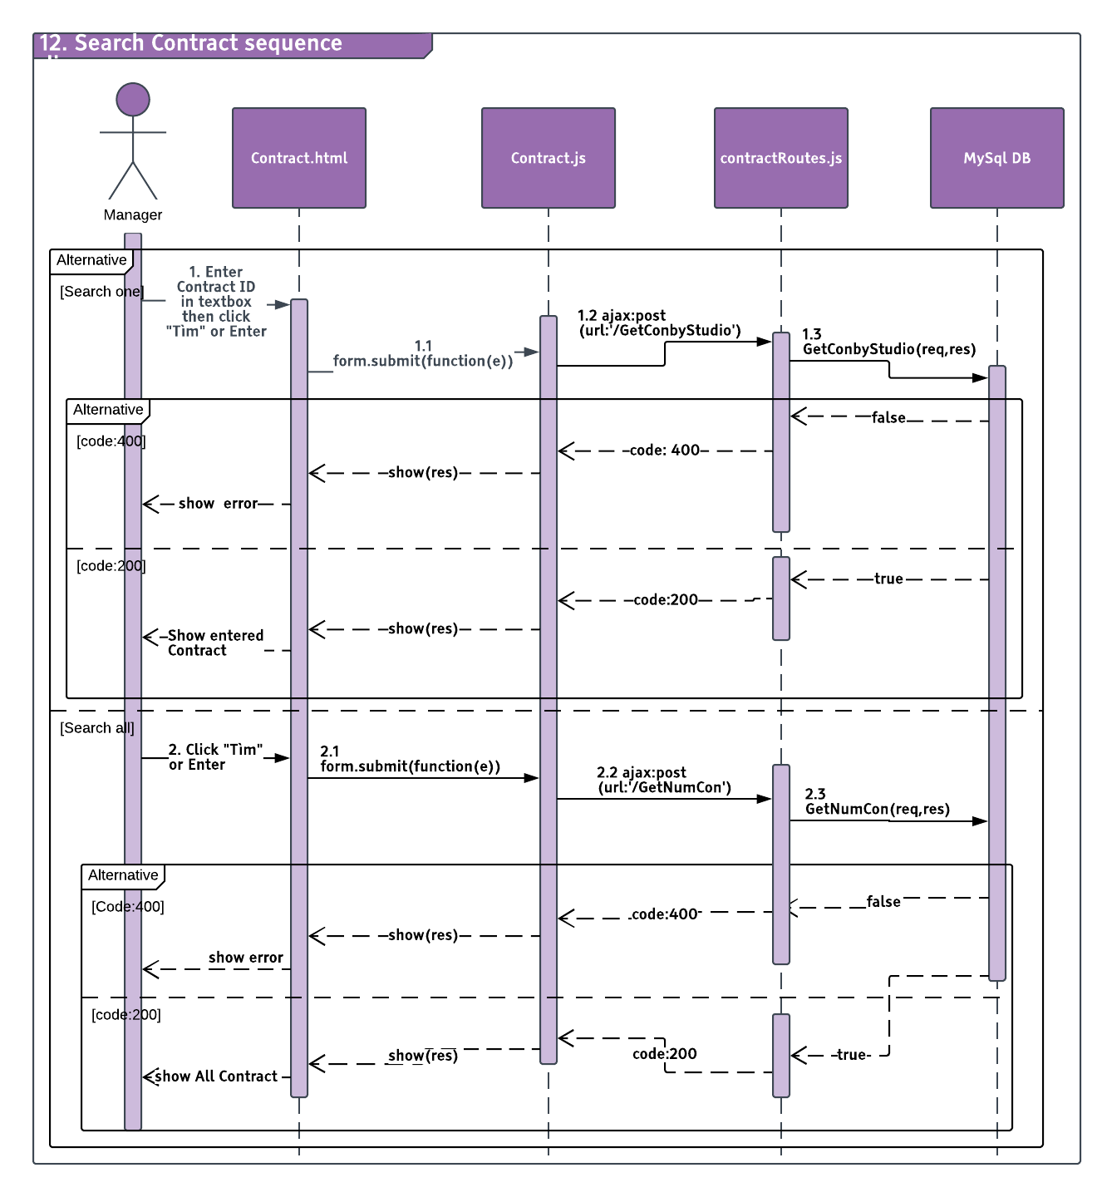

#### Add Contract

##### Description

Manager can add more Contract.

##### Design

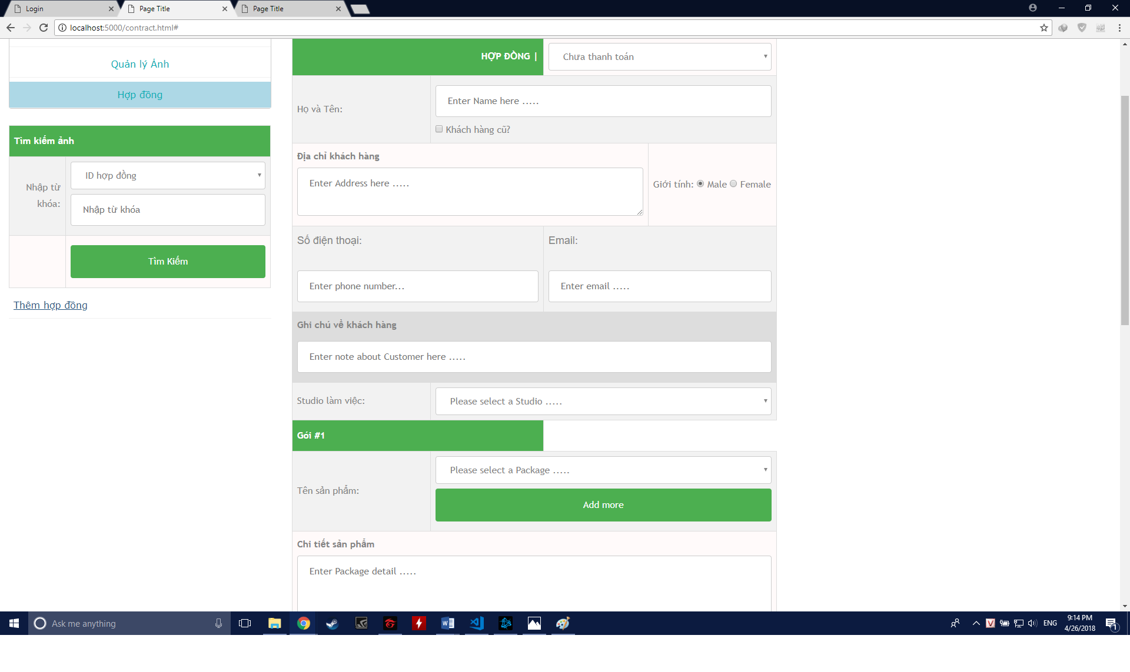

##### Class Diagram

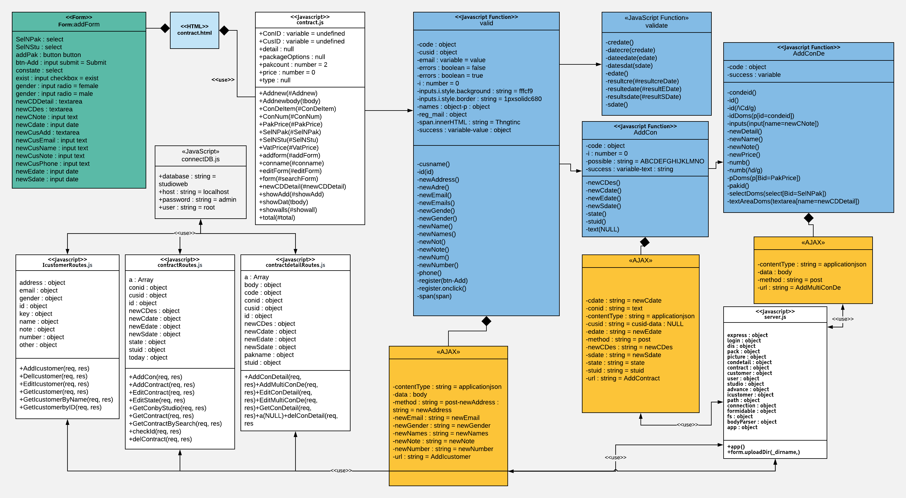

##### Class Specification

|  |  |  |  |  |
| --- | --- | --- | --- | --- |
| **Description** | Manager add contract action | | | |
| **Base Class** | Controller | | | |
| **Source File** | contractrouter.js, IcustommerRouter.js, contractdetailrouter.js | | | |
| **Namespace** | app/public/routes/ | | | |
| **Attributes** | **N/A** | | | |
| **Methods** | **Name** | **Input** | **Output** | **Description** |
| GetcustomByName | Request, result | View | Get Customer by Custummer Name |
|  | AddIcustomer | Request, result | View | Add new customer |
|  | AddContract | Request, result | View | Add new contract |
|  | AddMultiConDe | Request, result | View | Add new Contract Detail |

##### Sequence Diagram

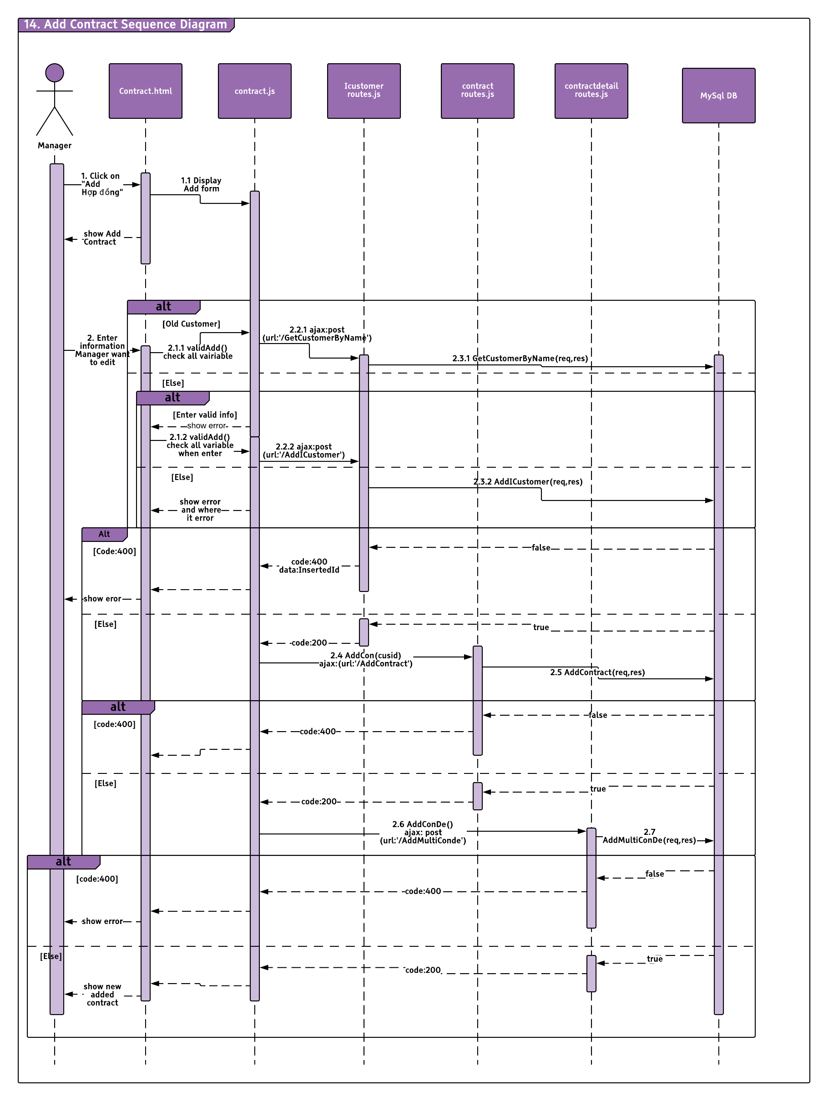

#### Edit Contract

##### Description

Manager can edit Contract.

##### Design

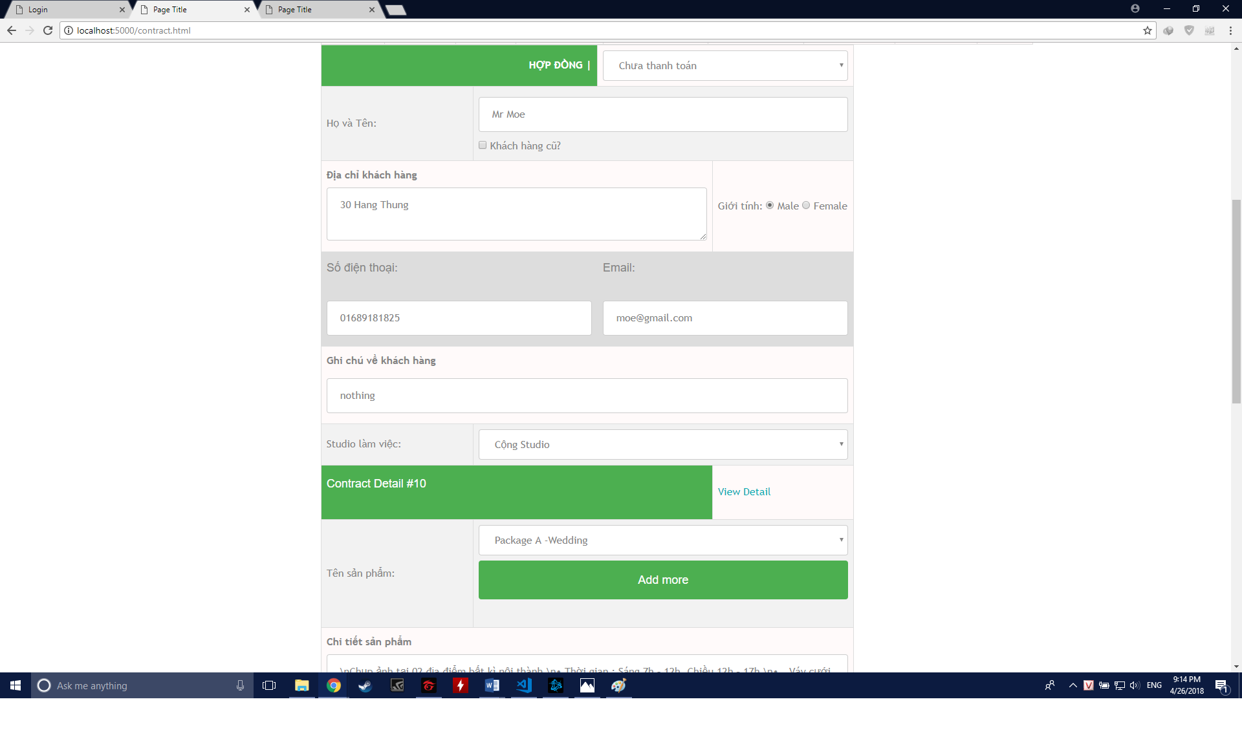

##### Class Diagram

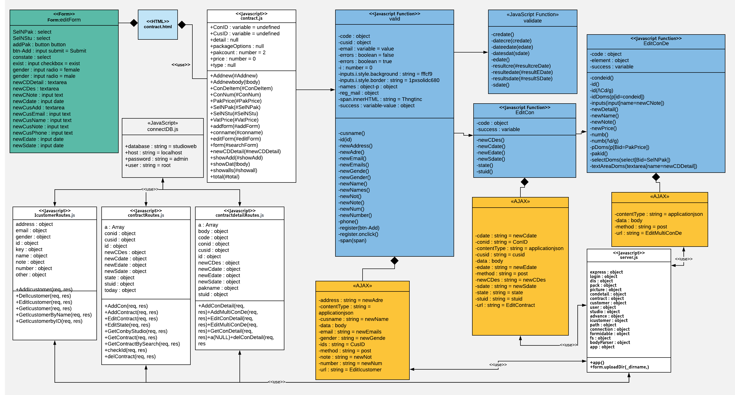

##### Class Specification

|  |  |  |  |  |
| --- | --- | --- | --- | --- |
| **Description** | Manager edit contract action | | | |
| **Base Class** | Controller | | | |
| **Source File** | contractrouter.js, IcustommerRouter.js, contractdetailrouter.js | | | |
| **Namespace** | app/public/routes/ | | | |
| **Attributes** | **N/A** | | | |
| **Methods** | **Name** | **Input** | **Output** | **Description** |
| EditICustomer | Request, result | View | Edit Custommer by Customer ID |
|  | EditContract | Request, result | View | Edit one Contract by Contract ID |
|  | EditMultiConDe | Request, result | view | Edit Contract Detail by Condetail ID |

##### Sequence Diagram

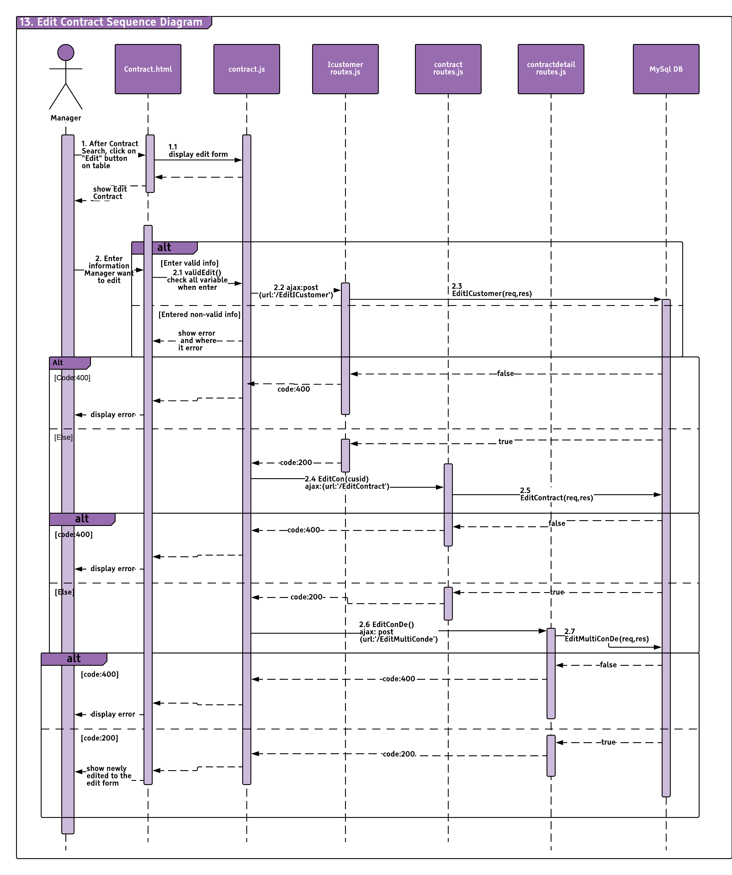

#### Search & View Package

##### Description

Manager can search and view Packkage.

##### Design

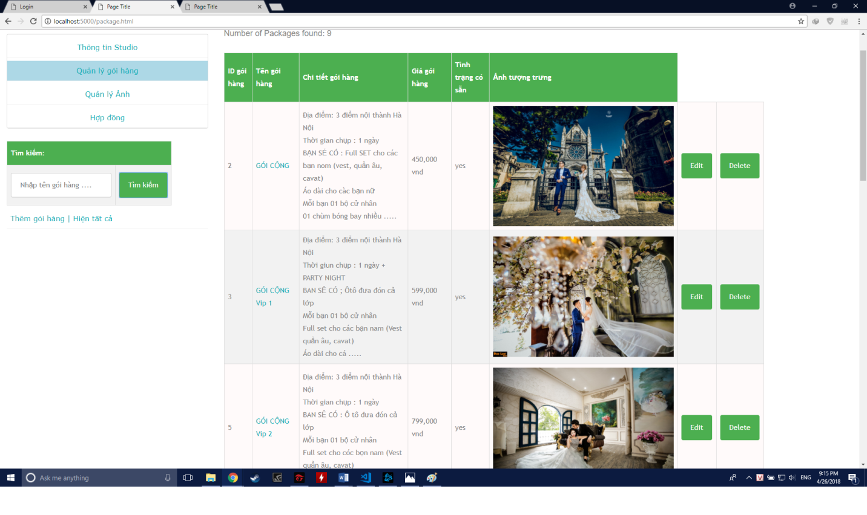

##### Class Diagram

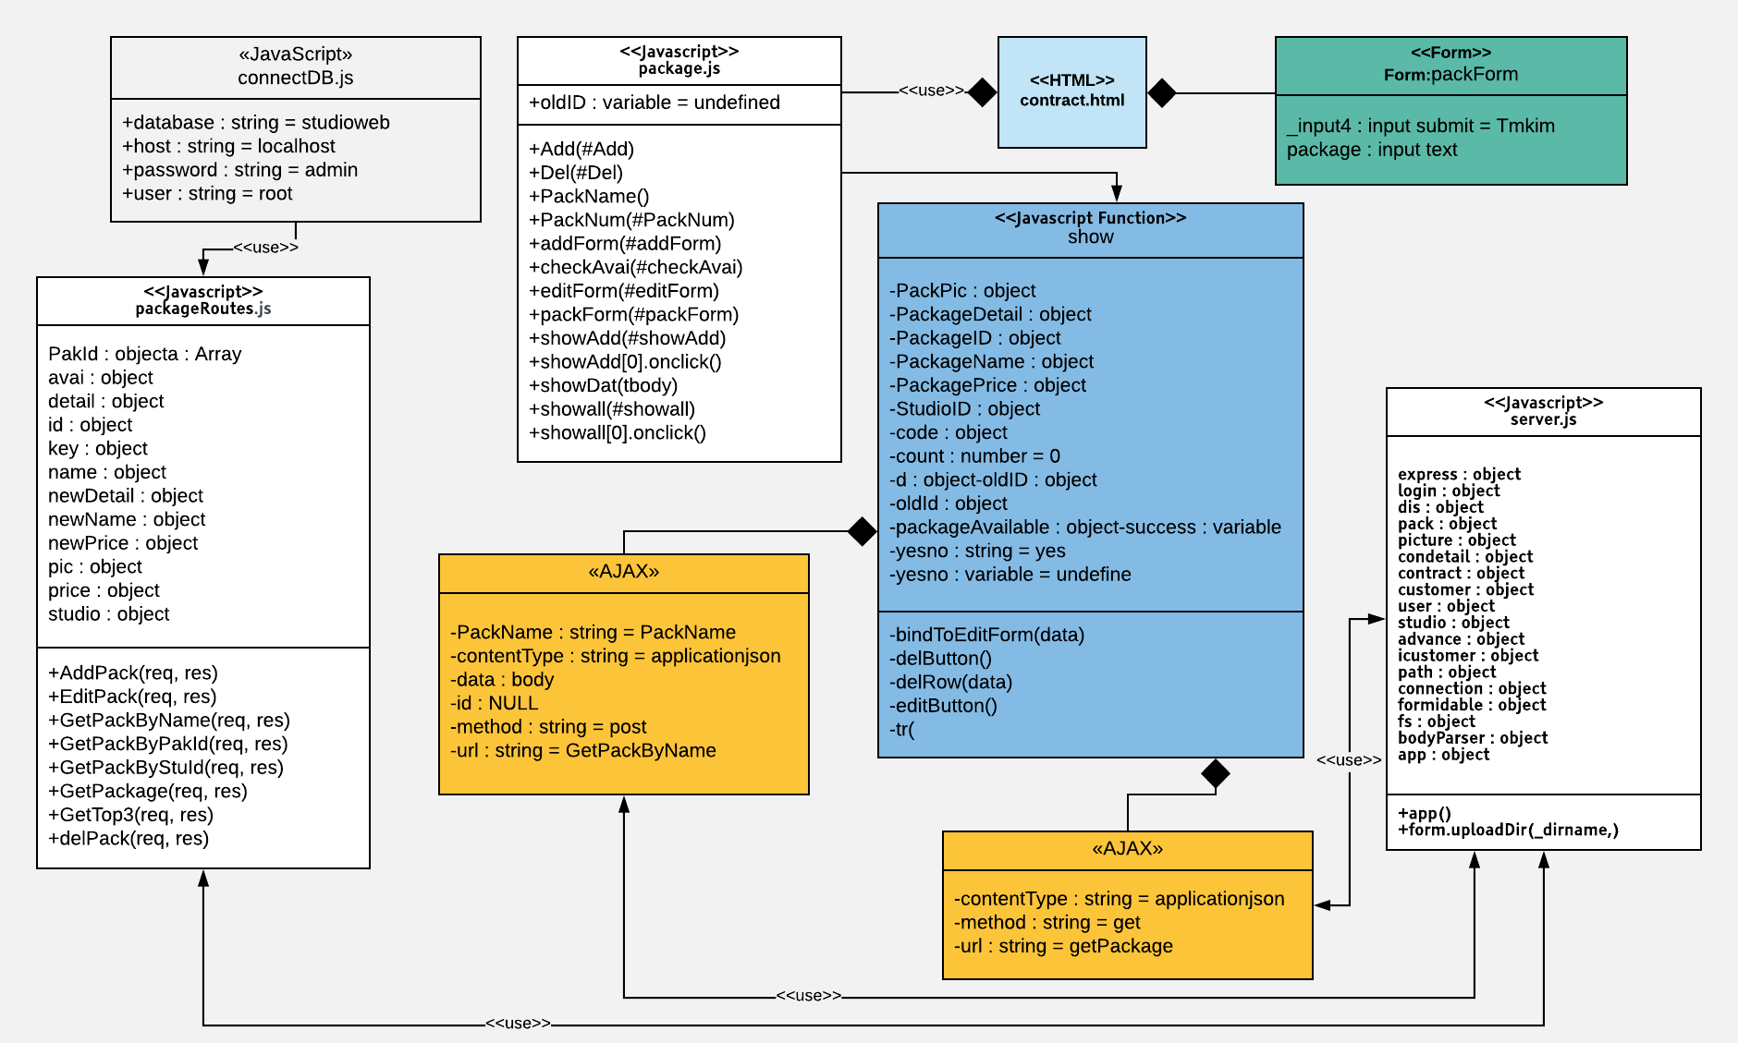

##### Class Specification

|  |  |  |  |  |
| --- | --- | --- | --- | --- |
| **Description** | Search and view package action | | | |
| **Base Class** | Controller | | | |
| **Source File** | packageRoutes.js | | | |
| **Namespace** | app/public/routes/ | | | |
| **Attributes** | **N/A** | | | |
| **Methods** | **Name** | **Input** | **Output** | **Description** |
| GetPacByName | Request, result | View | Get Package info by Name Package |

##### Sequence Diagram

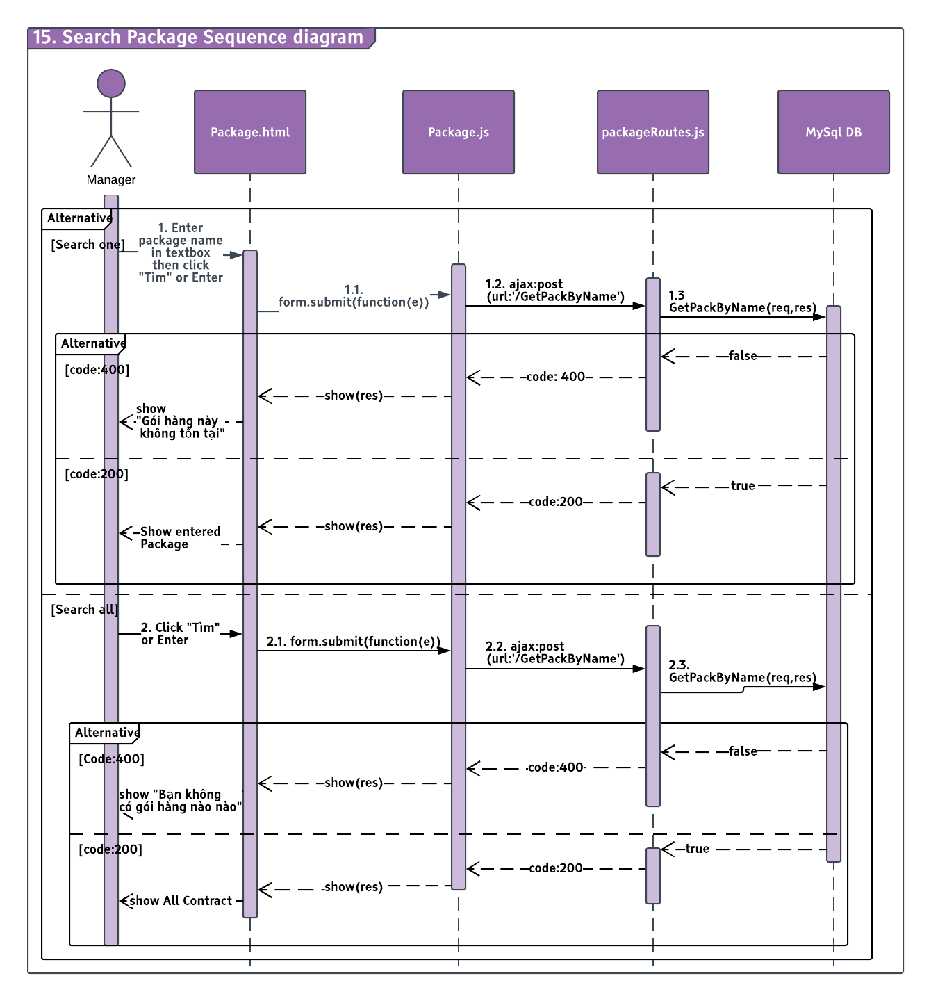

#### Add Package

##### Description

Manager can Add package.

##### Design

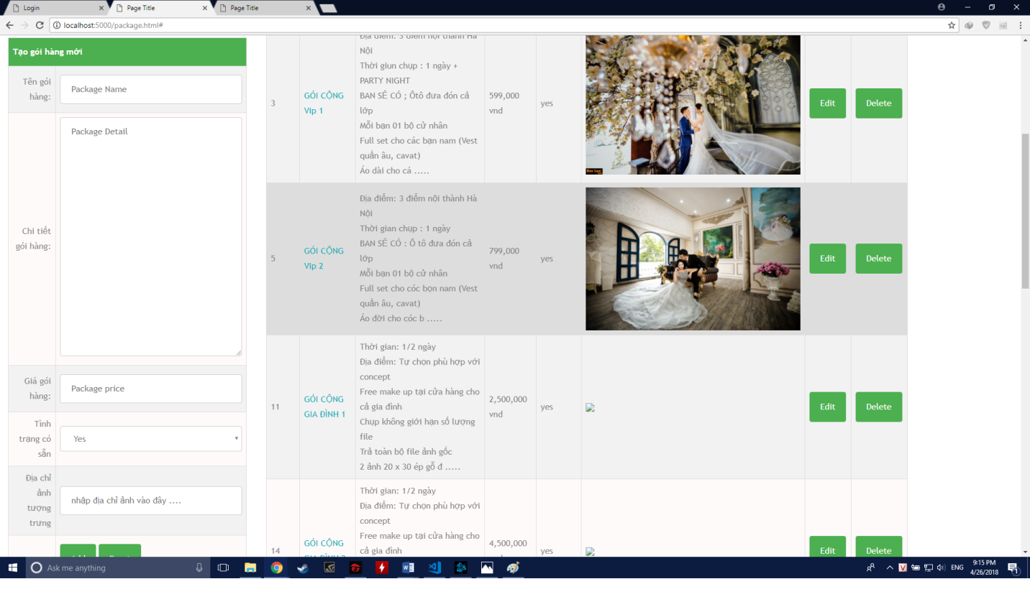

##### Class Diagram

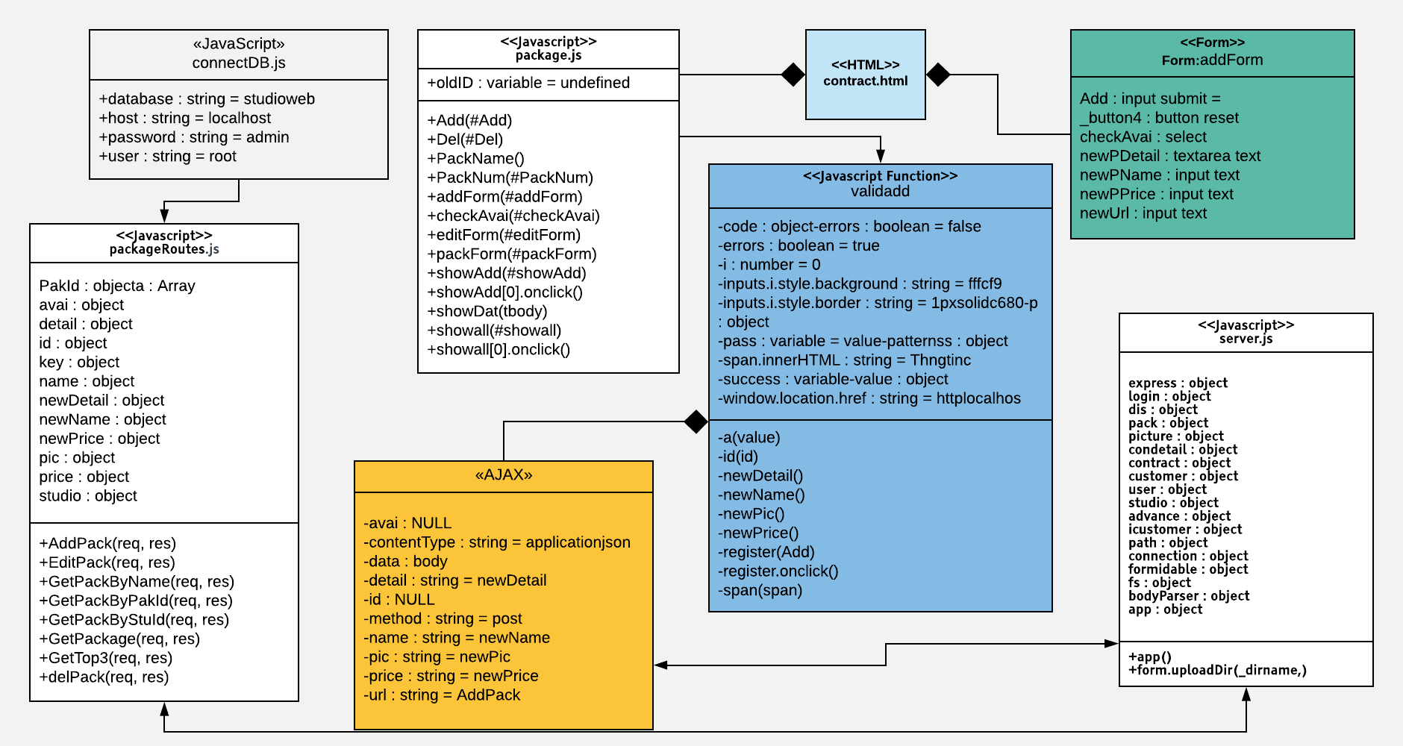

##### Class Specification

|  |  |  |  |  |
| --- | --- | --- | --- | --- |
| **Description** | Add pakage action | | | |
| **Base Class** | Controller | | | |
| **Source File** | packageRoutes.js | | | |
| **Namespace** | app/public/routes/ | | | |
| **Attributes** | **N/A** | | | |
| **Methods** | **Name** | **Input** | **Output** | **Description** |
| AddPack | Request, result | View | Add one package by Package ID |

##### Sequence Diagram

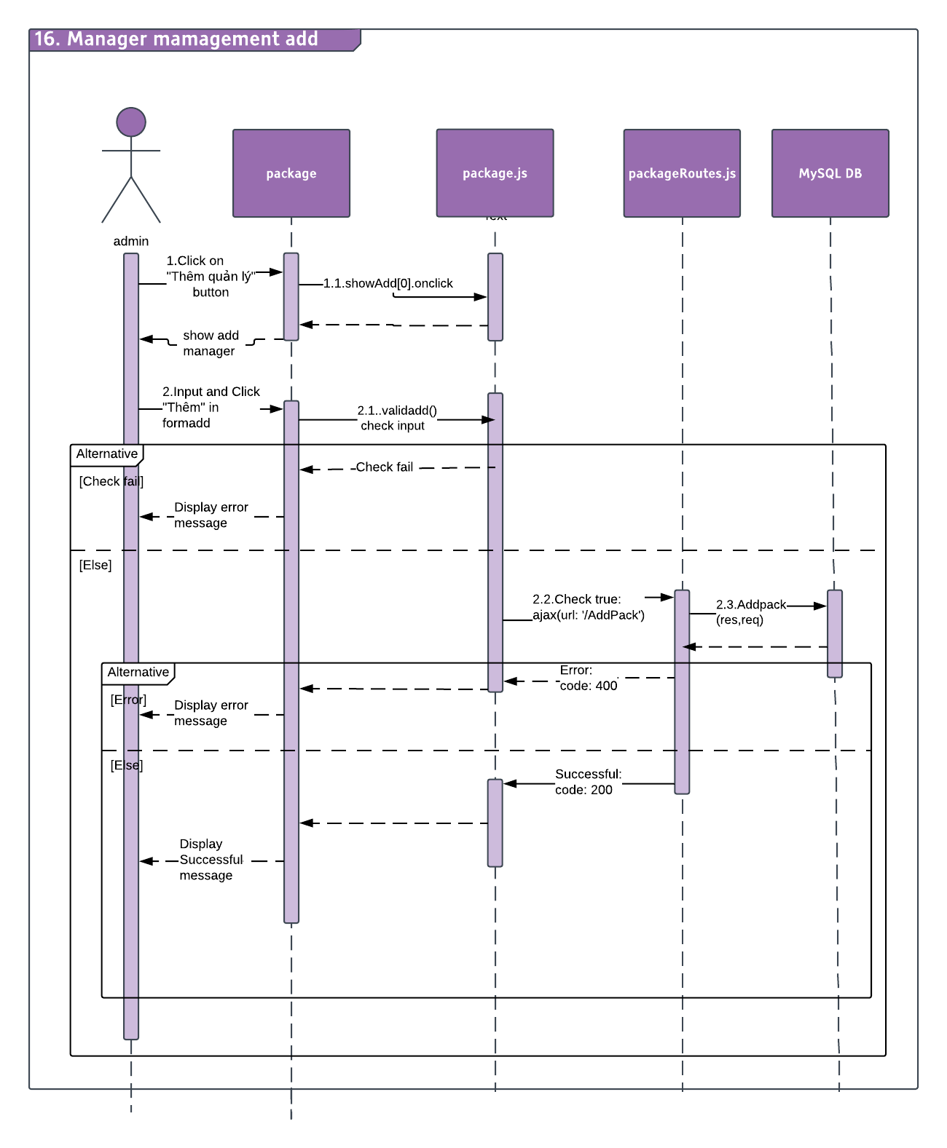

#### Edit Package

##### Description

Manager can edit package.

##### Design

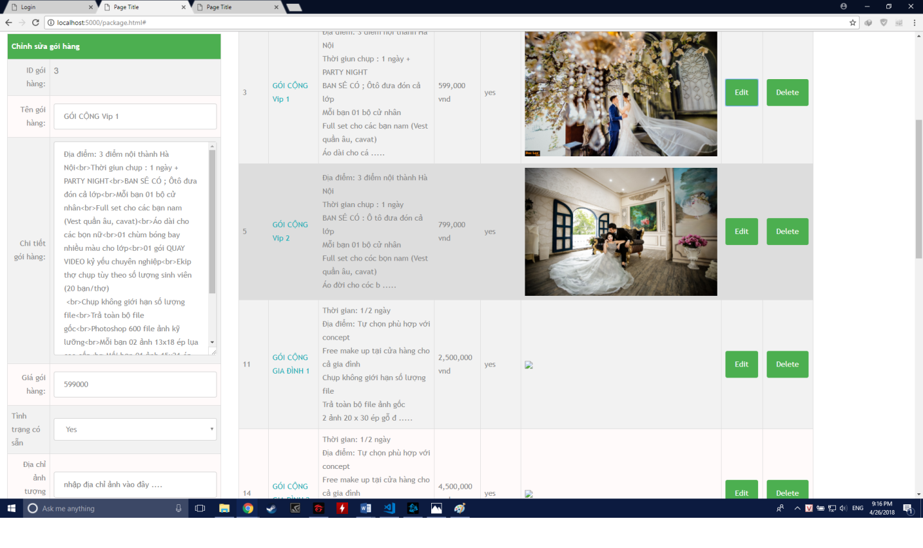

##### Class Diagram

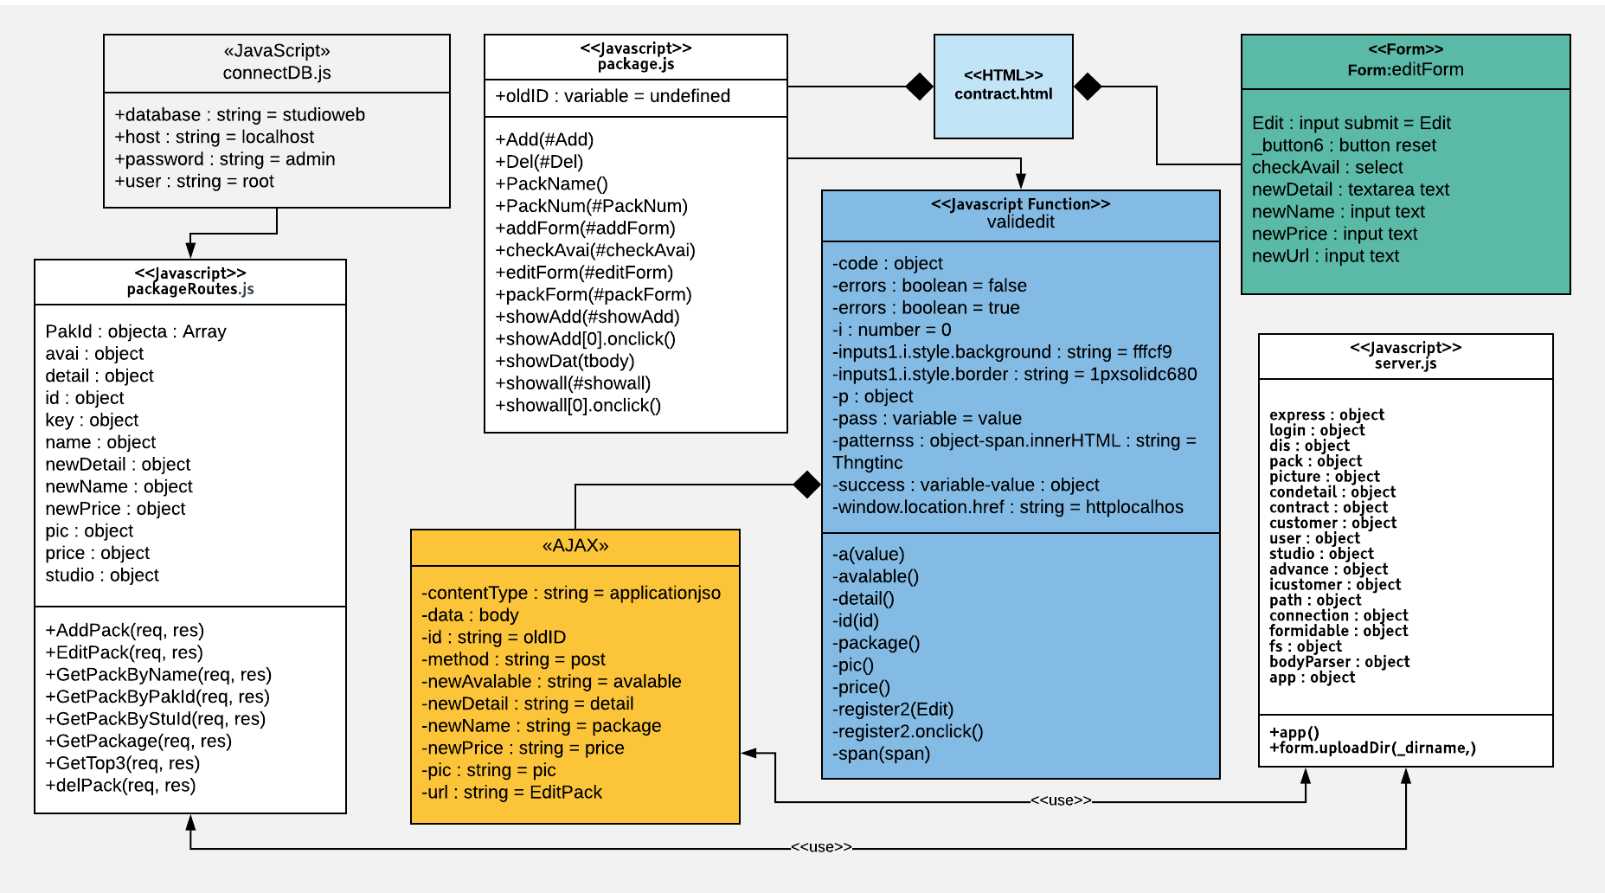

##### Class Specification

|  |  |  |  |  |
| --- | --- | --- | --- | --- |
| **Description** | Edit package action | | | |
| **Base Class** | Controller | | | |
| **Source File** | packageRoutes.js | | | |
| **Namespace** | app/public/routes/ | | | |
| **Attributes** | **N/A** | | | |
| **Methods** | **Name** | **Input** | **Output** | **Description** |
| EditPack | Request, result | View | Edit one package by Package ID |

##### Sequence Diagram

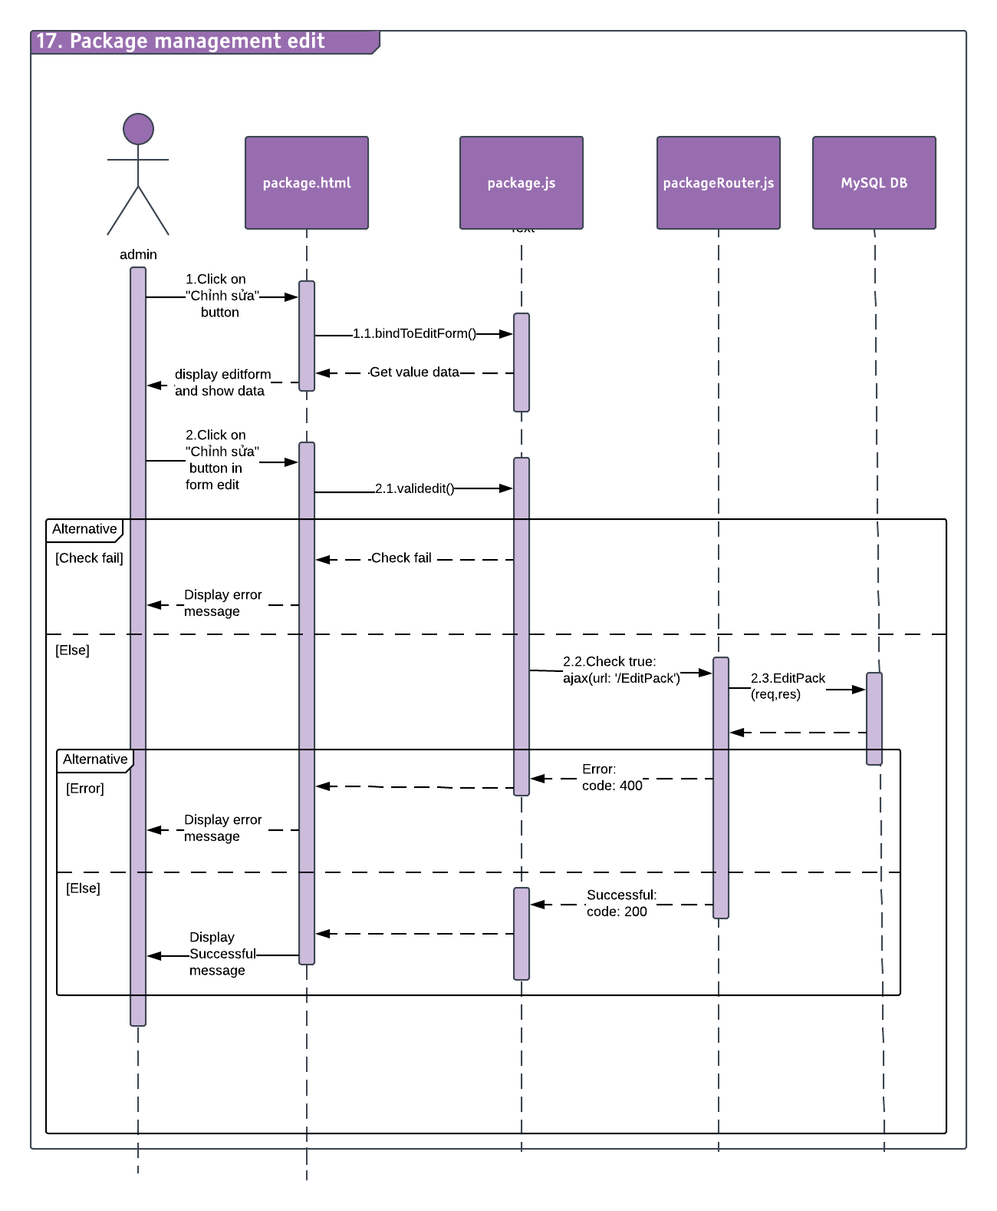

#### View Picture

##### Description

Manager can view picture.

##### Design

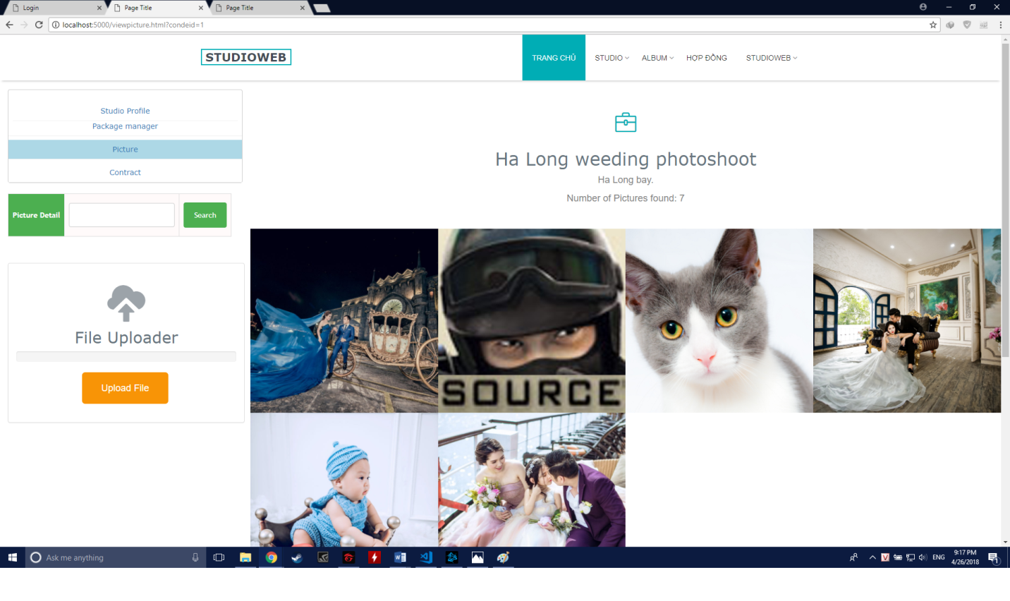

##### Class Diagram

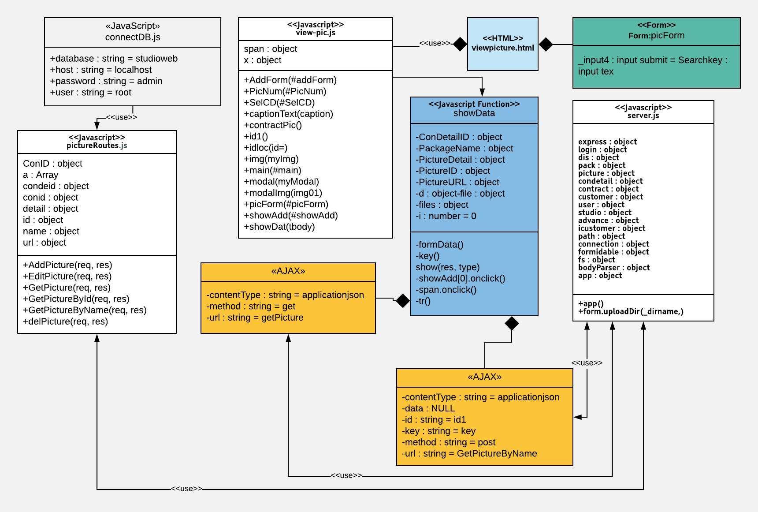

##### Class Specification

|  |  |  |  |  |
| --- | --- | --- | --- | --- |
| **Description** | Edit package action | | | |
| **Base Class** | Controller | | | |
| **Source File** | pictureRoutes.js | | | |
| **Namespace** | app/public/routes/ | | | |
| **Attributes** | **N/A** | | | |
| **Methods** | **Name** | **Input** | **Output** | **Description** |
| GetPicture | Request, result | View | Get Picture info by Name ID |

##### Sequence Diagram

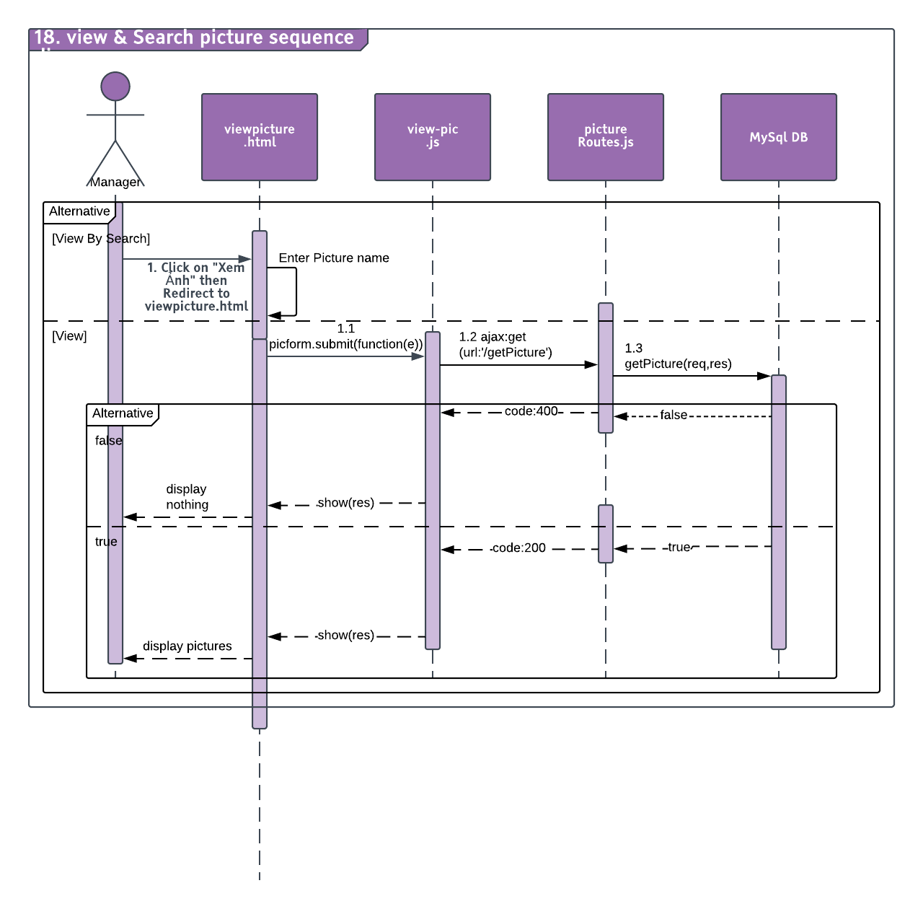

#### Edit Picture Info

##### Description

Manager can edit Picture info

##### Design

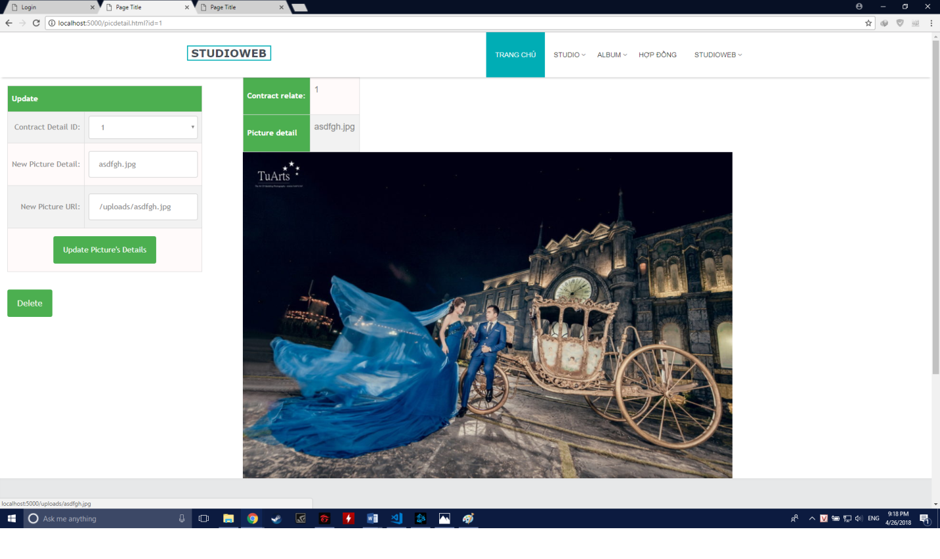

##### Class Diagram

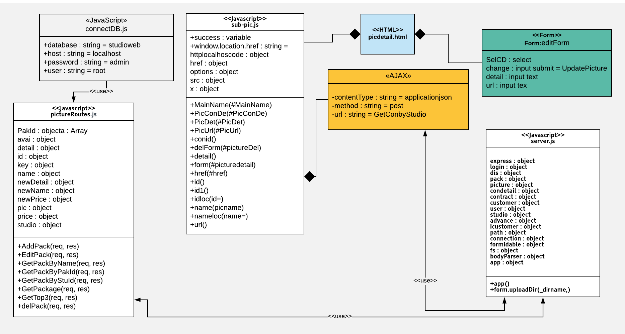

##### Class Specification

|  |  |  |  |  |
| --- | --- | --- | --- | --- |
| **Description** | Edit picture action | | | |
| **Base Class** | Controller | | | |
| **Source File** | packageRoutes.js | | | |
| **Namespace** | app/public/routes/ | | | |
| **Attributes** | **N/A** | | | |
| **Methods** | **Name** | **Input** | **Output** | **Description** |
|  | Request, result | View |  |

##### Sequence Diagram

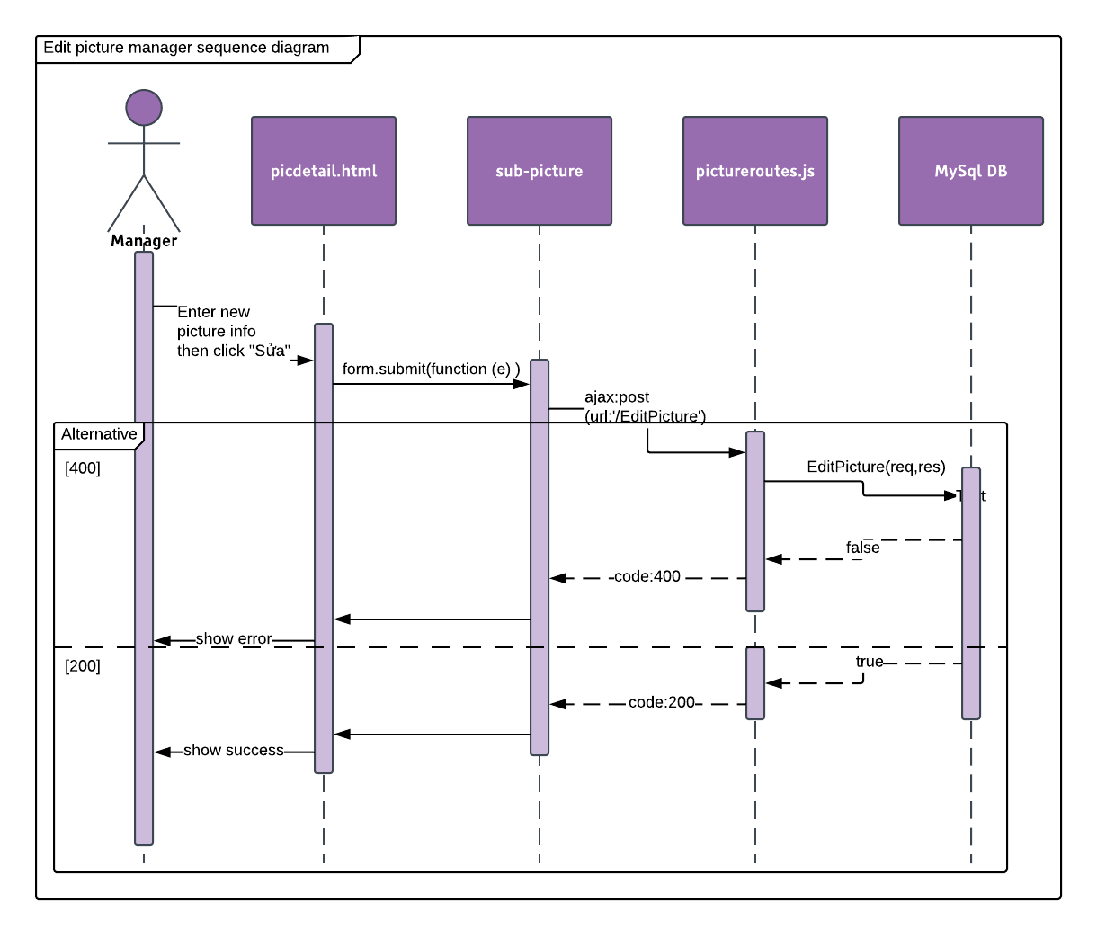

#### Upload Picture

##### Description

Manager can upload picture.

##### Design

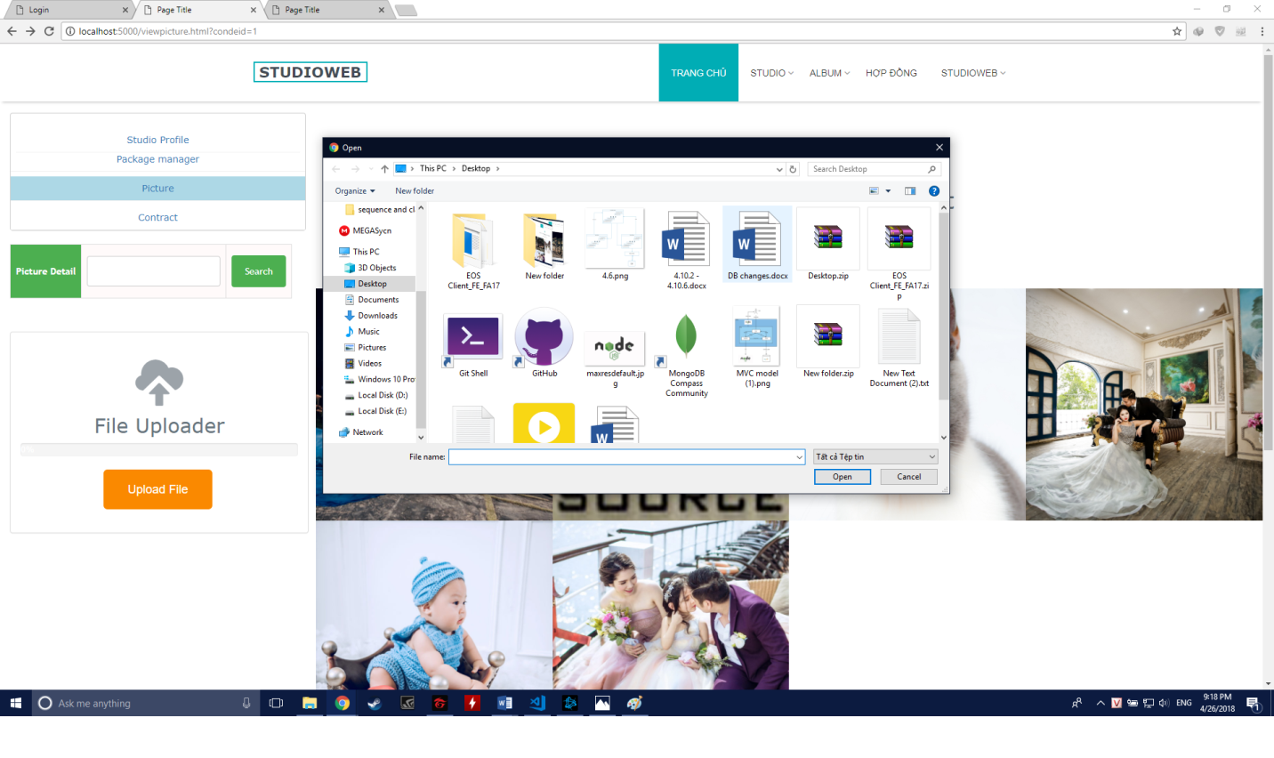

##### Class Diagram

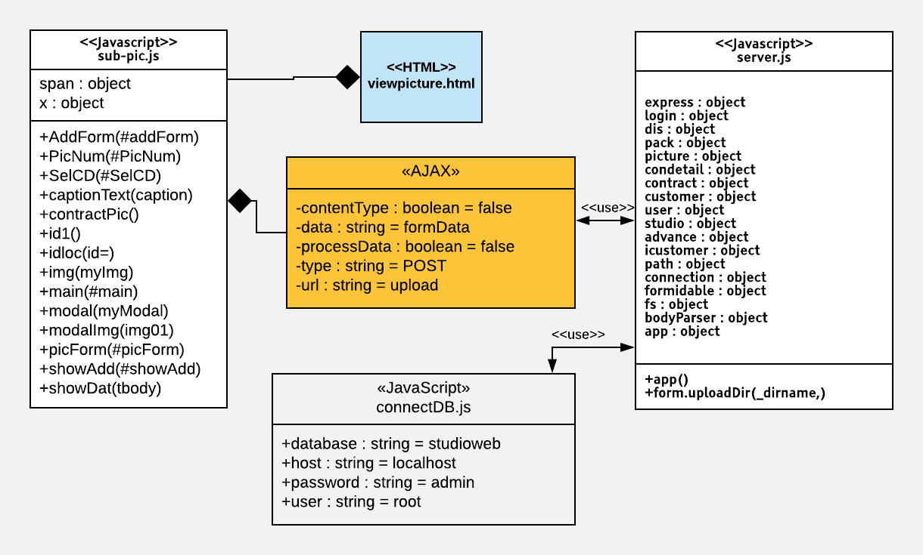

##### Class Specification

|  |  |  |  |  |
| --- | --- | --- | --- | --- |
| **Description** | Upload picture action | | | |
| **Base Class** | Controller | | | |
| **Source File** | pictureRoutes.js | | | |
| **Namespace** | app/public/routes/ | | | |
| **Attributes** | **N/A** | | | |
| **Methods** | **Name** | **Input** | **Output** | **Description** |
| upload | Request, result | View | Upload picture |

##### Sequence Diagram

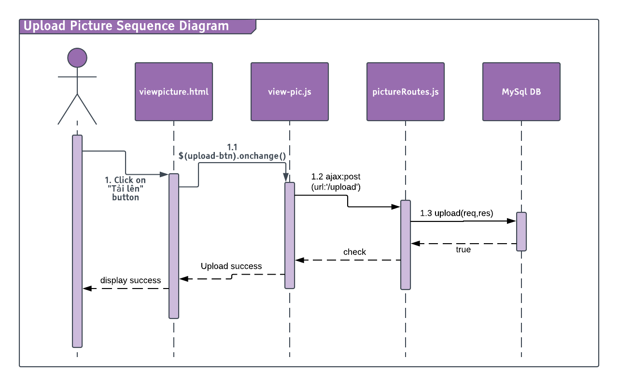

#### Delete Picture

##### Description

Manager can delete picture.

##### Design

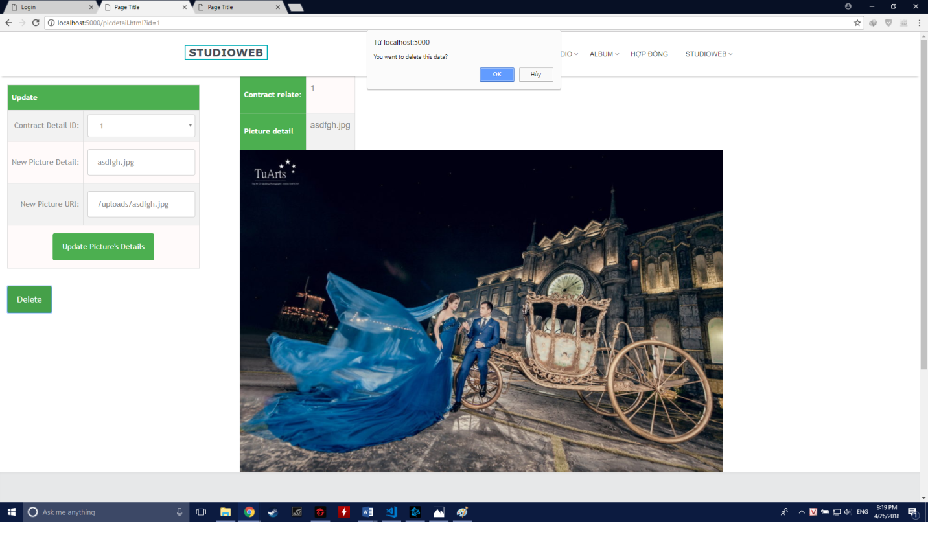

##### Class Diagram

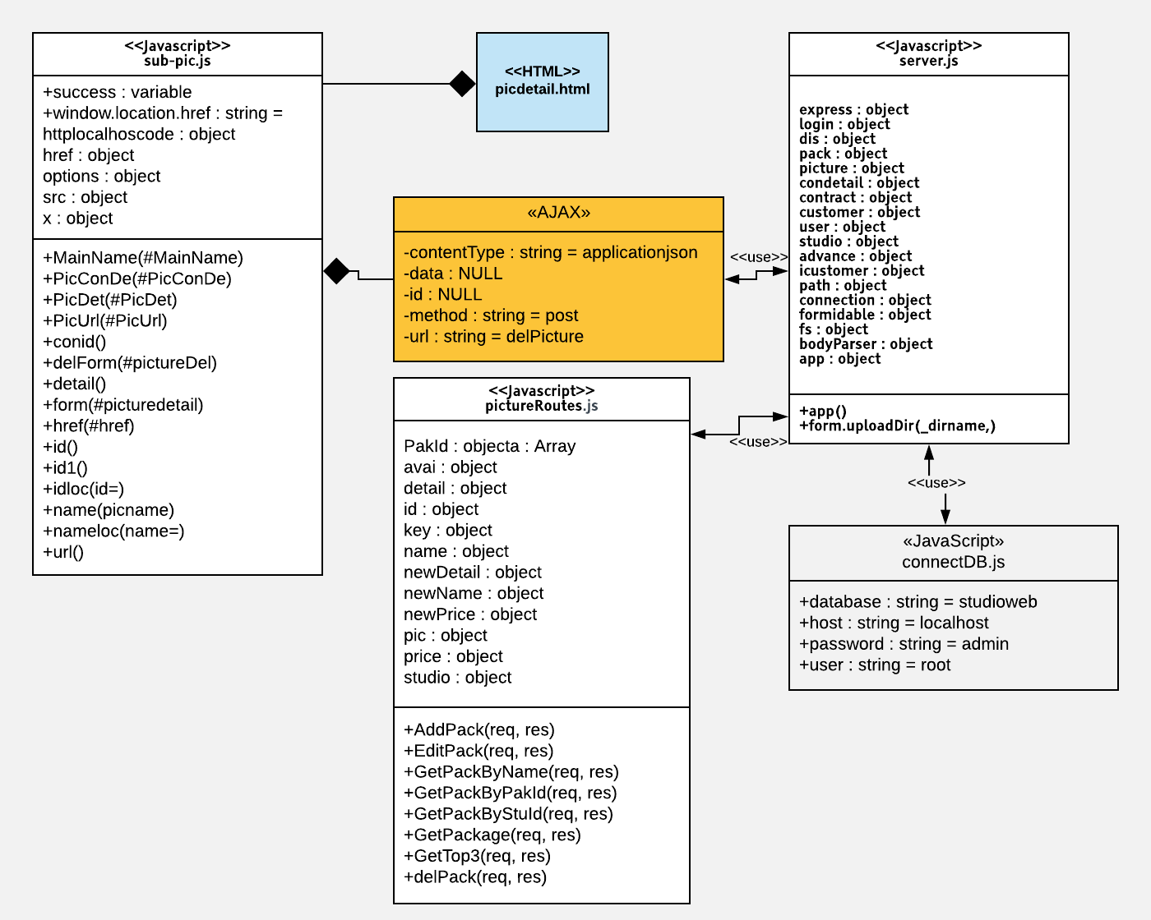

##### Class Specification

|  |  |  |  |  |
| --- | --- | --- | --- | --- |
| **Description** | Upload picture action | | | |
| **Base Class** | Controller | | | |
| **Source File** | pictureRoutes.js | | | |
| **Namespace** | app/public/routes/ | | | |
| **Attributes** | **N/A** | | | |
| **Methods** | **Name** | **Input** | **Output** | **Description** |
| DelPicture | Request, result | View | Delete picture by ID |

##### Sequence Diagram

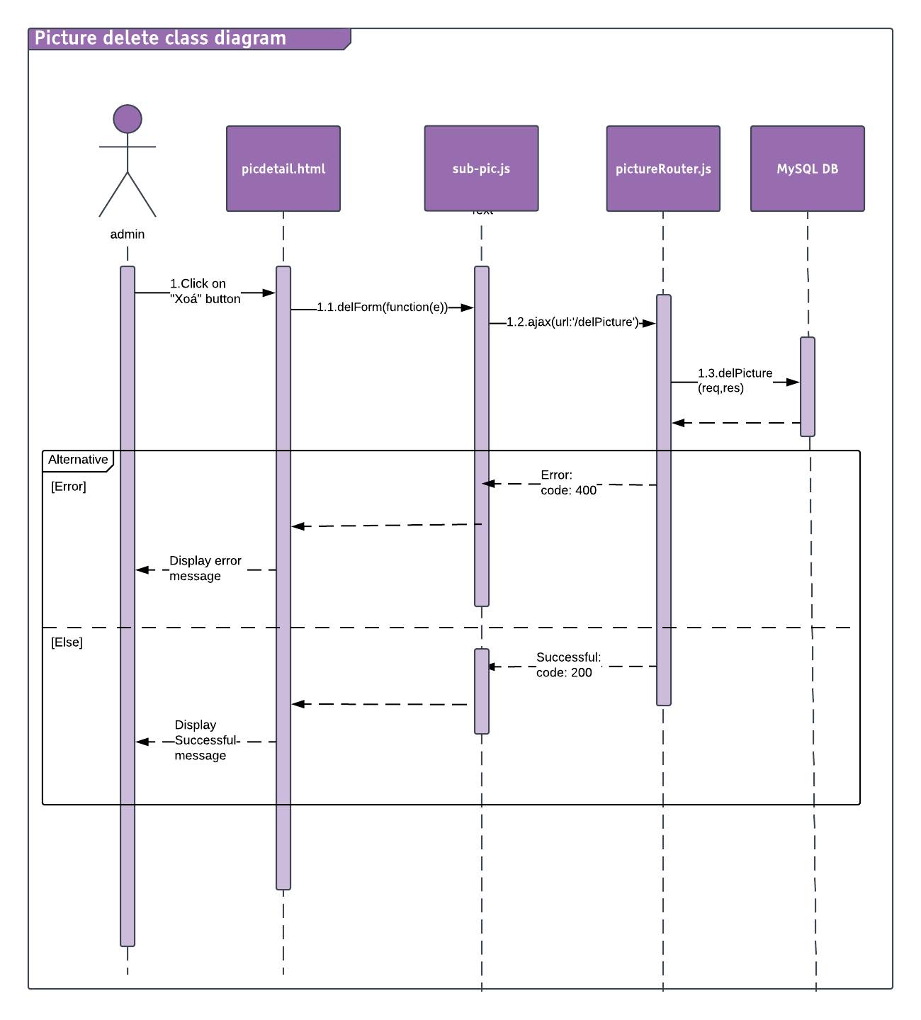

#### View Customer Information

##### Description

Manager can view Customer Information

##### Design

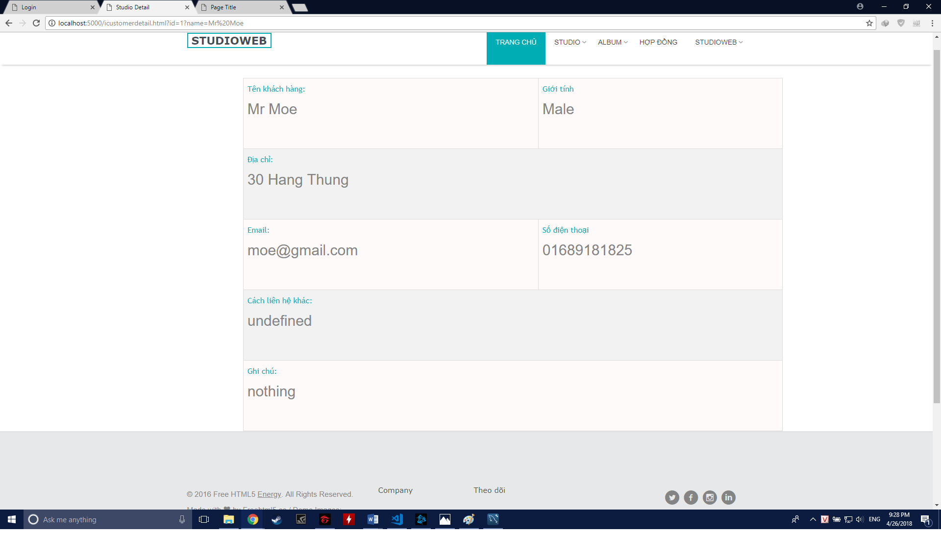

##### Class Diagram

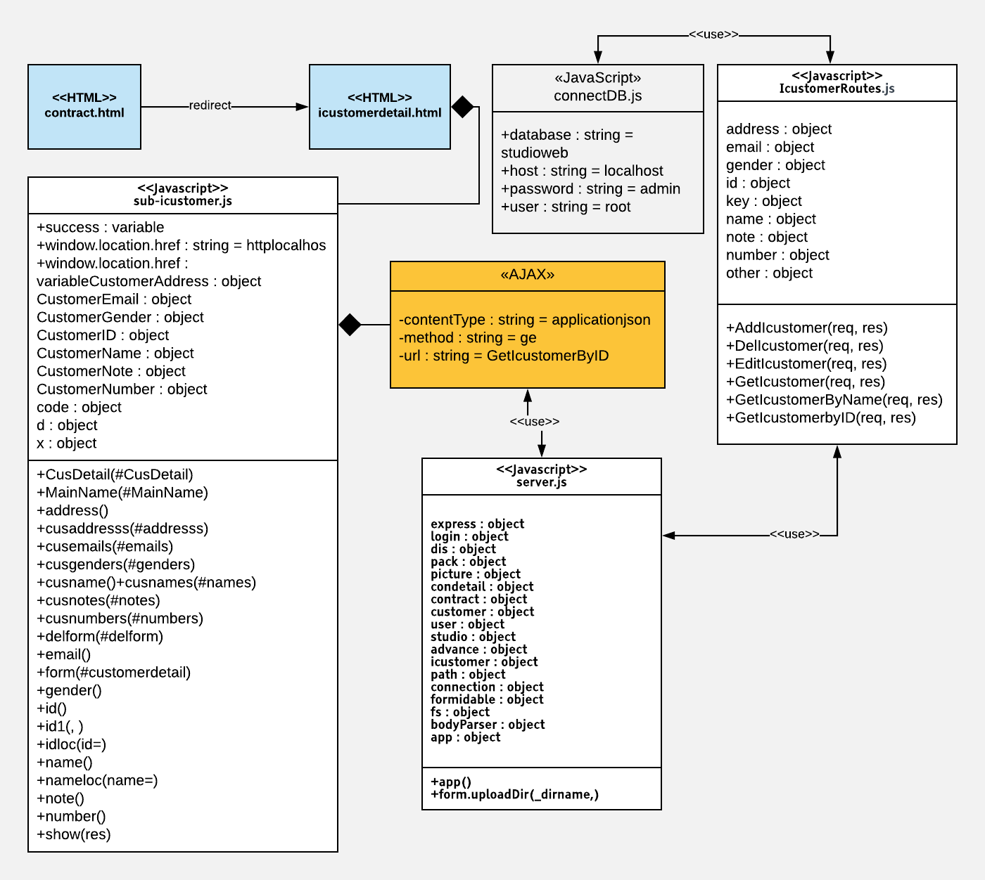

##### Class Specification

|  |  |  |  |  |
| --- | --- | --- | --- | --- |
| **Description** | Get customer information by name | | | |
| **Base Class** | Controller | | | |
| **Source File** | customerRoutes.js | | | |
| **Namespace** | app/public/routes/ | | | |
| **Attributes** | **N/A** | | | |
| **Methods** | **Name** | **Input** | **Output** | **Description** |
| GetICustomerByID | Request, result | View | Get Customer info by ID |

##### Sequence Diagram

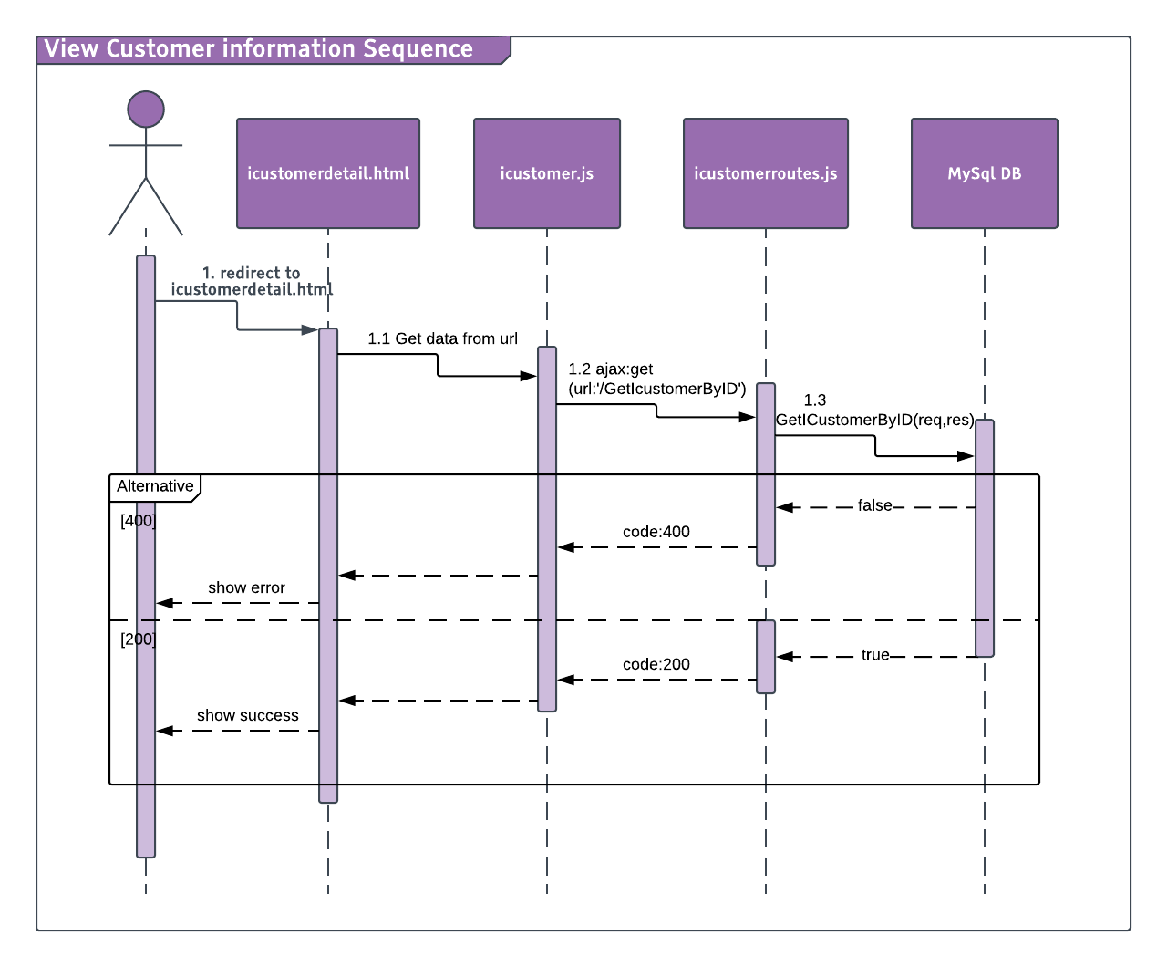

### Customer

#### See Studio Information

##### Description

Customer can see Studio basic information and location.

##### Design

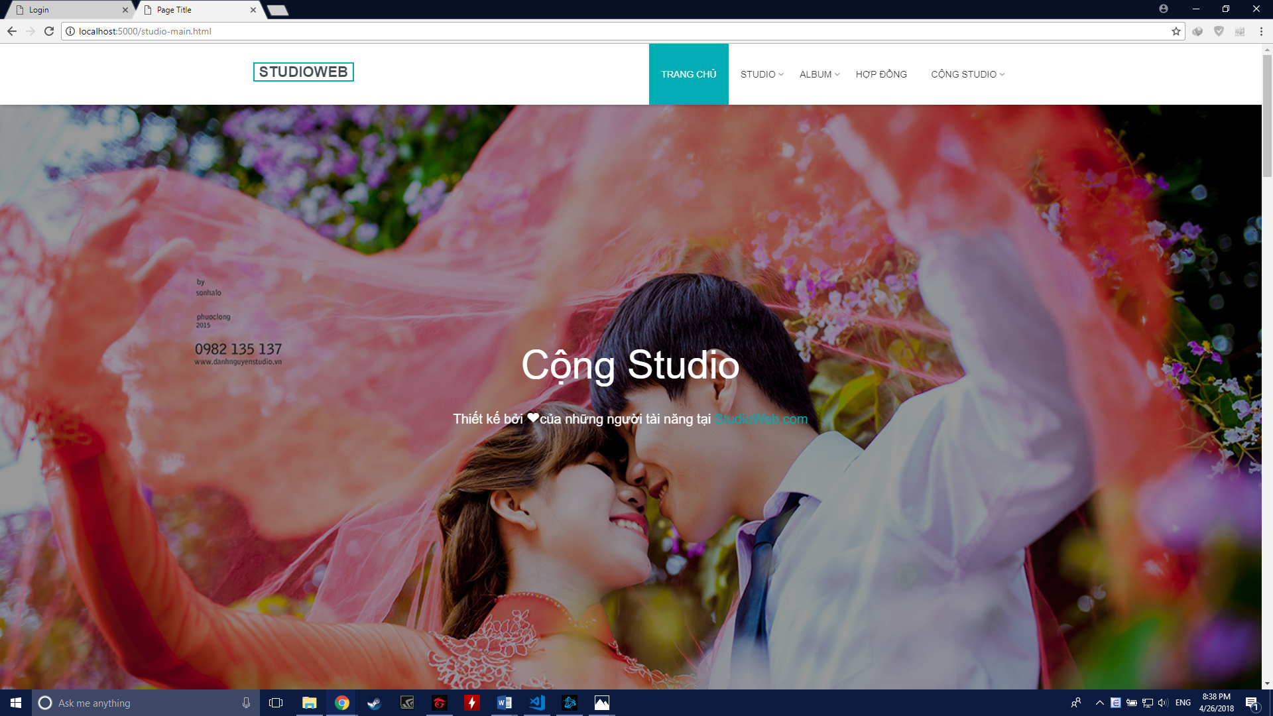

##### Class Diagram

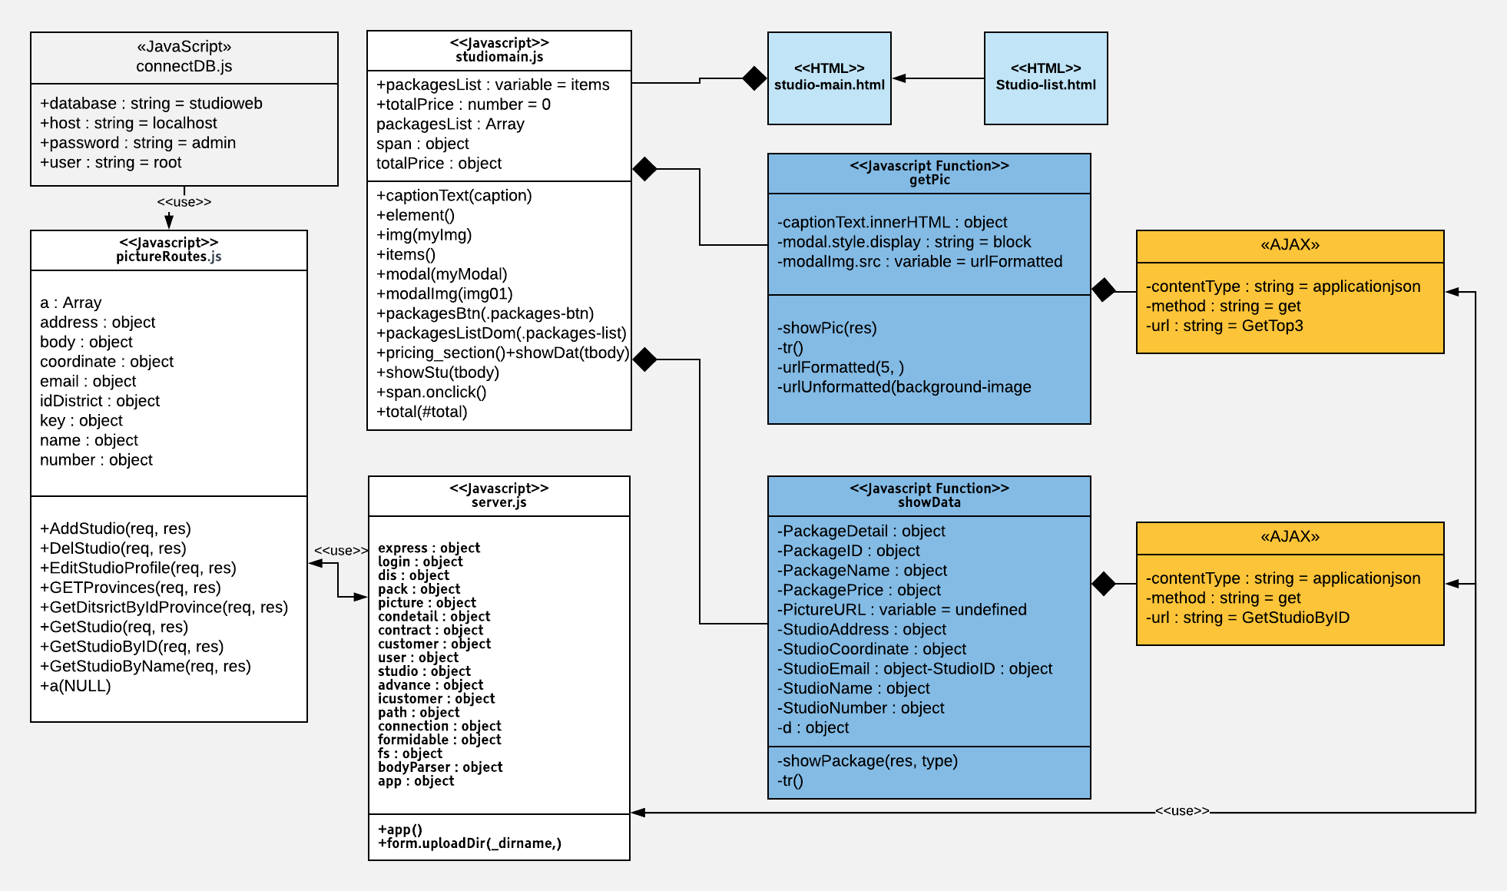

##### Class Specification

|  |  |  |  |  |
| --- | --- | --- | --- | --- |
| **Description** | Get Studio information | | | |
| **Base Class** | Controller | | | |
| **Source File** | studioRoutes.js | | | |
| **Namespace** | app/public/routes/ | | | |
| **Attributes** | **N/A** | | | |
| **Methods** | **Name** | **Methods** | **Output** | **Description** |
| GetStudioByID | Request, result | view | Get studio information By Studio ID to bind |

|  |  |  |  |  |
| --- | --- | --- | --- | --- |
| **Description** | Get 3 package to show | | | |
| **Base Class** | Controller | | | |
| **Source File** | packageRoutes.js | | | |
| **Namespace** | app/public/routes/ | | | |
| **Attributes** | **N/A** | | | |
| **Methods** | **Name** | **Methods** | **Output** | **Description** |
| GetTop3 | Request, result | view | Get top 3 first package of the current studio page |

##### Sequence Diagram

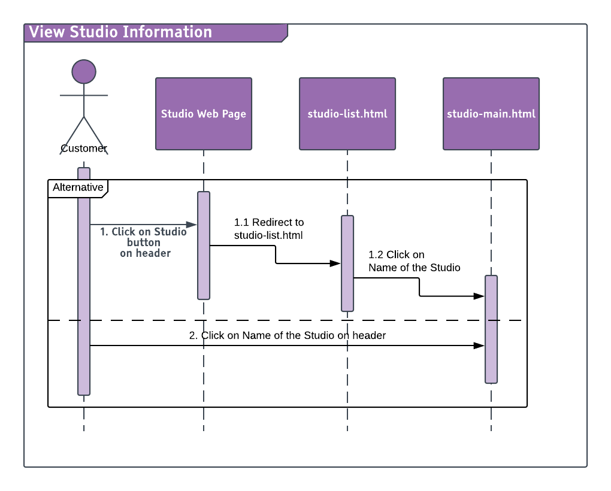

#### See Album

##### Description

Customer can see sample album.

##### Design

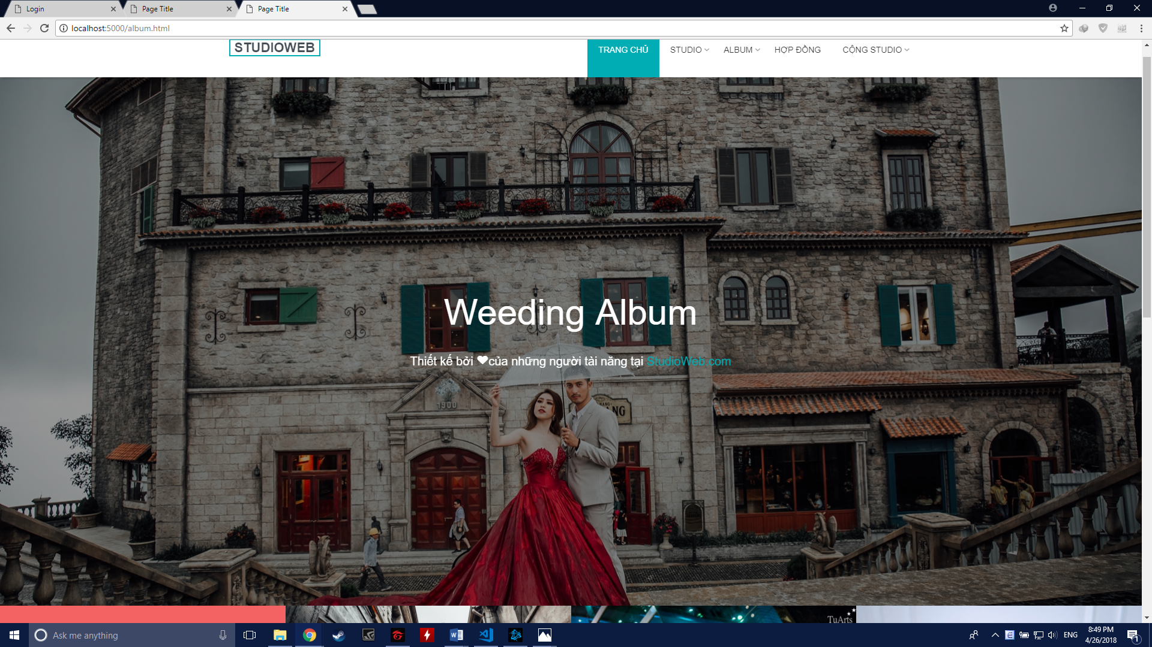

##### Class Diagram

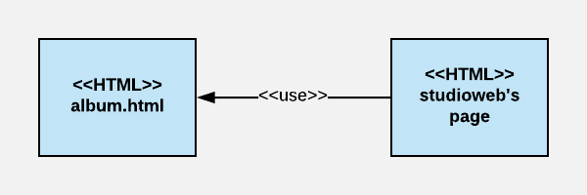

##### Sequence Diagram

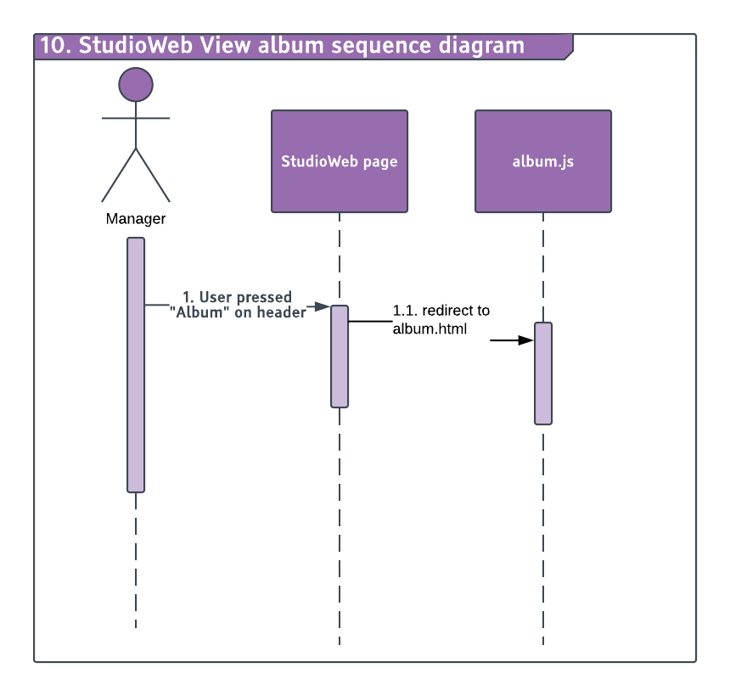

#### See package Information

##### Description

Customer can see Package detail information.

##### Design

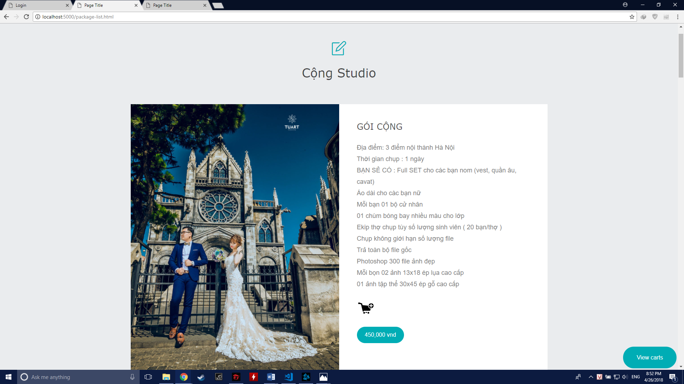

##### Class Diagram

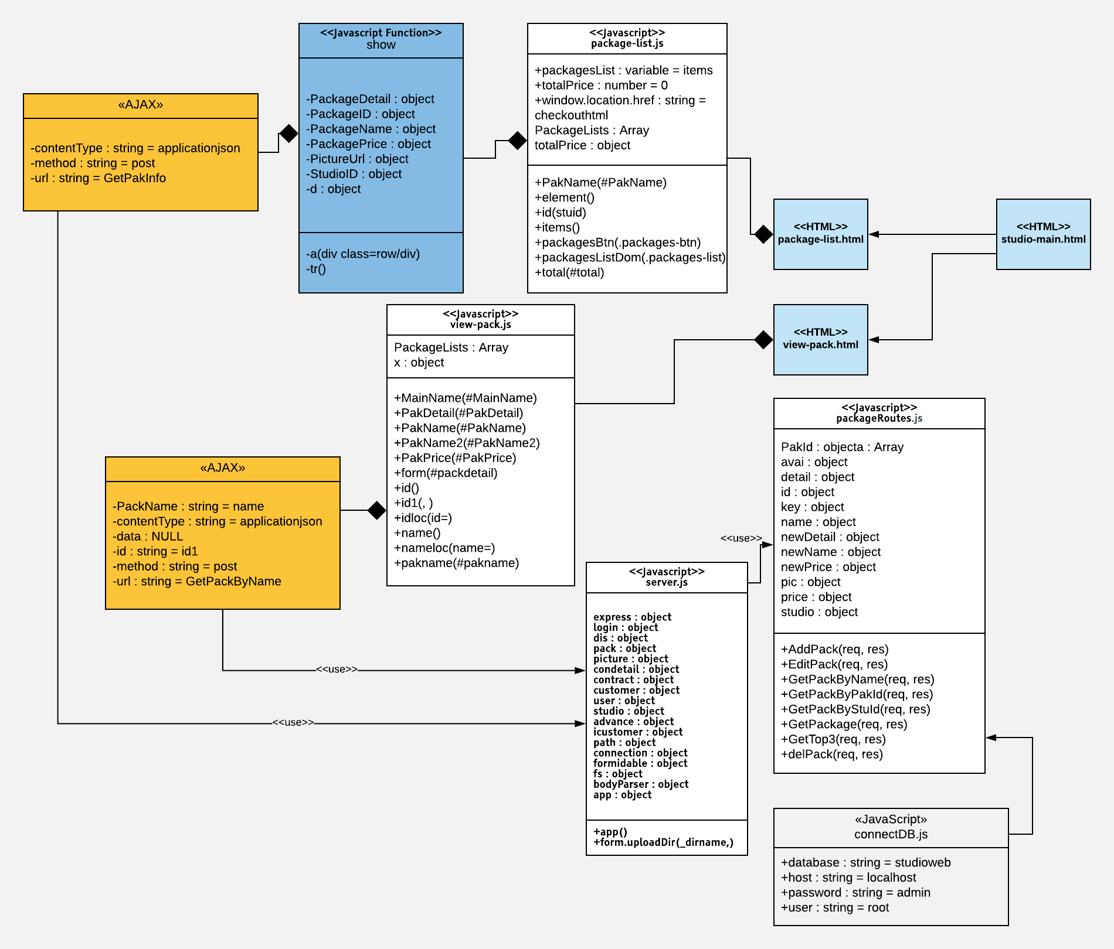

##### Class Specification

|  |  |  |  |  |
| --- | --- | --- | --- | --- |
| **Description** | Get package info | | | |
| **Base Class** | Controller | | | |
| **Source File** | packageRoutes.js | | | |
| **Namespace** | app/public/routes/ | | | |
| **Attributes** | **N/A** | | | |
| **Methods** | **Name** | **Methods** | **Output** | **Description** |
| GetPakInfo | Request, result | view | Get all package information by Studio ID |
|  | GetPackByName | Request, result | View | Get package information by Studio name |

##### Sequence Diagram

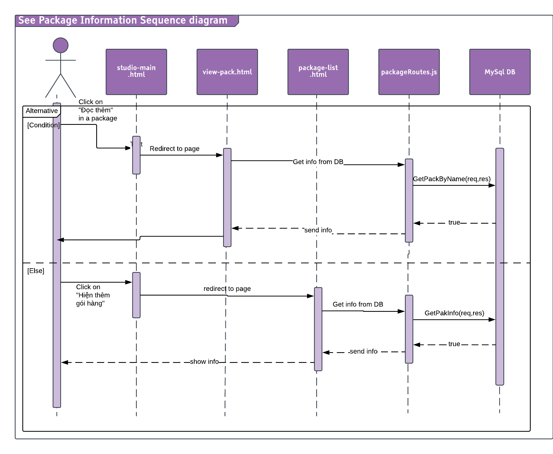

#### Order photo and leave information

##### Description

Customer can order a photo package and leave contact information.

##### Design

##### Class Diagram

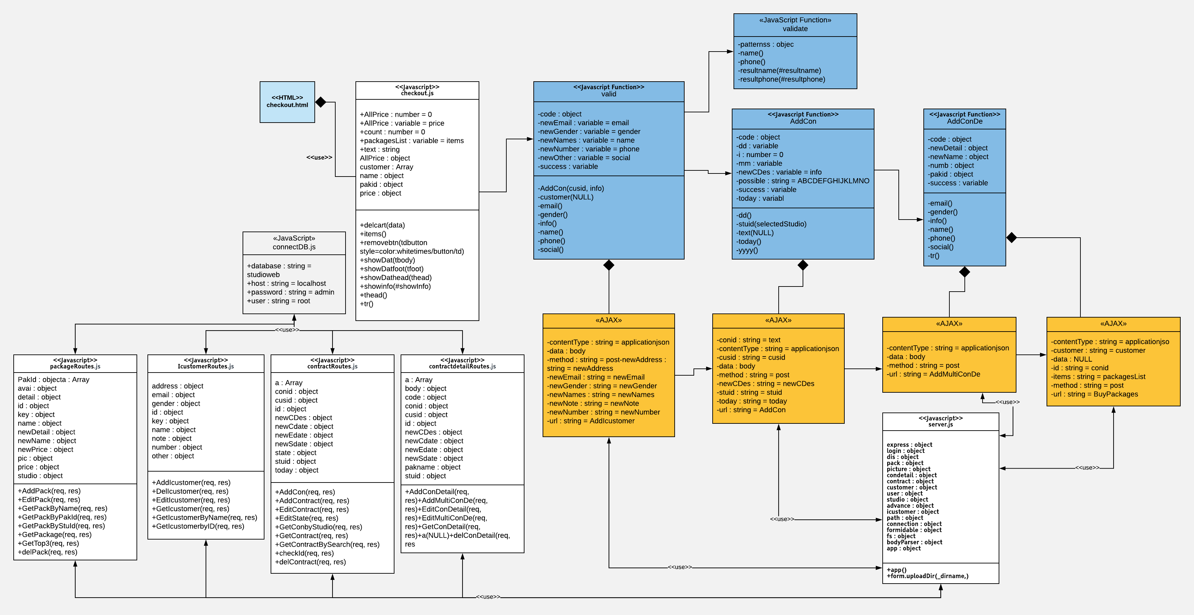

##### Class Specification

|  |  |  |  |  |
| --- | --- | --- | --- | --- |
| **Description** | Customer leave information and order for Manager to add contract action | | | |
| **Base Class** | Controller | | | |
| **Source File** | contractrouter.js, IcustommerRouter.js, contractdetailrouter.js, packageroutes.js | | | |
| **Namespace** | app/public/routes/ | | | |
| **Attributes** | **N/A** | | | |
| **Methods** | **Name** | **Input** | **Output** | **Description** |
| GetcustomByName | Request, result | View | Get Customer by Custummer Name |
|  | AddIcustomer | Request, result | View | Add new customer |
|  | AddContract | Request, result | View | Add new contract |
|  | AddMultiConDe | Request, result | View | Add new Contract Detail |
|  | BuyPackage | Request, result | View | After successful purchase, a new contract is created then it will send email to Customer about the detail of the contract |

##### Sequence Diagram

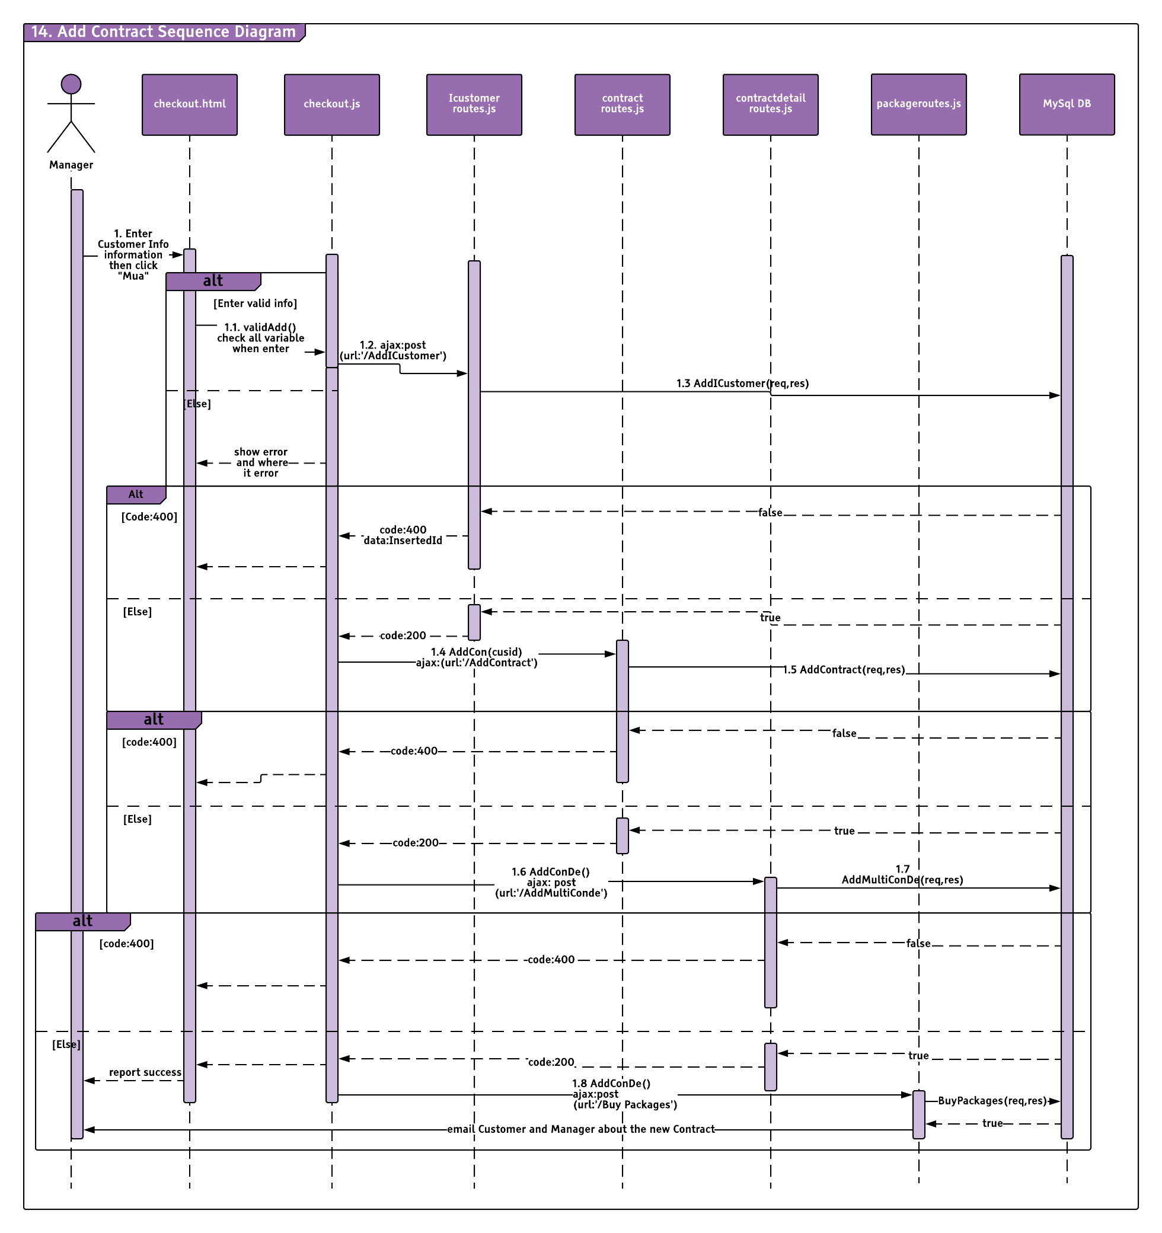

#### View Contract

##### Description

Customer can see and keep track of photo contract

##### Design

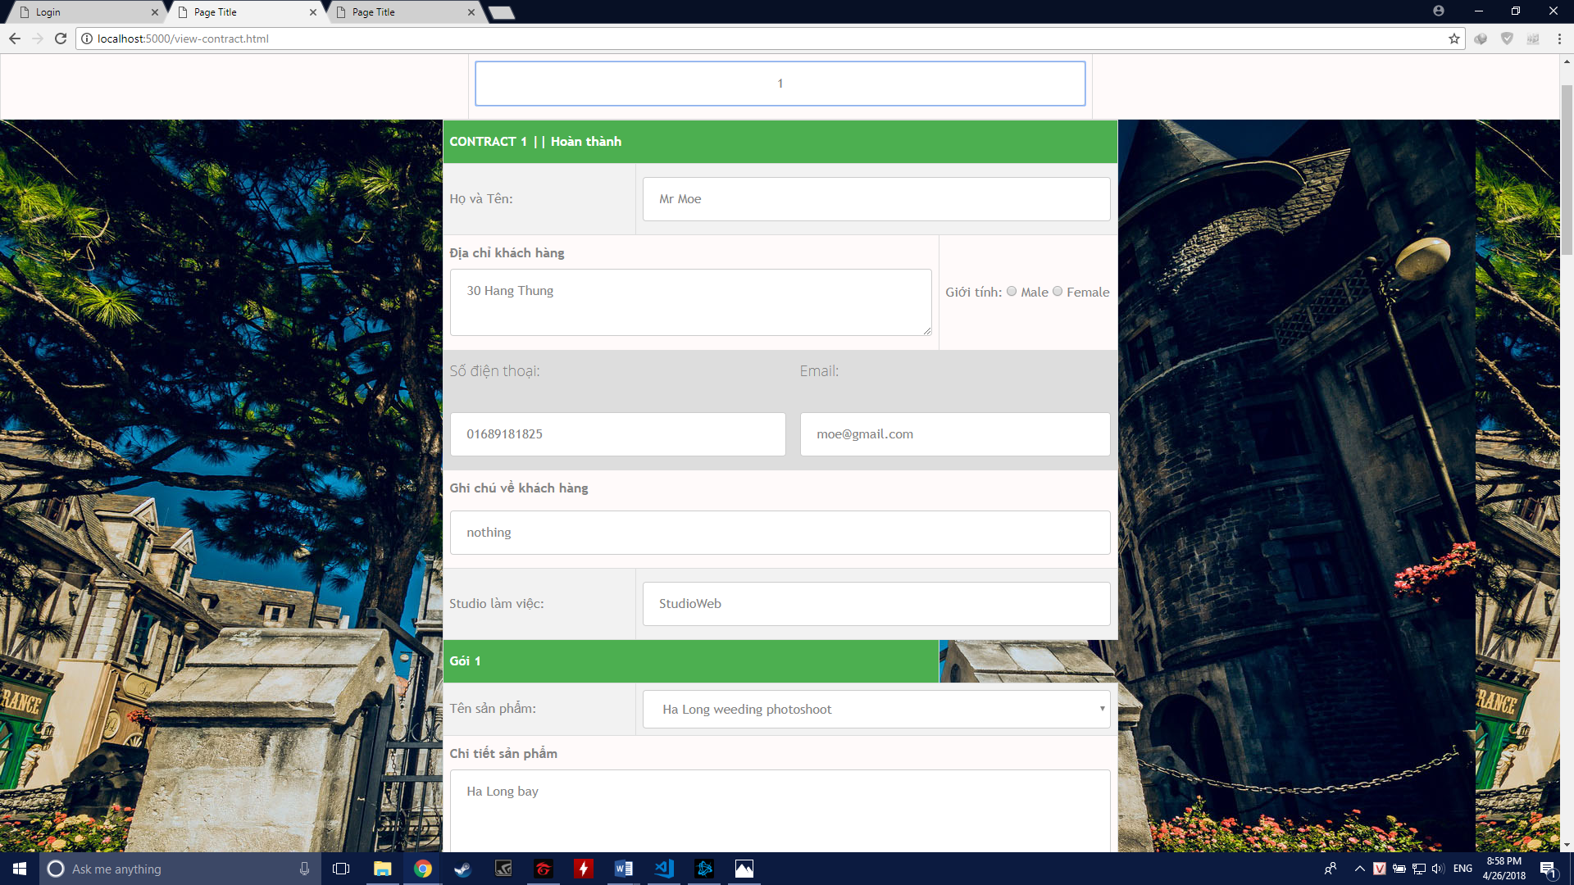

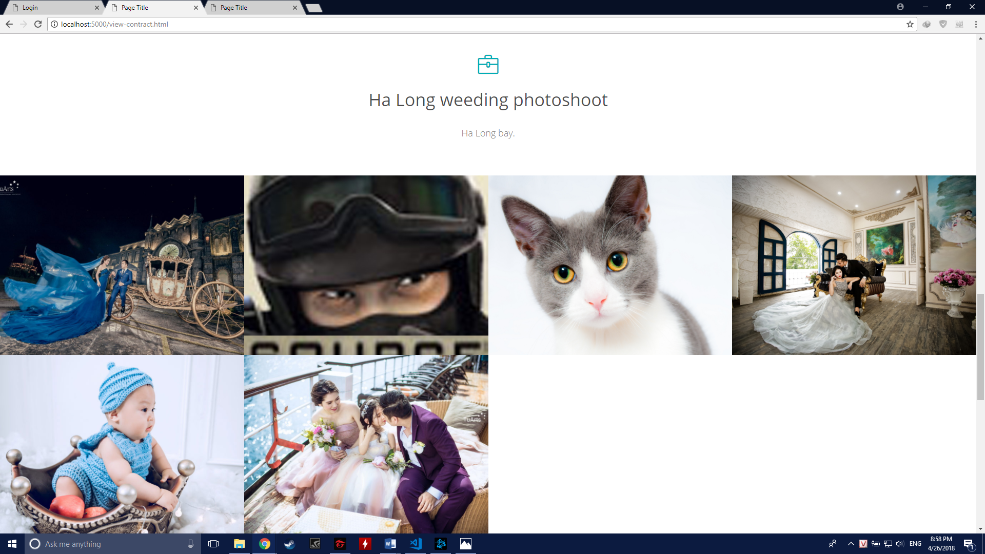

##### Class Diagram

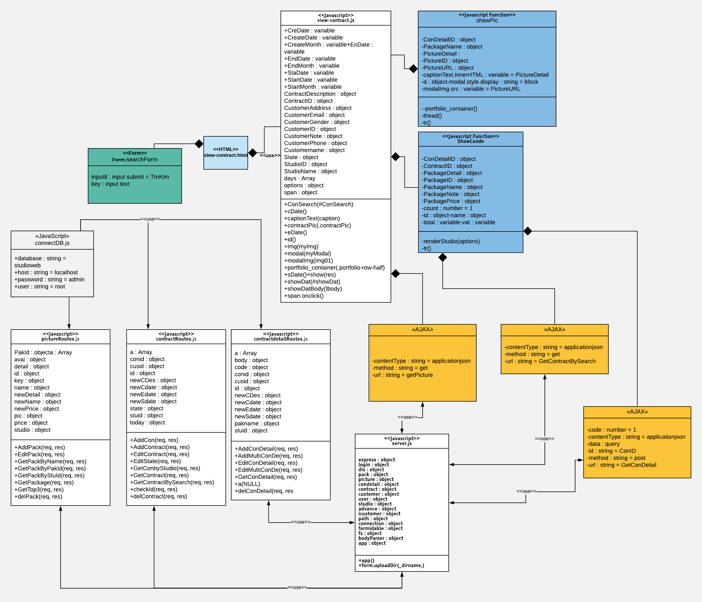

##### Class Specification

|  |  |  |  |  |
| --- | --- | --- | --- | --- |
| **Description** | Get contract related pictures to show | | | |
| **Base Class** | Controller | | | |
| **Source File** | PictureRoutes.js | | | |
| **Namespace** | app/public/routes/ | | | |
| **Attributes** | **N/A** | | | |
| **Methods** | **Name** | **Methods** | **Output** | **Description** |
| GetPicture | Request, result | view | Get all contract related pictures |

|  |  |  |  |  |
| --- | --- | --- | --- | --- |
| **Description** | Get Contract where customer enter contract ID | | | |
| **Base Class** | Controller | | | |
| **Source File** | contractRoutes.js | | | |
| **Namespace** | app/public/routes/ | | | |
| **Attributes** | **N/A** | | | |
| **Methods** | **Name** | **Methods** | **Output** | **Description** |
| GetContractBySearch | Request, result | view | Get entered contract info |

|  |  |  |  |  |
| --- | --- | --- | --- | --- |
| **Description** | Get all contract detail included in the customer contract | | | |
| **Base Class** | Controller | | | |
| **Source File** | contractdetailRoutes.js | | | |
| **Namespace** | app/public/routes/ | | | |
| **Attributes** | **N/A** | | | |
| **Methods** | **Name** | **Methods** | **Output** | **Description** |
| GetConDetail | Request, result | view | Get all detail of the contract |

##### Sequence Diagram

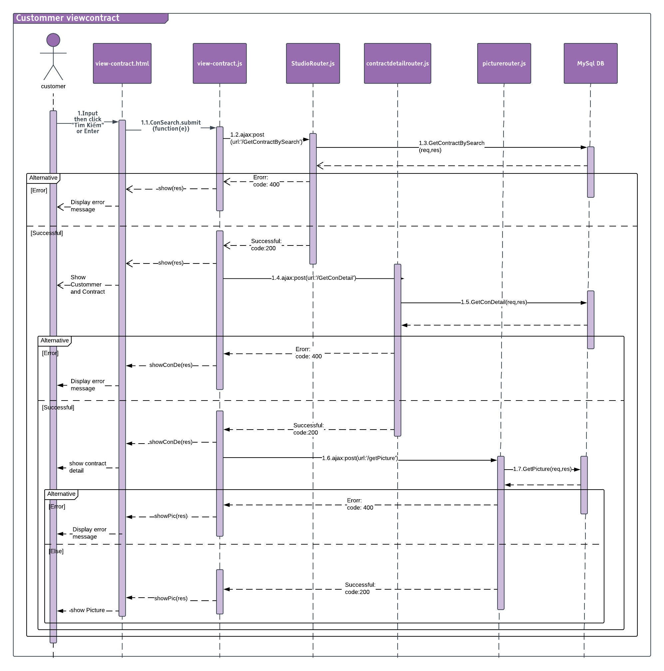

# SOFWARE TESTING ソフトウェアテスト

## Introduction　はじめに

### Purpose　目的

This is the comprehensive test plan of the Jobs Finding System project. The purpose of this chapter describes scopes of test plan and activities which need to be taken during test process of project. It addresses the following items:

* Scope of Testing
* Requirement for Testing
* Test Strategy
* Test Resources
* Test Milestones
* Test Deliverables

### References　参照資料

| Title/File name | Author | Version |
| --- | --- | --- |
| PSM_IntegrationTestCases.xlsx | DungPT | 1.0 |
| PSM_SystemTestCases.xlsx | DungPT | 1.0 |

### Background information　背景情報

The target of testing is ensured all functions will be run correctly as SRS description. In addition, restrict maximum of defect during the using of Website. To do this target, Website have to:

* Pass all of the following stages of testing: Unit Testing, Integration Testing, System Testing and Acceptance Testing.
* Pass all of the following types of testing: Function Testing, User Interface Testing, Data and Data Integrity Testing
* Run normally in popular browsers and many types of device or display resolution.

### Scope of testing　テスト範囲

The scope of test will be limited to testing on 3 browser: Google Chrome, Mozilla Firefox, Microsoft Edge.

Functional items and non-functional items will be verified and passed by eJob development team, then be validated and approved by project manager and supervisor of JFS project.

## Constraints　制約事項

* Deadline for testing only can be met if development progress is on time.
* Working process must be reported daily to PTL.
* Have more environments should be tested: Window XP, Window 8 … and more browsers: Chrome 53, Firefox, Microsoft Edge 38 …

### Risk listリスク一覧

|  |  |  |  |
| --- | --- | --- | --- |
| No | Risk | Mitigation | Contingencies |
|  | PC have problem during test | Fix a problem | Find a other PC |
|  | Tester may be sick in test phase or may leave the project before completion | + Discussing  + Committing  + Assigning tasks appropriately | + Persuading  + Reviewing and re-planning the whole project |
|  | Scope: SRS/SAD may be changed | + Discussing  + Reviewing the whole project frequently | + Re-planning test phase  + Re-creating test case |
|  | Time of Coding phase may last too long | + Committing  + Assigning tasks | Working over time |

Table 5.2.1 Risk list

## Requirements for Test　テスト要求

### Test items　テスト頭目

|  |  |  |  |
| --- | --- | --- | --- |
| No | Name of features and functions | Outline of features and functions | Note |
|  | Login | Sign in on PSM with admin or manager account. |  |
|  | Forgot Password to send request forgot password. |  |
|  |
|  |
|  |
|  |
|  | User Manager  ( Admin Role ) | Search Manager of any Studio |  |
|  | Add Manager to any Studio |  |
|  | Edit Manager |  |
|  | Delete Manager |  |
|  | Studio Manager  ( Admin Role ) | Search Studio |  |
|  | Add Studio |  |
|  | Edit Studio |  |
|  | Delete Studio |  |
|  | District Manager  ( Admin Role ) | Search District |  |
|  | Add District |  |
|  | Edit District |  |
|  | Delete District |  |
|  | Studio Information  ( Manager Role ) | Edit Studio Infomation |  |
|  | Package Manager  ( Manager Role ) | Search Package |  |
|  | Add Package |  |
|  | Edit Package |  |
|  | Delete Package |  |
|  | Picture Manager  ( Manager Role ) | Search Picture |  |
|  | Add Picture |  |
|  | Edit Picture |  |
|  | Delete Picture |  |
|  | Upload Picture |  |
|  | Contract Manager  ( Manager Role ) | Search Contract |  |
|  | Add Contract |  |
|  | Edit Contract |  |
|  | Delete Contract |  |
|  | Edit Contract Detail |  |
|  | Delete Contract Detail |  |
|  | View Picture |  |
|  | Add Contract Detail |  |
|  | Edit Customer Infomation |  |
|  | Home Page  ( Customer ) | View Sample Picture |  |
|  | View About US |  |
|  | Studio List Page  ( Customer ) | View Information of Studio |  |
|  | Studio Detail Page  ( Customer ) | View Sample Picture |  |
|  | View Package |  |
|  | Add Package to Cart |  |
|  | Cart Page  ( Customer ) | Remove Package on Cart |  |
|  | Buy Package |  |
|  | Show Contract Code |  |
|  | Album Page  ( Customer ) | Show Sample Picture |  |
|  | Contract Page  ( Customer ) | Enter Contract Code |  |
|  | Show Contract |  |
|  | View Picture |  |

Table 5.3.1

### Acceptance Test Criteria　テスト受入基準

List of criteria to define what levels of test quality are sufficient to move to the next testing phase:

* Test coverage : 100%
* Successful Test coverage : 90%
* Number of defects/Weighted defects : 3~4 defects/KLOC

List of criteria which are based on to accept the products, for Test team to accept source code after Unit test of Development team:

* Number of UTC/KLOC: 40 UTC/KLOC
* Number or Weighted defects/KLOC : 3~4 defects/KLOC
* Statement coverage: 100%
* Branch coverage: 100%
* Path coverage: 100%

List of criteria which are based on to accept the products, for Integration test:

* Number of UTC/KLOC: 30 UTC/KLOC
* Number or Weighted defects/KLOC : 2~3 defects/KLOC
* Statement coverage: 100%
* Branch coverage: 100%
* Path coverage: 100%

List of criteria which are based on to accept the products, for System test:

* Number of UTC/KLOC: 20 UTC/KLOC
* Number or Weighted defects/KLOC : 5~6 defects/KLOC
* Statement coverage: 100%
* Branch coverage: 100%
* Path coverage: 100%

List of criteria which are based on to accept the products, for Acceptance test:

* Number or Weighted defects/KLOC : 1~2 defects/KLOC
* Statement coverage: 100%
* Branch coverage: 100%
* Path coverage: 100%

### Feature not to be tested　テストされない特徴

* The stable of website when do no connect internet.
* Manage Website’s payment activities**.** Manage the activity that user pay for system when they use paid-required service.

## Test strategy　テスト戦略

### Test Model　テストモデル

JFS follows V-Model process: The entire process of our Project is divided into 2 corresponding stages: Developing and Testing. Each developing process will be performed in parallel with the corresponding testing process. Bugs will be detected early.

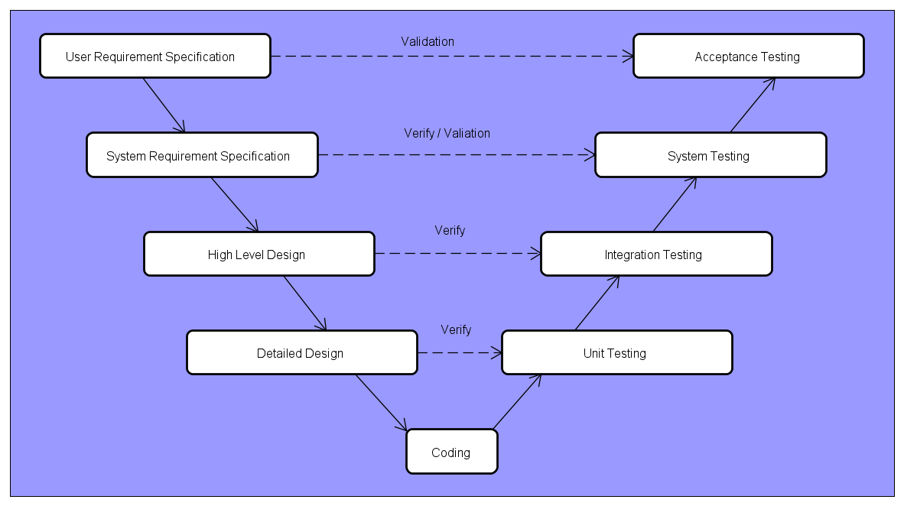

JFS will be tested by 3 phases:

**Phase 1 : Integration testing**

* After finishing component testing, integration testing will be performed by testers.
* Material are integration test cases, high- level design and test tools.
* Integration test focuses on specific areas of use cases when all requirements are completed.
* Integration test should be performed to ensure all components incorporate well.
* When executing integration testing, if any bugs are found, testers have to log on”Defect Log Management”file and assign to developer fix it and redo this process until it is correct.

*Rule for filling test result:*

|  |  |
| --- | --- |
| Test result pass | Pass |
| Test result fail | Fail |
| Do not test | Untested |
| Cannot test | N/A (Not available) |

**Phase 2: System testing**

* After finishing integration testing and developers collect all functions and items, testers will be performed system testing, it means doing test whole system.
* Material area system test case, SRS
* If any bugs are found, developers have to fix and testers will verify them. System test is ended only when test cases are passed and no bug is found.

*Rule for filling test result:*

|  |  |
| --- | --- |
| Test result pass | Pass |
| Test result fail | Fail |
| Do not test | Untested |
| Cannot test | N/A (Not available) |

**Phase 3: Acceptance testing**

* Acceptance testing is performed after the system testing
* Base on business/user requirement specification, system is tested again, for ensure there is not lacking or mistake any requirement.
* If there is any problem, developers have to fix/update and tester will verify them.
* Acceptance testing is ended only when whole system met requirement specification.

### Test types テストタイプ

### Function Testing　機能テスト

* Function Testing is a type of software testing whereby the system is tested against the functional requirements/ specifications.
* Functions are tested by feeding them input and examining the output. Functional testing ensures that the requirements are properly satisfied by application. This type of testing is not concerned with how processing occurs, but rather, with results of processing.
* During functional testing, **Black Box Testing** technique is used in which the internal logic of the system being tested is not known to the tester.

|  |  |
| --- | --- |
| Test Objective: | Ensure proper target-of-test functionality, including navigation, data entry, processing, and retrieval. |
| Technique: | Execute each use case, use-case flow, or function, using valid and invalid data, to verify the following:  -    The expected results occur when valid data is used.  -    The appropriate error or warning messages are displayed when invalid data is used.  -    Each business rule is properly applied.  - Use Test tool |
| Completion Criteria: | -   All planned tests have been executed.  -     All identified defects have been addressed and closed |
| Special Considerations: | Identify or describe those items or issues (internal or external) that impact the implementation and execution of function test |

Table 5.4.3 Function Testing

### User Interface Testing　ユーザーインターフェーステスト

* User interface testing, a testing technique used to identify the presence of defects is a product/software under test by using GUI.
* GUI testing evaluates design elements such as layout, colors, [fonts](http://whatis.techtarget.com/definition/font), font sizes, labels, text boxes, text formatting, captions, buttons, lists, icons, links and content.

|  |  |
| --- | --- |
| Test Objective: | Verify the following:  Navigation through the target-of-test properly reflects business functions and requirements, including window-to-window, field-to-field, and use of access methods (tab keys, mouse movements, accelerator keys)  Window objects and characteristics, such as menus, size, position, state, and focus conform to standards. |
| Technique: | Create or modify tests for each window to verify proper navigation and object states for each application window and objects. |
| Completion Criteria: | Each window successfully verified to remain consistent with benchmark version or within acceptable standard. |
| Special Considerations: | Not all properties for custom and third party objects can be accessed. |

Table 5.4.4 User Interface Testing

### Data and Database Integrity Testing　でーたおよびデータベース整合性テスト

Data integrity corresponds to the quality of data in the databases and to the level by which users examine data quality, integrity and reliability. Data integrity testing verifies that the data in the database is accurate and functions as expected within a given application.

|  |  |
| --- | --- |
| Test Objective: | Ensure database access methods and processes function properly and without data corruption. |
| Technique: | * Invoke each database access method and process, seeding each with valid and invalid data or requests for data. * Inspect the database to ensure the data has been populated as intended, all database events occurred properly, or review the returned data to ensure that the correct data was retrieved for the correct reasons |
| Completion Criteria: | All database access methods and processes function as designed and without any data corruption. |
| Special Considerations: | * Testing may require a DBMS development environment or drivers to enter or modify data directly in the databases. * Processes should be invoked manually. * Small or minimally sized databases (limited number of records) should be used to increase the visibility of any non-acceptable events. |

Table 5.4.5 Data and Database Integrity Testing

### Test stages　テストステージ

| Type of Tests | Stage of Test | | |
| --- | --- | --- | --- |
| Integration | System | Acceptance | |
| Function Test | X | X | X | |
| User Interface test |  | X |  | |
| Date integrity test | X | X |  | |

Table 5.4.6 Test Stages

## Resource　リソース

### Human Resource　人的リソース

|  |  |  |  |
| --- | --- | --- | --- |
| Worker/Doer | Role | Specific Responsibilities/Comments | Location |
| DungPT | Test leader | Write Test Case, Test Report , Check bug | FPT University Vietnam |
| TrungNH | Tester | Fix Bug | FPT University Vietnam |
| VuCL | Tester | Fix Bug | FPT University Vietnam |

Table 5.5.1 Human Resource

### Test management　テスト管理

#### Test management　テスト管理

Test management is practice of organizing and controlling the process and artifacts required for testing effort.

The general goal of test management is to allow teams to plan, develop, execute, and assess all testing activities within the overall software development effort. This includes coordinating efforts of all those involved in the testing effort, tracking dependencies and relationships among test assets and, most importantly, defining, measuring, and tracking quality goals.

* **Test planning** is the overall set of tasks that address the questions of why, what, where, and when to test. The reason why a given test is created is called a test motivator (for example, a specific requirement must be validated). What should be tested is broken down into many test cases for a project. Where to test is answered by determining and documenting the needed software and hardware configurations. When to test is resolved by tracking iterations (or cycles, or time period) to the testing.
* **Test authoring** is a process of capturing the specific steps required to complete a given test. This addresses the question of how something will be tested. This is where somewhat abstract test cases are developed into more detailed test steps, which in turn will become test scripts (either manual or automated).
* **Test execution** entails running the tests by assembling sequences of test scripts into a suite of tests. This is a continuation of answering the question of how something will be tested (more specifically, how the testing will be conducted).
* **Test reporting** is how the various results of the testing effort are analyzed and communicated. This is used to determine the current status of project testing, as well as the overall level of quality of the application or system.

### Defect management　欠陥管理

Defect management is crucial to closing the loop between requirements, implementation and verification and validation. Traditional defect tracking management, implemented in a standalone fashion, can no longer address the complexity and pace of change in modern software development. Defect management processes must be tightly interlinked with all of the other software development processes. The defect management process contains the following elements:

* **Defect Discovery** – Identification and reporting of potential defects. The defect tracking software must be simple enough so that people will use it, but ensure that the minimum necessary information is captured. The information captured here should be enough to reproduce the defect and allow development to determine root cause and impact.
* **Defect Analysis & Prioritization** – The development team determines if the defect report corresponds to an actual defect, if the defect has already been reported, and what the impact and priority of the defect is. Prioritization and scheduling of the defect resolution is often part of the overall change management process for the software development organization.
* **Defect Resolution –** Here the development team determines the root cause, implements the changes needed to fix the defect, and documents the details of the resolution in the defect management software, including suggestions on how to verify the defect is fixed. In organizations using [Software Product Lines](http://www.mks.com/challenges/product-lines) approaches, or other shared component approaches, defect resolution may need to be coordinated across multiple branches of development.
* **Defect Verification** – The build containing the resolution to the defect is identified, and testing of the build is performed to ensure the defect truly has been resolved, and that the resolution has not introduced side effects or regressions. Once all affected branches of development have been verified as resolved, the defect can be closed.
* **Defect Communication** – This encompasses automatic generation of defect metrics for management reporting and process improvement purposes, as well as visibility into the presence and status of defects across all disciplines of the software development team.

## Test environment　たテスト環境

|  |  |  |  |  |
| --- | --- | --- | --- | --- |
| Name | Screen Resolution | Browser | Purpose | Detail |
| ASUS TP550LA | 1366x768 | Google Chrome, Mozilla Firefox, Microsoft Edge | Device for create and execute test | Microsoft Windows 10 Professional |
| ASUS  FX502VM | 1920x1080 | Google Chrome, Mozilla Firefox, Internet Explorer | Device for create and execute test | Microsoft Windows 10 Professional |

### Hardware ハードウェア

Table 5.6.1 Hardware

### Software　ソフトウェア

|  |  |  |
| --- | --- | --- |
| Name | Purpose | Detail |
| Chrome | Executing test | Chrome 53.0 |
| Firefox | Executing test | Firefox |
| Microsoft Edge | Executing test | Microsoft Edge 38 |

# 

## Test Milestones　テストマイルストーン

|  |  |  |  |
| --- | --- | --- | --- |
| Milestone Task | Effort (pd) | Start Date | End Date |
| Create Test Plan | 6 | 15/03/2018 | 20/03/2018 |
| Review & update TP | 2 | 21/03/2018 | 21/03/2018 |
| Create Integration Test case | 3 | 22/03/2018 | 27/03/2018 |
| Review & Update Integration TC | 1 | 28/03/2018 | 28/03/2018 |
| Create System Test case | 3 | 29/03/2018 | 03/04/2018 |
| Review & Update System TC | 1 | 04/04/2018 | 04/04/2018 |
| Execute Integration test Iterative 1 | 3 | 05/04/2018 | 10/04/2018 |
| Execute System test Iterative 1 | 3 | 11/04/2018 | 16/04/2018 |
| Execute Integration test Iterative 2 | 3 | 17/04/2018 | 22/04/2018 |
| Execute System test Iterative 2 | 3 | 23/04/2018 | 28/04/2018 |

Table 5.7 Test Milestones

## Deliverables　納品物

| No | Deliverables | Responsibilities | Delivered Date |
| --- | --- | --- | --- |
|  | Test Plan | Test Lead | 22/03/2018 |
|  | Integration Test Cases | Test Lead | 10/04/2018 |
|  | System Test cases | Test Lead | 16/04/2018 |
|  | Defect log Management | Tester | 26/04/2018 |
|  | Test reports | PM | 26/04/2018 |

Table 5.8 Deliverables

## Test Case　テストケース

Refer to:

* + PSM_Integration Test Case_v1.0.xlsx
  + PSM _System Test Case_v1.0.xlsx

## Test Report　テストレポート

### Integration Test Report　統合テストレポート

|  |  |  |  |  |  |  |
| --- | --- | --- | --- | --- | --- | --- |
| **No** | **Module code** | **Pass** | **Fail** | **Untested** | **N/A** | **Number of**  **test cases** |
|  | Login Page | 24 | 0 | 0 | 0 | 12 |
|  | User Manager | 22 | 0 | 0 | 0 | 22 |
|  | Studio Manager | 46 | 0 | 0 | 0 | 46 |
|  | District Manager | 9 | 0 | 0 | 0 | 9 |
|  | Manager Login | 5 | 0 | 0 | 0 | 5 |
|  | Studio Profile | 28 | 0 | 0 | 0 | 28 |
|  | Package Manager | 26 | 0 | 0 | 0 | 26 |
|  | Contract Manager | 94 | 0 | 0 | 0 | 94 |
|  | Picture Manager | 16 | 0 | 0 | 0 | 16 |
|  | Home Page | 15 | 0 | 0 | 0 | 15 |
|  | Studio List Page | 5 | 0 | 0 | 0 | 5 |
|  | Studio Detail Page | 8 | 0 | 0 | 0 | 8 |
|  | Cart Page | 12 | 0 | 0 | 0 | 12 |
|  | Contract Page | 4 | 0 | 0 | 0 | 4 |
|  | **Sub total** | 307 | 0 | 0 | 0 | 307 |

Table 5.10.4

### System Test Report　システムテストレポート

|  |  |  |  |  |  |  |
| --- | --- | --- | --- | --- | --- | --- |
| **No** | **Module code** | **Pass** | **Fail** | **Untested** | **N/A** | **Number of test cases** |
|  | Login Page | 7 | 0 | 0 | 0 | 7 |
|  | Forgot Password | 7 | 0 | 0 | 0 | 7 |
|  | Quản lí nhân viên | 11 | 0 | 0 | 0 | 11 |
|  | Quản lí Studio | 12 | 0 | 0 | 0 | 12 |
|  | Quản lí Tỉnh | 6 | 0 | 0 | 0 | 6 |
|  | Thông tin Studio | 3 | 0 | 0 | 0 | 3 |
|  | Quản lí gói chụp ảnh | 11 | 0 | 0 | 0 | 11 |
|  | Quản lí ảnh | 10 | 0 | 0 | 0 | 10 |
|  | Quản lí hợp đồng | 19 | 0 | 0 | 0 | 19 |
|  | Studio Page | 14 | 0 | 0 | 0 | 14 |
|  | **Sub total** | 96 | 0 | 0 | 0 | 96 |

Table 5.10.5

### Test Report　テストレポート

|  |  |  |  |  |  |  |  |  |
| --- | --- | --- | --- | --- | --- | --- | --- | --- |
| **Phase** | **Round 1** | | | | **Round 2** | | | |
| Pass | Fail | Untested | N/A | Pass | Fail | Untested | N/A |
| **Integration Test** | 220 | 0 | 88 | 0 | 307 | 0 | 0 | 0 |
| **System Test** | 73 | 0 | 23 | 0 | 96 | 0 | 0 | 0 |
| **Total** | **293** | **0** | **104** | **0** | **403** | **0** | **0** | **0** |

Table 5.10.5

# USER MANUAL　ユーザーマニュアル

## Home Page /ホームページ

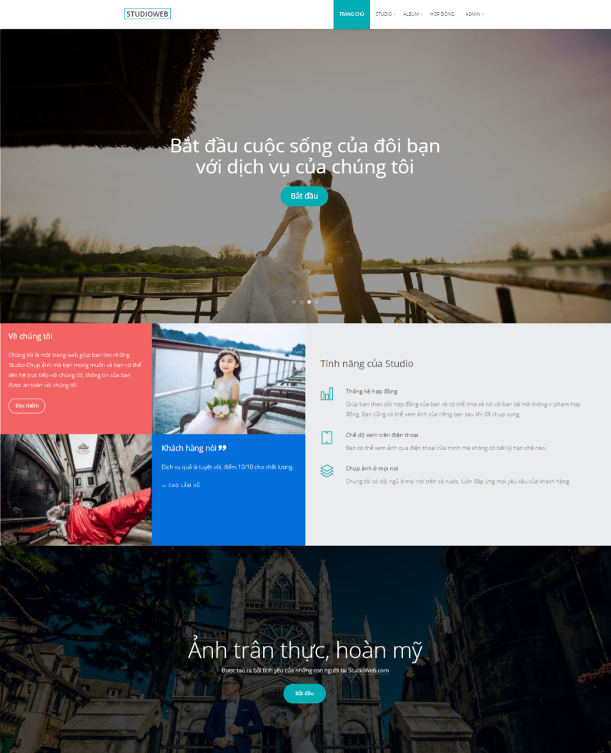

## Admin Guidelines /管理ガイドライン

### Login/**ログイン**

*Step 1*: Click”Đăng nhập”on header in Home Page. System will display the Login page.

ホームページのヘッダーにある「Đăng nhập」をクリックします。 ログインページが表示されます。

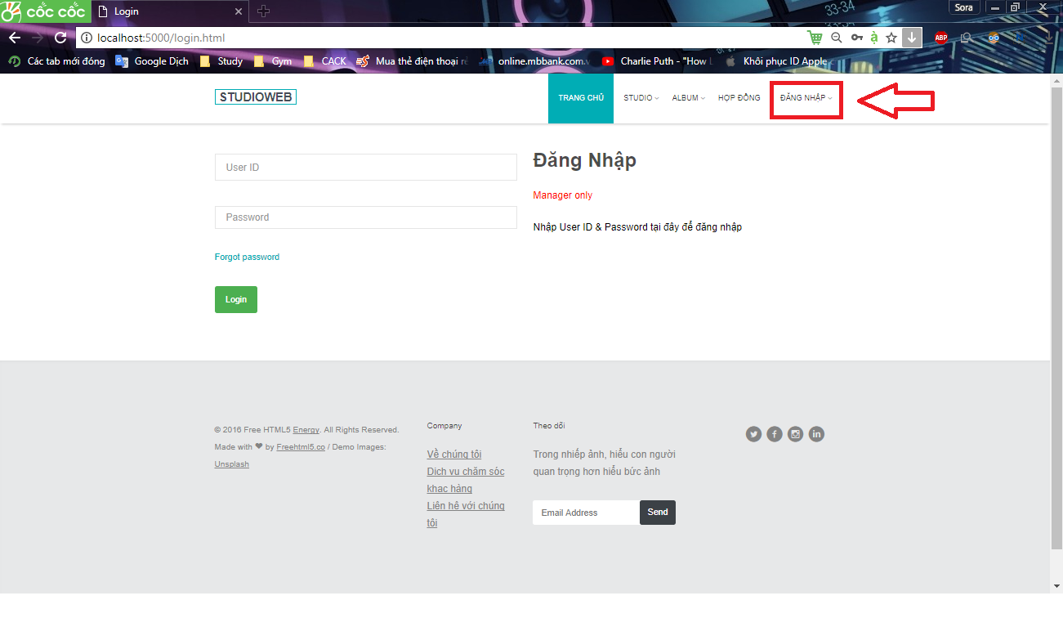

*Step 2*: Enter login credentials and click”Đăng nhập”to log in.

ログイン資格情報を入力して「Đăng Nhập」をクリックしてログインします。

### Log out /ログアウト

*Step 1*: Click”Đăng xuất”in the top right corner.

右上隅にある[Đăng xuất]をクリックします。

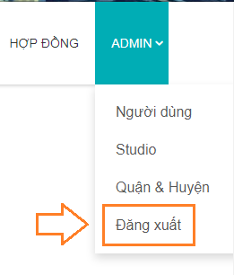

### Admin Manager /管理者マネージャ

After login successfully with admin, account admin will be display.

管理者とのログインに成功すると、アカウント管理者が表示されます。

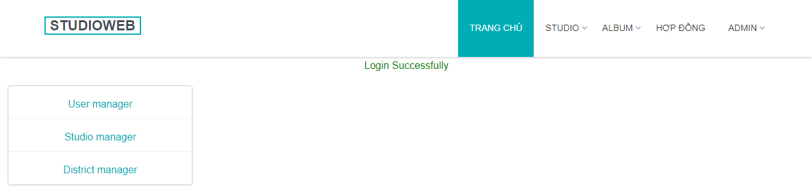

### List Manager /リストマネージャー

Click on”Quản lý nhân viên”link to open List Manager page.

“Quản lý nhân viên”リンクをクリックして、リストマネージャーページを開きます。

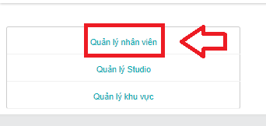

### Search Manager /検索マネージャ

*Option 1:*

オプション1 :

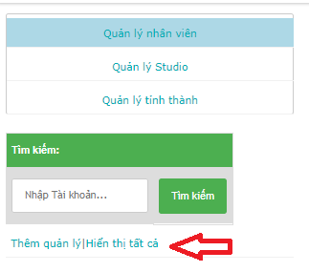

Click on”Hiển thị tất cả”link to display all Manager.

すべてのマネージャを表示するには、[Hiển thị tất cả] をクリックします。

*Option 2:*

オプション2：

*Step 1:* Empty Search field.

ステップ1 : 空の検索フィールド。

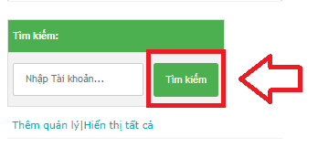

*Step 2:* Click on “Tìm Kiếm” button. All Managers will be display.

ステップ 2:”Tìm Kiếm”ボタンをクリックしてください。すべてのマネージャーが表示されます。

*Option 3*:

オプション3:

*Step 1:* Enter correct”Tài khoản”or a part of”Tài khoản”in Search text field.

ステップ 1: 検索テキストフィールドに「Tài khoản」または「Tài khoản」の一部を入力します。

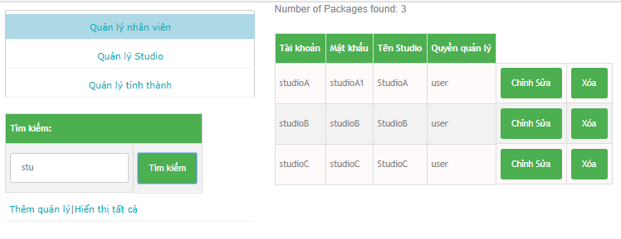

*Step 2:* Click on button”Tìm Kiếm”. All Managers have”Tài Khoản”like search value will be display.

ステップ 2: 検索テキストフィールドに「Tài khoản」または「Tài khoản」の一部を入力します。

### **Edit Manager /編集マネージャ**

*Step 1:* Click on”Chỉnh sửa”button.”Chỉnh sửa quản lý”form will be display.

ステップ 1:”Chỉnh sửa”ボタンをクリックしてください。”Chỉnh sửa quản lý”フォームが表示されます。

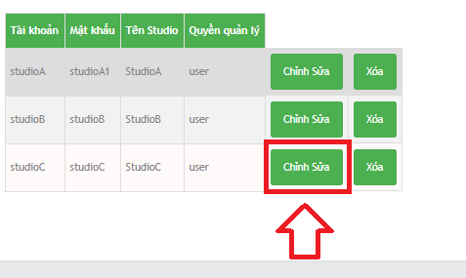

*Step 2:* Enter new Password on”Mật khẩu”field.

ステップ 2:”Mật khẩu”フィールドに新しいパスワードを入力してください。

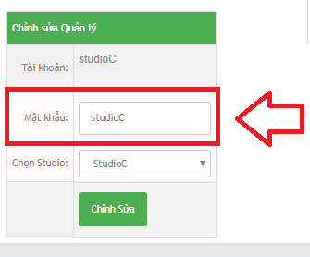

* New Password rules : /新しいパスワードルール：
  + In range 6 ~ 32 character. / 範囲は6〜32文字です。
  + Not empty. / 空ではない。
  + Can contain special character (!@#$%^&*). /特殊文字（！@＃$％^＆*）を含むことができます。

*Step 3:* Select Studio.

ステップ 3: スタジオを選択します。

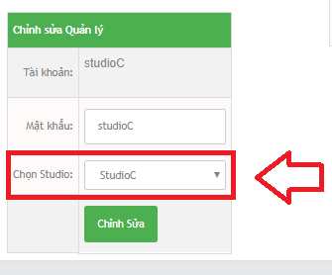

*Step 4:* Click”Chỉnh sửa”button.

ステップ 4:”Chỉnh sửa”ボタンをクリックしてください。

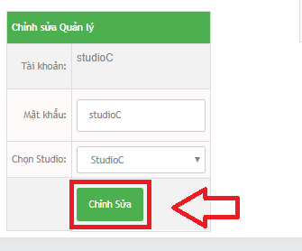

### **Delete Manager /マネージャを削除**

*Step 1:* Click on “Xóa” button.

ステップ 1:”Xóa”ボタンをクリックしてください。

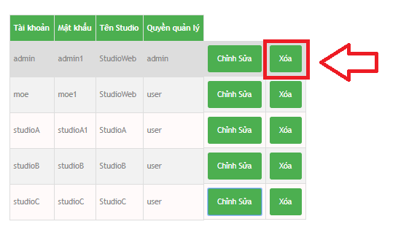

*Step 2:* Click on OK button on confirm window.

ステップ 2:”Xóa”ボタンをクリックしてください。

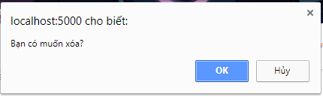

4. Add Manager /マネージャを追加

Click on”Thêm quản lý”link to open”Thêm người quản lý”form.

“Thêm quản lý”リンクをクリックして、”Thêm người quản lý”フォームを開きます。

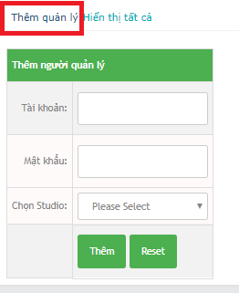

*Step 1:* Enter new Manager Account on”Tài khoản”field.

ステップ 1: 新しい管理者アカウントを「敬称」フィールドに入力してください。

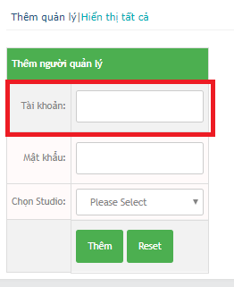

* New Manager Account rules : / 新しいマネージャアカウントルール：
  + Not special character. /特殊文字ではありません。
  + Not empty./ 空ではない。
  + In range 6 ~ 32 character. /範囲は6〜32文字です。

*Step 2:* Enter new Password in”Mật khẩu”field.

ステップ 2:”Mậtkhẩu”フィールドに新しいパスワードを入力してください。

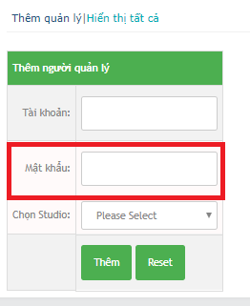

* New Password rules : / 新しいパスワードルール:
  + In range 6 ~ 32 character. 範囲は6〜32文字です。
  + Not empty. 空ではない。
  + Can contain special character (!@#$%^&*).特殊文字（！@＃$％^＆*）を含むことができます。

*Step 3:* **Select Studio.**

ステップ 3: **スタジオを選択**

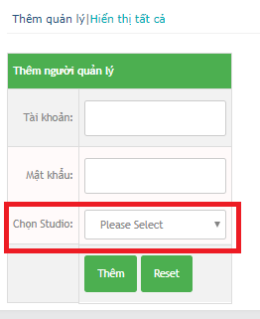

*Step 4:* Click”Thêm”button.

ステップ 4:”Thêm”ボタンをクリックします。

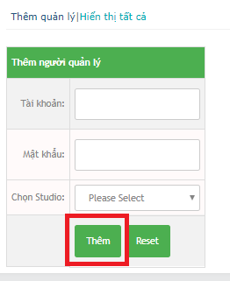

Reset button to clear all field.

すべてのフィールドをクリアするリセットボタン。

### Studio Manager. /スタジオマネージャー。

Click on”Quản lý Studio”link to open Studio Manager form.

スタジオマネージャーフォームを開くには、”Quản lý Studio”リンクをクリックしてください。

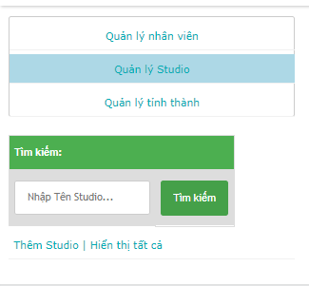

### Search Studio /スタヂオを検索する。

Option 1:

オプション 1:

Click”Hiển thị tất cả”link to display all Studio.

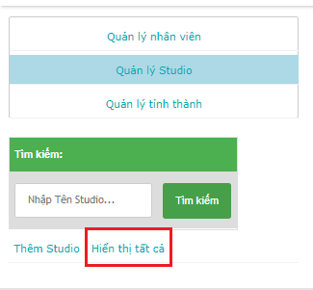

Option 2:

オプション 2:

*Step 1:* Empty Search field.

ステップ 1: 空の検索フィールド。

*Step 2:* Click on”Tìm kiếm”button. All Studios will be display

ステップ 2:”Tìm kiếm”ボタンをクリックしてください。 すべてのスタジオが表示されます

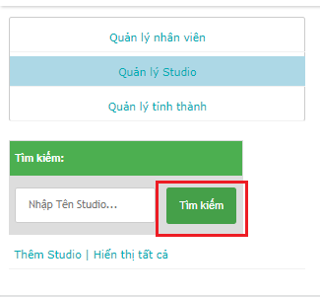

Option 3:

オプション 3:

*Step 1:* Enter correct or a part of”Tên Studio”.

ステップ 1: 「Tên Studio」の一部または全部を入力してください。

*Step 2:* Click on”Tìm kiếm”button. All Studio have”Tên Studio”like search value will be display.

ステップ 2:”Tìm kiếm”ボタンをクリックしてください。 すべてのスタジオに”Tên Studio”という検索値が表示されます。

### Show Studio location/スタジオロケーションを表示する。

Click on”Tọa độ Studio”link to open Studio location on Google Map page.

「Tọa độ Studio」リンクをクリックして、GoogleマップページでStudioの場所を開きます。

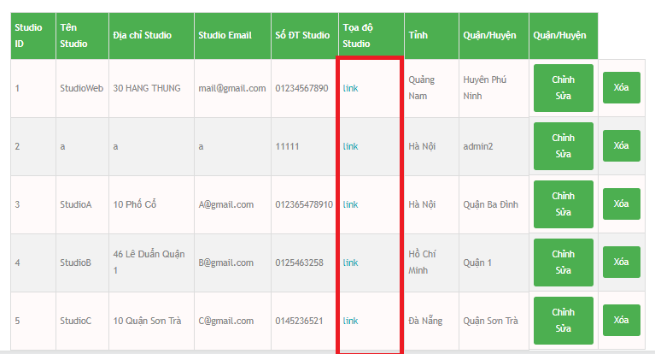

### Edit Studio / スタヂオの編集

*Step 1:* Click on”Chỉnh sửa”button to open”Chỉnh sửa Studio”form.

ステップ 1：”Chỉnh sửa”ボタンをクリックして”Chỉnh sửa Studio”フォームを開きます。

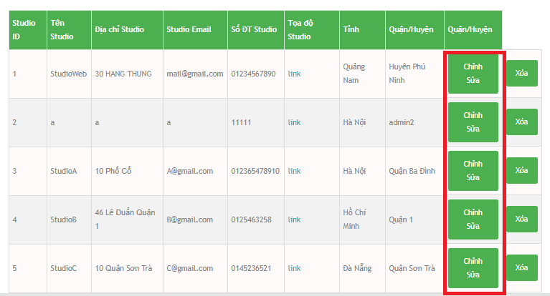

*Step 2:* Enter new Studio Name on”Tên Studio”field.

ステップ 2:”Tên Studio”欄に新しいスタジオ名を入力してください。

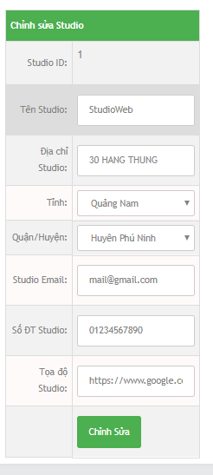

* New Studio Name rules : “Tên Studio”欄に新しいスタジオ名を入力してください。
  + Not empty. 空ではありません。
  + In range 6 ~ 32 character. 範囲は6〜32文字です。

*Step 3:* Enter new Studio Adress on”Địa chỉ Studio”field.

ステップ 3：”Địa chỉ Studio”欄に新しいスタジオアドレスを入力してください。

* New Studio Adress rules : 新しいスタジオアドレスのルール：
  + Not empty. 空ではありません。
  + In range 6 ~ 32 character. 範囲は6〜32文字です。

*Step 4:* Select”Tỉnh”.

ステップ 4：”Tỉnh”選択します。

*Step 5:* Select”Quận / Huyện”.

ステップ 5 ：”“Quận / Huyện”選択します。

Step 6 : Enter new Studio Email on Studio Email field.

ステップ 6

* New Studio Email rules :
  + Correct form.(abc@abc.abc)
  + Not empty.
  + Just allow”@”,”.”character.
  + In range 6 ~ 32 character.

Step 7 : Enter new Studio Number on”Số ĐT Studio”filed.

ステップ 7

* New Studio Number rules :
  + Must be number.
  + Not empty.
  + In range 10 ~ 12 character.

Step 8 : Enter new Studio Coordinate on”Tọa độ Studio”field.

ステップ 8

* New Studio Coordinate rules :
  + Not empty.
  + Correct form. (Float number , Float number).

Step 9 : Click on”Chỉnh Sửa”button.

ステップ 9

### Delete Studio.

*Step 1:* Click on”Xóa”button.

ステップ 1:

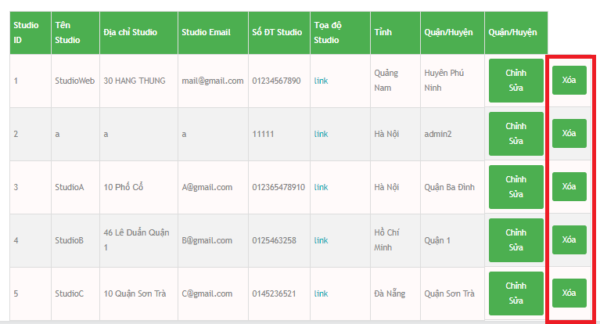

*Step 2:* Click OK button on confirm window.

ステップ 2:

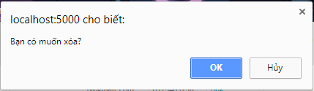

### Add Studio

*Step 1:* Click on”Thêm Studio”link to open”Thêm Studio mới”form.

ステップ 1

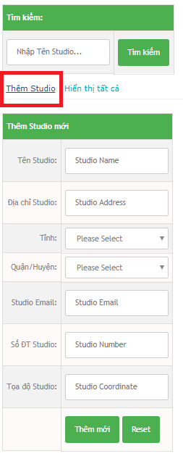

*Step 2:* Enter Studio Name on”Tên Studio”field.

ステップ 2:

* Studio Name rules :
  + Not special character.
  + Not empty.
  + In range 6 ~ 32 character.

*Step 3:* Enter Studio Adress on”Địa chỉ Studio”field.

ステップ 3:

* Studio Adress rules :
  + Not empty.
  + In range 6 ~ 32 character.

*Step 4:* Select”Tỉnh”.

ステップ 4:

*Step 5:* Select”Quận / Huyện”.

ステップ 5:

Step 6 : Enter Studio Mail on Studio Email field.

ステップ 6:

* Studio Email rules : スタジオ電子メールのルール：
  + Correct form.([abc@abc.abc)](mailto:abc@abc.abc)) 正しい形式（abc@abc.abc）
  + Not empty. 空ではありません。
  + Just allow”@”,”.”character.”@”、”。”キャラクター。
  + In range 6 ~ 32 character. 範囲は6〜32文字です。

Step 7 : Enter Studio Number on”Số ĐT Studio”field.

ステップ 7:”Số ĐT Studio”フィールドにスタジオ番号を入力します。

* Studio Number rules : スタジオ番号の規則：
  + Must be number. 数字でなければなりません。
  + Not empty. 空ではありません。
  + In range 10 ~ 12 character. 範囲は10〜12文字です。

Step 8 : Enter Studio Coordinate on”Tọa độ Studio”field.”Tọa độ Studio”フィールドにスタジオ座標を入力します。

ステップ 8:

* Studio Coordinate rules : Studio Coordinateのルール：
  + Not empty. 空ではありません。
  + Correct form. (Float number , Float number). 正しい形式。 （フロート数、フロート数）。

Step 9 : Click on”Thêm mới”button.”Thêm mới”ボタンをクリックします。

ステップ 9:

Reset button to clear all text field. すべてのテキストフィールドをクリアするためのリセットボタン。

### District Manager /地区マネージャー。

Click on”Quản lí tỉnh thành”link to display District manager form.

地区マネージャーフォームを表示するには、[Quản lí tỉnh thành]リンクをクリックしてください。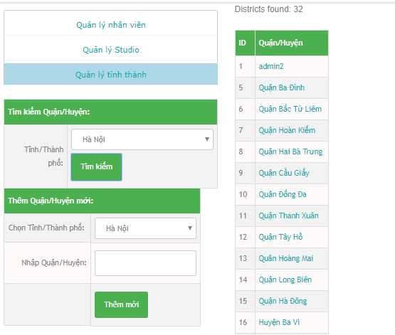

### Search District /地区の検索

*Step 1:* Select”Tỉnh / Thành phố”.

ステップ 1: 「時間/分」を選択します。

*Step 2:* Click”Tìm kiếm”button.

ステップ 2:”Tìm kiếm”ボタンをクリックします。

### Add new District/新しい地区を追加します。

*Step 1:* Choose”Tỉnh / Thành Phố”.

ステップ 1:”Tỉnh/ThànhPhố”を選択します。

*Step 2:* Enter new District on”Nhập Quận / Huyện”field.

ステップ 2:”Nhập Quận/Huyện”欄に新しい地区を入力します。

* New Dictrict rules : 新しいDictrictルール
  + Not special character. 特殊文字ではありません。
  + Not empty. 空ではありません。
  + In range 6 ~ 32 character. 範囲は6〜32文字です。

*Step 3:* Click”Thêm mới”button.

ステップ 3:”Thêmmới”ボタンをクリックします。

# Manager Guidelines.マネージャガイドライン。

### **Login ログイン**

*Step 1:* Click”Đăng nhập”on header in Home Page. System will display the Login page.

ステップ 1: 「Đăngnhập」をクリックします。 ログインページが表示されます。



*Step 2:* Enter login credentials and click”Đăng nhập”to log in.

ステップ 2: ログイン資格情報を入力し、「Đăng nhập」をクリックしてログインします。

* **After login Manager page will be display.**

**ログインマネージャページが表示されます**。

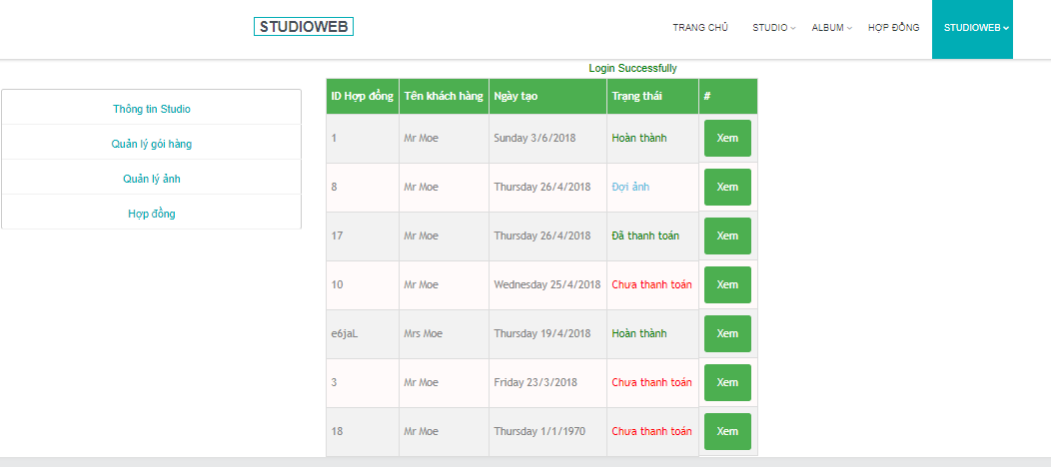

### Logoutログアウト

Click”Đăng xuất”in the top right corner.

右上隅にある[Đăng xuất]をクリックします。

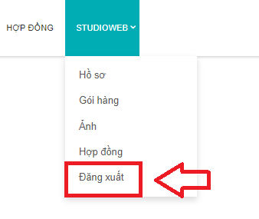

### Studio Profileスタジオのプロフィール

Click on”Thông tin Studio”link to display Studio Profile form.

“Thông tin Studio”リンクをクリックすると、Studio Profileフォームが表示されます。

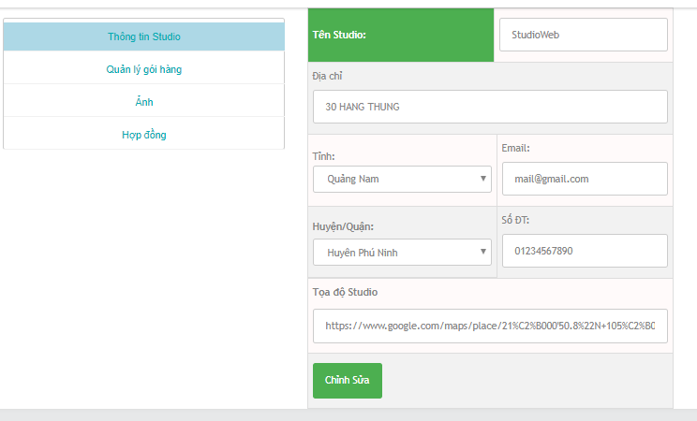

### Edit Studio Profile / スタヂオプロフィールを編集

*Step 1:* Edit field want to edit.

ステップ 1：編集したいフィールドを編集します。

*Step 2:* Click on”Chỉnh sửa”button.

ステップ 2：”Chỉnh sửa”ボタンをクリックします。

### Package Manager ・パッケージマネージャー

Click”Quản lí gói hàng”link to display Package Manager form.

パッケージマネージャフォームを表示するには、[Quản lí gói hàng]リンクをクリックしてください。

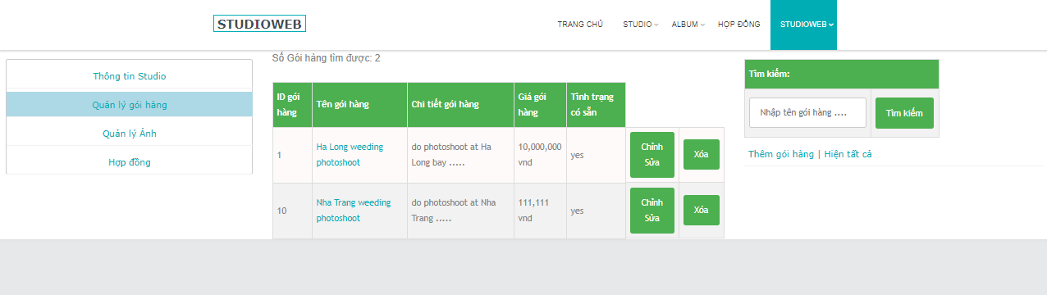

### Search Package 検索パッケージ

Option 1 : Click on”Hiển thị tất cả”link to display all package.

オプション 1: すべてのパッケージを表示するには、リンクをクリックしてください。

Option 2 :

オプション 2:

*Step 1:* Empty Search field.

ステップ 1: 空の検索フィールド。

*Step 2:* Click Search button. All package will be display.

ステップ 2: 検索ボタンをクリックします。すべてのパッケージが表示されます。

Option 3 :

オプション 3:

*Step 1:* Enter correct or a part of Package Name to search field.

ステップ 1: 検索するパッケージ名またはパッケージ名の一部を入力します。

*Step 2:* Click Search button, All package have package name like search value will be display.

ステップ 2: 検索ボタンをクリックすると、すべてのパッケージに検索値のようなパッケージ名が表示されます。

### Edit Package ・パッケージの編集

*Step 1:* Click on Edit button to display Edit Package form.

ステップ 1:Editボタンをクリックして、Edit Packageフォームを表示します。

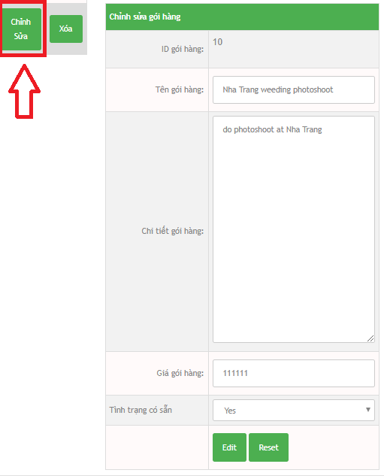

Step 2: Enter new Package Name. 新しいパッケージ名を入力します。

ステップ 2:

* New Package Name rules : 新しいパッケージ名規則：
  + Not special character. 特殊文字ではありません。
  + Not empty. 空ではありません。
  + In range 6 ~ 32 character. 範囲は6〜32文字です。

*Step 3:* Enter new Package Detail. 新しいパッケージの詳細を入力します。

ステップ 3:

* New Package Detail rules : 新しいパッケージ詳細ルール：
* Not empty. 空ではありません。

*Step 4:* Enter new Package Price. 新しいパッケージ価格を入力してください。

ステップ 4

* New Package Price rules : 新しいパッケージ価格ルール：
  + Must be number bigger than 0. 0より大きい数である必要があります。

*Step 5:* Select Package Avalability.

ステップ 5：パッケージ可用性を選択します。

Step 6 : Click Edit button. [EDIT]ボタンをクリックします。

ステップ 6 : [EDIT]ボタンをクリックします。

Reset button to clear all field.

すべてのフィールドをクリアするリセットボタン。

### Delete Package. パッケージを削除します。

*Step 1:* Click on”Xóa”button.

ステップ 1:”Xóa”ボタンをクリックします。

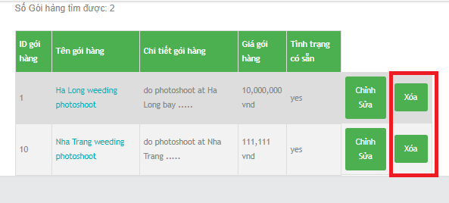

*Step 2:* Click OK button on confirm window.

ステップ 2: 確認画面で「OK」ボタンをクリックしてください。



### Picture Manager 画像マネージャ

Click on”Quản lý ảnh”link to display Picture Manager.

画像マネージャを表示するには、”Quản lý ảnh”リンクをクリックしてください。

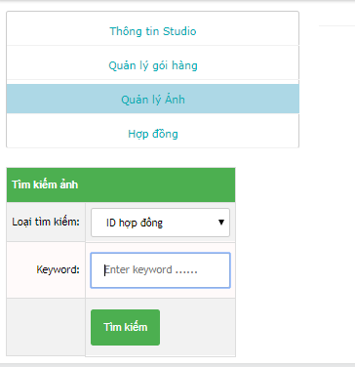

### Search Contract Detail by keyword/キーワード別検索契約の詳細

Option 1 :

オプション 1

*Step 1:* Select Search Type is”ID hợp đồng”.

ステップ 1: 検索タイプの選択は”ID hợp đồng”です。

*Step 2:* Enter correct ContractID on keyword field.

ステップ 2: キーワードフィールドに正しいContractIDを入力します。

*Step 3:* Click on”Tìm kiếm”button.

ステップ 3:”Tìm kiếm”ボタンをクリックします。

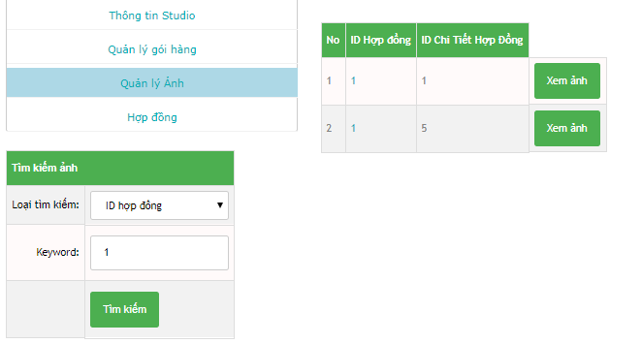

Option 2 :

オプション 2:

*Step 1:* Select SearchType is”Tên khách hàng”.

ステップ 1: 検索タイプを選択するには、[Tên khách hàng]をクリックします。

*Step 2:* Enter correct or a part of Customer Name on keyword field.

ステップ 2: キーワードフィールドに顧客名の一部または全部を入力します。

*Step 3:* Click on”Tìm kiếm”button.

ステップ 3:”Tìm kiếm”ボタンをクリックします。

### View Picture写真を見る

Click on”Xem ảnh”button to open Picture Detail page.

“Xem ảnh”ボタンをクリックすると、Picture Detailページが開きます。

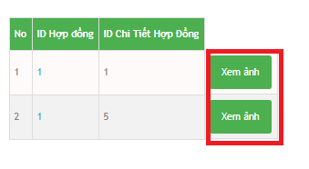

### Search Picture検索画像

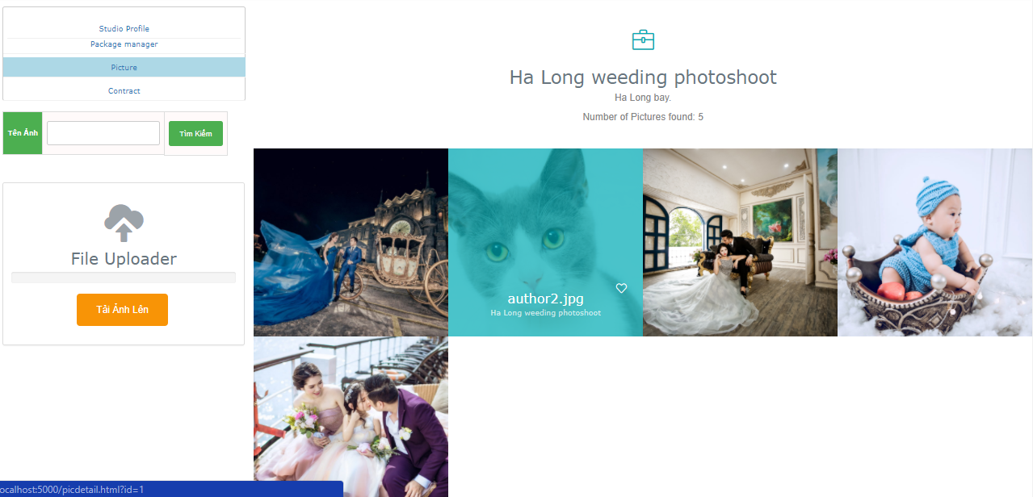

*Step 1:* Enter correct or a part of Picture Name on”Tên Ảnh”field.

ステップ 1:”Tên Ảnh”欄に画像名の一部または全部を入力します。

*Step 2:* Click”Tìm Kiếm”button.

ステップ 2:”Tìm Kiếm”ボタンをクリックします。

### Upload Picture

*Step 1:* Click on”Tải Ảnh Lên”button.

ステップ 1:”Tải Ảnh Lên”ボタンをクリックしてください。

*Step 2:* Choose picture file on computer.

ステップ 2: コンピュータ上の画像ファイルを選択します。

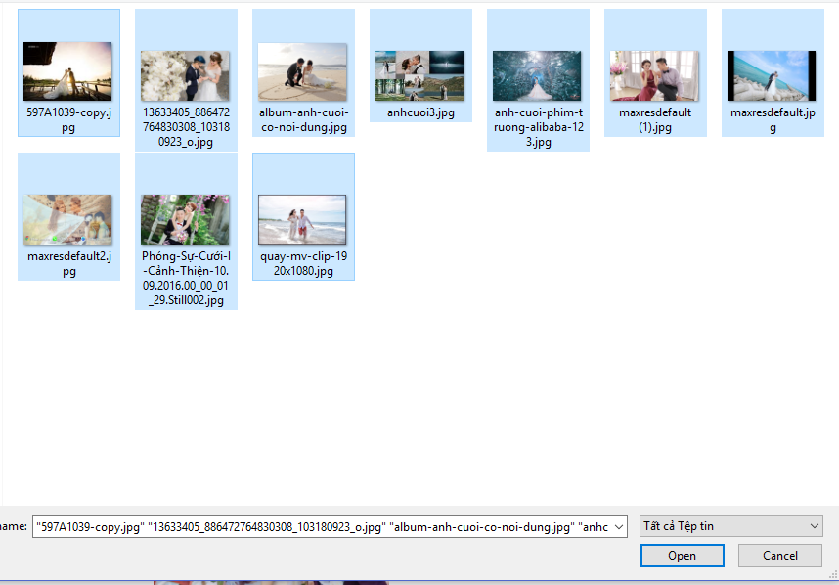

*Step 3:* Click Open button.

ステップ 3: 「OPEN」ボタンをクリックします。

### Update Picture Detail写真の詳細を更新します。

*Step 1:* Click on Picture want to update to open Picture Detail form.

ステップ 1: 「ピクチャ詳細」フォームを開くために更新したいピクチャをクリックします。

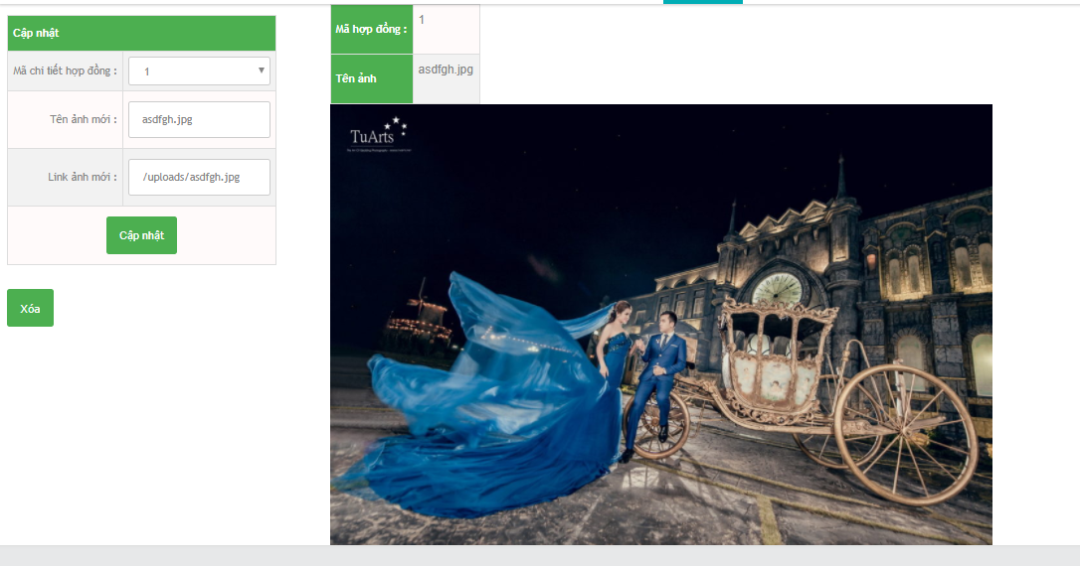

*Step 2:* Select”Mã chi tiết hợp đồng”.

ステップ 2:”Mã chi tiết hợp đồng”を選択します。

*Step 3:* Enter new Picture Name in “Tên ảnh mới”field.

ステップ 3: 新しい画像名を”Tên ảnh mới”フィールドに入力します。

*Step 4:* Enter new Picture URL on”Link ảnh mới”field.

ステップ 4:”Link ảnh mới”フィールドに新しい画像URLを入力します。

*Step 5:* Click”Cập nhật”button.

ステップ 5:”Cậpnhật”ボタンをクリックします。

### Delete Picture. 画像を削除します。

*Step 1:* Click on Picture want to delete to open Picture Detail form.

ステップ 1:「画像を削除する」をクリックして、「画像の詳細」フォームを開きます。

*Step 2:* Click on”Xóa”button.

ステップ 2:”Xóa”ボタンをクリックします。

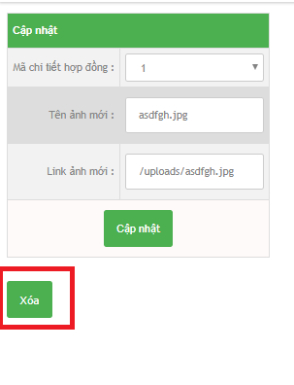

*Step 3:* Click on OK button on confirm window.

ステップ 3: 確認ウィンドウで[OK]ボタンをクリックします。



### Contract Manager 契約マネージャー

Click on”Hợp đồng”link to open Contract Manager page.

“Hợp đồng”リンクをクリックして、契約マネージャーページを開きます。

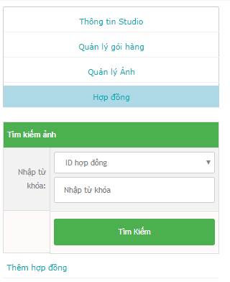

### Search Contract 検索契約

Option 1 :

*Step 1:* Empty keyword field.

ステップ 1: 空のキーワードフィールド。

*Step 2:* Click on”Tìm kiếm”button. All Contract will be display.

ステップ 2:”Tìm kiếm”ボタンをクリックします。すべての契約が表示されます。

Option 2 :

*Step 1:* Select Seach type is”ID hợp đồng”.

ステップ 1: 選択するタイプは”ID hợp đồng”です。

*Step 2:* Enter correct Contract ID in”Nhập từ khóa”field.

ステップ 2:”Nhập từ khóa”フィールドに正しい契約IDを入力します。

*Step 3:* Click on”Tìm kiếm”button. All Contract have Contract ID equal Search value will be display.

ステップ 3:”Tìm kiếm”ボタンをクリックします。すべての契約には契約IDが等しい検索値が表示されます。

Option 3 :

*Step 1:* Select Search type is”Tên khách hàng”.

検索タイプを「Tên khách hàng」を選択します。

ステップ 1:

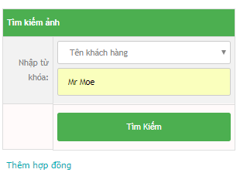

*Step 2:* Enter correct or a part of exsit Customer Name on”Nhập từ khóa”field.

“Nhập từ khóa”欄にお客様の氏名の一部または全部を入力します。

ステップ 2:

*Step 3:* Click”Tìm kiếm”button. All Contract have Customer Name like Search value will be display.

ステップ 3:”Tìmkiếm”ボタンをクリックします。すべての契約に検索値のような顧客名が表示されます。

Option 4 : オプション4：

*Step 1:* Select Search type is”Số ĐT khách hàng”.

ステップ 1: 検索タイプを「Số ĐT khách hàng」にします。

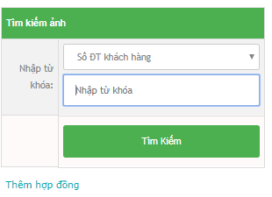

*Step 2:* Enter correct or a part of exsit Customer Phone on”Nhập từ khóa”field.

ステップ 2:”Nhập từ khóa”欄に顧客電話番号の一部または全部を入力します。

*Step 3:* Click”Tìm kiếm”button. All Contract have Customer Phone like keyword value will be display.

ステップ 3:”Tìm kiếm”ボタンをクリックします。すべての契約は、顧客の電話のようなキーワードの値が表示されます。

Edit Contract. 契約の編集

*Step 1:* Click on”Sửa”button to display Edit Contract form.

ステップ 1:”Sửa”ボタンをクリックして契約編集フォームを表示します。



*Step 2:* Select”Tình trạng hợp đồng”.

ステップ 2:”Tình trạng hợp đồng”を選択します。

*Step 3:* Edit field want to edit.

ステップ 3: 編集したいフィールドを編集します。

* Edit Contract rules : 契約ルールの編集
  + Customer Name : 顧客名
    - Not empty.
    - Not special character. 特殊文字ではありません。
    - In range 6 ~ 32 character. 範囲は6〜32文字です。
    - Not number. 番号ではありません。
  + Address : 住所
    - Not empty.
    - In range 6 ~ 32 character. 範囲6〜32文字
  + Gender : 性別
    - Just select only one. 1つだけを選択する.
  + Phone : 電話
    - Not empty.
    - Must be number. 番号でなければなりません.
    - In range 10 ~ 12 character. 範囲は10〜12文字です。
  + Email : 電子メール
    - Must be correct form. 正しい形式でなければなりません.
    - Not empty. 空ではない.
    - Just allow '@','.' character. '@' '、' '。'を許可するだけです。キャラクター。
    - In range 6 ~ 32 character. 範囲は6〜32文字です。
  + Studio working : スタジオウォーク：
    - Must choose 選択する必要があります。
    - Name of product: 製品名
    - Must choose 選択する必要があります。
    - Package detail : パッケージの詳細：
    - Not empty：
  + Contract detail : 契約の詳細
    - Not empty
    - Create date : 作成日
    - Must choose. 選択する必要があります。
    - Must smaller or equal with Start date and End Date. 開始日と終了日以下でなければなりません。
    - Start date : 開始日
    - Must choose. 選択する必要があります。
    - Must smaler or equal with End date. 終了日がより鈍いか等しい。
    - End Date : 終了日
    - Must choose bigger or equal with Create date and Start Date. 作成日と開始日より大きいか等しいかを選択する必要があります。

*Step 4:* Click on”Nhập”button.

“Nhập”ボタンをクリックします。

ステップ 4

### Add Contract 契約を追加します。

*Step 1:* Click on”Thêm hợp đồng”link to display Add Contract form.

ステップ 1:”Thêm hợp đồng”リンクをクリックして契約書式を表示します。

*Step 2:* Select Contract status.

ステップ 2: 契約ステータスを選択します。

*Step 3:* Enter Customer Name

ステップ 3: 顧客名を入力します。

* + Customer Name rules :
  + Not empty. 空ではない。
  + Not special character. 特殊文字ではありません。
  + In range 6 ~ 32 character. 特殊文字ではありません。
  + Not number. 番号ではありません。

*Step 4:* If Customer is old Customer click on checkbox”Khách hàng cũ?”to skip enter Adress, Gender, Email, Note.

ステップ 4: 顧客が古い顧客の場合は、チェックボックス”Khách hàng cũ？ 「アドレス、性別、電子メール、注記」をスキップします。

*Step 5:* Enter Customer Adress on”Địa chỉ khách hàng”field.

ステップ 5: 「Địa chỉ khách hàng」欄に顧客の住所を入力します。

* Adress rules : 住所規則：
* Not empty. 空ではない。
* In range 6 ~ 32 character. 範囲は6〜32文字です。

Step 6 : Select Gender

ステップ 6: 性別を選択します。

Step 7 : Enter Customer Phone on”Số điện thoại”field.

ステップ 7: 「Số điện thoại」欄に顧客電話番号を入力します。

* Phone rules : 電話規則：
  + Not empty. 空ではない。
  + Must be number. 番号でなければなりません。

Step 8 : Enter Customer Email on Email field.

ステップ 8: 「電子メールに顧客の電子メールを入力」フィールド。

* Email rules : メールルール：
  + Must be correct form. 正しい形式でなければなりません。
  + Not empty. 空ではない。
  + Just allow '@','.' character. '@'、 '。'を許可するだけです。キャラクター。
  + In range 6 ~ 32 character. 範囲は6〜32文字です。

Step 9 : Enter Note or not on”Ghi chú về khách hàng”field.

ステップ 9: 「Ghichúvềkháchhàng」フィールドに注釈を入力するかどうかを入力します。

Step 10 : Select Package on”Tên sản phẩm”dropdown list.

If Customer buy more than one Package. Click”Nhập thêm”button to add more package.

ステップ 10: 「テンプレート」ドロップダウンリストでパッケージを選択します。

Step 11 : Enter Note or not on”Ghi chú :”field.

ステップ 11: 「Ghichú：」フィールドにノートを入力するかどうかを入力します。

Step 12 : Enter Contract Detail on”Chi tiết hợp đồng”field.

ステップ 12: 「Chitiếthợpđồng」フィールドに契約の詳細を入力します。

Step 13 : Select”Ngày lập nên hợp đồng”.

ステップ 13:”Ngàylậpnênhợpđồng”を選択します。

Step 14 : Select”Ngày bắt đầu làm việc”.

ステップ 14:”Ngàybắtđầulàmviệc”を選択します。

Step 15 : Select”Ngày kết thúc ( theo dự đoán )”.

ステップ 15:”**Ngàykếtthúc（theodựđoán）”を選択します。**

Step 16 : Click”Nhập”.

ステップ 16:”Nhập”をクリックします。

### View Contract Detail. 契約の詳細を表示します。

Click on”ID Hợp đồng”link to open Contract Detail page.

“IDHợpđồng”リンクをクリックして契約の詳細ページを開きます。

### Edit Contract Detail. 契約の詳細を編集する。

*Step 1:* Click on”Sửa”button.

ステップ 1:”Sửa”ボタンをクリックします。

*Step 2:* Edit field want to edit.

ステップ 2: 編集したいフィールドを編集します。

*Step 3:* Click”Chỉnh sửa”button.

ステップ 3:”Chỉnhsửa”ボタンをクリックします。

### Delete Contract Detail. 契約の詳細を削除します。

*Step 1:* Click on”Xóa”button.

ステップ 1: 契約の詳細を削除します。

*Step 2:* Click OK button on confirm window.

ステップ 2: 確認ウィンドウで[OK]ボタンをクリックします。

### View Picture form Contract Detail. 画像形式の契約の詳細を表示します。

Click on”Xem ảnh”button to open Picture Detail Page.

“Xem ảnh”ボタンをクリックすると、画像の詳細ページが開きます。

### Add new Picture Detail. 新しい画像の詳細を追加します。

*Step 1:* Click on”Thêm mới chi tiết hợp đồng”link to display Add new Picture Detail form.

ステップ 1: [新しい画像の詳細の追加]フォームが表示されるように、[リンクをクリック]をクリックします。

*Step 2:* Enter Package Name on”Tên gói hàng”field.

ステップ 2:”Tên gói hàng”欄にパッケージ名を入力します。

* Package Name rules : パッケージ名規則：
  + Not special character. 特殊文字ではありません。
  + Not empty. 空ではない。
  + In range 6 ~ 32 character. 範囲は6〜32文字です。

*Step 3:* Enter Package Detail on”Chi tiết gói hàng”field.

ステップ 3: 「Chitiếtgóihàng」フィールドにパッケージの詳細を入力します。

* Package Detail rules : パッケージの詳細ルール：
  + Not empty. 空ではない。

*Step 4:* Enter Package Price on”Giá gói hàng”field.

ステップ 4:”Giágóihàng”欄にパッケージ価格を入力します。

* Package Price rules : パッケージ価格ルール：
  + Must be number bigger than 0. 0より大きい数である必要があります。

*Step 5:* Enter Not or not on”Ghi chú”field.

ステップ 5:”Ghichú”フィールドには入力しないでください。

Step 6 : Click on”Thêm mới”button.

ステップ 6:”Thêmmới”ボタンをクリックします。

## Customer Guidelines. 顧客ガイドライン。

### Open Home Page ホームページを開く。

Option 1 : Click on StudioWeb logo on header.

オプション1：ヘッダのStudioWebロゴをクリックします。

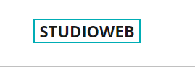

Option 2 : Click on”Trang Chủ”button on header.

オプション2：ヘッダーの「TrangChủ」ボタンをクリックします。

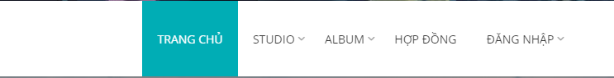

### View Studio Listスタジオリストを表示します。

Option 1 : Click on Studio button on header.

オプション1：ヘッダーの[スタジオ]ボタンをクリックします。

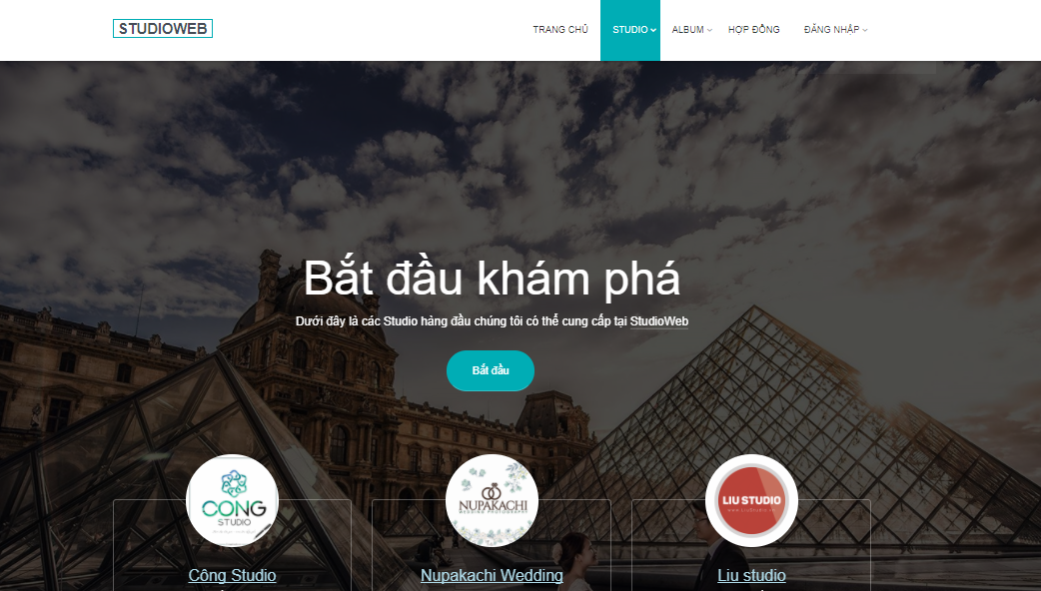

Option 2 : Click one of three”Bắt đầu”button on Home Page.

オプション2：ホームページの3つの「Bắtđầu」ボタンの1つをクリックします。



### View Studio Detail Page Studioの詳細ページを表示する

Option 1 : オプション1 ：

*Step 1:* Take the mouse on Studio to open Studio list dropdown list.

ステップ 1: Studioでマウスを操作して、スタジオリストのドロップダウンリストを開きます。

*Step 2:* Click on Studio want to view.

ステップ 2: 見たいスタジオをクリックします。

Option 2 :

*Step 1:* Click on Studio button on header to open Studio list page.

ステップ 1: ヘッダーのスタジオボタンをクリックしてスタジオリストページを開きます。

*Step 2:* Click on Studio Name link to open Studio Detail page.

ステップ 2: Studio Nameリンクをクリックして、Studio Detailページを開きます。

### View Package Detailパッケージの詳細を表示します。

*Step 1:* On Studio Detail page. Scroll page to view list of Package.

ステップ 1: スタヂオの詳細ページ。パッケージの一覧を表示するページをスクロールします。

*Step 2:* Click on”Xem thêm”button to open Package Detail page.

ステップ 2：”Xem thêm”ボタンをクリックしてPackage Detailページを開きます。

### Add Package on Cart. カートにパッケージを追加します。

*Step 1:* On Package list in Studio Detail. Click on Cart icon of Package want to buy.

ステップ 1: スタジオの詳細のパッケージリスト購入したいパッケージのカートアイコンをクリックしてください。

*Step 2:* Click on Open Cart button Cart Detail page.

ステップ 2: カートを開くボタンをクリックします。カートの詳細ページ。

*Step 3:* Enter Name on”Tên khách hàng”field.

ステップ 3:”Tênkháchhàng”フィールドに名前を入力します。

*Step 4:* Select Gender.

ステップ 4: 性別を選択します。

*Step 5:* Enter Phone Number on”Số ĐT khách hàng”field.

ステップ 5: 「Số ĐT khách hàng」欄に電話番号を入力します。

Step 6 : Enter Customer Email on Customer Email field.

ステップ 6: 顧客電子メールに顧客電子メールを入力します。

Step 7 : Enter Customer Facebook link on Customer Facebook field.

ステップ 7: 顧客のFacebookフィールドにCustomer Facebookのリンクを入力します。

Step 8 : Enter Note or not on Note field.

ステップ 8: メモフィールドに注釈を入力するか否かを入力します。

Step 9 : Click Buy button.

ステップ 9:購入ボタンをクリックします。

### View review Album. アルバムを見る。

Click on Album button on header to display review album on Studio.

ヘッダーの[アルバム]ボタンをクリックすると、スタジオにレビューアルバムが表示されます。

### View one of Album type. アルバムタイプの1つを表示します。

*Step 1:* Take the mouse on Album button in header.

ステップ 1: ヘッダーのアルバムボタンにマウスを移動します。

*Step 2:* Click one of Album type in Album list dropdown list.

ステップ 2: アルバムリストドロップダウンリストでアルバムタイプをクリックします。

### Show own Contract. 自分の契約を表示する。

*Step 1:* Click on Contract button on header.

ステップ 1: ヘッダーの契約ボタンをクリックします。

*Step 2:* Enter Contract code to display Customer contract.

ステップ 2: 顧客契約を表示する契約コードを入力します。

### Show About Us. 私たちについて

Click”Về chúng tôi”link on footer to open About us page.

フッターの”Vềchúngtôi”リンクをクリックしてAbout usページを開きます。